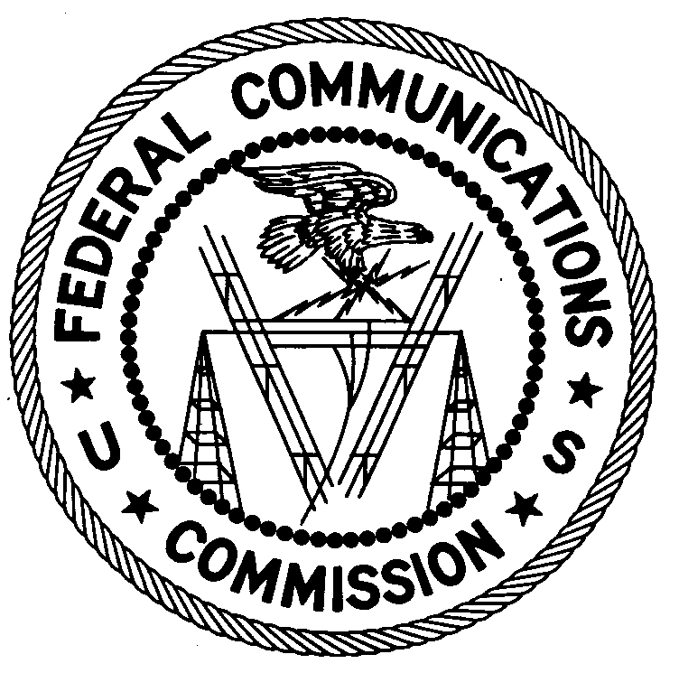
FEDERAL COMMUNICATIONS COMMISSION
ENFORCEMENT BUREAU
REGION ONE

Columbia Regional Office
9050 Junction Drive
Annapolis Junction, Maryland 20701
Field@FCC.gov
(301) 725-1996

May 16, 2019

Traffic Control Services LLC DBA Flagger Force
Middletown, Pennsylvania

WARNING OF UNLICENSED OPERATION

Case Number: EB-FIELDNER-19-00028817

On March 7, 2019, the Columbia Office of the Federal Communications Commission’s (FCC’s or Commission’s) Enforcement Bureau (Bureau) received information that Traffic Control Services LLC DBA Flagger Force is operating radio transmitting equipment in the areas of Pennsylvania, Maryland, Delaware and New Jersey without authorization. Flagger Force employees are allegedly operating two-way radios on the Land Mobile Radio Service (LMRS) frequency 464.550 MHz and on multiple frequencies in the Family Radio Service (FRS) and General Mobile Radio Service (GMRS) including 467.6125 MHz, 467.6375 MHz, 467.6625 MHz, and 462.7250 MHz.

The Commission’s records show that the Flagger Force does not hold a license to operate any radio transmitting equipment on the LMRS frequency 464.550 MHz. Furthermore, there is no evidence that Flagger Force holds, or is eligible to hold, a license to operate radio transmitting equipment on any GMRS frequency. Although an individual license is not required to operate radio transmitting equipment in the FRS, the radio transmitting equipment must be certificated for use in the FRS in accordance with subpart J of part 2 of the Commission’s Rules.

Radio stations operating on a range of frequencies, including 464.550 MHz, must be licensed by the FCC pursuant to Section 301 of the Communications Act of 1934, as amended (Act). The only exception to this licensing requirement is for certain transmitters using or operating at a power level or mode of operation that complies with the standards established in Part 15 of the Commission’s rules. The above described operations by Traffic Control Services LLC DBA Flagger Force on these frequencies violates Section 301 of the Act.

You are hereby warned that operation of radio transmitting equipment without a valid radio station authorization constitutes a violation of the Federal laws cited above and will subject the operator to severe penalties, including, but not limited to, in rem seizure of the offending radio equipment without further notice, substantial fines, and criminal sanctions, including imprisonment.

UNLICENSED OPERATION OF THESE RADIO STATIONS MUST BE DISCONTINUED IMMEDIATELY AND MUST NOT RESUME.

You have ten (10) days from the date of this notice to respond with any evidence that you have authority to operate granted by the FCC. Your response should be sent to the address in the letterhead and reference the listed case number. Under the Privacy Act of 1974, we are informing you that the Commission’s staff will use all relevant material information before it to determine what, if any, enforcement action is required to ensure your compliance with FCC Rules. This will include any information that you disclose in your reply.

You may contact this office if you have any questions.

David C. Dombrowski
Regional Director
Region One
Enforcement Bureau
Federal Communications Commission

Attachments:
Excerpts from the Communications Act of 1934, As Amended
Enforcement Bureau, "Inspection Fact Sheet", March 2005

The Land Mobile Radio Service license WQOB287 authorizes Traffic Control Services LLC DBA Flagger Force to operate radio transmitting equipment on the frequencies 461.1125 MHz, 461.2125 MHz, 466.1125 MHz, and 466.2125 MHz.
Pursuant to Section 95.1705 of the Rules, a valid individual license is required to operate a GMRS station. 47 CFR § 95.1705.
47 CFR § 95.603(d).
47 U.S.C. § 301.
47 CFR §§ 15.1 et seq.
47 U.S.C. § 301.
See 47 U.S.C. §§ 401, 501, 503, and 510.
5 U.S.C. § 552a(e)(3).

