FEDERAL COMMUNICATIONS COMMISSION
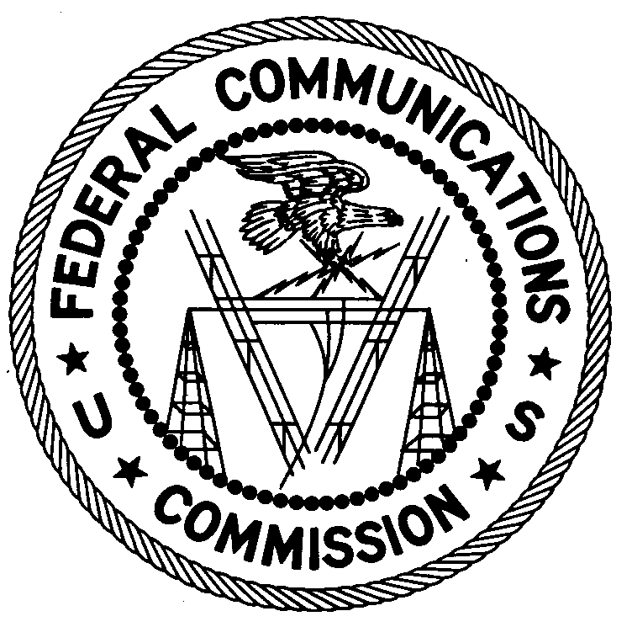
ENFORCEMENT BUREAU
REGION TWO

Atlanta Regional Office
P.O. Box 1493
Powder Springs, GA 30127
Field@FCC.gov
(678) 293-3194

May 20, 2019
BY FIRST CLASS MAIL AND UPS

Thousand Oaks Bible Church
15801 Jones Maltsberger Rd
San Antonio, TX 78247

NOTICE OF UNLICENSED OPERATION AND
NOTIFICATION OF HARMFUL INTERFERENCE

Case Number: EB-FIELDSCR-19-00028748

The Federal Communications Commission (FCC or Commission) received a complaint from the Federal Aviation Administration (“FAA”) CSA Spectrum Engineering Team concerning interference to Air Traffic Control channel 128.650 MHz in San Antonio. On March 28, 2019, an Agent from the Dallas Office of the FCC’s Enforcement Bureau (Bureau) conducted an investigation and determined that the source of the interference to the FAA was a spurious signal that was drifting on and around 128.650 MHz. The signal was determined to be emanating from an Orion-5000 mobileblackbox.com FM broadcast transmitter located at the Thousand Oaks Bible Church. After the Agent notified the Church about the cause of the interference, the transmitter was powered off and the interference ceased.

Operation on 128.650 MHz is reserved for aviation services. In addition, radio stations operating on many frequencies, including 128.650 MHz, must be licensed by the FCC pursuant to Section 301 of the Communications Act of 1934, as amended (Act). The only exception to this licensing requirement is for certain transmitters using or operating at a power level or mode of operation that complies with the standards established in Part 15 of the Commission’s rules. Non-licensed operation of a Part 15 device is subject to the condition that it must not cause harmful interference and, if harmful interference occurs, operation of the device must cease. You have no valid license to operate a radio transmitter on 128.650 MHz. In addition, transmitters operating in the aviation frequencies must be certificated for use. There was no evidence of an FCC ID label on the device to show that the device had received a certification or any other FCC equipment authorization. Thus, this station is operating in violation of Section 301 of the Act.

You are hereby warned that operation of radio transmitting equipment without a valid radio station authorization constitutes a violation of the Federal laws cited above and could subject the operator to severe penalties, including, but not limited to, substantial monetary fines, in rem arrest action against the offending radio equipment, and criminal sanctions including imprisonment.

UNAUTHORIZED OPERATION OF THIS RADIO TRANSMITTING DEVICE AND ASSOCIATED HARMFUL INTERFERENCE MUST CEASE IMMEDIATELY AND MUST NOT RESUME

You have ten (10) days from the date of this notice to respond with any evidence or actions to correct the interference issue and to ensure that it will not recur. Your response should be sent to the address in the letterhead and reference the listed case number. Under the Privacy Act of 1974, we are informing you that the Commission’s staff will use all relevant material information before it to determine what, if any, enforcement action is required to ensure your compliance with FCC rules. This will include any information that you disclose in your reply.

You may contact this office if you have any questions.

Ronald Ramage
Regional Director
Region Two
Enforcement Bureau

47 CFR § 87.173(b).
47 U.S.C. § 301.
47 CFR § 15.5.
47 CFR § 87.145.
See 47 U.S.C. §§ 401, 501, 503 and 510.
5 U.S.C. § 552a(e)(3).

