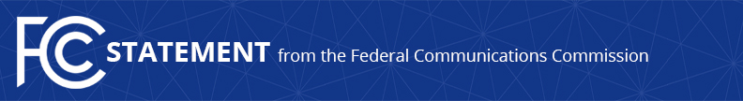

Media Contact:
Will Wiquist, (202) 418-0509
will.wiquist@fcc.gov

For Immediate Release

CHAIRMAN PAI STATEMENT ON LATEST PROGRESS IN COMBATTING MALICIOUS SPOOFING
--
WASHINGTON, May 30, 2019—Federal Communications Commission Chairman Ajit Pai today welcomed the latest step toward implementation of call authentication to combat malicious caller ID spoofing and unwanted robocalls. Earlier today, the Alliance for Telecommunications Industry Solutions (ATIS) announced its selection of iconectiv as policy administrator of the SHAKEN/STIR call authentication framework. The Chairman issued the following statement:

“Unwanted robocalls are American consumers’ number one complaint to the FCC. Many of these robocalls are made by scammers who mask their identity, harass consumers, and seek to defraud vulnerable communities. ‘Call authentication’ is critical for protecting consumers against these calls. It will ensure that voice providers are exchanging accurate information about the source of calls traveling across their networks. Moreover, I have proposed that the FCC create a safe harbor for carriers that block calls because they are not authenticated under the SHAKEN/STIR framework. I appreciate ATIS’s work on this issue and look forward to seeing deployment of SHAKEN/STIR by major carriers this year. Consumers are sick and tired of robocalls and they want and deserve relief as soon as possible.”

###
Media Relations: (202) 418-0500 / ASL: (844) 432-2275 / TTY: (888) 835-5322 / Twitter: @FCC / www.fcc.gov

This is an unofficial announcement of Commission action. Release of the full text of a Commission order constitutes official action. See MCI v. FCC, 515 F.2d 385 (D.C. Cir. 1974).

