FEDERAL COMMUNICATIONS COMMISSION
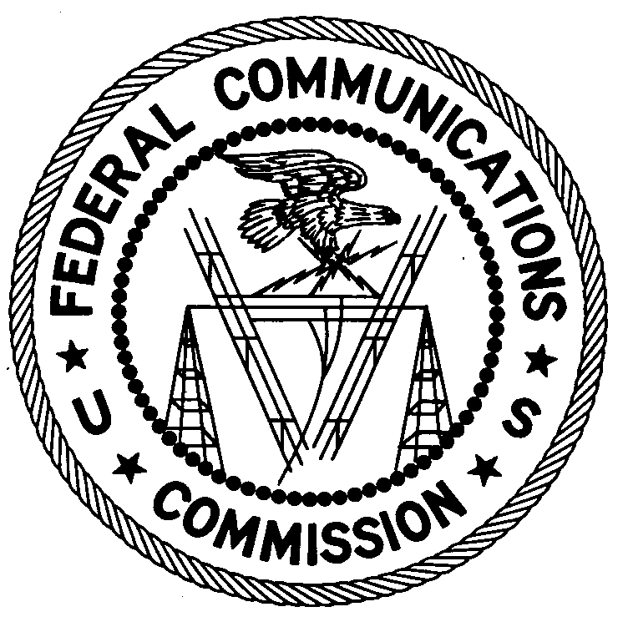
ENFORCEMENT BUREAU
REGION ONE

Columbia Regional Office
9050 Junction Drive
Annapolis Junction, Maryland 20701
FIELD@FCC.gov

(301) 725-1996

June 4, 2019

BY UPS AND FIRST-CLASS MAIL

Joseph Foster
Island Park, NY

NOTICE OF UNLICENSED OPERATION AND
NOTIFICATION OF HARMFUL INTERFERENCE

Case Number: EB-FIELDNER-16-00021179

The New York Office of the Federal Communications Commission’s (FCC or Commission’s) Enforcement Bureau (Bureau) received a complaint from the Nassau County Police Department (NCPD) Emergency Ambulance Bureau (EAB) concerning harmful interference and unauthorized transmissions on the frequencies 468.1000 MHz (MED 5), 467.9500 MHz (MED 9) and 467.9750 MHz (MED 10) which are used for emergency response in Nassau County, New York.

On March 16, 2019, Agents of the FCC Enforcement Bureau (Bureau) used direction finding techniques to identify that the source of the unauthorized transmissions on 468.100 MHz was located at a multi-family dwelling on the 200 Block of North Nassau Lane, Island Park, New York. Through further investigation on April 11, 2019, Detectives from the NCPD and FCC Agents confirmed that you were the source of the unauthorized transmissions on the frequency 468.100 MHz and the harmful interference to the NCPD EAB. The Commission’s records show that no license was issued for your operation on the Public Safety frequency 468.100 MHz in the Island Park, New York area.

Radio stations operating on a range of frequencies, including the Land Mobile Radio Service frequency 468.1000 MHz, must be licensed by the FCC pursuant to section 301 of the Communication Act of 1934, as amended (Act). The only exceptions to this licensing requirement are certain transmitters using or operating at a power level or mode of operation that complies with the standards established in Part 15 of the Commission’s rules. Non-licensed operation pursuant to Part 15 of the Commission’s rules is subject to the condition that it must not cause harmful interference and, if harmful interference occurs, operation of the device must cease. As noted above, Commission records show that you do not have a license to operate on the Public Safety frequency 468.100 MHz in the Island Park, New York area. In addition, operation on 468.1000 MHz is limited to public safety entities. The NCPD EAB stated that you do not have permission to operate on the frequency 468.1000 MHz. Furthermore, your unauthorized transmissions caused harmful interference to public safety operations on this frequency. Thus, your station is operating in violation of 47 U.S.C. § 301.

Operation of radio transmitting equipment without a valid FCC authorization or license is a violation of section 301 of the Act and may subject the responsible parties to substantial monetary fines, in rem arrest action against the offending radio equipment, and criminal sanctions including imprisonment. Because unlicensed operation creates a danger of interference to important radio communications services and may subject the operator to severe penalties, this letter emphasizes the importance of complying strictly with these legal requirements.
UNAUTHORIZED OPERATION OF THIS RADIO TRANSMITTING DEVICE AND ASSOCIATED HARMFUL INTERFERENCE MUST CEASE IMMEDIATELY AND MUST NOT RESUME

You have ten (10) days from the date of this notice to respond concerning your operation of this Part 15 device. Your response should describe the steps you are taking to avoid operating on unauthorized frequencies and preventing future interference. Your response should be sent to the address in the letterhead and reference the listed case number. Under the Privacy Act of 1974, we are informing you that the Commission’s staff will use all relevant material information before it to determine what, if any, enforcement action is required to ensure your compliance with FCC rules. This will include any information that you disclose in your reply.

You may contact this office if you have any questions.

David C. Dombrowski
Regional Director
Region One
Enforcement Bureau
Federal Communications Commission

Enclosures
Excerpts from the Communications Act of 1934, As Amended
Enforcement Bureau, "Inspection Fact Sheet", March 2005

The Nassau County Police Department is licensed under the call signs KUJ797 and KO8667.
47 U.S.C. § 301.
47 CFR §§ 15.1 et seq.
47 CFR § 15.5(c).
47 CFR § 90.20(c)(2).
47 U.S.C. § 301.
See 47 U.S.C. §§ 401, 501, 503 and 510.
See 47 U.S.C. §§ 401, 501, 503 and 510.
5 U.S.C. § 552a(e)(3).

