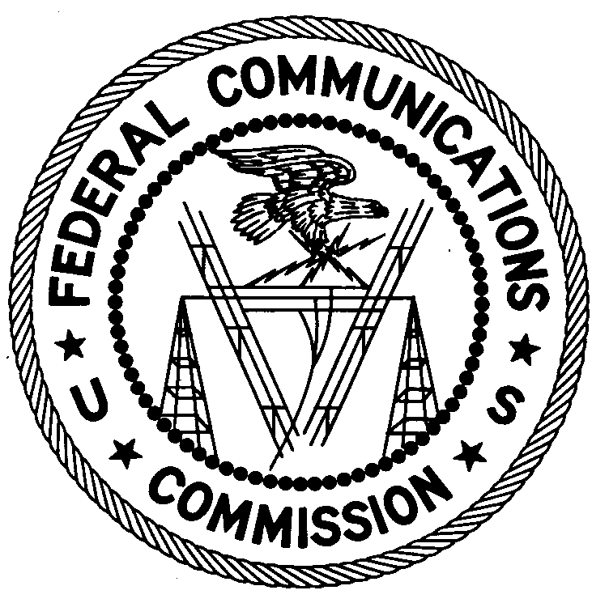
FEDERAL COMMUNICATIONS COMMISSION
ENFORCEMENT BUREAU
REGION ONE

Columbia Regional Office

9050 Junction Drive

Annapolis Junction, Maryland 20701

Field@FCC.gov
(301) 725-1996

June 11, 2019

Ron Adams
Ligonier, Pennsylvania

NOTICE OF UNLICENSED OPERATION

Case Numbers: EB-FIELDNER-19-00028828

EB-FIELDNER-19-00029139

On April 8 and April 9, 2019, an Agent from the Columbia Offices of the Federal Communications Commission’s (FCC’s or Commission’s) Enforcement Bureau (Bureau) investigated unlicensed FM stations operating on the frequencies 102.3 MHz and 100.9 MHz in Ligonier, Pennsylvania. The Agent confirmed by direction finding techniques that radio signals on the frequency 102.3 MHz were emanating from a residential property on Peters Road in Ligonier, Pennsylvania and the radio signals on the frequency 100.9 MHz were emanating from a residential property on South Grant Street in Ligonier, Pennsylvania. Through an investigation, the Agent found that you were the operator of both stations. The Commission’s records show that no license was issued for operation of broadcast stations on 102.3 MHz and 100.9 MHz at these locations in Ligonier, Pennsylvania.

Radio stations operating on a range of frequencies, including 102.3 MHz and 100.9 MHz, must be licensed by the FCC pursuant to section 301 of the Communications Act of 1934, as amended (Act). The only exception to this licensing requirement is for certain transmitters using or operating at a power level or mode of operation that complies with the standards established in part 15 of the Commission’s rules. The Agent measured the field strength of the signals on the frequencies 102.3 MHz and 100.9 MHz for the stations and found that it exceeded the maximum permitted level of 250 µV/m at 3 meters for non-licensed devices. Thus, these stations are operating in violation of section 301 of the Act.

Operation of radio transmitting equipment without a valid FCC authorization or license is a violation of section 301 of the Act and may subject the responsible parties to substantial monetary fines, in rem arrest action against the offending radio equipment, and criminal sanctions including imprisonment. Because unlicensed operation creates a danger of interference to important radio communications services and may subject the operator to severe penalties, this letter emphasizes the importance of complying strictly with these legal requirements.

UNLICENSED OPERATION OF THESE RADIO STATIONS MUST BE DISCONTINUED IMMEDIATELY.

You have ten (10) days from the date of this notice to respond with any evidence that you have authority to operate granted by the FCC. Your response should be sent to the address in the letterhead and reference the listed case numbers. Under the Privacy Act of 1974, we are informing you that the Commission’s staff will use all relevant material information before it to determine what, if any, enforcement action is required to ensure your compliance with FCC Rules. This will include any information that you disclose in your reply.

You may contact this office if you have any questions.

David C. Dombrowski
Regional Director
Region One
Enforcement Bureau
Federal Communications Commission

Attachments:
Excerpts from the Communications Act of 1934, As Amended
Enforcement Bureau, "Inspection Fact Sheet", March 2005

47 CFR § 73.201.
47 U.S.C. § 301.
47 CFR §§ 15.1 et seq.
47 U.S.C. § 301.
47 U.S.C. § 301.
See 47 U.S.C. §§ 401, 501, 503 and 510.
5 U.S.C. § 552a(e)(3).

