FEDERAL COMMUNICATIONS COMMISSION
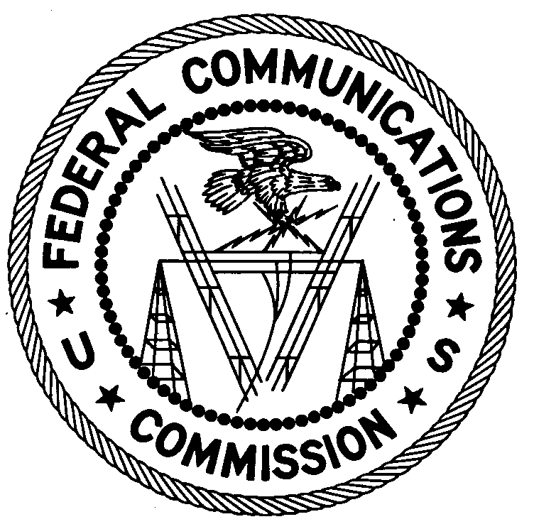
ENFORCEMENT BUREAU
REGION ONE

Columbia Regional Office
9050 Junction Drive
Annapolis Junction, Maryland 20701
FIELD@FCC.gov
(301) 725-1996

June 18, 2019

Gerlens Cesar
Radio Teleboston
Malden, Massachusetts

NOTICE OF UNLICENSED OPERATION

Case Numbers: EB-FIELDNER-19-00029169

EB-FIELDNER-17-00025344

EB-FIELDNER-17-00024874

The Boston Office of the Federal Communications Commission’s (FCC or Commission) Enforcement Bureau (Bureau) has received complaints about an unlicensed FM station operating on 92.1 MHz and 90.1 MHz at different locations in and around Boston, Massachusetts.

On May 16, 2019, Agents from the Bureau’s Region One investigated an unlicensed FM station operating on the frequency 92.1 MHz in Everett, Massachusetts. The Agents confirmed by direction-finding techniques that radio signals on the frequency 92.1 MHz were emanating from a multi-unit building on Judson Street in Malden, Massachusetts. The Commission’s records show that no license was issued for the operation of a radio station on 92.1 MHz at this location in Malden, Massachusetts.

On April 16, 2019, an Agent from the Bureau’s Region One investigated an unlicensed FM station operating on the frequency 90.1 MHz in Boston, Massachusetts. The Agent confirmed by direction-finding techniques that radio signals on the frequency 90.1 MHz were emanating from a multi-unit building on Blue Hill Avenue in Mattapan, Massachusetts. The Commission’s records show that no license was issued for the operation of a radio station on 90.1 MHz at this location in Mattapan, Massachusetts.

On April 16, 2019, an Agent from the Bureau’s Region One investigated an unlicensed FM station operating on the frequency 92.1 MHz in Brockton, Massachusetts. The Agent confirmed by direction-finding techniques that radio signals on the frequency 92.1 MHz were emanating from a multi-unit building on Cherry Street in Brockton, Massachusetts. The Commission’s records show that no license was issued for the operation of a radio station on 92.1 MHz at this location in Brockton, Massachusetts.

Through investigation, the Bureau’s Agents determined that you are the operator of the stations identified above.

Radio stations operating on a range of frequencies, including 92.1 MHz and 90.1 MHz, must be licensed by the FCC pursuant to section 301 of the Communications Act of 1934, as amended (Act). The only exception to this licensing requirement is for certain transmitters using or operating at a power level or mode of operation that complies with the standards established in part 15 of the Commission’s rules. On May 16, 2019, Agents measured the field strength of the signal on the frequency 92.1 MHz for the station in Malden, Massachusetts, on April 16, 2019, an Agent measured the field strength of the signal on 90.1 MHz in Mattapan, Massachusetts, and on April 16, 2019, an Agent measured the field strength of the signal on 92.1 MHz in Brockton, Massachusetts. The signals exceeded the maximum permitted level of 250 µV/m at 3 meters for non-licensed devices. Thus, these stations were operating in violation of section 301 of the Act.

You are hereby warned that operation of radio transmitting equipment without a valid radio station authorization constitutes a violation of the Federal laws cited above and will subject the operator to severe penalties, including, but not limited to, in rem seizure of the offending radio equipment without further notice, substantial fines, and criminal sanctions, including imprisonment.

UNLICENSED OPERATION OF THESE RADIO STATIONS MUST BE DISCONTINUED IMMEDIATELY AND MUST NOT RESUME.

You have ten (10) days from the date of this notice to respond with any evidence that you have authority to operate granted by the FCC. Your response should be sent to the address in the letterhead and reference the listed case numbers. Under the Privacy Act of 1974, we are informing you that the Commission’s staff will use all relevant material information before it to determine what, if any, enforcement action is required to ensure your compliance with FCC Rules. This will include any information that you disclose in your reply.

You may contact this office if you have any questions.

David C. Dombrowski
Regional Director
Region One
Enforcement Bureau
Federal Communications Commission

Attachments:
Excerpts from the Communications Act of 1934, As Amended
Enforcement Bureau, "Inspection Fact Sheet", March 2005

47 CFR § 73.201.
47 U.S.C. § 301.
47 CFR §§ 15.1 et seq.
47 U.S.C. § 301.
See 47 U.S.C. §§ 401, 501, 503 and 510.
5 U.S.C. § 552a(e)(3).

