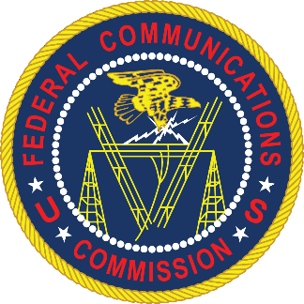

“Security VULNERABILITIES Within Our Communications Networks: Find it, Fix it, Fund it”
Stakeholder Workshop
Convened and Moderated by
Commissioner Geoffrey Starks

Federal Communications Commission
445 12th Street S.W., Commission Meeting Room, Washington, D.C. 20554

June 27, 2019
9:30 AM – 1:00 PM

Workshop Agenda*
9:30 AM Welcoming Remarks from Commissioner Starks
“Description of the Threat”
Jim Lewis, Senior Vice President and Director, Technology Policy Program, Center for Strategic & International Studies (CSIS)
Professor Jonathan Mayer, Assistant Professor of Computer Science and Public Affairs, Princeton University
Panel 1
10:00 AM Find it: The Scope of the Problem
This panel will focus on how to identify which equipment poses a threat and where it is located.
Panelists:
- Brian Hendricks, Vice President of Policy and Government Relations, Nokia
- Jim Lewis, CSIS
- John Nettles, President, Pine Belt Telephone Company
- Mike Saperstein, Vice President, Policy & Advocacy, USTelecom
Panel 2
11:00 AM Fix It: How to Ensure that Networks are Secure
This panel will consider options for fixing identified security problems, including discussion of what equipment needs to be fixed, whether replacing equipment is the best approach, or whether monitoring or other measures can be part of the solution.
Panelists:
- Carri Bennet, General Counsel, The Rural Wireless Association
- Bill Chotiner, Director, Radio Access Network Evolution, Ericsson
- Travis Russell, Director of Cybersecurity, Oracle Communications
- Dileep Srihari, Senior Policy Counsel and Acting Head of Government Affairs, Telecommunications Industry Association (TIA)

Panel 3
12:00 PM Fund It: National Problems Require National Solutions
This panel will address questions regarding funding, including the amount required for equipment replacement and threat mitigation, potential public and private sources, and what safeguards and other conditions should be attached.
Panelists:
      - Jeff Johnston, Senior Economist, CoBank
      - Alexi Maltas, Senior Vice President, General Counsel, Competitive Carriers Association (CCA)
      - Christopher Reno, Director of Accounting, Union Telephone Company

12:55 PM Closing Remarks from Commissioner Starks

