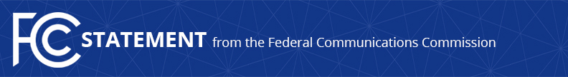
Media Contact:
Will Wiquist, (202) 418-0509
will.wiquist@fcc.gov

For Immediate Release

CHAIRMAN PAI ON THE SHAKEN/STIR ROBOCALL SUMMIT
--
WASHINGTON, July 11, 2019—Federal Communications Commission Chairman Ajit Pai issued the following statement on today’s SHAKEN/STIR Robocall Summit at the FCC:

“We must move aggressively to help consumers combat scam robocalls that use and abuse caller ID spoofing, and that’s why we held today’s summit. The summit was productive, and we received generally encouraging signs that companies are headed toward full implementation of the SHAKEN/STIR caller ID authentication framework. I was pleased to hear from voice service providers, vendors, consumer advocates, and others about the successes to date and the challenges that remain.

“Given what I heard today, I am optimistic that the major voice service providers will meet the end-of-2019 deadline for implementation I set for them. That said, we stand ready to take regulatory action if this deadline is not met. We have already adopted a Notice of Proposed Rulemaking and will move quickly to mandate SHAKEN/STIR if needed.

“As I’ve said before and as panelists noted today, there is no silver bullet to solving the problem of unwanted robocalls. But caller ID authentication is an important part of the solution. And we will continue to execute on the rest of our multi-pronged strategy as well. We have been and will continue to do everything we can to protect American consumers from this scourge.”

To see materials from today’s SHAKEN/STIR Robocall Summit, visit: https://www.fcc.gov/SHAKENSTIRSummit

To learn more about caller ID authentication and the SHAKEN/STIR framework, visit: https://www.fcc.gov/call-authentication

###
Office of Chairman Pai: (202) 418-1000 / Twitter: @AjitPaiFCC / www.fcc.gov/leadership/ajit-pai

This is an unofficial announcement of Commission action. Release of the full text of a Commission order constitutes official action. See MCI v. FCC, 515 F.2d 385 (D.C. Cir. 1974).

