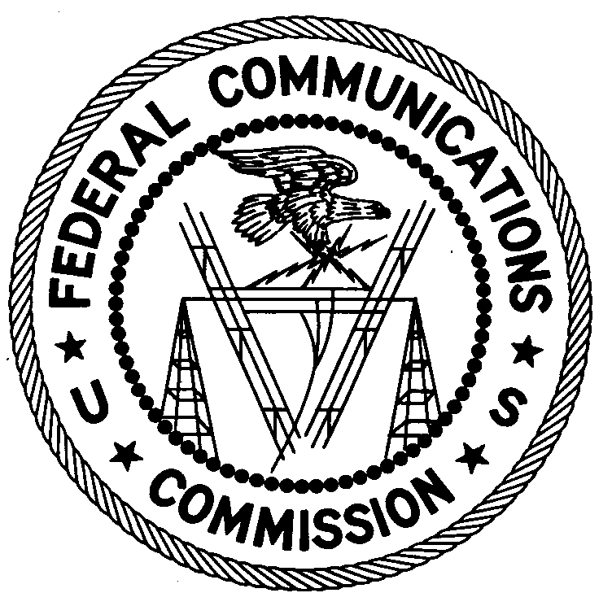
FEDERAL COMMUNICATIONS COMMISSION
ENFORCEMENT BUREAU
REGION THREE

Los Angeles Regional Office

11331 183rd Street, PMB # 365

Cerritos, CA 90703

Field@FCC.gov
(562) 860-7474

July12, 2019

Thomas Barnes
La Grande, Oregon

Case Number: EB-FIELDWR-19-00029179

NOTICE OF UNLICENSED OPERATION

On May 15, 2019, in response to a complaint, an Agent from the Portland Office of the Federal Communications Commission’s (FCC’s or Commission’s) Enforcement Bureau (Bureau) investigated an unlicensed FM station operating on the frequency 92.3 MHz in La Grande, Oregon. Through investigation, the Agent determined that you were the operator of the station. The Commission’s records show that no license was issued for operation of a broadcast station on 92.3 MHz at this location in La Grande, Oregon.

Radio stations operating on a range of frequencies, including 92.3 MHz, must be licensed by the FCC pursuant to section 301 of the Communications Act of 1934, as amended (Act). The only exception to this licensing requirement is for certain transmitters using or operating at a power level or mode of operation that complies with the standards established in part 15 of the Commission’s rules. On May 15, 2019, the Agent measured the field strength of the signal on the frequency 92.3 MHz for the station and found that it exceeded the maximum permitted level of 250 microvolts per meter (µV/m) at 3 meters established under part 15. Thus, this station is operating in violation of section 301 of the Act. During the FCC inspection accompanied by the La Grande Police Department on May 15, 2019, to show a good faith effort to comply with the Rules, you shut down the station and voluntarily surrendered a non-certified transmitter model ST-15B and a vertical antenna.

You are hereby warned that operation of radio transmitting equipment without a valid radio station authorization constitutes a violation of the Federal laws cited above and could subject the operator to severe penalties, including, but not limited to, substantial monetary fines, in rem seizure of the offending radio equipment, and criminal sanctions, including imprisonment.

UNLICENSED OPERATION OF THIS RADIO STATION MUST BE DISCONTINUED IMMEDIATELY.

You have ten (10) days from the date of this notice to respond with any evidence that you have authority to operate granted by the FCC. Your response should be sent to the address in the letterhead and reference the listed case number. Under the Privacy Act of 1974, we are informing you that the Commission’s staff will use all relevant material information before it to determine what, if any, enforcement action is required to ensure your compliance with the Commission’s Rules. This will include any information that you disclose in your reply.

You may contact this office if you have any questions.

FEDERAL COMMUNICATIONS COMMISSION

Lark Hadley
Regional Director
Region Three
Enforcement Bureau

Attachments:
Excerpts from the Communications Act of 1934, As Amended
Enforcement Bureau, "Inspection Fact Sheet", March 2005

47 CFR § 73.201.
47 U.S.C. § 301.
47 CFR §§ 15.1 et seq.
47 U.S.C. § 301.
See 47 U.S.C. §§ 401, 501, 503 and 510.
5 U.S.C. § 552a(e)(3).

