FEDERAL COMMUNICATIONS COMMISSION
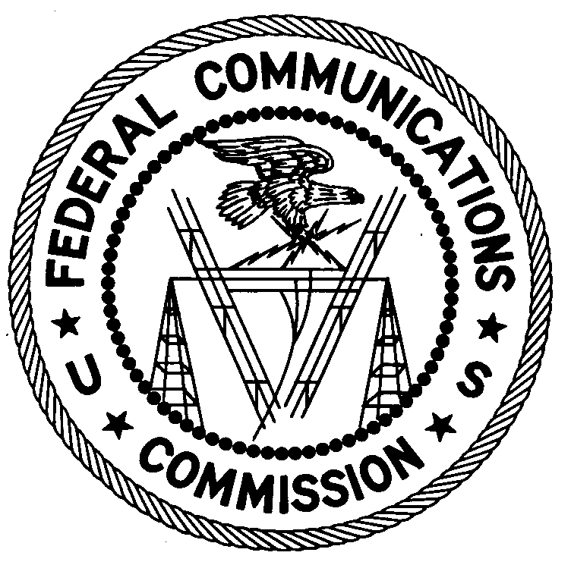
ENFORCEMENT BUREAU
REGION ONE

Columbia Regional Office
9050 Junction Drive
Annapolis Junction, Maryland 20701
FIELD@FCC.gov
(301) 725-1996

July 23, 2019

Daniel O. Gaquin, Resident Agent
Terrace Hall Partners, LLC
Burlington, Massachusetts

NOTICE OF UNLICENSED OPERATION

Case Number: EB-FIELDNER-19-00029189

On May 30, 2019, an Agent from the Federal Communications Commission’s (FCC or Commission’s) Enforcement Bureau (Bureau) investigated a complaint of an unmodulated radio signal on the frequency 99.9 MHz in Burlington, Massachusetts. The Agents confirmed by direction finding techniques that radio signals on frequency 99.9 MHz were emanating from a commercial building at 87 Terrace Hall Way in Burlington, Massachusetts. Corporation records list you as the resident agent of the owner of the property. The Commission’s records show that no license was issued for the operation of a radio station on 99.9 MHz at this location in Burlington, Massachusetts.

Radio stations operating on a range of frequencies, including 99.9 MHz, must be licensed by the FCC pursuant to section 301 of the Communications Act of 1934, as amended (Act). The only exception to this licensing requirement is for certain transmitters using or operating at a power level or mode of operation that complies with the standards established in part 15 of the Commission’s rules. On May 30, 2019, the Agent measured the field strength of the signal on the frequency 99.9 MHz for the station and found that it exceeded the maximum permitted level of 250 µV/m at 3 meters for non-licensed devices. Thus, this station was operating in violation of section 301 of the Act.

You are hereby warned that operation of radio transmitting equipment without a valid radio station authorization constitutes a violation of the Federal laws cited above and will subject the operator to severe penalties, including, but not limited to, in rem seizure of the offending radio equipment without further notice, substantial fines, and criminal sanctions, including imprisonment.

UNLICENSED OPERATION OF THIS RADIO STATION MUST BE DISCONTINUED IMMEDIATELY AND MUST NOT RESUME.

You have ten (10) days from the date of this notice to respond with any evidence that you have authority to operate granted by the FCC. Your response should be sent to the address in the letterhead and reference the listed case number. Under the Privacy Act of 1974, we are informing you that the Commission’s staff will use all relevant material information before it to determine what, if any, enforcement action is required to ensure your compliance with FCC Rules. This will include any information that you disclose in your reply.

You may contact this office if you have any questions.

David C. Dombrowski
Regional Director
Region One
Enforcement Bureau
Federal Communications Commission

Attachments:
Excerpts from the Communications Act of 1934, As Amended
Enforcement Bureau, "Inspection Fact Sheet", March 2005

47 CFR § 73.201.
47 U.S.C. § 301.
47 CFR §§ 15.1 et seq.
47 U.S.C. § 301.
See 47 U.S.C. §§ 401, 501, 503 and 510.
5 U.S.C. § 552a(e)(3).

