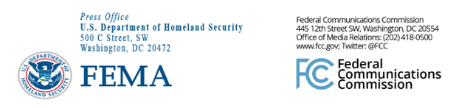

FEMA Media Contacts:
FEMA News Desk, (202) 646-3272, fema-news-desk@fema.dhs.gov

FCC Media Contacts:
FCC Office of Media Relations, (202) 418-0500, MediaRelations@fcc.gov

For Immediate Release

FEMA AND FCC CONDUCT NATIONWIDE EAS TEST
--
WASHINGTON, July 24, 2019—FEMA, in coordination with the Federal Communications Commission, will conduct a nationwide test of the Emergency Alert System (EAS) on Wednesday, Aug. 7, 2019.

The nationwide test will be sent to radio and television stations beginning at 2:20 p.m. EDT.

The test is being conducted through FEMA’s Integrated Public Alert and Warning System. This year, the test message will originate from designated radio stations, known as Primary Entry Point stations, which participate in a component of IPAWS called the National Public Warning System.

All other radio and television stations, cable, wireline service providers, and direct broadcast satellite service providers should subsequently receive and broadcast the test message.

This year’s test will evaluate the readiness of the national alerting capability in the absence of internet connectivity. The test will be approximately one minute long, have a limited impact on the public with only minor interruption of radio and television programs, and will be similar to regular monthly EAS tests. Both the audio message and text crawl should be accessible to people with disabilities.

The test will not include a message on cell phones via Wireless Emergency Alerts.

###
Media Relations: (202) 418-0500 / ASL: (844) 432-2275 / TTY: (888) 835-5322 / Twitter: @FCC / www.fcc.gov

This is an unofficial announcement of Commission action. Release of the full text of a Commission order constitutes official action. See MCI v. FCC, 515 F.2d 385 (D.C. Cir. 1974).

