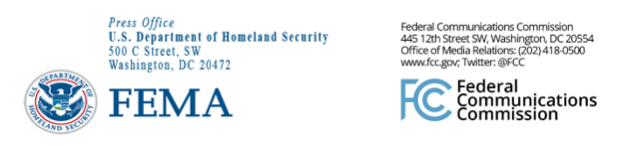

FEMA Media Contacts:
FEMA News Desk, (202) 646-3272, fema-news-desk@fema.dhs.gov

FCC Media Contacts:
FCC Office of Media Relations, (202) 418-0500, MediaRelations@fcc.gov

For Immediate Release

NATIONWIDE EMERGENCY ALERT SYSTEM TEST ON AUGUST 7
FEMA and the FCC Remind the Public About Upcoming Test Alert
on TVs and Radios
--
WASHINGTON, August 5, 2019—FEMA, in coordination with the Federal Communications Commission, reminds the public that it will conduct a nationwide test of the Emergency Alert System (EAS) on Wednesday, Aug. 7, 2019. The nationwide test message will be sent to radio and television stations beginning at 2:20 p.m. EDT.

The test will not include the Wireless Emergency Alert system, which sends alerts to cell phones. This is solely a test of alerting on radio and television.

The test is being conducted through FEMA’s Integrated Public Alert and Warning System. This year, the test message will originate from designated radio stations, known as Primary Entry Point stations, which participate in a component of IPAWS called the National Public Warning System.

All other radio and television broadcasters, cable systems, wireline video providers, and satellite radio and television providers should subsequently receive and broadcast the test message.

This year’s test will evaluate the readiness of the national alerting capability in the absence of internet connectivity. The test will be approximately one minute long, with only a minor interruption of radio and television programs, and similar to regular monthly EAS tests. Both the audio message and text crawl should be accessible to people with disabilities.

For further information about the test, please visit: https://www.fema.gov/emergency-alert-test.

###
Media Relations: (202) 418-0500 / ASL: (844) 432-2275 / TTY: (888) 835-5322 / Twitter: @FCC / www.fcc.gov

This is an unofficial announcement of Commission action. Release of the full text of a Commission order constitutes official action. See MCI v. FCC, 515 F.2d 385 (D.C. Cir. 1974).

