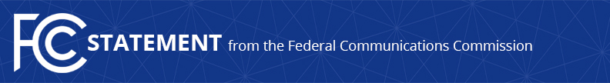
Media Contact:
Will Wiquist, (202) 418-0509
will.wiquist@fcc.gov

For Immediate Release

CHAIRMAN PAI STATEMENT ON PROGRESS BY MAJOR PHONE COMPANIES IN IMPLEMENTING CALLER ID AUTHENTICATION
--
WASHINGTON, August 14, 2019—Federal Communications Commission Chairman Ajit Pai issued the following statement in reaction to news that AT&T and T-Mobile are beginning to roll out the exchange of call authentication information between their two networks based on the SHAKEN/STIR framework. This follows similar arrangements between these companies and Comcast:

“Simply put: this is great news for American consumers. Putting into practice the SHAKEN/STIR framework means more reliable caller ID information for consumers, better insight for industry into which robocalls might be scams and should be blocked, and a stronger ability for the FCC to go after bad actors and help stop robocalls—our top consumer protection priority.

“I’m pleased with the progress being made to implement SHAKEN/STIR, and I thank the technical teams at AT&T, T-Mobile, and Comcast for helping to advance this important consumer protection effort. I have made clear that, by the end of this year, the FCC expects major voice service providers to meet our goal of ‘signing’ calls between carriers. Implementation of SHAKEN/STIR is a crucial step in improving the accuracy of the caller ID information that consumers receive. Recent announcements indicate that all of the largest voice service providers can meet our deadline—and we will be monitoring them closely to ensure that they do so.”

To learn more about caller ID authentication and the SHAKEN/STIR standards, visit: https://www.fcc.gov/call-authentication.

###
Media Relations: (202) 418-0500 / ASL: (844) 432-2275 / TTY: (888) 835-5322 / Twitter: @FCC / www.fcc.gov

This is an unofficial announcement of Commission action. Release of the full text of a Commission order constitutes official action. See MCI v. FCC, 515 F.2d 385 (D.C. Cir. 1974).

