Media Contact:
Michael Scurato, (202) 418-2083
michael.scurato@fcc.gov

For Immediate Release

COMMISSIONER GEOFFREY STARKS VISITS NEW MEXICO TRIBAL COMMUNITIES TO LEARN ABOUT BROADBAND CHALLENGES
--
WASHINGTON, August 19, 2019—Last week, Commissioner Geoffrey Starks visited Tribal communities in New Mexico where he discussed the challenges of internet inequality with Congressman Ben Ray Luján, the U.S. House Assistant Speaker, and community leaders. Commissioner Starks toured the Pueblos of San Felipe and Santo Domingo with Congressman Luján, visited the Mescalero Apache Tribe with members of the New Mexico Public Regulation Commission, and met with the leadership of the To’Hajiilee Navajo Chapter.

“One of my top priorities is making sure that everyone can access affordable, high quality broadband,” said Commissioner Starks. “It was important to me to dedicate one of my first trips exclusively to hearing about the challenges faced by Tribal communities, which are among the hardest hit by internet inequality. I was honored by the warm welcome from the leaders of the Mescalero Apache Tribe, the Pueblos of San Felipe and Santo Domingo, and the To’Hajiilee Navajo Chapter. I appreciated the opportunity to join Congressman Luján in his home state to learn more about the communications issues faced by New Mexicans. I will carry with me the stories of the people I met on this trip throughout my tenure at the Commission.”

On Thursday, Commissioner Starks toured the Mescalero Apache Reservation, where he viewed the facilities of Mescalero Apache Telecom, Inc. with Godfrey Enjady, founder and general manager, and Chairwoman Teresa Becenti-Aguilar and Commissioner Jefferson Byrd of the New Mexico Public Regulations Commission. Mr. Enjady described the ongoing process of bringing high quality broadband to the Mescalero Apache Tribe and explained the challenges he continues to face in his efforts to bring connectivity to the entire community. Commissioner Starks was welcomed by Mescalero Apache Tribe President Butch Blazer and Vice President Gabe Aguilar at the Tribal headquarters, visited the Inn of the Mountain Gods, the Tribe’s largest employer and broadband customer, and the Mescalero Apache School.

On Friday, Commissioner Starks joined Congressman Ben Ray Luján to visit the Pueblos of San Felipe and Santo Domingo. Commissioner Starks and Congressman Luján heard from community leaders and members of the Middle Rio Grande Valley Tribal Consortium about the quest to bring fiber connectivity to libraries in communities where many do not have access to broadband at home. Cynthia Aguilar, a librarian with the Santo Domingo Pueblo Library, compared the impact of broadband connectivity to the arrival of the railroad to the Pueblo a century ago.

Also, on Friday, Commissioner Starks visited the To’Hajiilee Indian Reservation with Sacred Wind Communications, where he met with To’Hajiilee Navajo Chapter President Mark Begay. There, he learned about the challenges faced by a remote Tribal community surrounded by deserts and mountainous terrain and heard of the potential for emerging wireless technologies to bring connectivity to more members of the community.

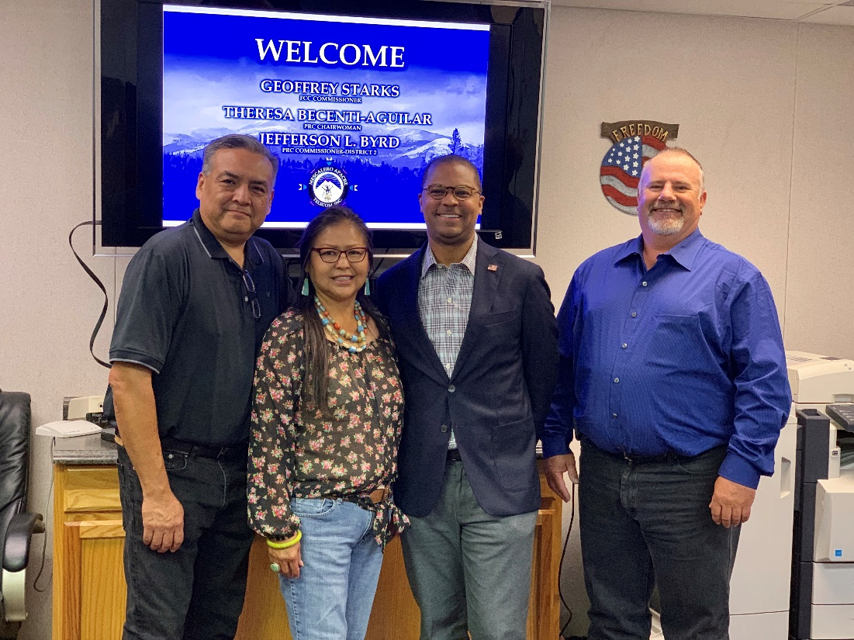

Godfrey Enjady, Mescalero Apache Telecom, Inc. (MATI); Chairwoman Theresa Becenti-Aguilar, New Mexico Public Regulation Commission (NM PRC); Commissioner Geoffrey Starks, FCC; Commissioner Jefferson Byrd, NM PRC

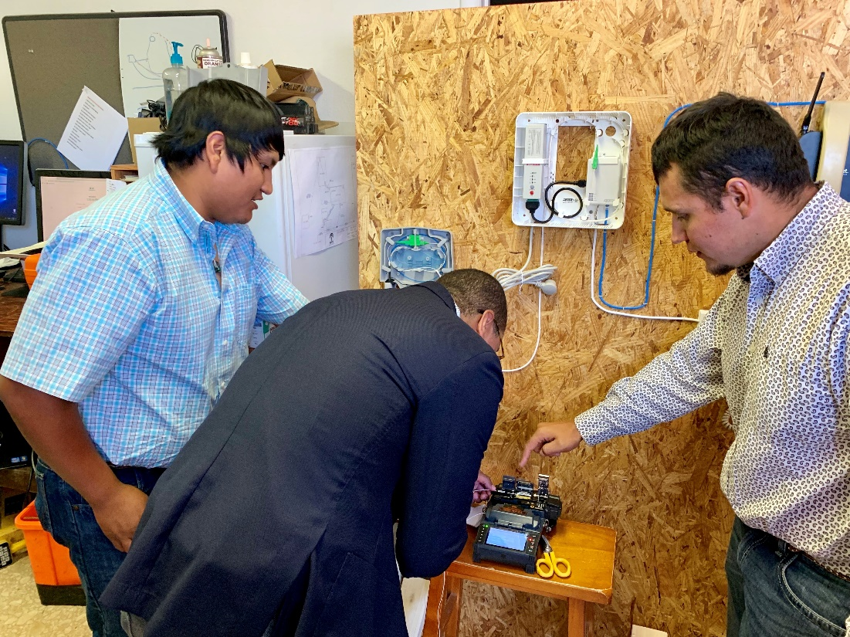

Commissioner Geoffrey Starks splices fiber optic cable at Mescalero Apache Telecom, Inc.

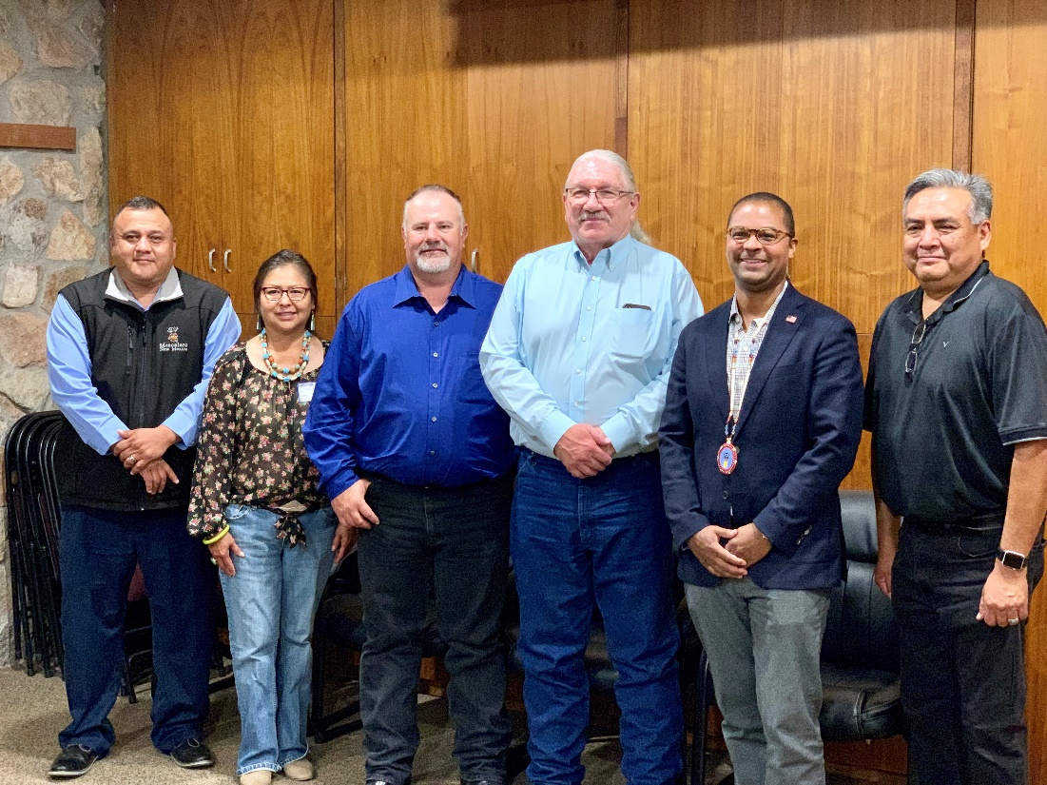

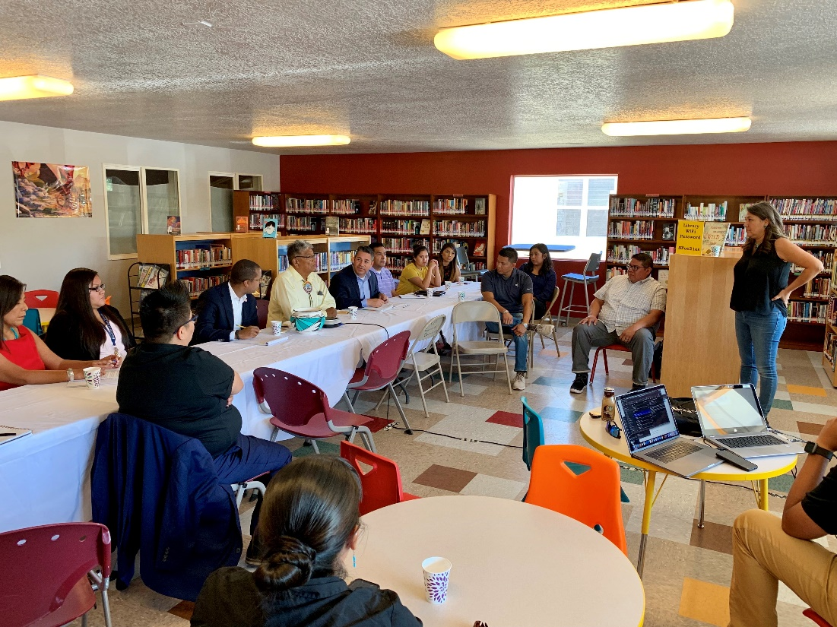

Vice President Gabe Aguilar, Mescalero Apache Tribe; Chairwoman Theresa Becenti-Aguilar, NM PRC; Commissioner Jefferson Byrd, NM PRC; President Butch Blazer, Mescalero Apache Tribe; Commissioner Geoffrey Starks; Godfrey Enjady, MATI

Kimball Sekaquaptewa, Chief Technology Director of the Santa Fe Indian School, briefs Congressman Ben Ray Luján and Commissioner Geoffrey Starks at the San Felipe Pueblo Library

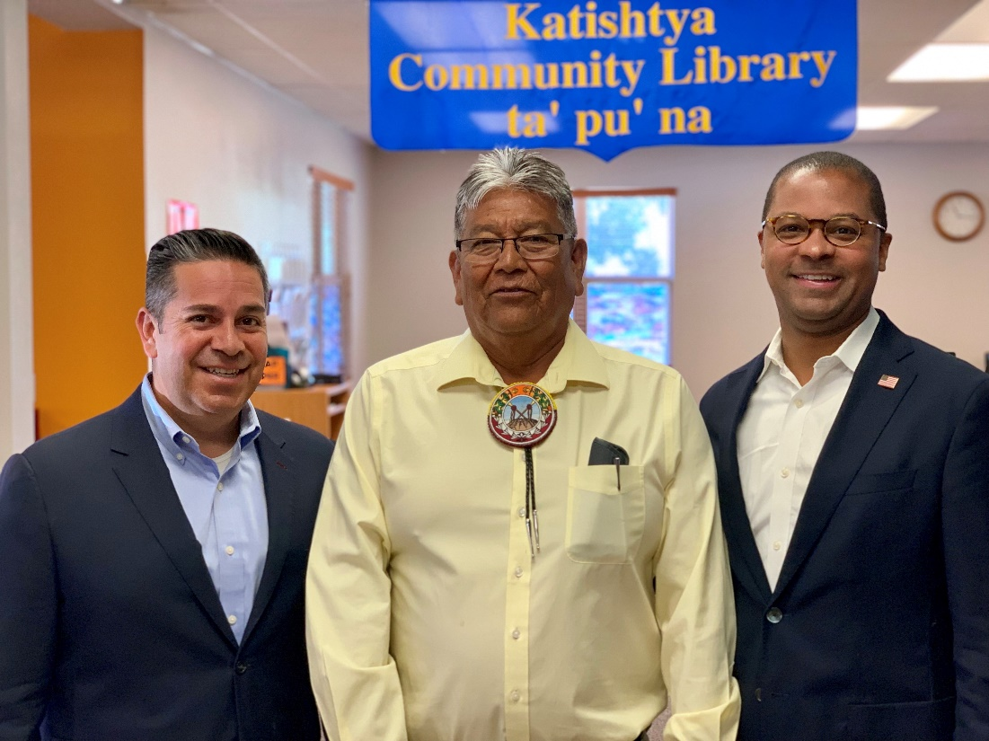

Congressman Ben Ray Luján; Lieutenant Governor John Duran, Pueblo of San Felipe; Commissioner Geoffrey Starks

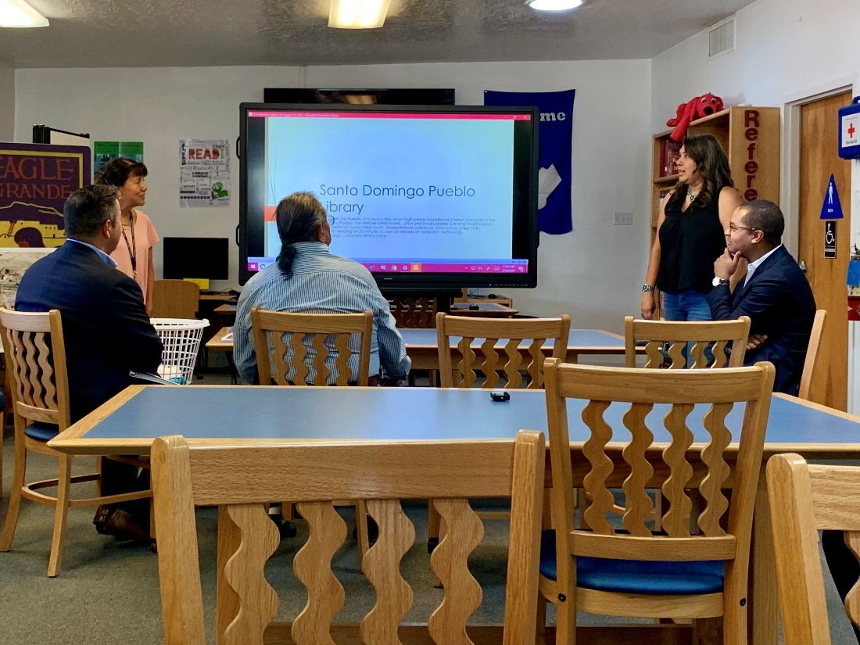

Librarian Cynthia Aguilar briefs Congressman Ben Ray Luján and Commissioner Geoffrey Starks at the Santo Domingo Pueblo Library

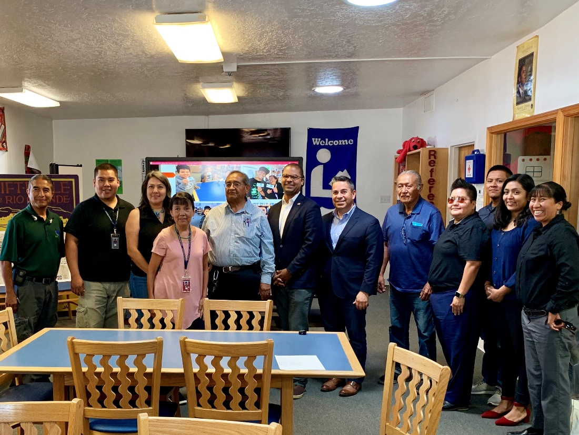

Congressman Ben Ray Luján, Commissioner Geoffrey Starks, and community leaders at the Santo Domingo Pueblo Library

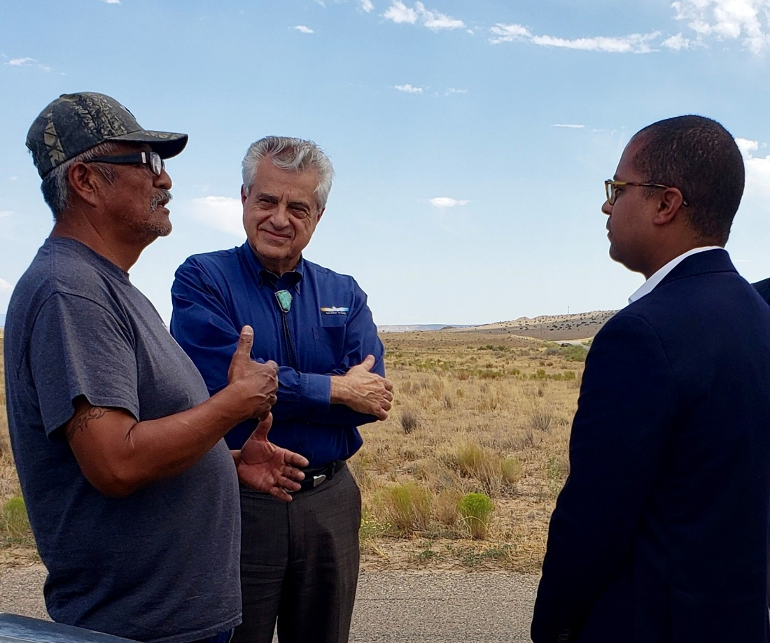

President Mark Begay, To’Hajiilee Navajo Chapter; John Badal, Chief Executive Officer, Sacred Wind Communications; Commissioner Geoffrey Starks

###
Office of Commissioner Geoffrey Starks: (202) 418-2500
ASL Videophone: (844) 432-2275
TTY: (888) 835-5322
Twitter: @GeoffreyStarks
www.fcc.gov/about/leadership/geoffrey-starks

This is an unofficial announcement of Commission action. Release of the full text of a Commission order constitutes official action. See MCI v. FCC, 515 F.2d 385 (D.C. Cir. 1974).

