FEDERAL COMMUNICATIONS COMMISSION
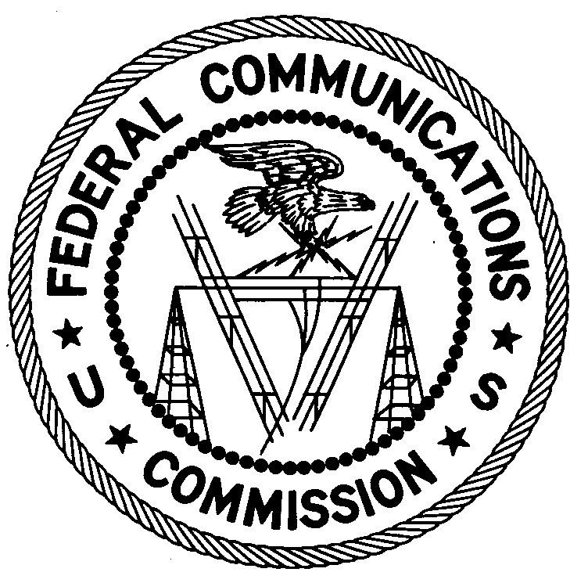
7435 Oakland Mills Road
Columbia, MD 21046
Telephone: 301-362-3000
Facsimile: 301-362-3290

December 10, 2019

Results of Tests on Cell Phone RF Exposure Compliance

Grantees: a) Apple Inc.
b) BLU Products, Inc.
c) Motorola Mobility LLC
d) Samsung Electronics Co Ltd

Model Numbers: 1) iPhone 7
2) iPhone X
3) iPhone XS
4) Vivo 5 Mini
5) Moto e5 Play
6) Moto g6 Play
7) Galaxy S9
8) Galaxy J3

FCC_IDs: 1) BCG-E3091A
2) BCG-E3161A
3) BCG-E3218A
4) YHLBLUVIVO5MN
5) IHDT56XC4
6) IHDT56XB1
7) A3LSMG960U
8) A3LSMJ337A

Report Number: 19TR1005

TABLE OF CONTENTS

1 INTRODUCTION 3
2 APPLICABLE RULES AND STANDARDS 3
3 TEST PROCEDURE 4
3.1 System Verification 4
3.1.1 Tissue Simulating Liquids Dielectric Parameters Verification 4
3.1.2 Dipole Verification 4
3.2 Devices Under Test (DUT) 4
3.3 SAR Test Setup 6
4 TEST RESULTS 8
5 CONCLUSION 8

INTRODUCTION

On August 21, 2019, the Chicago Tribune published an article entitled “We tested popular cellphones for radio frequency radiation. Now the FCC is investigating.” The Chicago Tribune article reported that its testing revealed that several popular cell phones produced radio frequency (RF) radiation levels in excess of the FCC’s specific absorption rate (SAR) limits for RF exposure. The Chicago Tribune’s tests, conducted by RF Exposure Lab, LLC located in San Marcos, California, included devices manufactured by Apple Inc., BLU Products, Inc., Motorola Mobility LLC, and Samsung Electronics Co Ltd.

The FCC takes claims of non-compliance with its regulations seriously and commenced its own testing program of the implicated handsets to determine if those handsets comply with the FCC rules as asserted by the manufacturers or if they are indeed operating over the RF exposure limits as claimed by the Chicago Tribune. The FCC Laboratory, pursuant to the rules (47 CFR § 2.945), requested a device sample for testing from the manufacturers and grantees of those devices. The FCC Laboratory also requested grantees to provide any necessary test software, RF cables, and other accessories required for testing the devices. All grantees provided the requested materials. Additionally, the FCC Laboratory purchased samples of the Apple iPhone XS, Samsung Galaxy S9, Motorola Moto g6 play, and BLU Vivo 5 Mini from the open market for additional testing. FCC testing commenced on August 30, 2019 and concluded on September 23, 2019. This report summarizes those results, which show that the handsets in question do comply with applicable FCC RF exposure limits.

The Commission’s RF exposure limits for the subject devices are based on SAR, which is a measure of the rate at which energy is absorbed by the human body when exposed to an RF electromagnetic field. The FCC rules (47 CFR §1.1310) specify limits based on frequency of operation and expected exposure conditions. For the type of exposure condition (i.e., general population/uncontrolled environment) under investigation, the FCC rules limit the maximum SAR level to 1.6 watts per kilogram (W/kg) or less averaged over the volume containing a mass of 1 gram (1-g) of tissue that is absorbing the most signal.

SAR testing uses standardized models of the human head and body that are filled with liquids that simulate the RF absorption characteristics of different human tissues. In order to determine compliance with the limit, each cell phone is tested while operating at its highest power level in all the frequency bands in which it operates, and in various specific positions against the head and body models, to simulate the way different users’ typically hold a cell phone, including to each side of the head. To test cell phones for SAR compliance, the cell phone is precisely placed in various common positions next to the head and body models, and a robotically-positioned probe takes a series of measurements of the electric field (proportional to SAR) at specific pinpoint locations in a very precise, grid-like pattern within the head and torso models. All data for each cell phone placement is submitted as a part of the equipment approval test report for final authorization. The highest SAR values for each frequency band are used in the final authorization to demonstrate compliance with the FCC’s RF exposure limits. Modern cell phones have a very large number of sensors, transmitters and antennas which need to be properly configured to ensure that the tests are conducted in the worst-case permissible operation. Testing each cell phone under its worst-case configuration requires detailed understanding of its design and antenna arrangements; most of this information is non-public and proprietary. This investigation focused on the operational modes evaluated in the Chicago Tribune report.

APPLICABLE RULES AND STANDARDS

RF exposure testing for the devices under test (DUT) was performed according to the following rules, standards, and policies and procedures.

- 47 CFR § 1.1307
- 47 CFR § 1.1310
- 47 CFR § 2.1093
- ANSI/IEEE Std C95.1-1992
- IEEE Std 1528-2013
- FCC KDB Publication 447498 D01 General RF Exposure Guidance v06
- FCC KDB Publication 865664 D01 SAR Measurement 100 MHz to 6 GHz v01r04
- FCC KDB Publication 648474 D04 Handset SAR V01r03
- FCC KDB Publication 941225 D01 3G SAR Procedures v03r01
- FCC KDB Publication 941225 D06 Hotspot Mode v02r01

TEST PROCEDURE

System Verification

An important step in performing SAR measurements is verification to ensure the measurement system will accurately and precisely measure SAR. This step consists of two parts, the Tissue Simulating Liquids Dielectric Parameters Verification and the Dipole Verification. Each of these parts has measurable quantities that must be within a specific tolerance in order to verify the system. General information about the Tissue Simulating Liquid Dielectric Parameter Verification and the Dipole Verification is contained in Sections 3.1.1 and 3.1.2, respectively. FCC engineers verified that the SAR measurement system was within tolerance to assure that subsequent testing would provide valid results.

Tissue Simulating Liquids Dielectric Parameters Verification

A key component of the SAR measurement system is the Tissue Simulating Liquid (TSL). This liquid is composed of varying chemicals including water and/or sucrose, bactericide, diethyl glycol butyl ether (DGBE), among others. These chemicals are combined in different proportions to create TSLs having conductivity and permittivity that mimic either brain or body tissue at a given frequency. It is important to confirm that these parameters are within a specific range close to the target parameters as variation in these parameters can significantly affect SAR results. A TSL verification was performed before SAR testing on each sample. General reference information, including sample TSL compositions, can be found in FCC KDB Publication 865664 D01.

Dipole Verification

The second step in the system verification is the dipole verification. A calibrated reference dipole is used to verify that the system accurately and precisely measures SAR. FCC KDB Publication 865664 D01 specifies that the system should measure a SAR result within ±10% of the expected value. Equipment calibrated by a certified calibration laboratory was utilized in performing the dipole verification as well as the subsequent SAR testing.

Devices Under Test (DUT)
Table 1 identifies and summarizes the manufacturer-provided as well as the FCC-purchased devices.

Table 1: Test Sample Serial Numbers

FCC ID | Manufacturer | Description | Serial Number | Sample Type
BCG-E3091A | Apple | iPhone 7 Portable Handset | C6K6HD69HG7N | Provided by Manufacturer
BCG-E3161A | Apple | iPhone X Portable Handset | C39VF007JH2Q | Provided by Manufacturer
BCG-E3218A | Apple | iPhone XS Portable Handset | GONZ50M7KPFR | Purchased by FCC
A3LSMG960U | Samsung | Galaxy S9 Portable Handset | R38K609SMYL | Provided by Manufacturer
A3LSMG960U | Samsung | Galaxy S9 Portable Handset | R3M706TT9A | Purchased by FCC
A3LSMJ337A | Samsung | Galaxy J3 Portable Handset | RF8KA1J3X6E | Provided by Manufacturer
IHDT56XC4 | Motorola | Moto e5 play Portable Handset | 359524090350295 | Provided by Manufacturer
IHDT56XB1 | Motorola | Moto g6 Play Portable Handset | 351864090034178 | Provided by Manufacturer
IHDT56XB1 | Motorola | Moto g6 Play Portable Handset | 3518643090300620 | Purchased by FCC
YHLBLUVIVO5MN | BLU | Vivo 5 Mini Portable Handset | 1080021018057240 | Provided by Manufacturer
YHLBLUVIVO5MN | BLU | Vivo 5 Mini Portable Handset | 1080021018069900 | Purchased by FCC

Figure 1 is a generic diagram of a DUT, showing how the edges and faces of a DUT are designated for testing purposes. This labeling convention is identical across each testing laboratory: the respective accredited testing laboratories used for the original device certifications, RF Exposure Lab LLC (Chicago Tribune’s contractor), and the FCC laboratory. Identifying each cell phone surface in a consistent way is important because testing is required for each surface to determine where the maximum SAR value occurs and labeling of edges and faces can be ambiguous during device operation due to screen rotation capabilities (portrait, landscape, etc.). Figure 1 depicts both the front and back views of the device, with the screen as reference.

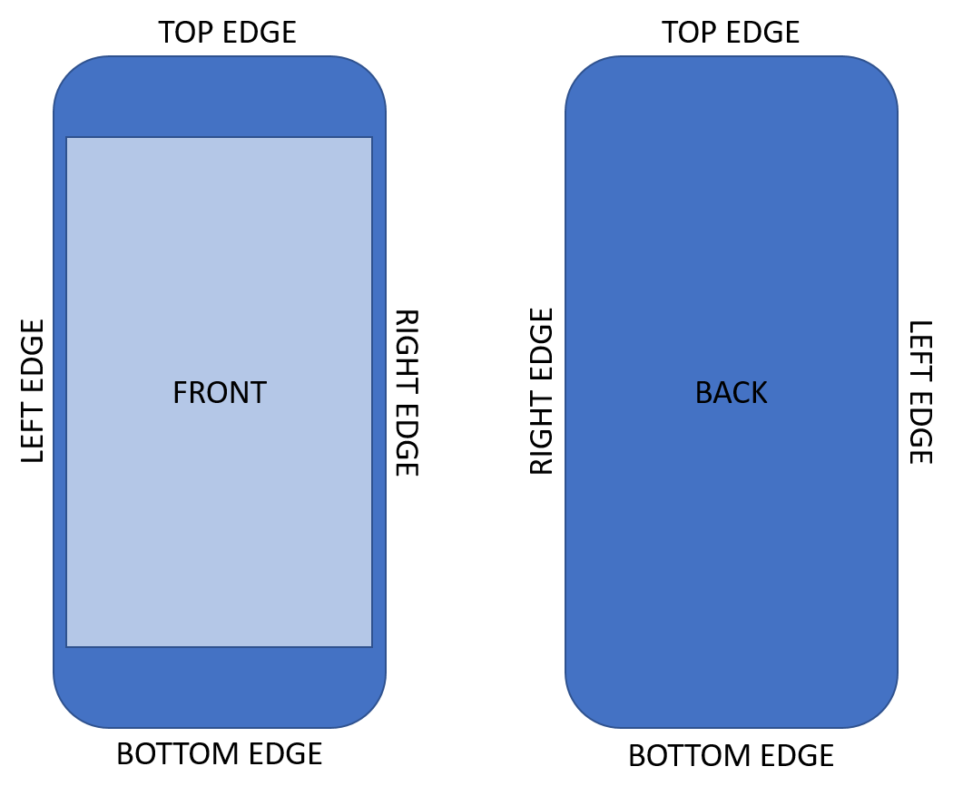
Figure 1: Generic Diagram of DUT Surfaces and Sides for Testing

SAR Test Setup

The test configuration corresponding to the maximum reported SAR value varied for each cell phone model, as shown in the original certification filing’s RF exposure compliance report for each device. Each cell phone model was tested for the specific bands of operations investigated by the Chicago Tribune’s test laboratory under the same configuration identified in the manufacturer’s RF exposure compliance report submitted at the time of its application for equipment authorization.

Using a Rohde & Schwarz CMU 200 Universal Radio Communication Tester, an over-the-air call was established with the DUT using this configuration. Figure 2 and Figure 3 depict an example of the Connection Control Screen and the Power Slot Graph Screen of the CMU 200, indicating that a successful connection was established.

Each DUT was positioned under the flat phantom of the FCC Laboratory’s DASY 6 SAR measurement system, which had been verified immediately preceding the SAR test (as described in Section 3.1). The DUT orientations and test separation distances used for the FCC’s SAR testing were the same as in each device’s original certification filing and were also used by RF Exposure Lab, LLC for its testing. The 1-g average SAR values were measured according to the procedures established in applicable FCC KDB Guidance Publications. This process was followed for both the grantee-provided DUTs and the FCC-purchased DUTs.

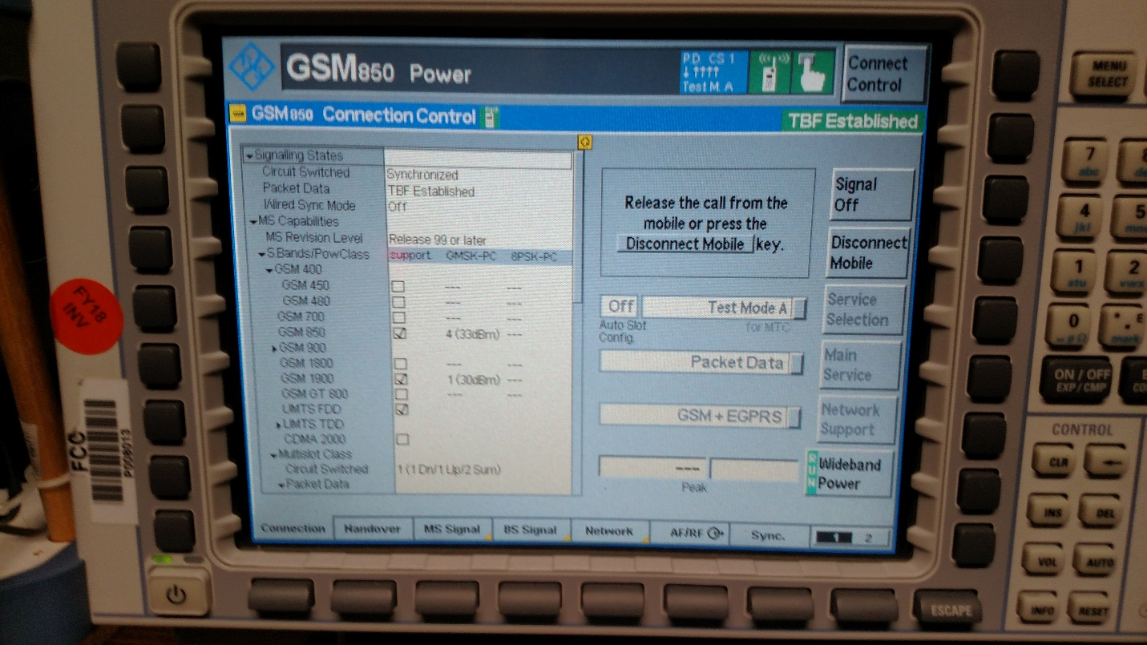
Figure 2: Connection Control Screen of CMU 200

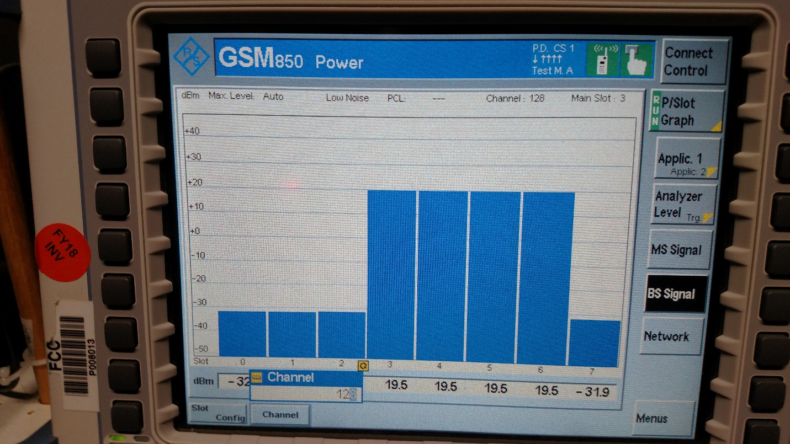
Figure 3: Power Slot Graph Screen on CMU 200

TEST RESULTS

Table 2 contains the SAR results for each device, including from the device’s original certification SAR report, the RF Exposure Lab, LLC tests, and the FCC Laboratory tests. The SAR test configurations correspond to the configuration having the highest reported SAR in each device’s respective original certification SAR reports. For comparison purposes in this report, all SAR results listed are the actual measured values; FCC procedures allow devices to be tested within their output power tune-up tolerance range, then with SAR results scaled to the maximum rated output power for compliance demonstration purposes. The maximum measured SAR must be below 1.6 watts per kilogram (W/kg) averaged over the volume containing a mass of 1 gram (1-g) of tissue for the device to be compliant with the FCC rules.

Table 2: SAR Test Results

FCC ID | Manufacturer | Description | Wireless Tech Tested | Test  Distance  (mm) | Original SAR Report Measured SAR Value (W/kg) | Chicago Tribune Measured SAR Value (W/kg) | FCC Lab Maximum Measured SAR Value (W/kg)
BCG-E3091A | Apple | iPhone 7 Portable Handset | WCDMA | 5 | 1.140 | 3.560 | 0.946
BCG-E3161A | Apple | iPhone X Portable Handset | WCDMA | 5 | 1.090 | 2.19 | 0.799
BCG-E3218A | Apple | iPhone XS Portable Handset | GPRS | 5 | 0.047 | N/A | 1.350
A3LSMG960U | Samsung | Galaxy S9 Portable Handset | CDMA | 15 | 0.795 | 0.625 | 0.538
A3LSMJ337A | Samsung | Galaxy J3 Portable Handset | WCDMA | 10 | 1.040 | 1.380 | 1.230
IHDT56XC4 | Motorola | Moto e5 Play Portable Handset | WCDMA | 5 | 1.120 | 4.700 | 1.020
IHDTF6XB1 | Motorola | Moto g6 Play Portable Handset | WCDMA | 5 | 0.944 | 0.247 | 1.250
YHLBLUVIVO5MN | BLU | Vivo 5 Mini Portable Handset | GPRS | 10 | 1.246 | 0.295 | 0.668

CONCLUSION

All sample cell phones tested by the FCC Laboratory, both grantee-provided and FCC-purchased samples, produced maximum 1-g average SAR values less than the 1.6 W/kg limit specified in the FCC rules. Therefore, all tested sample devices comply with the FCC RF radiation exposure general population/uncontrolled limits for peak spatial-average SAR of 1.6 W/kg, averaged over any 1 gram of tissue as specified in 47 CFR § 2.1093(d)(2), and these tests did not produce evidence of violations of any FCC rules regarding maximum RF exposure levels.

The Chicago Tribune SAR results are for iPhone X with FCC ID BCG-E3175A; the FCC Lab SAR results are for iPhone X with FCC ID BCG-E3161A since the phone with the FCC ID BCG-E3175A was not available.
This cell phone was purchased by the FCC Lab and was not included in the Chicago Tribune report.

