FEDERAL COMMUNICATIONS COMMISSION
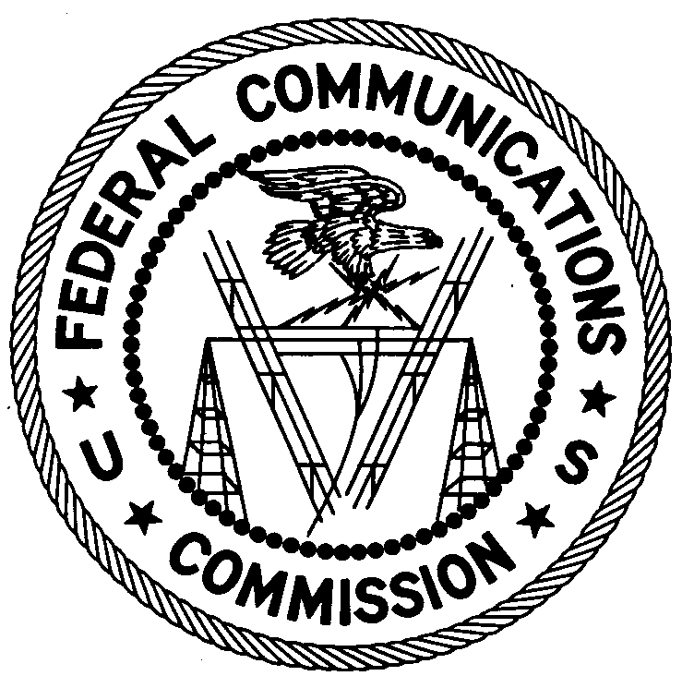
ENFORCEMENT BUREAU
REGION ONE

Columbia Regional Office

9050 Junction Drive

Annapolis Junction, Maryland 20701

FIELD@FCC.gov

(301) 725-1996

January 10, 2020

Seiontec Systems, LLC.
Lynchburg, VA
Case No.: EB-FIELDNER-19-00030053

NOTICE OF UNLICENSED OPERATION

On November 12, 2019, Agents from the Columbia Office of the Enforcement Bureau of the Federal Communications Commission’s (FCC or Commission) responded to a complaint of unauthorized operation in the Private Operational Fixed Point-to Point Microwave Service (MG) in Monroe, Virginia. The Agents confirmed by direction finding techniques that emissions on the frequency of 11,005 MHz were emanating from Seiontec’s radio transmitting equipment located on Tobacco Row Mountain in Monroe, Virginia, near the coordinates of 37-33-48.7 N, 79-11-35.5 W.

Radio stations operating on a range of frequencies, including the Microwave Service frequency 11,005 MHz, must be licensed by the FCC pursuant to section 301 of the Communication Act of 1934, as amended (Act). The Commission’s records show that Seiontec does not hold a license to operate Private Operational Fixed Point-to Point Microwave Service (MG) Station on 11,005 MHz at this location.

You are hereby warned that operation of radio transmitting equipment without a valid radio station authorization constitutes a violation of the Federal laws cited above and may subject the operator to severe penalties, including, but not limited to, substantial monetary fines, in rem arrest action against the offending radio equipment, and criminal sanctions, including imprisonment.

UNLICENSED OPERATION OF THIS RADIO STATION MUST BE DISCONTINUED IMMEDIATELY.

You have ten (10) days from the date of this notice to respond with any evidence that you have authority to operate granted by the FCC. Your response should be sent to the address in the letterhead and reference the listed case number. Under the Privacy Act of 1974, we are informing you that the Commission’s staff will use all relevant material information before it to determine what, if any, enforcement action is required to ensure your compliance with FCC Rules. This will include any information that you disclose in your reply.

You may contact this office if you have any questions.

David C. Dombrowski
Regional Director
Region One
Enforcement Bureau
Federal Communications Commission

Attachments:
Excerpts from the Communications Act of 1934, As Amended
Enforcement Bureau, "Inspection Fact Sheet", March 2005

47 U.S.C. § 301.
See 47 U.S.C. §§ 401, 501, 503 and 510.
5 U.S.C. § 552a(e)(3).

