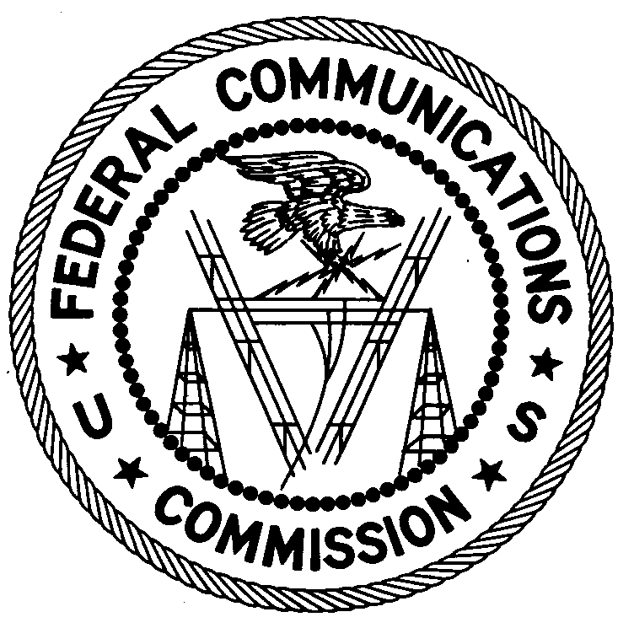
Federal Communications Commission
Enforcement Bureau
Region Three

Los Angeles Regional Office

11331 183rd St., PMB #365

Cerritos, CA 90703

(562) 860-7474

field@fcc.gov

January 29, 2020

Issac Danielian
Encino, CA
Case No.: EB-FIELDWR-19-00029991

NOTIFICATION OF HARMFUL INTERFERENCE

On October 7, 2019, in response to an interference complaint, an Agent from the Los Angeles Office of the Enforcement Bureau of the Federal Communications Commission’s (FCC or Commission) confirmed, by direction finding techniques, that radio emissions in the 156.8 MHz band (the VHF marine safety and calling Channel 16) were emanating from a radio transmitter device located on your vessel “Sea Birds” (ID: PEA881171687) at 13924 Panay Way, D1300:Slip 15, Marina Del Rey, California. The Agent determined that the device was a VHF Marine Radio (Model M55) manufactured by ICOM and certified for Marine Band Communications. The Agent confirmed that interference to USCG ceased when your equipment was unplugged.

Operation on 156.8 MHz is reserved for the marine radio service and is for ship to ship or ship to shore (coast station) operation. Specifically, the frequency 156.8 MHz (VHF Marine Channel 16) is designated as the international radiotelephone distress, urgency, safety, call and reply frequency for ships and coast stations. Section 80.89(a) of the Rules states that “[s]tations must not engage in superfluous radio-communication.” In addition, section 80.89(d) of the Rules states that “Stations must not use telephony, transmit signals or communications not addressed to a particular station or stations . . . .” At the time of the investigation, the Agent determined that your ICOM VHF Marine Radio (Model M55) was transmitting an unmodulated signal with no authorized purpose for the transmissions.

You are hereby notified, pursuant to sections 80.89(a) and (d) of the Commission’s rules, that the radio transmitter equipment located in your vessel “Sea Birds” (ID: PEA881171687) at 13924 Panay Way, D1300:Slip 15, Marina Del Rey, California was causing harmful interference to licensed communications. Continued operation of this device in a manner that causes harmful interference after your receipt of this warning constitutes a violation of the Federal laws cited above and could subject the operator to severe penalties, including, but not limited to, substantial monetary fines, in rem arrest action against the offending radio equipment, and criminal sanctions including imprisonment.
OPERATION OF THIS TRANSMITTING DEVICE ON FREQUENCIES THAT CAUSE HARMFUL INTERFERENCE MUST CEASE IMMEDIATELY AND MUST NOT RESUME
You have ten (10) days from the date of this notice to respond concerning your operation of this device. Your response should also describe the steps you are taking to ensure that your operation does not interfere with the frequency 156.8 MHz (VHF Marine Channel 16). Your response should be sent to the address in the letterhead and reference the listed case number. Under the Privacy Act of 1974, we are informing you that the Commission’s staff will use all relevant material information before it to determine what, if any, enforcement action is required to ensure your compliance with the Act and FCC rules. This will include any information that you disclose in your reply.

You may contact this office if you have any questions.

Lark Hadley
Regional Director
Region Three
Enforcement Bureau

Attachments:

Excerpts from the Communications Act of 1934, As Amended
Enforcement Bureau, "Inspection Fact Sheet"

47 CFR §§ 80.1 et seq.
47 CFR § 80.369(e)(3).
47 CFR § 80.89(a).
47 CFR § 80.89(d).
47 CFR § 80.89(a), (d).
See 47 U.S.C. §§ 401, 501, 503 and 510.
5 U.S.C. § 552a(e)(3).

