Media Contact:
Tina Pelkey, (202) 418-0536
tina.pelkey@fcc.gov

For Immediate Release

CHAIRMAN PAI VISITS WIND RIVER RESERVATION IN WYOMING TO SEE GIGABIT-SPEED BROADBAND DEPLOYMENT

$4.1 Million From FCC’s Connect America Fund Phase II Auction Has Been Authorized to Serve More Than 800 Rural Homes and Businesses

WASHINGTON, February 11, 2020—Federal Communications Commission Chairman Ajit Pai today visited the Wind River Indian Reservation in Wyoming. He met with Northern Arapaho Tribal representatives and toured areas that are receiving funding from the FCC to deploy gigabit-speed broadband. Specifically, Wind River Internet—the provider—is receiving $4.1 million from the Connect America Fund Phase II auction to deploy gigabit-speed service to 849 rural homes and businesses on the reservation.

“Bringing high-speed connectivity to rural Tribal lands can be a game-changer,” said Chairman Pai. “That’s why bridging the digital divide is my top priority. I was pleased to have the opportunity to visit the Wind River Indian Reservation today to see firsthand the gigabit-speed broadband deployment. This will be critical to providing those living there with access to digital opportunity.”

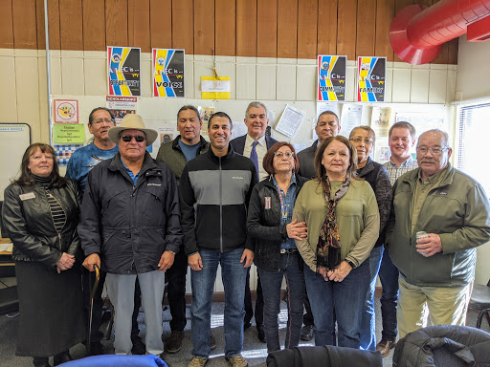

The Connect America Fund Phase II auction is part of a broader effort by the FCC to close the
digital divide in the United States. In addition to the funding that is being made available through this auction, the FCC recently voted to launch the $20.4 billion Rural Digital Opportunity Fund, which will further advance broadband deployment throughout rural America, including on Tribal lands. Carriers bidding on rural Tribal lands will have an advantage in the auction through an adjusted reserve price that makes more support per location available and more areas eligible. Chairman Pai has proposed to commence bidding in the auction on October 22, 2020.

During his visit, Chairman Pai also discussed with Tribal leaders the Tribal Priority Window. The FCC opened up the Tribal Priority Window earlier this month for federally recognized Tribes to apply for spectrum in the 2.5 GHz band. This band—the single largest band of contiguous spectrum below 3 GHz—offers favorable coverage and capacity characteristics for next-generation mobile services, such as 5G. Through this first-of-its-kind priority window, Tribes can obtain 2.5 GHz spectrum for free before any commercial auction. The Rural Tribal Priority Window will close on August 3, 2020.

###
Media Relations: (202) 418-0500 / ASL: (844) 432-2275 / TTY: (888) 835-5322 / Twitter: @FCC / www.fcc.gov

This is an unofficial announcement of Commission action. Release of the full text of a Commission order constitutes official action. See MCI v. FCC, 515 F.2d 385 (D.C. Cir. 1974).

