Media Contact:
Alisa Valentin, (202) 418-2500
alisa.valentin@fcc.gov
For Immediate Release

COMMISSIONER GEOFFREY STARKS TOURS THE DEEP SOUTH TO LEARN ABOUT COMMUNICATIONS CHALLENGES AND OPPORTUNITIES
WASHINGTON, February 20, 2020—This week, Commissioner Geoffrey Starks visited communities in Georgia and Alabama where he discussed the challenges of internet inequality, the future of work, and the importance of diversity in STEM with Congresswoman Lucy McBath, Congressman Hank Johnson, community leaders, and business owners.
“Internet inequality does not impact just one type of community in our nation. Unfortunately, it continues to be presented through a very narrow lens. Through my travels I have seen that internet inequality impacts rural communities, communities of color, urban communities, low-income communities, and the many ways in which those identities intersect,” said Commissioner Starks. “It was important for me to visit this diverse region of United States to assist in elevating that narrative. I am appreciative of the opportunity to meet with Congresswoman Lucy McBath, Congressman Hank Johnson, and the community leaders in Georgia and Alabama who highlighted not only the challenges of internet inequality, but also the opportunities that their communities experience when they gain access to robust broadband. This trip serves as a reminder that when our most marginalized communities succeed, we are all better off. I’m thankful for the people who told me their stories and spoke openly about what more we can do to help everyday Americans from our position at the Commission,” adds Commissioner Starks.
On Saturday, Commissioner Starks participated in a town hall focused on the 2020 Census convened by Congresswoman Lucy McBath at Tucker-Reid H. Cofer Library in Tucker, Georgia. Starks gave remarks about how broadband access will drastically impact those who participate in the census, which will have far-reaching impacts for all communities over the next decade. The town hall also included presentations from Fair Count and Dekalb County; both entities and Congresswoman McBath have been working tirelessly to ensure that historically undercounted communities participate in this year’s census.
Later that day, Commissioner Starks and Congressman Hank Johnson hosted a dinner with Black leaders in the technology sector who are based in Atlanta, Georgia. During this dinner, the guests discussed how to reduce bias in artificial intelligence systems, economic opportunity for the Black community in the STEM field, and the challenges of inclusion in a space that does not reflect the diversity of America.
On Sunday, Commissioner Starks toured the Entercom Communications studios with V103’s Program Director, Reggie Rouse, and radio personality and host of “The Morning Culture,” JR, in Midtown Atlanta. During this tour they discussed the importance of localism as it relates to news and information, music, and sports. Also, on Sunday, Commissioner Starks traveled to Senoia, Georgia where he visited Britain Turner, President of AirFi, to discuss the challenges and opportunities of wireless internet service providers in the suburbs of Atlanta, Georgia.
On Monday, Commissioner Starks traveled to Leary, Georgia for the 2020 Growers Meeting where he met with farmers and others in the agricultural industry in Southwest Georgia. He heard from the Executive Director of the Flint River Soil and Water Conservation District, Perri Campis, about this region’s contributions to the agricultural industry and how broadband challenges hinder Southwest Georgia’s ability to compete in this economy.
Commissioner Starks then traveled to Albany, Georgia where he met with Fredando “Farmer Fredo” Jackson, Executive Director of Flint River Fresh, at one of his community farms. Farmer Fredo said that sparse cellular service at the community farms impacts his ability to immediately share public information about his sites. He also shared that he has concerns about his future plans to accept electronic benefit transfer cards from members of the community who reside in food deserts because the transactions cannot be completed without proper internet access.
Commissioner Starks also visited Cuthbert, Georgia where he met with representatives from Fair Count, Ed Reed and Kevin Brown, as well as Frederick Cannon, owner of Unique Images Barbershop. Cuthbert is a small town with a little over 3,800 residents; the city sits in Randolph County and has historically been deemed “hard to count” by the US Census Bureau. Fair Count installed internet service in Cannon’s barbershop so members of the community can participate in the upcoming census. The tour of Southwest Georgia ended with a visit to the Tifton-Tift County Chamber of Commerce where Commissioner Starks discussed both the pitfalls and opportunities of the Rural Digital Opportunity Fund with residents, politicians, and educators.
On Tuesday, Commissioner Starks traveled to Alabama State University, one of more than 100 HBCUs in the nation, for a panel discussion on the state of broadband in Alabama. The Montgomery-based school was founded in 1867 and it traditionally and currently has students from rural communities all across the Deep South. State Senator Bobby Singleton and Selma Mayor Darrio Melton were also panelists and they highlighted the importance of Black communities being centered in the ongoing policy discussions about rural broadband access.
The last stop of the Southern Tour was Selma, Alabama where Commissioner Starks visited with the Executive Director of the Selma Housing Authority, Kennard Randolph, to discuss a recent initiative created by Mayor Darrio Melton that brings free broadband and tablets to families with children in the George Washington Carver Homes, which are located just a few blocks away from the historic Edmund Pettus Bridge. During this meeting, the Commissioner had the opportunity to hear from a mother of three who discussed how the lives of her family members have been transformed because of access to both these tablets and broadband. Because of this program, she is now able to complete her online assignments for her degree program and her children can complete their homework without trips to the local library or local restaurants that have Wi-Fi access.
“The conversation that I had with a mother in Selma reminded me that we can’t stand by as our most burdened communities continue to be overburdened by scheduling visits to the library or local fast-food restaurants to connect to the internet. It was easy to see that access to broadband in her home has positively impacted her life. In my role at the FCC, I will continue to fight for mothers who are doing the absolute best they can to gain access to broadband under extremely challenging economic circumstances,” said Commissioner Starks.
###
Office of Commissioner Geoffrey Starks: (202) 418-2500
ASL Videophone: (844) 432-2275
TTY: (888) 835-5322
Twitter: @GeoffreyStarks
www.fcc.gov/about/leadership/geoffrey-starks
This is an unofficial announcement of Commission action. Release of the full text of a Commission order constitutes official action. See MCI v. FCC, 515 F.2d 385 (D.C. Cir. 1974).

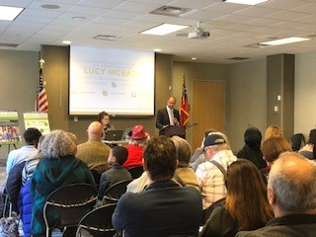
Commissioner Starks gives remarks at Congresswoman Lucy McBath’s Census Town Hall in Tucker, Georgia.
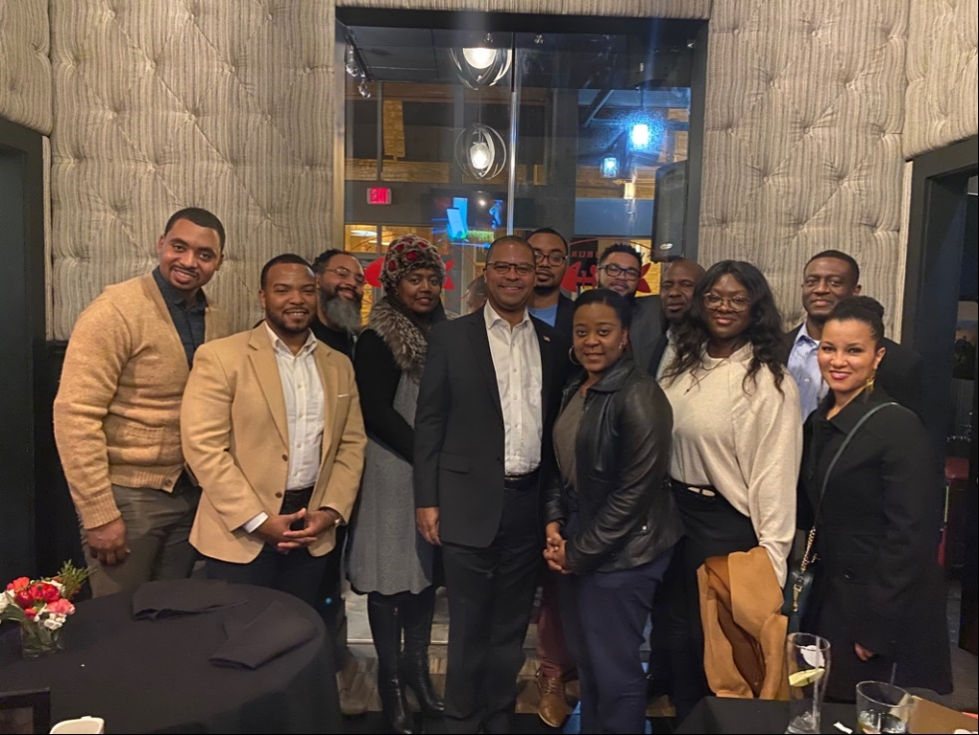
Commissioner Starks and Congressman Hank Johnson hosted a dinner with Black leaders in the technology sector based in Atlanta, Georgia including Travis Nunnally, Co-Founder of Brain Rain Solutions; Chris Gilmore, Of Counsel at Townsend & Lockett, LLC; Rodney Sampson, Co-Founder of Opportunity Hub; Shanterria Sampson, Co-Founder of Opportunity Hub; Dr. Troy Nunnally, Co-Founder of Brain Rain Solutions; Barry Givens; Managing Director at Techstars & Managing Partner at Collab Capital, Dr. Nashlie Sephus, Applied Science Manager at Amazon Web Services (AWS) AI & Founder of TheBeanPath.org; Conrad Meertins, CEO of Famteck; Mone’t Fulgham, CFO of Render Atlanta; Marcellus Haynes, Founder of Technologists of Color; Mrs. Marcellus Haynes; and Jewel Burks Solomon, Partner at Collab Capital and Head of Google Startups (not pictured).
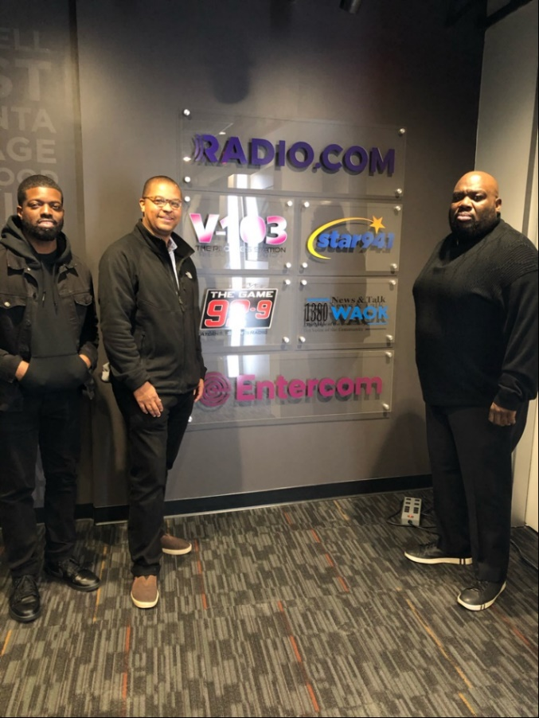
JR, Radio Personality and Co- Host of “The Morning Culture” on V103;
Commissioner Geoffrey Starks, FCC; Reggie Rouse, Program Director of V103

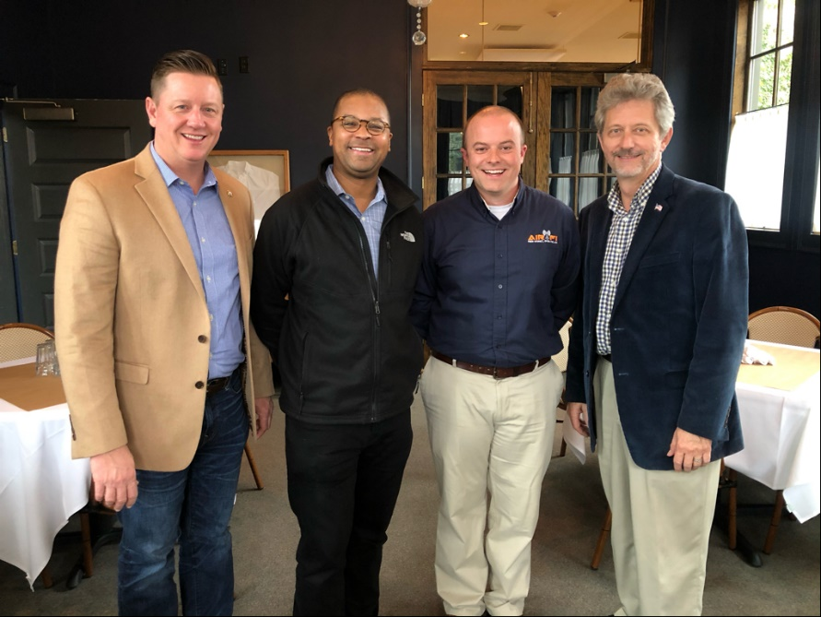
Representative Ken Pullin, Georgia State Representative; Commissioner Geoffrey Starks, FCC; Britain Turner, President of AirFi; Briar Johnson, Pike County Commission Chairman

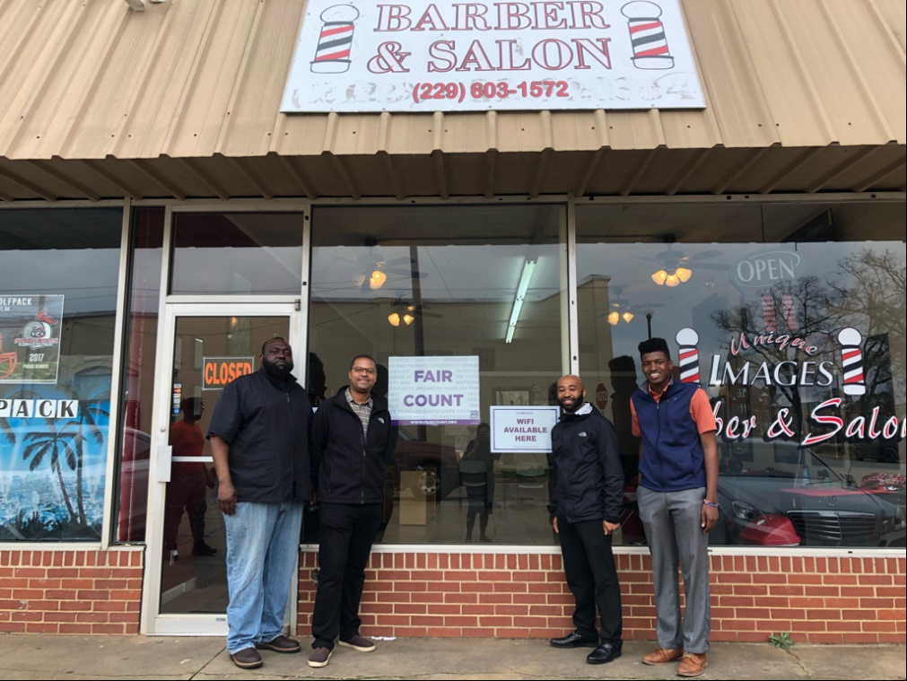
Fredrick Cannon, Owner of Unique Images Barbershop; Commissioner Geoffrey Starks, FCC; Ed Reed, Fair Count Program Director; Kevin Brown, Fair Count Lead Organizer

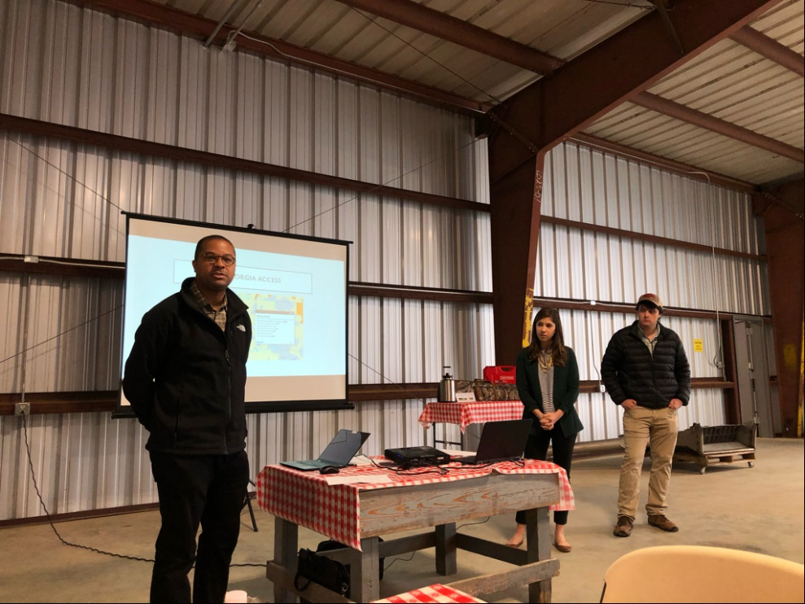
Commissioner Geoffrey Starks speaks at the 2020 Growers Meeting with local farmers from
Southwest Georgia.

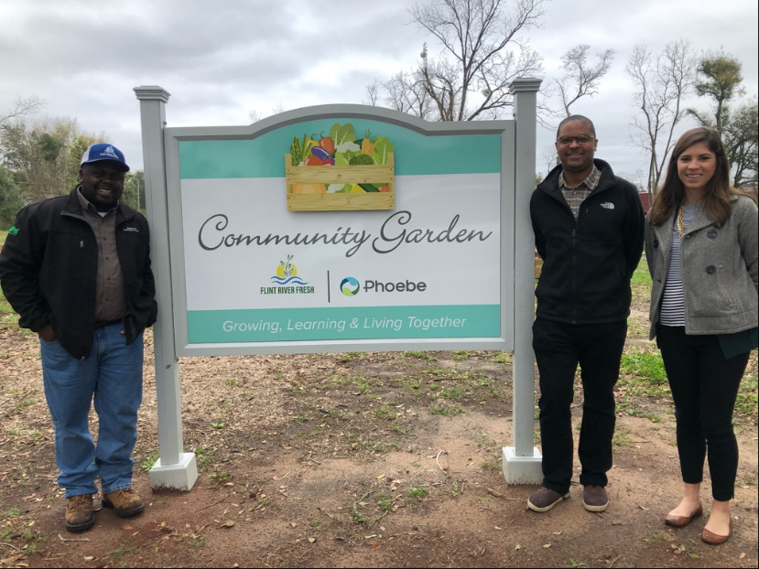
Fredando “Farmer Fredo” Jackson, Executive Director of Flint River Fresh; Commissioner Geoffrey Starks, FCC; Perris Campis, Executive Director of Flint River Soil and Water Conservation District

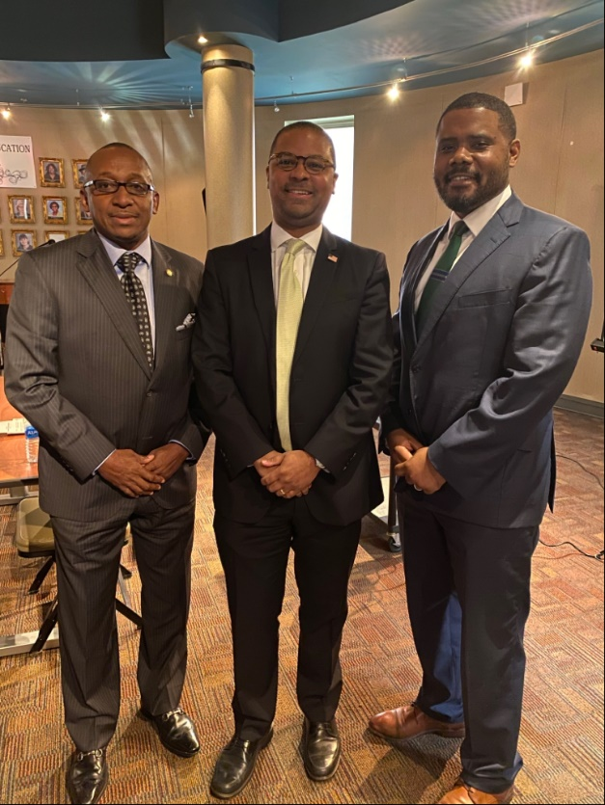
Senator Bobby Singleton, Alabama State Senate; Commissioner Geoffrey Starks, FCC;
Mayor Darrio Melton, Mayor of Selma, Alabama

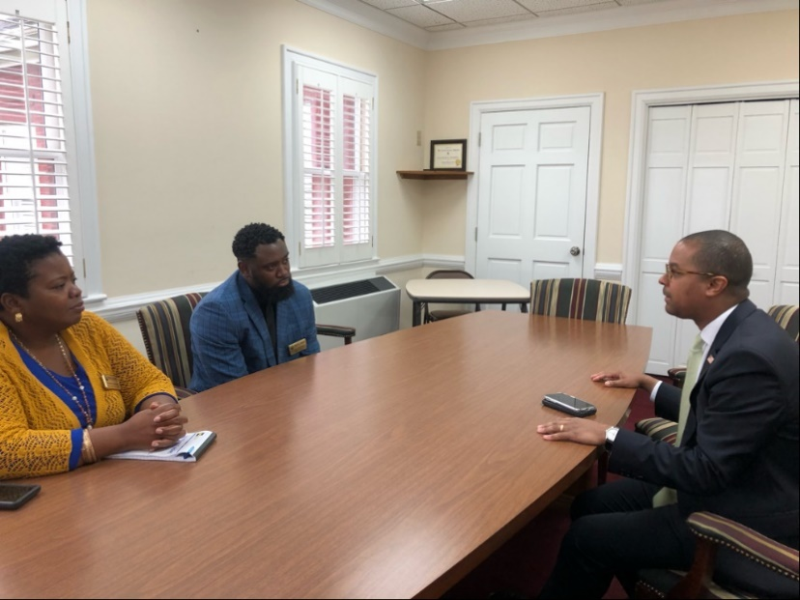
Commissioner Geoffrey Starks meets with the Selma Housing Authority Executive Director, Kennard Randolph, to discuss Mayor Darrio Melton’s broadband access and tablet initiative.

