Media Contact:
Austin Bonner (202) 418-2500
austin.bonner@fcc.gov
For Immediate Release

COMMISSIONER GEOFFREY STARKS VISITS PUERTO RICO TO LEARN
ABOUT MAKING COMMUNICATIONS NETWORKS MORE RESILIENT

WASHINGTON, February 26, 2020—Last weekend, Commissioner Geoffrey Starks visited Puerto Rico, where he convened a field hearing on communications resiliency and visited mountain areas to learn about the challenges of deploying resilient infrastructure in Puerto Rico’s rural areas.

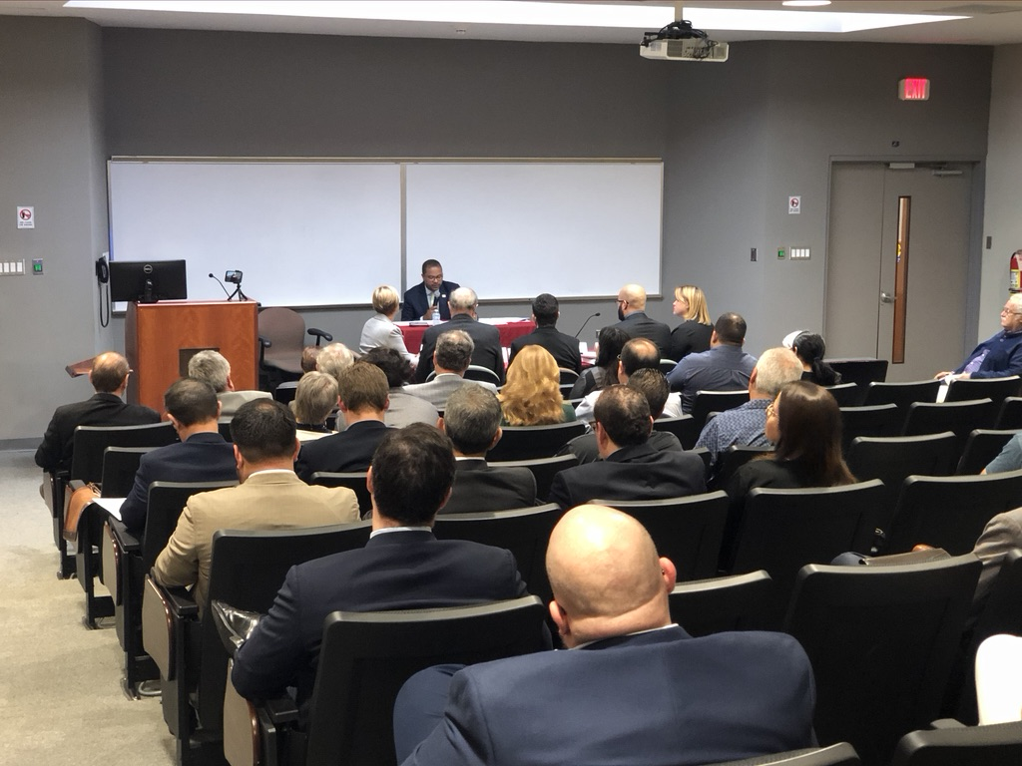
In San Juan, the Commissioner held a field hearing including testimony to hear directly from Puerto Ricans about the steps taken to improve the resiliency of communications networks since Hurricanes Irma and Maria, how communications networks and recovery efforts performed during the recent earthquakes, and what additional actions are needed to ensure that communications networks are always available. Witnesses included stakeholders from local government; the labor movement; the healthcare, education, and disaster recovery sectors; and the communications sector. A copy of the Commissioner’s remarks, a list of witnesses, and links to their testimony are available at https://www.fcc.gov/news-events/events/2020/02/commissioner-starks-puerto-rico-field-hearing-resilient-communications.

“I am grateful to the many witnesses and members of the public who attended the hearing and took time to share their on-the-ground experiences with me,” said Commissioner Starks. “Hearing the ways that communications outages affected individuals and recovery efforts strengthens my resolve that the Federal Communications Commission must do everything it can to make our communications networks more resilient. We cannot take away the anxiety and fear that many Puerto Ricans felt when they could not reach friends, family, and emergency services, and we cannot bring back loved ones who died because help was unreachable, but we can work to make sure communications failures like the one Puerto Rico experienced never happen again.”
Commissioner Starks, panelists, and attendees at the Friday’s field hearing at the University of Puerto Rico School of Law.

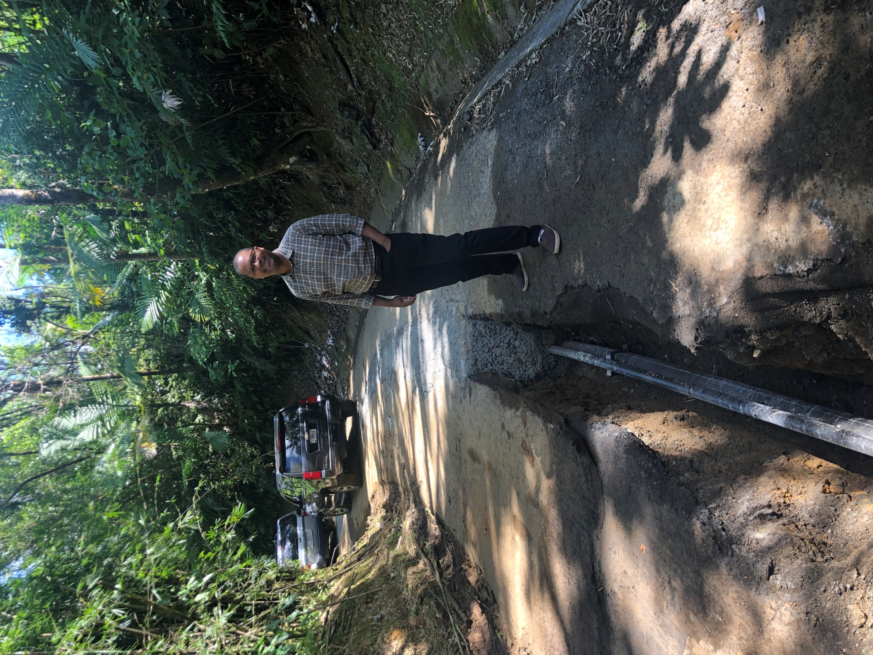
On Saturday, Commissioner Starks visited communications facilities in the El Yunque National Forest. To take advantage of clear lines of sight (including to stations in the U.S. Virgin Islands), these facilities sit high in the mountains above dense rainforest. That positioning, while valuable from a communications perspective, also makes these facilities more vulnerable to natural disasters and harder to reconnect during a recovery effort. During Commissioner Starks’s visit, crews were working their way up the mountain burying conduits for electrical power and fiber optics in order to improve resiliency. To limit the impact on the surrounding forest, they dig trenches in the existing service road, install the conduits, and then fill the trench with concrete—a complex process made more challenging by the mountainous terrain and rainforest weather.

“Seeing the process of hardening our communications infrastructure up close drives home the point that this is critical—and difficult—work,” said Commissioner Starks. “I thank the Federal Aviation Administration and the U.S. Forest Service for their hospitality, and I applaud the many Puerto Ricans working hard to make these improvements. Time is of the essence, and the FCC needs to fast-track its support for these efforts.”

“There are four key lessons I took from this trip,” Commissioner Starks continued. “First, access to power will always be a central issue. During the recent earthquakes, the overwhelming majority of cell-site outages resulted from power loss, not damage to facilities. These are long-term challenges; one of the facilities I visited is still, more than two years later, running on a generator after hurricane damage destroyed its power lines. I am encouraged that many stakeholders are exploring expanded coordination agreements with power utilities and alternative sources of energy. At the federal level, we urgently need to consider new rules and legislation to ensure access to power.
Commissioner Starks surveys progress on a project to bury fiber and electrical lines.

Second, there was a pronounced digital divide in Puerto Rico long before Hurricane Maria and the recent earthquakes. As I saw up close, bringing reliable, resilient broadband to rural communities in Puerto Rico often means adapting to challenging terrain. Ending internet inequality in Puerto Rico will take sustained commitment and significant resources. The FCC needs to provide both.

Third, communications failures exacerbated the mental health challenges that many Puerto Ricans, including first responders and 911 workers, faced in the wake of Hurricane Maria and the recent earthquakes. Many Puerto Ricans cannot access mental health care professionals, who are in short supply—especially in rural areas. Telehealth could help all Puerto Ricans access the care and support they need, but only if we close the digital divide.

Finally, Puerto Ricans stand ready to meet these challenges. Alongside stories of hardship and real struggles, the people I met also emphasized the many acts of bravery, community service, sacrifice, and commitment to others they have seen over the last two-and-a-half years. The FCC must be a good partner to the many Puerto Ricans working hard to improve their communities. I look forward to collaborating with them and learning from them.”

###
Office of Commissioner Geoffrey Starks: (202) 418-2500
ASL Videophone: (844) 432-2275
TTY: (888) 835-5322
Twitter: @GeoffreyStarks
www.fcc.gov/about/leadership/geoffrey-starks

This is an unofficial announcement of Commission action. Release of the full text of a Commission order constitutes official action. See MCI v. FCC, 515 F.2d 385 (D.C. Cir. 1974).

