Working Toward the 5G Fund for Rural America:
Option A Eligibility Analysis

Rural Broadband Auctions Task Force &
Office of Economics and Analytics

Working Toward the 5G Fund for Rural America: Option A Eligibility Analysis

Introduction
Since late 2018, major U.S. mobile wireless carriers have lit up 5G networks covering more than 200 million Americans in aggregate. And as a condition of its recently completed transaction with Sprint, T-Mobile made binding commitments to deploy 5G service covering 99% of the population nationwide within six years, and 90% of the population in rural areas within the same time period. The Commission remains concerned, however, that even with these significant deployment commitments, some rural areas will remain where there is insufficient financial incentive for mobile wireless carriers to invest in 5G-capable networks, and those communities could be excluded from the technological and economic benefits of 5G for years to come.
As the next step in its efforts to close the digital divide and reform legacy high-cost support, the Chairman released a draft Notice of Proposed Rulemaking (NPRM) that would establish the 5G Fund for Rural America, making up to $9 billion in Universal Service Fund support available to carriers to deploy voice and advanced 5G mobile broadband services through multi-round reverse auctions in two phases. Phase I of the 5G Fund would target at least $8 billion in support to rural areas of our country that would be unlikely to see timely deployment of 5G broadband service absent high-cost support or as part of T-Mobile’s transaction-related commitments.
The NPRM sought comment on an “Option A” proposal that would establish the areas eligible for support in Phase I of the 5G Fund based upon existing data sources that identify rural areas. To assist the public in understanding what areas would be eligible for support, staff has considered the degree of rurality of any given area using U.S. Department of Agriculture (USDA) Rural-Urban Commuting Area (RUCA) codes that employ U.S. Census Bureau and American Community Survey data to categorize census tracts based on population density, urbanization, and daily commuting patterns. In particular, the areas eligible for 5G Fund Phase I support would be any census tract that is part of RUCA codes 5-10, excluding from such tracts any census block categorized as “urban” or that is water-only.
The top states in terms of land area percentage that would be eligible for 5G Fund Phase I support under this definition would be:
- Nebraska (92%)
- North Dakota (91%)
- South Dakota (90%)
- Montana (89%)
- Wyoming (86%)
- Vermont (85%)
- Kansas (85%)
- Maine (83%)
- Colorado (81%)
- Idaho (81%)
The top states in terms of population percentage that would be eligible for 5G Fund Phase I support under this definition would be:
- Vermont (47%)
- Maine (34%)
- Montana (33%)
- North Dakota (33%)
- South Dakota (32%)
- Mississippi (31%)
- Kentucky (27%)
- Wyoming (26%)
- New Hampshire (24%)
- Iowa (23%)
Consistent with the proposals in the draft 5G Fund NPRM, staff notes that the areas potentially eligible for Phase I support under Option A represent an upper bound on eligibility, and the actual areas that would be eligible in the Phase I auction may be significantly reduced due to T-Mobile’s binding 5G commitments. Because T-Mobile’s 5G commitments are based upon population covered and are not geographically-based, staff is unable to generate maps that take into account those areas that may be ultimately removed from eligibility due to commitments by T-Mobile to deploy 5G service in those areas.
An online version of the maps in this analysis can be viewed on the Commission’s website at: https://www.fcc.gov/reports-research/maps/5g-fund-option-a-eligibility-analysis/.

Data Sources
The staff analysis and the maps contained herein rely upon U.S. Census Bureau population and geographic data, as well as the Rural-Urban Commuting Area codes released by the U.S. Department of Agriculture’s Economic Research Service.

Summary of Eligibility
State | Eligible Pops. | Eligible Pops. % | Eligible Area  (sq. km) | Total Area  (sq. km) | Eligible Area %
Alabama | 693,910 | 15% | 57,105 | 131,174 | 44%
Arizona | 280,165 | 4% | 189,321 | 294,200 | 64%
Arkansas | 660,073 | 23% | 90,752 | 134,768 | 67%
California | 633,686 | 2% | 256,714 | 403,503 | 64%
Colorado | 337,932 | 7% | 217,295 | 268,422 | 81%
Connecticut | 29,042 | 1% | 1,209 | 12,542 | 10%
Delaware | 37,198 | 4% | 912 | 5,045 | 18%
Florida | 276,862 | 1% | 29,588 | 138,949 | 21%
Georgia | 739,811 | 8% | 60,303 | 149,482 | 40%
Hawaii | 69,989 | 5% | 11,642 | 16,633 | 70%
Idaho | 246,478 | 16% | 173,269 | 214,050 | 81%
Illinois | 653,874 | 5% | 75,346 | 143,780 | 52%
Indiana | 671,096 | 10% | 39,312 | 92,788 | 42%
Iowa | 693,305 | 23% | 108,381 | 144,661 | 75%
Kansas | 428,644 | 15% | 180,342 | 211,755 | 85%
Kentucky | 1,168,237 | 27% | 69,742 | 102,279 | 68%
Louisiana | 365,703 | 8% | 42,474 | 111,897 | 38%
Maine | 447,106 | 34% | 65,942 | 79,887 | 83%
Maryland | 94,838 | 2% | 4,984 | 25,151 | 20%
Massachusetts | 46,591 | 1% | 2,375 | 20,205 | 12%
Michigan | 1,096,506 | 11% | 99,303 | 146,600 | 68%
Minnesota | 831,131 | 16% | 162,894 | 206,228 | 79%
Mississippi | 918,532 | 31% | 84,360 | 121,533 | 69%
Missouri | 907,693 | 15% | 117,679 | 178,050 | 66%
Montana | 324,685 | 33% | 337,353 | 376,965 | 89%
Nebraska | 355,060 | 19% | 182,099 | 198,956 | 92%
Nevada | 60,414 | 2% | 184,563 | 284,329 | 65%
New Hampshire | 310,252 | 24% | 17,249 | 23,189 | 74%
New Jersey | 11,566 | 0% | 825 | 19,047 | 4%
New Mexico | 214,282 | 10% | 228,011 | 314,194 | 73%
New York | 910,102 | 5% | 60,748 | 122,049 | 50%
North Carolina | 1,187,971 | 12% | 56,868 | 125,923 | 45%
North Dakota | 218,929 | 33% | 163,461 | 178,705 | 91%
Ohio | 1,117,443 | 10% | 54,194 | 105,828 | 51%
Oklahoma | 710,933 | 19% | 139,363 | 177,662 | 78%
Oregon | 292,374 | 8% | 189,450 | 248,607 | 76%
Pennsylvania | 717,228 | 6% | 43,551 | 115,884 | 38%
Rhode Island | 1,051 | 0% | 23 | 2,677 | 1%
South Carolina | 424,520 | 9% | 26,082 | 77,864 | 33%
South Dakota | 263,300 | 32% | 176,920 | 196,346 | 90%
Tennessee | 933,481 | 15% | 57,094 | 106,802 | 53%
Texas | 1,248,594 | 5% | 415,886 | 676,653 | 61%
Utah | 119,140 | 4% | 162,222 | 212,885 | 76%
Vermont | 293,897 | 47% | 20,352 | 23,874 | 85%
Virginia | 673,143 | 8% | 38,581 | 102,257 | 38%
Washington | 354,556 | 5% | 108,838 | 172,112 | 63%
West Virginia | 311,207 | 17% | 27,823 | 62,266 | 45%
Wisconsin | 902,539 | 16% | 96,197 | 140,290 | 69%
Wyoming | 145,718 | 26% | 215,112 | 251,457 | 86%
American Samoa | 55,519 | 100% | 197 | 197 | 100%
N. Mariana Islands | 58,883 | 100% | 471 | 471 | 100%
Guam | 159,444 | 100% | 531 | 531 | 100%
Total | 24,704,633 | 8% | 5,145,308 | 7,671,602 | 67%

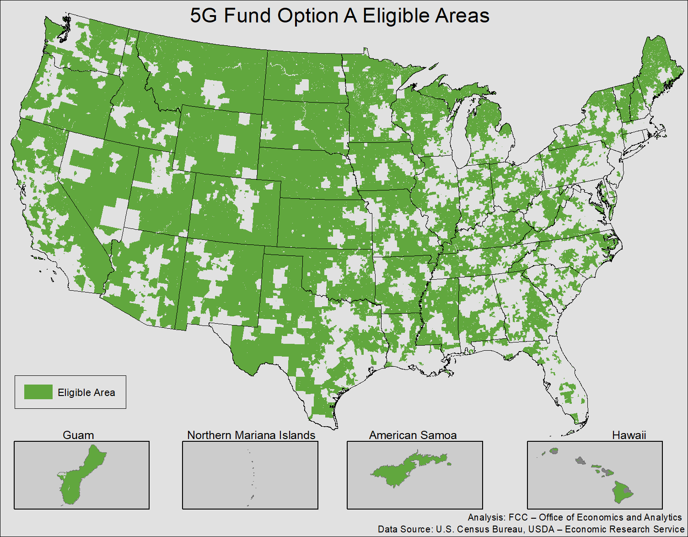

Alabama
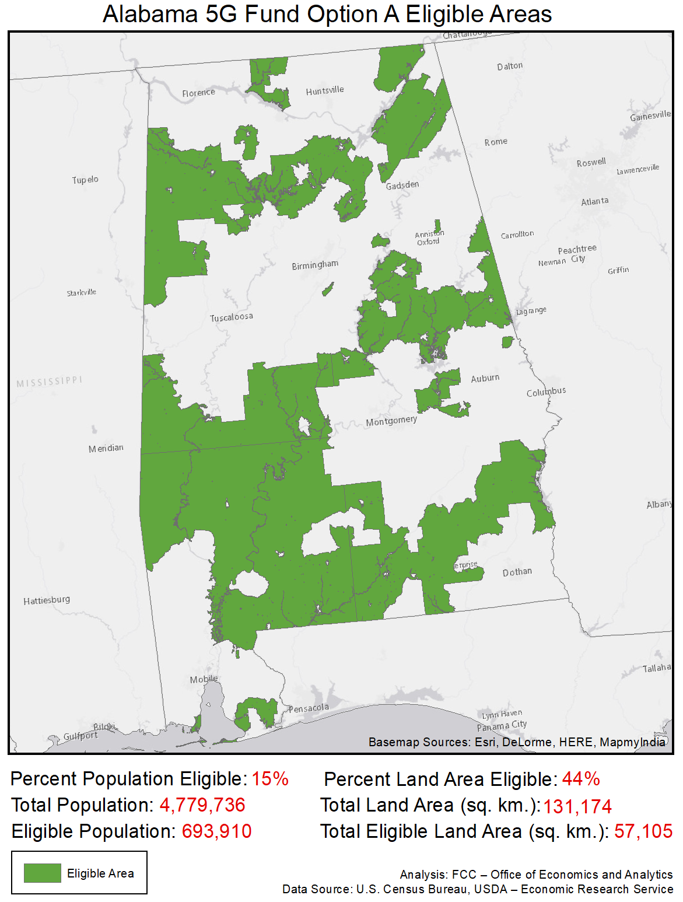

Arizona
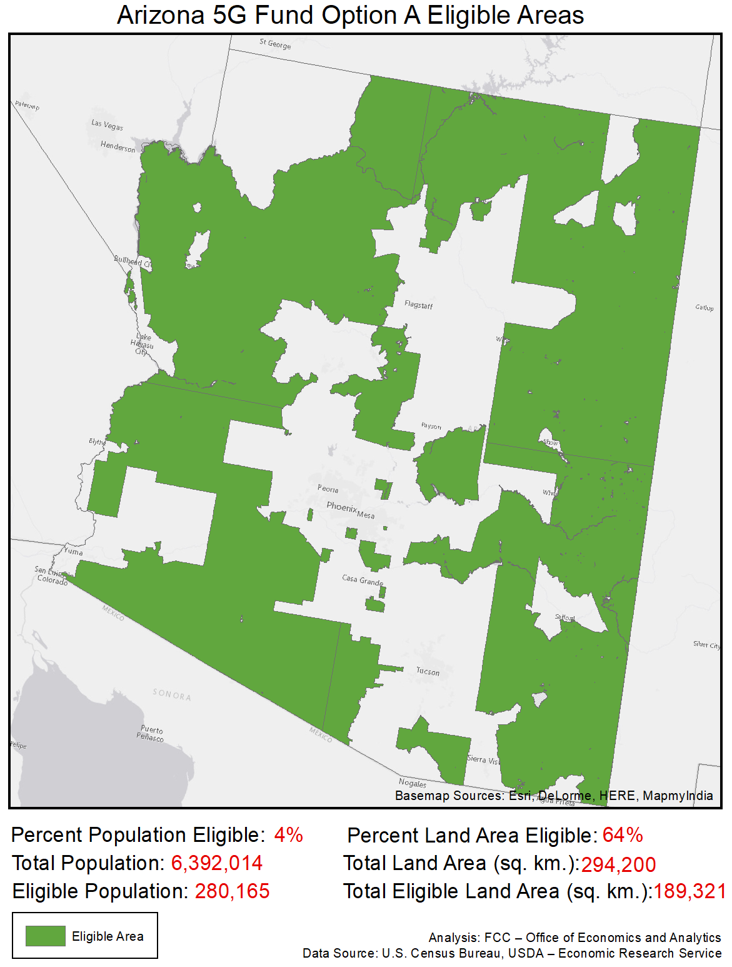

Arkansas
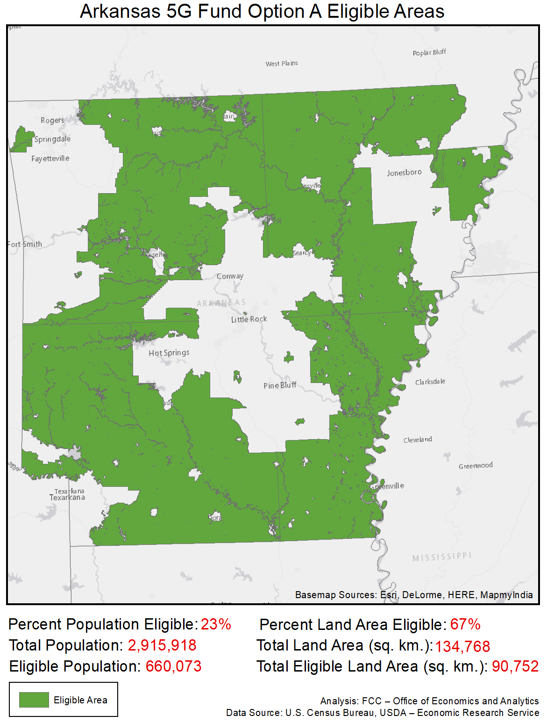

California
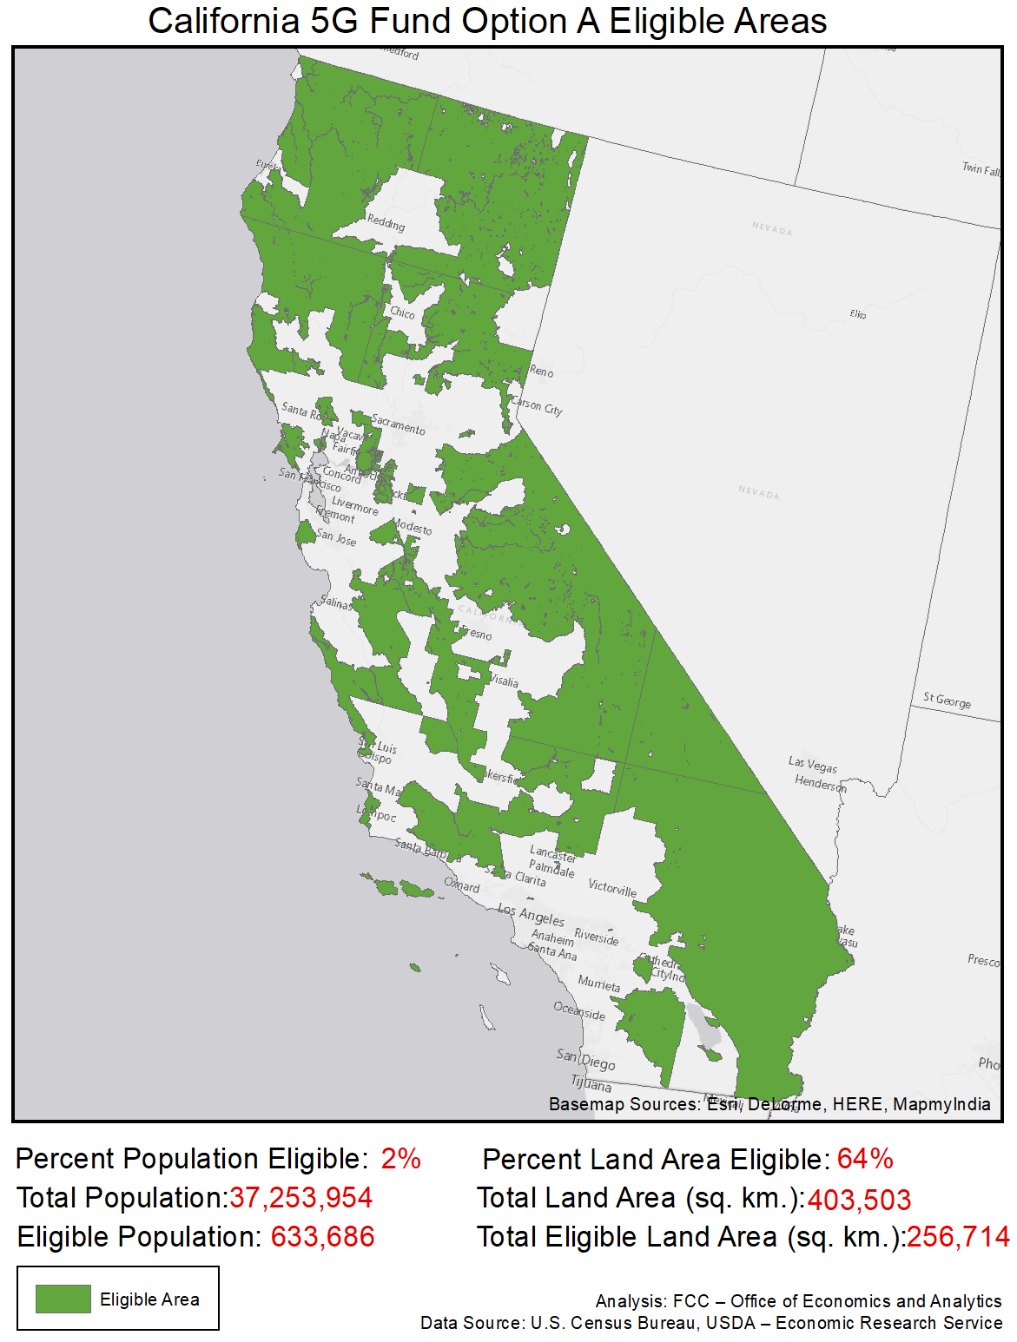

Colorado
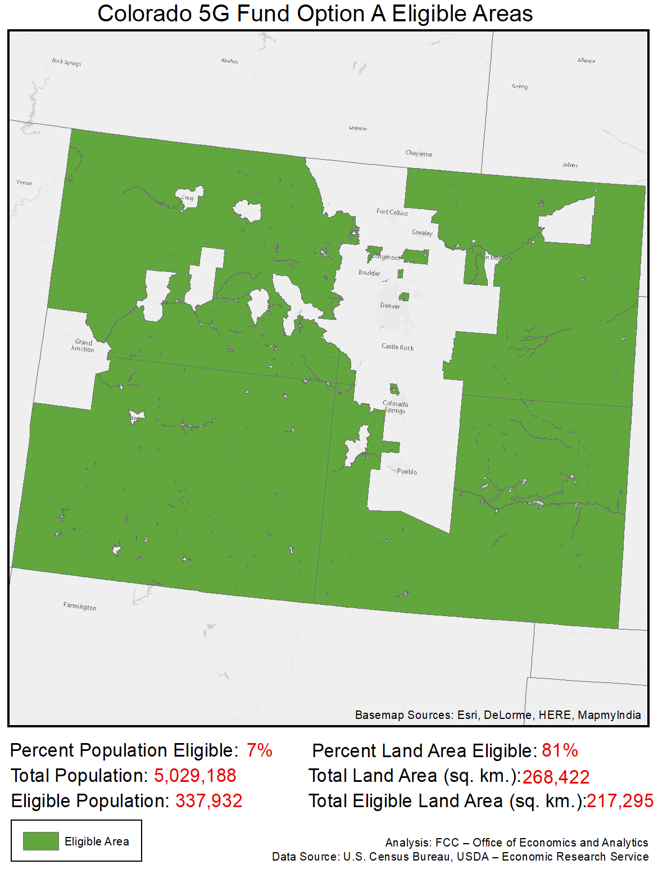

Connecticut
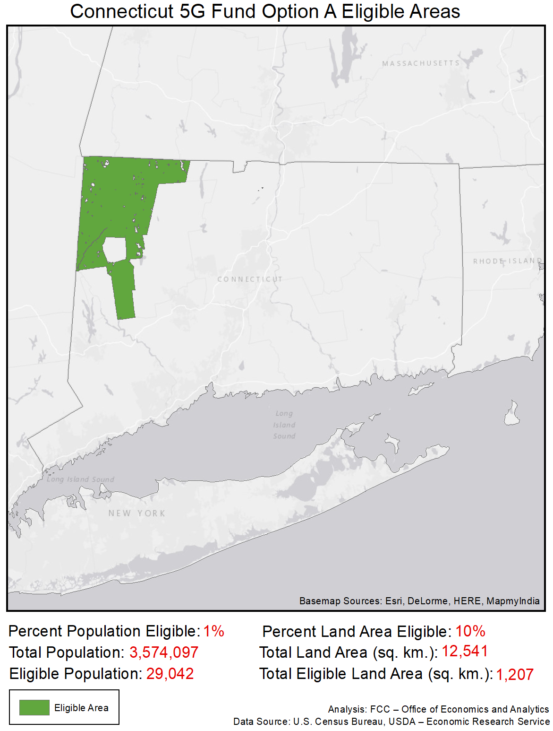

Delaware
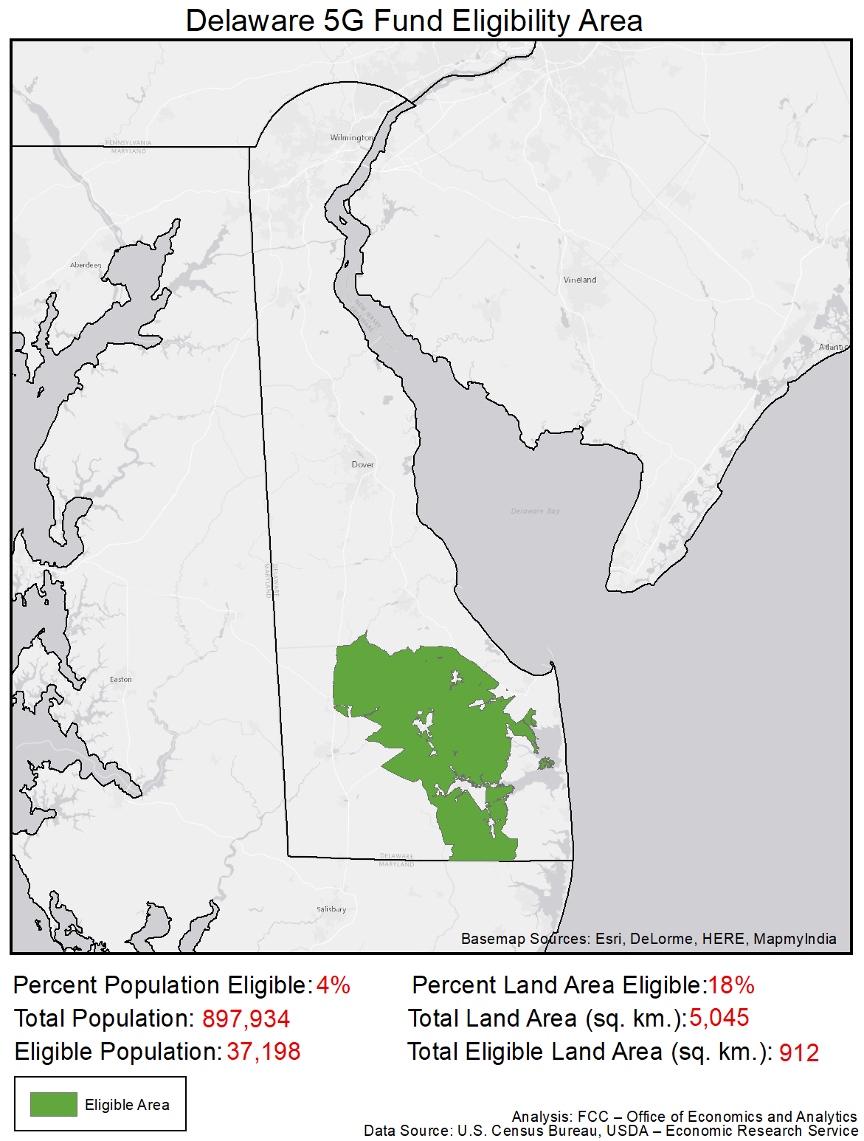

Florida
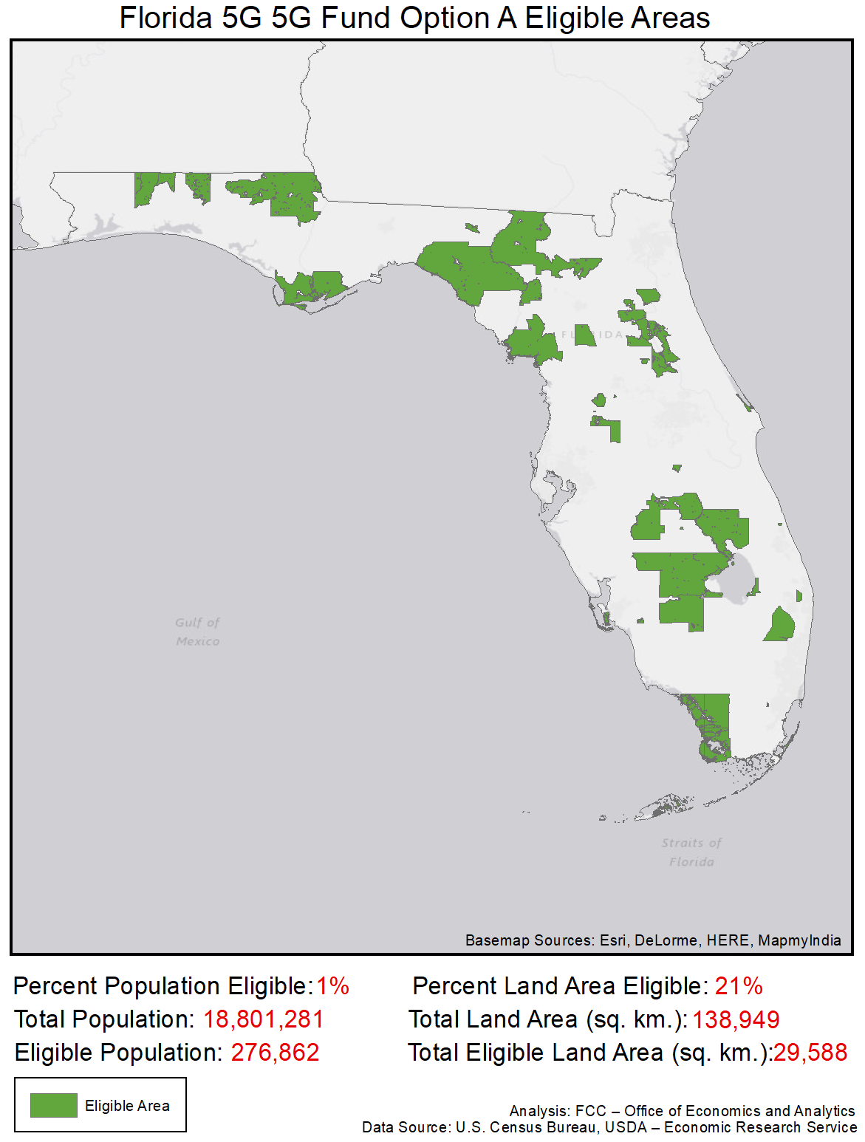

Georgia
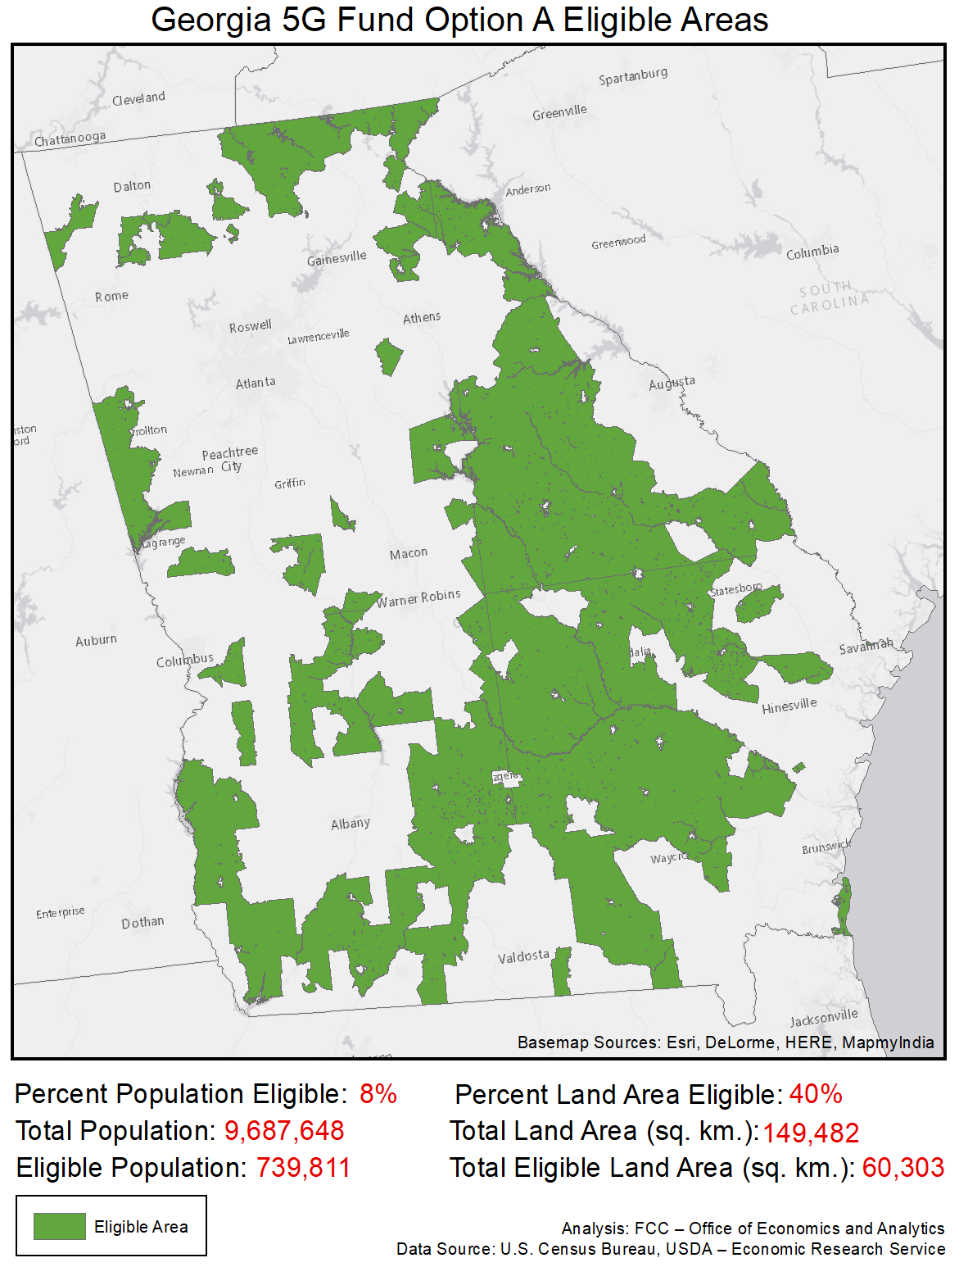

Hawaii
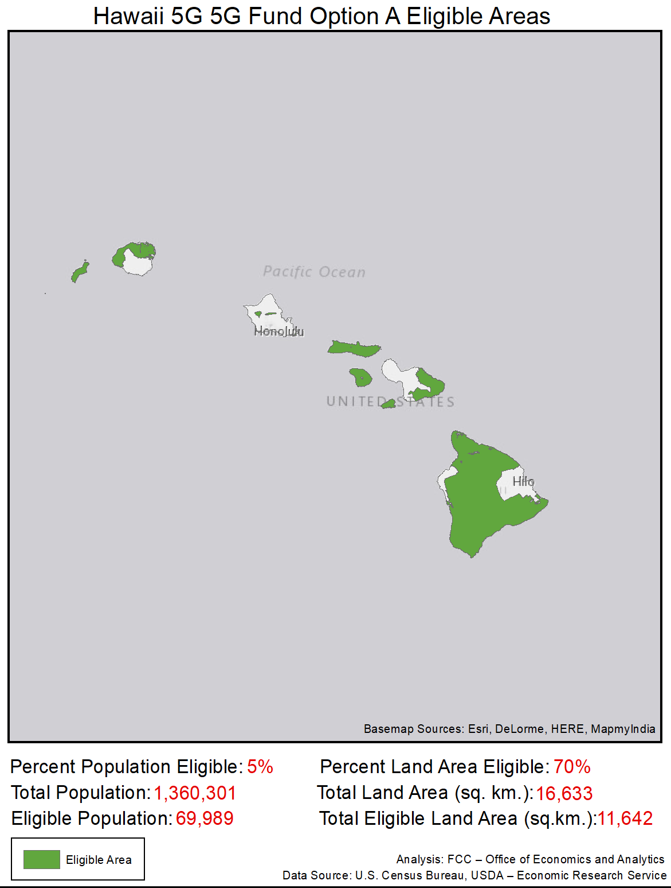

Idaho
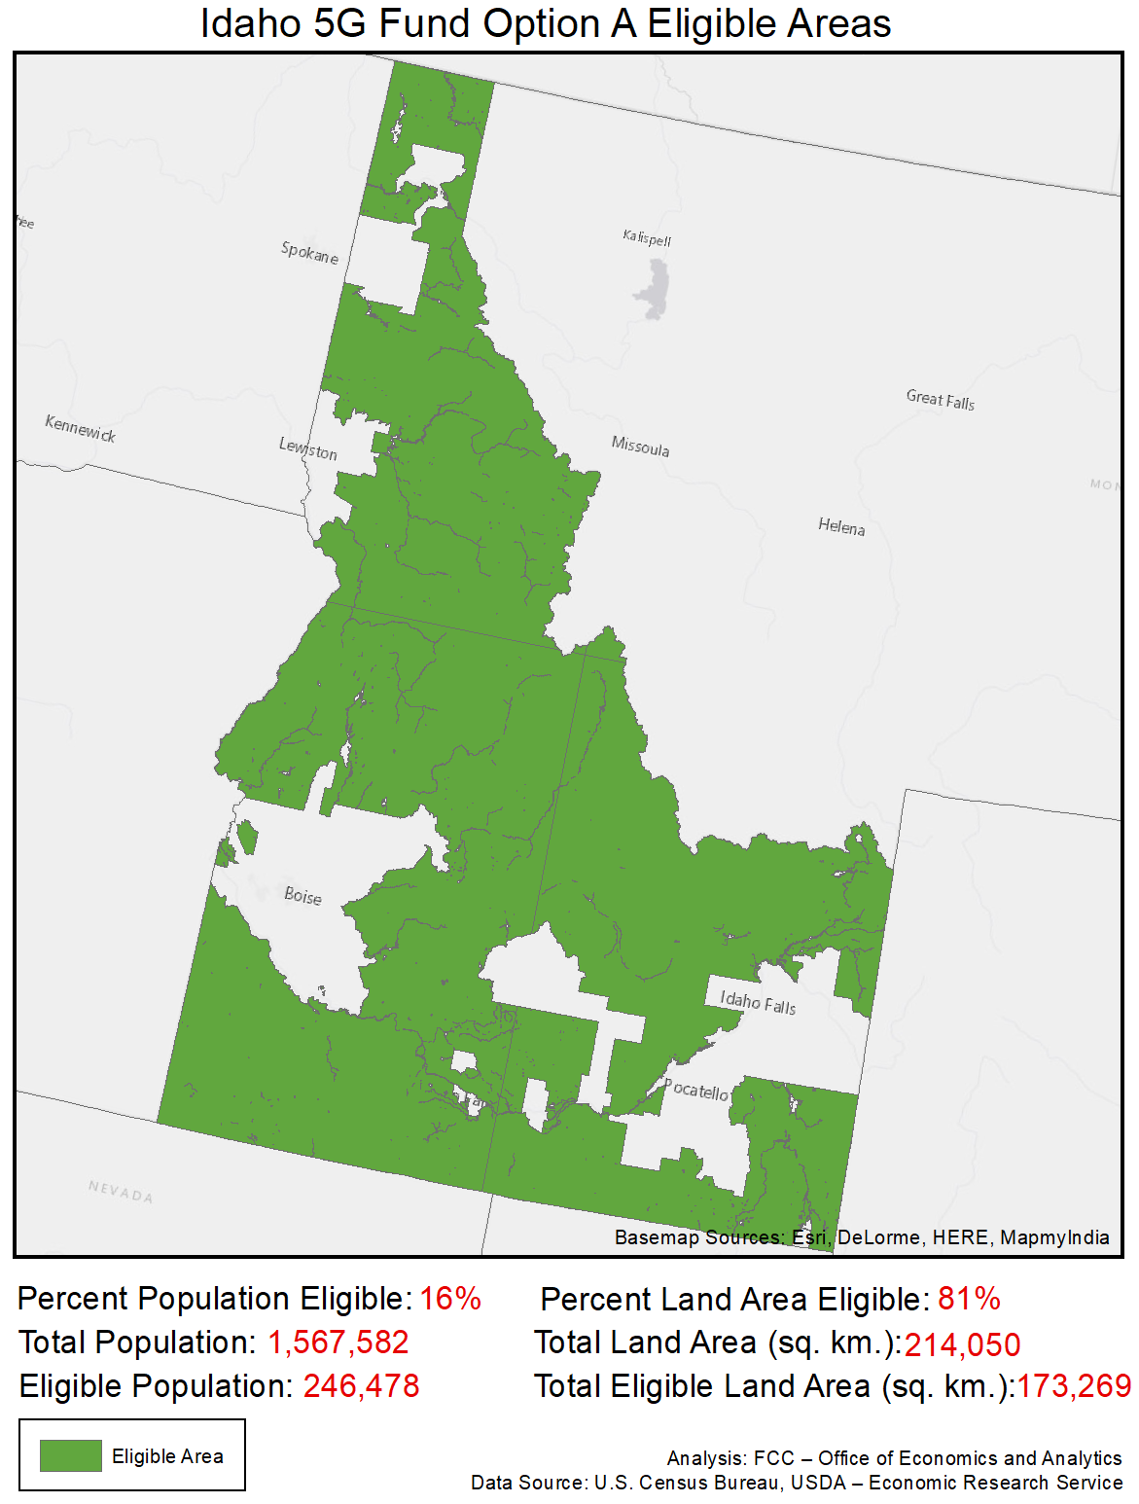

Illinois
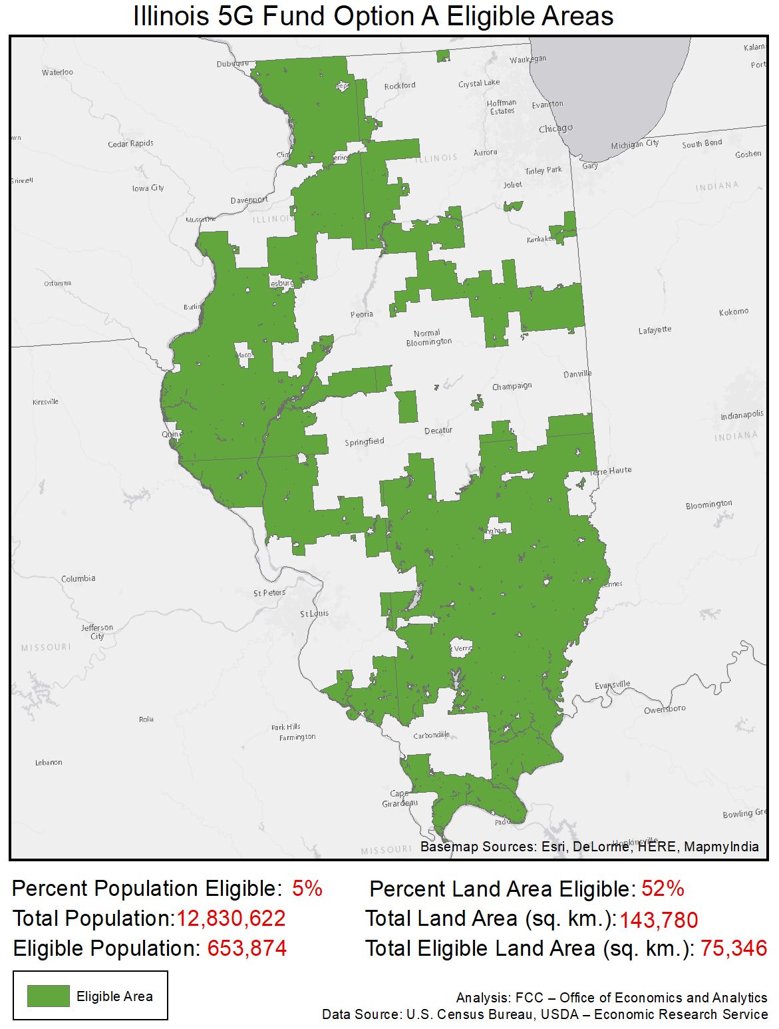

Indiana
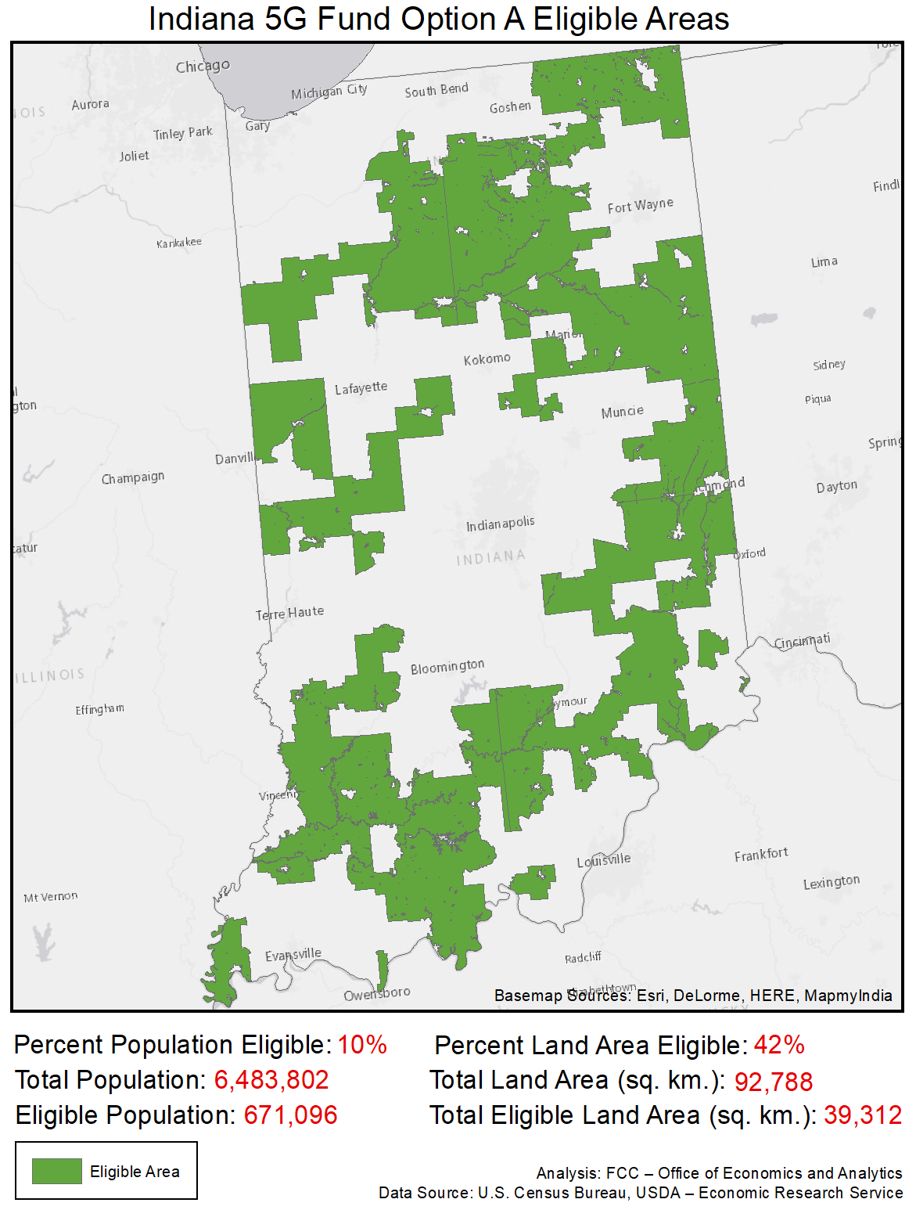

Iowa
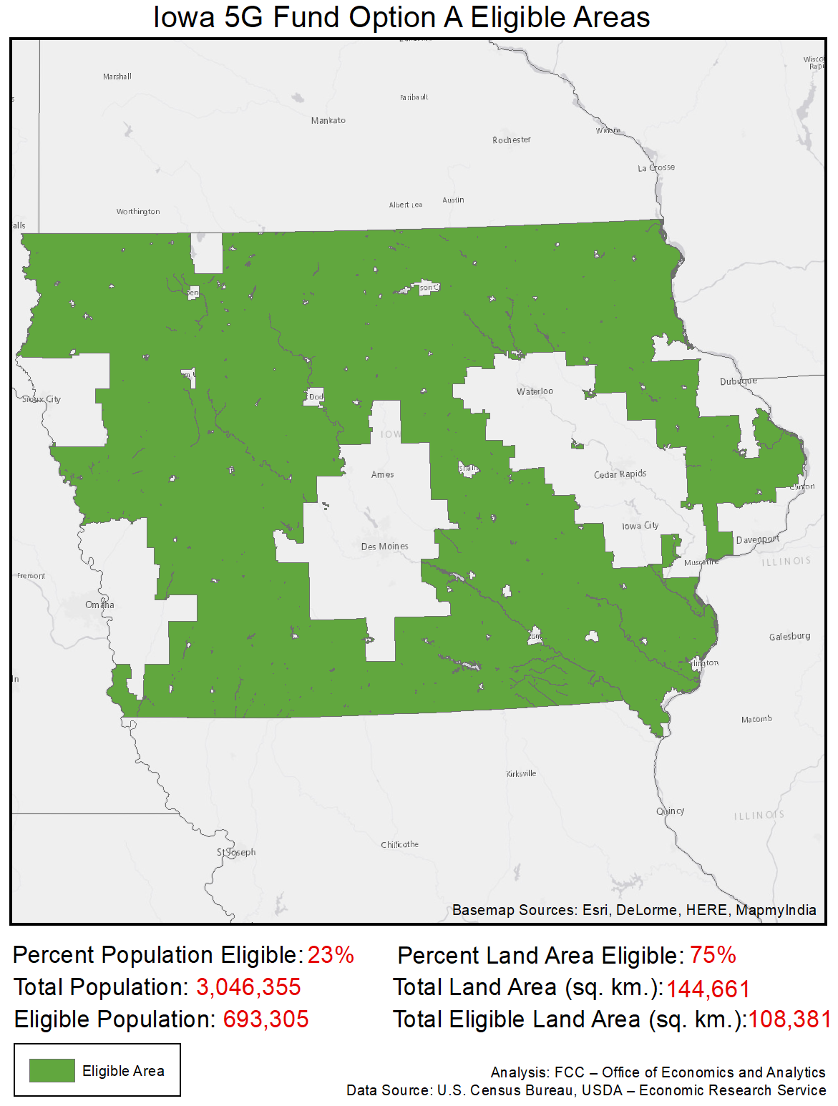

Kansas
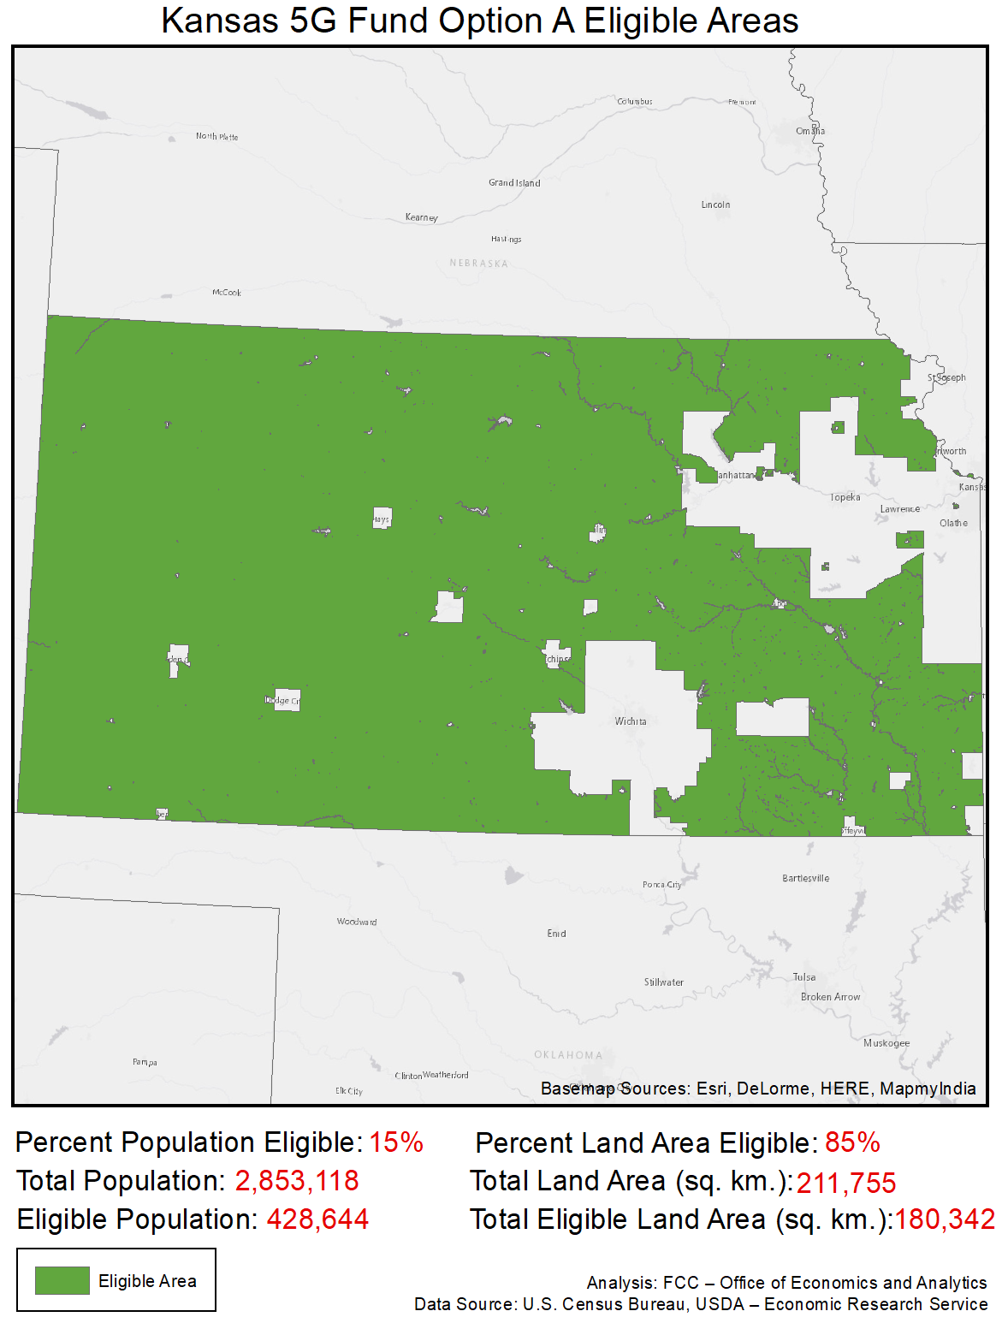

Kentucky
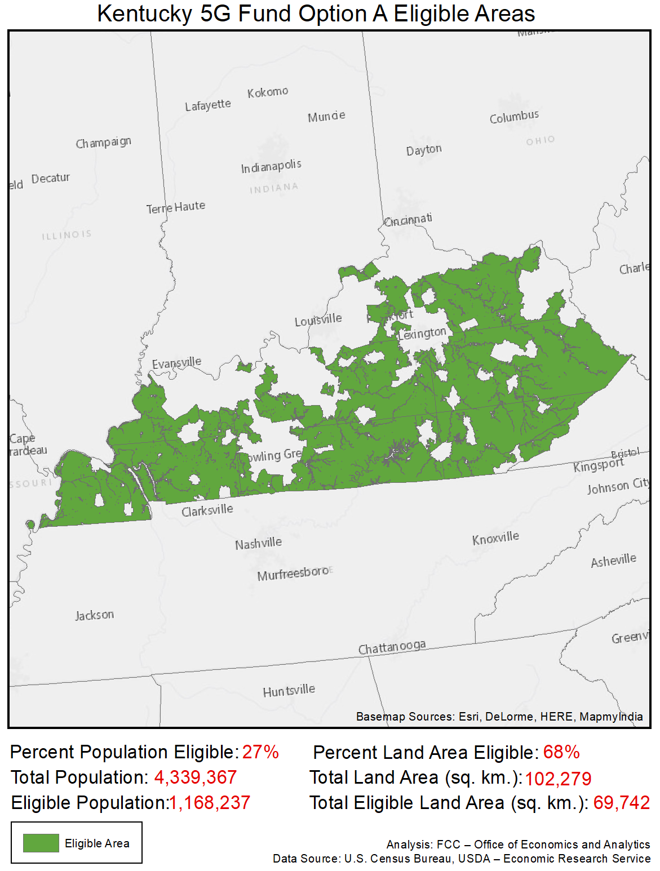

Louisiana
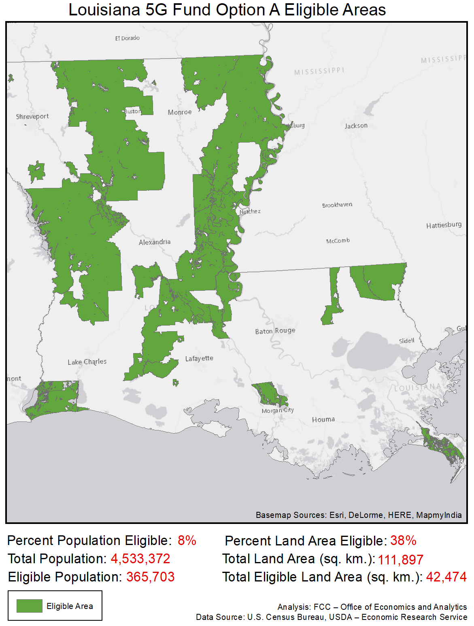

Maine
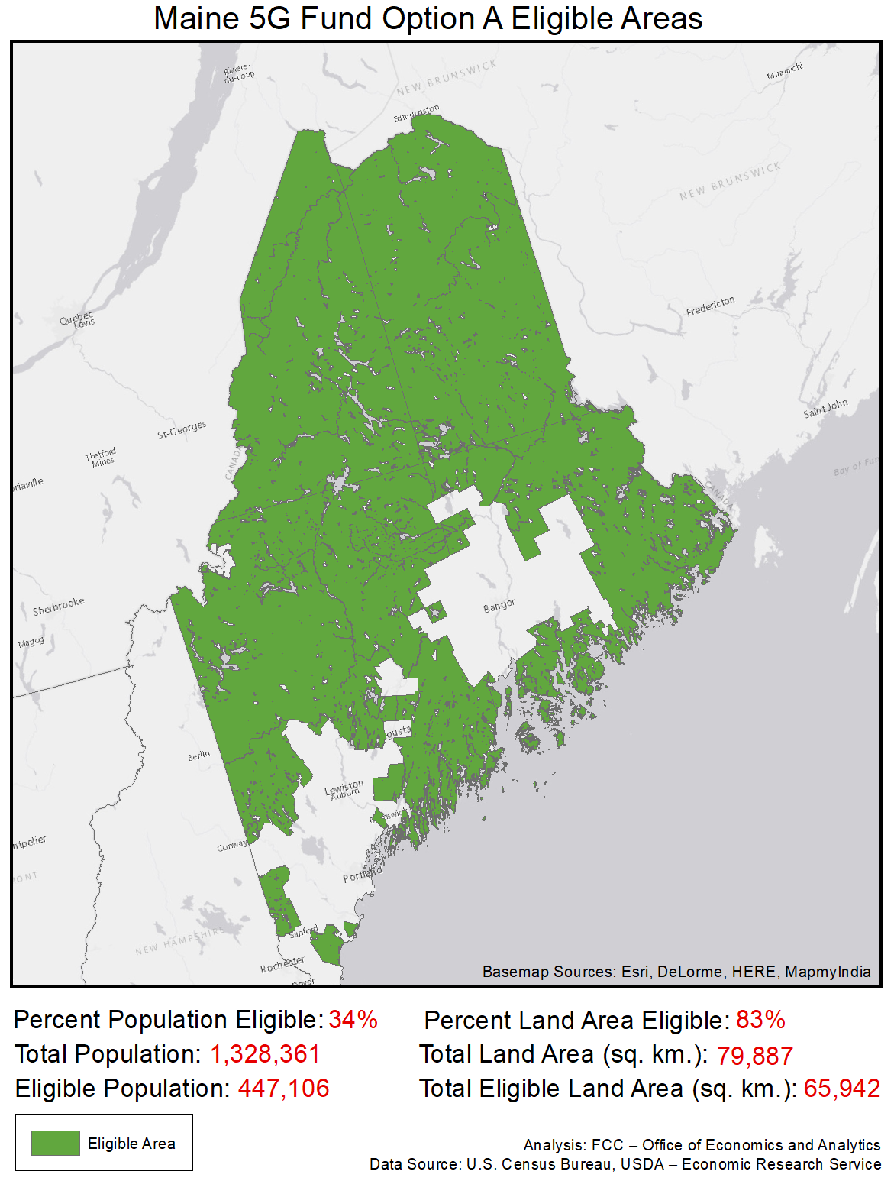

Maryland
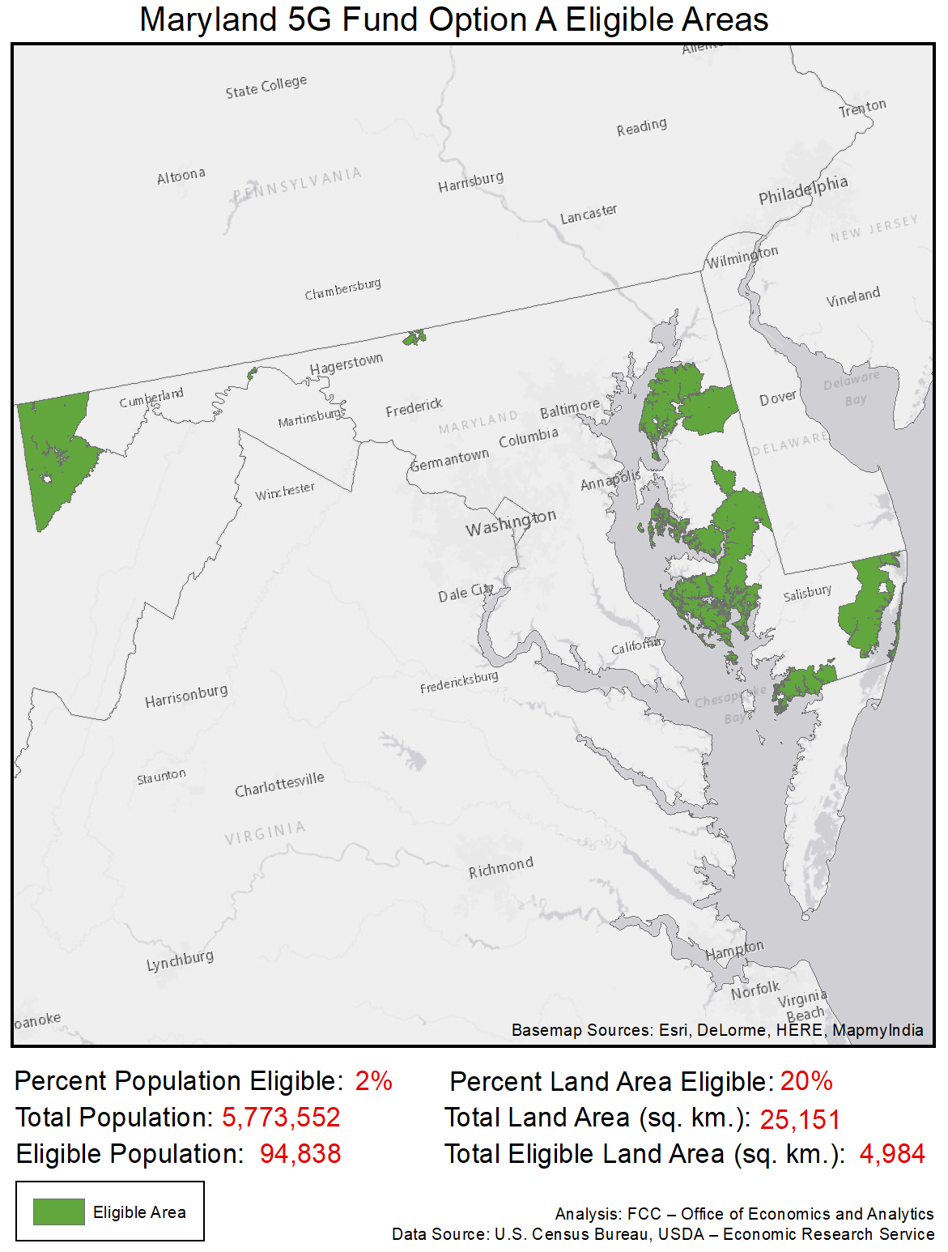

Massachusetts
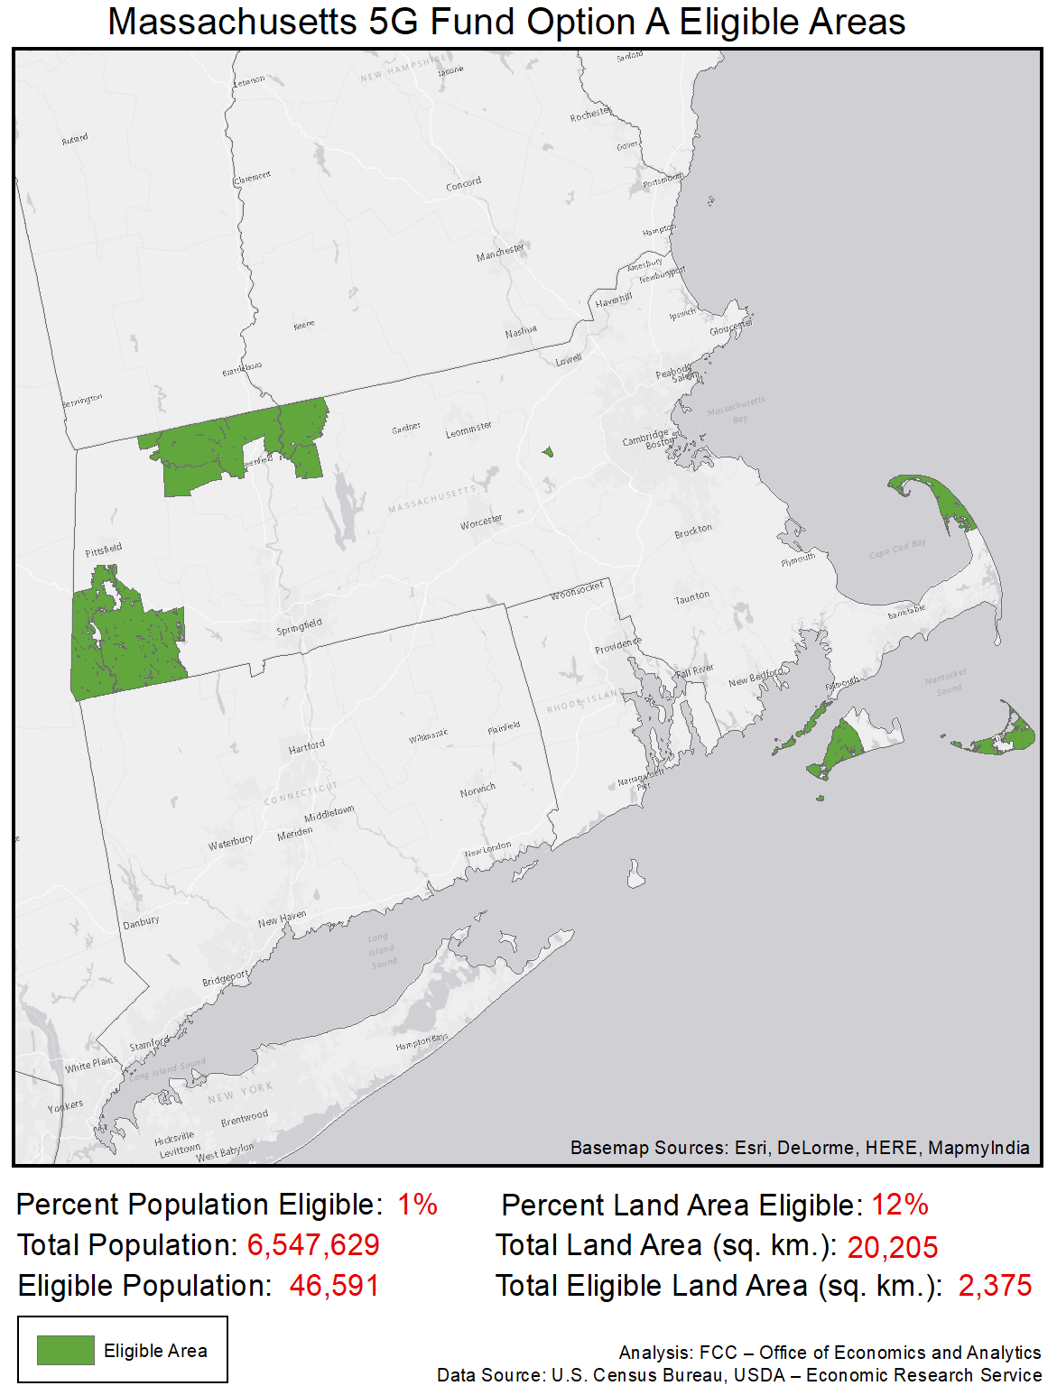

Michigan
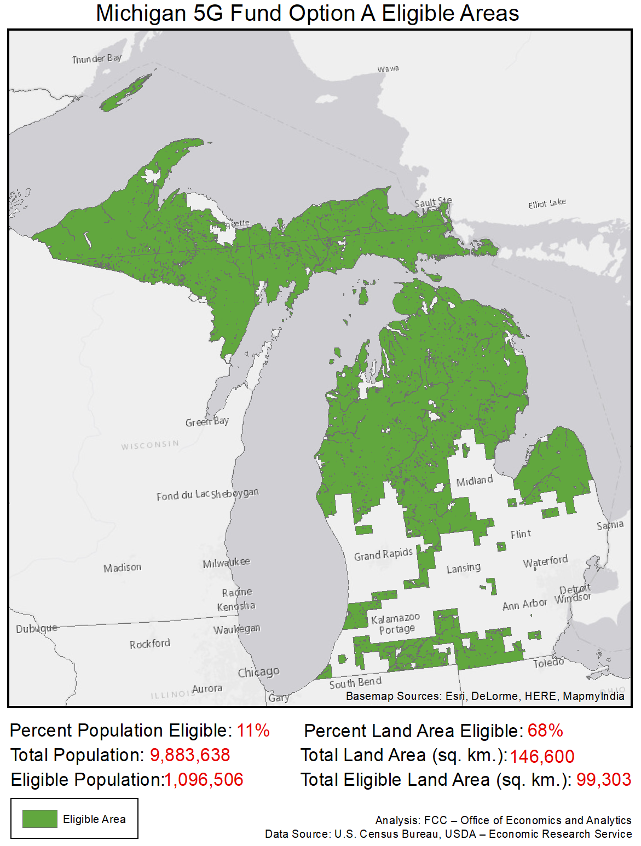

Minnesota
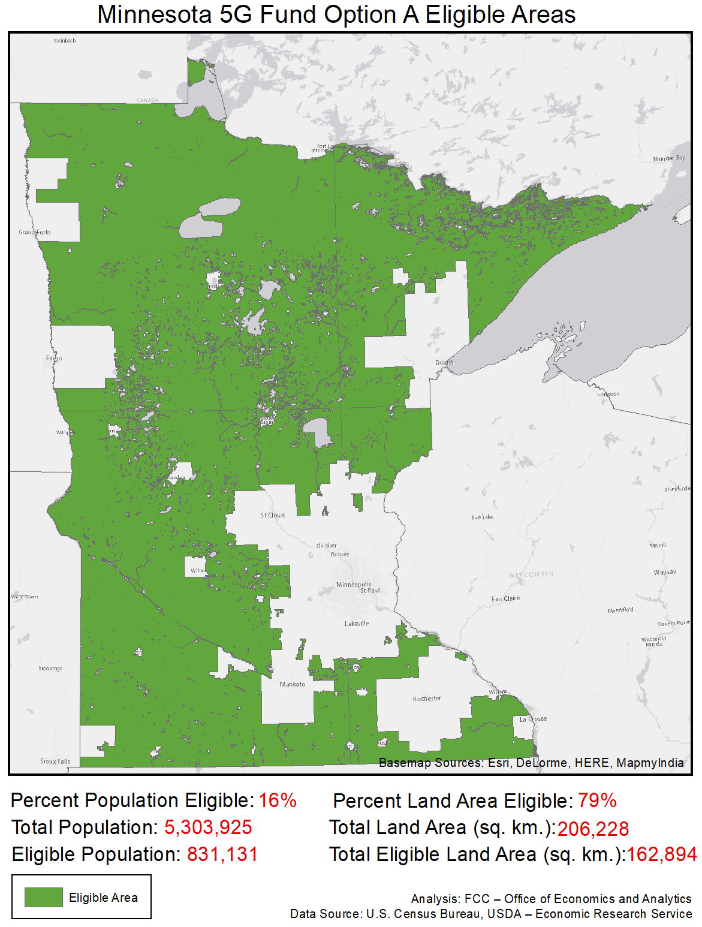

Mississippi
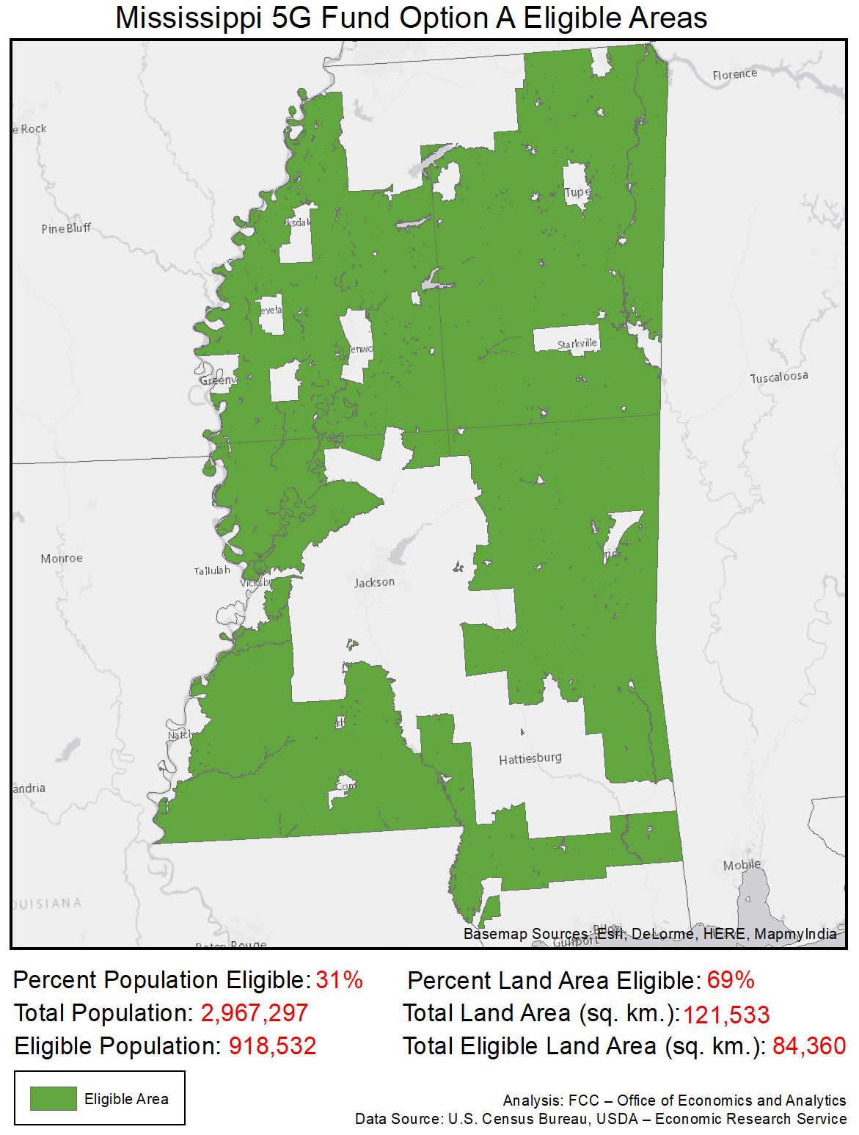

Missouri
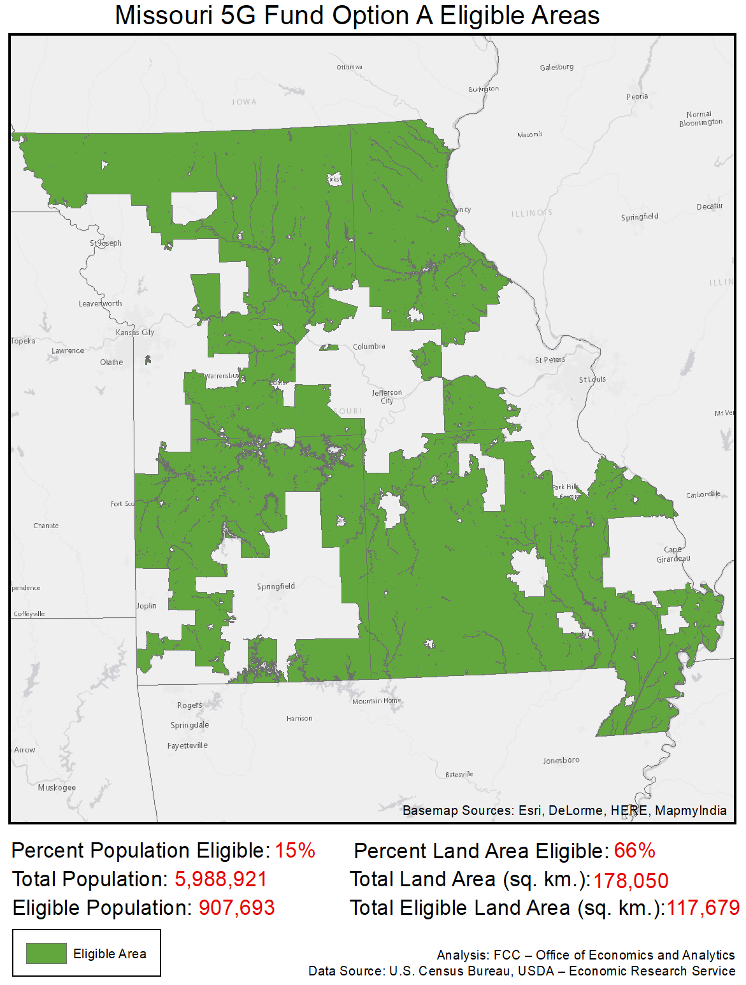

Montana
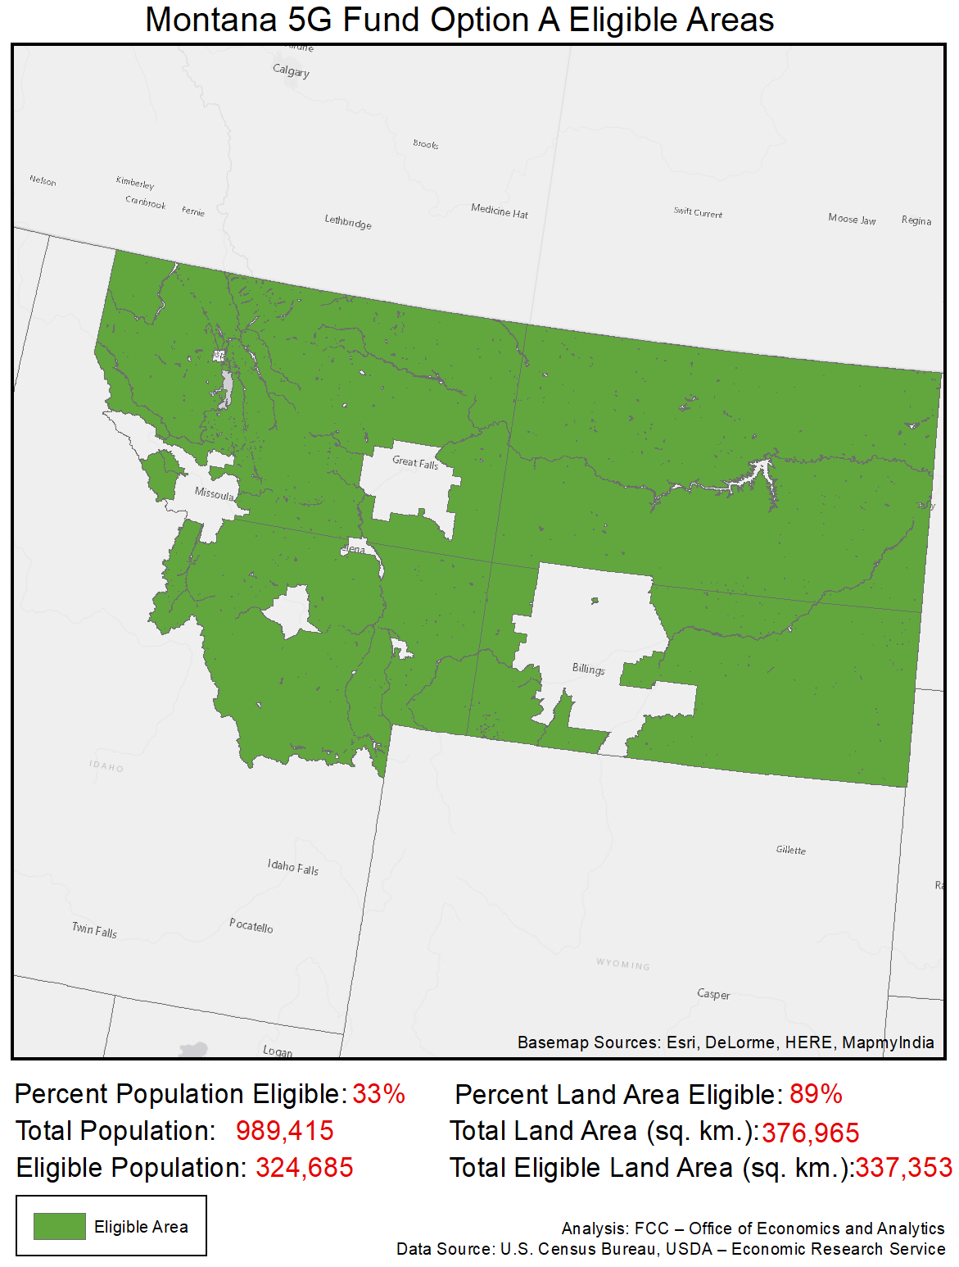

Nebraska
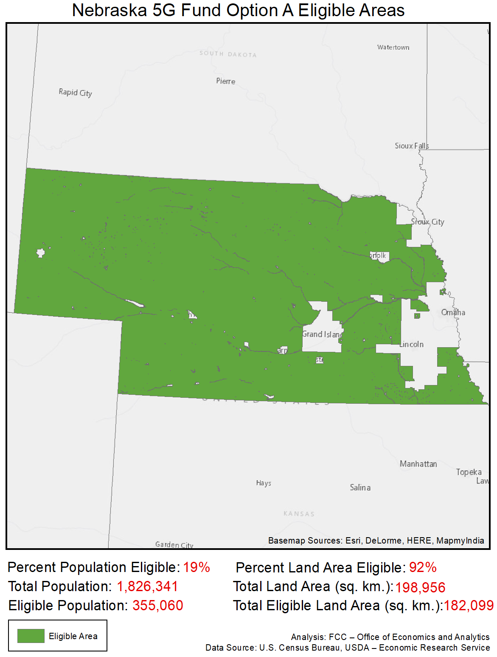

Nevada
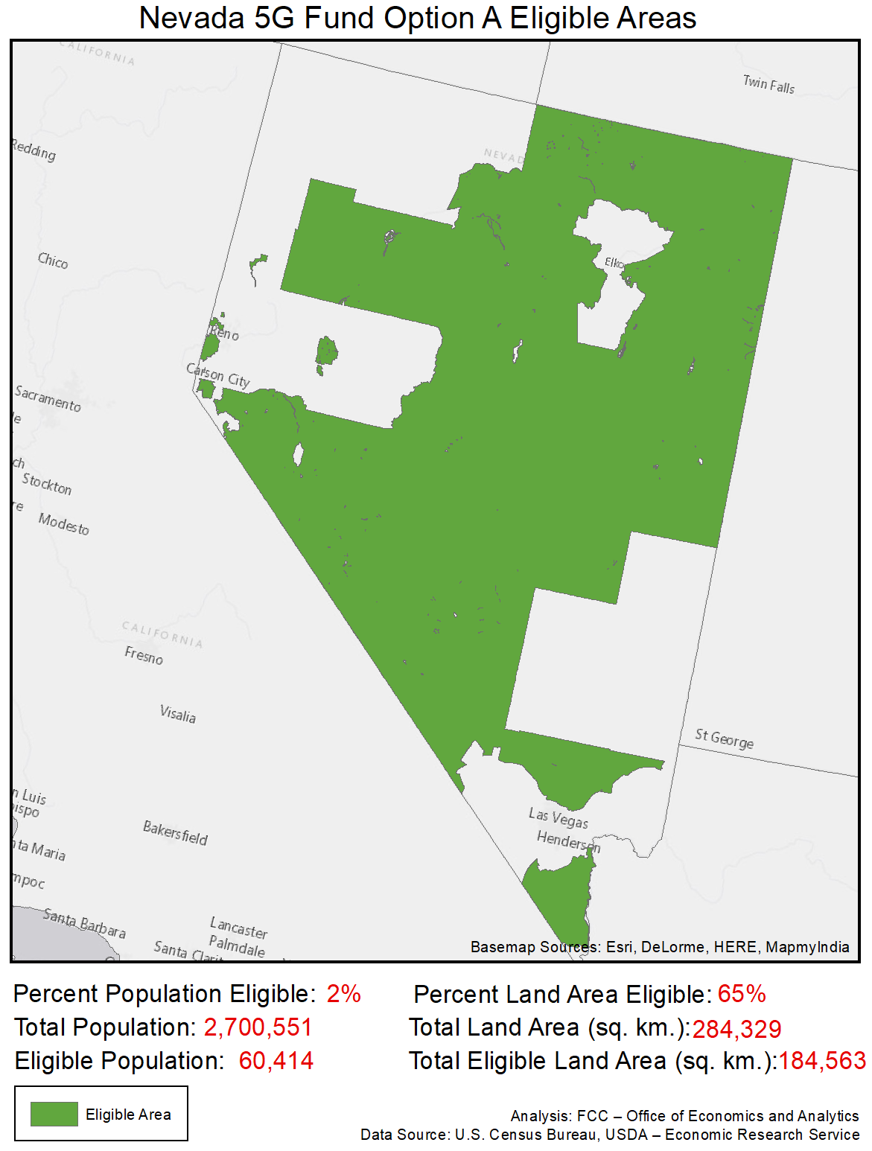

New Hampshire
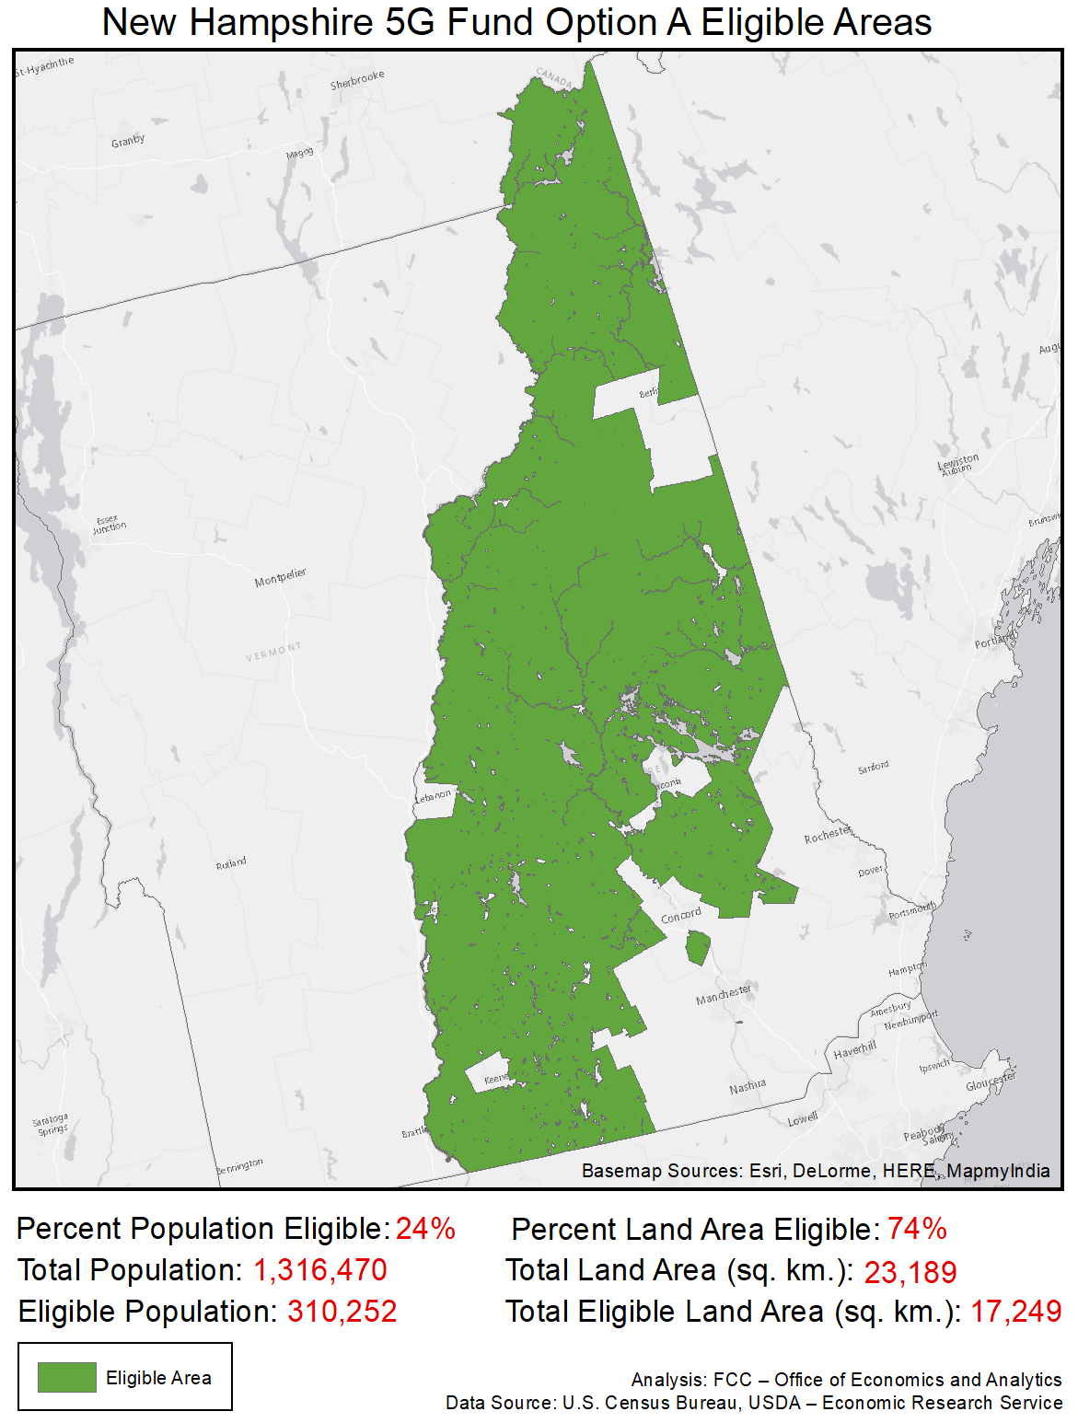

New Jersey
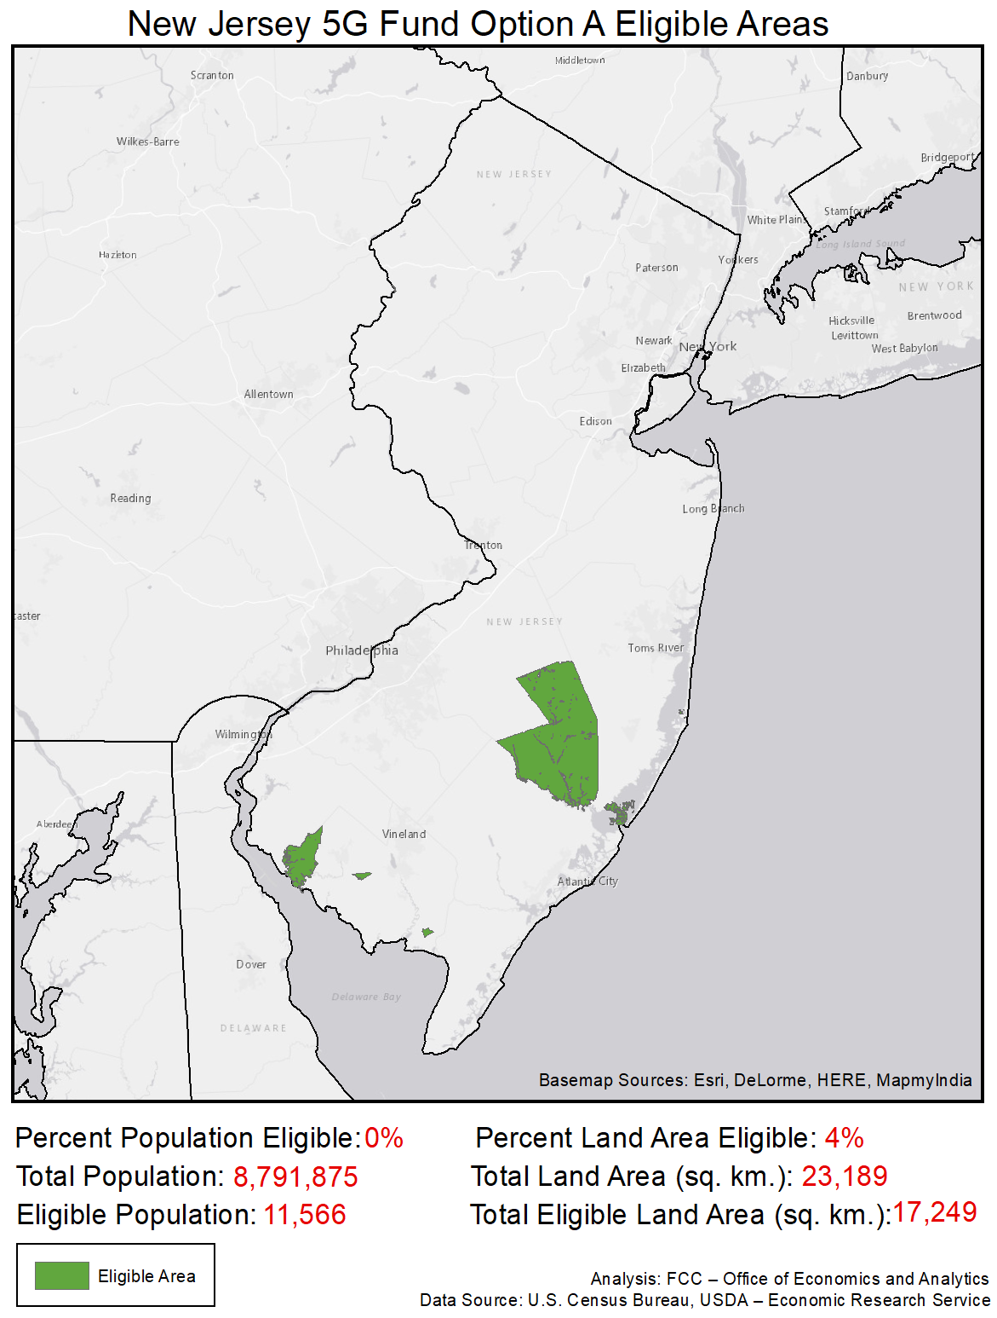

New Mexico
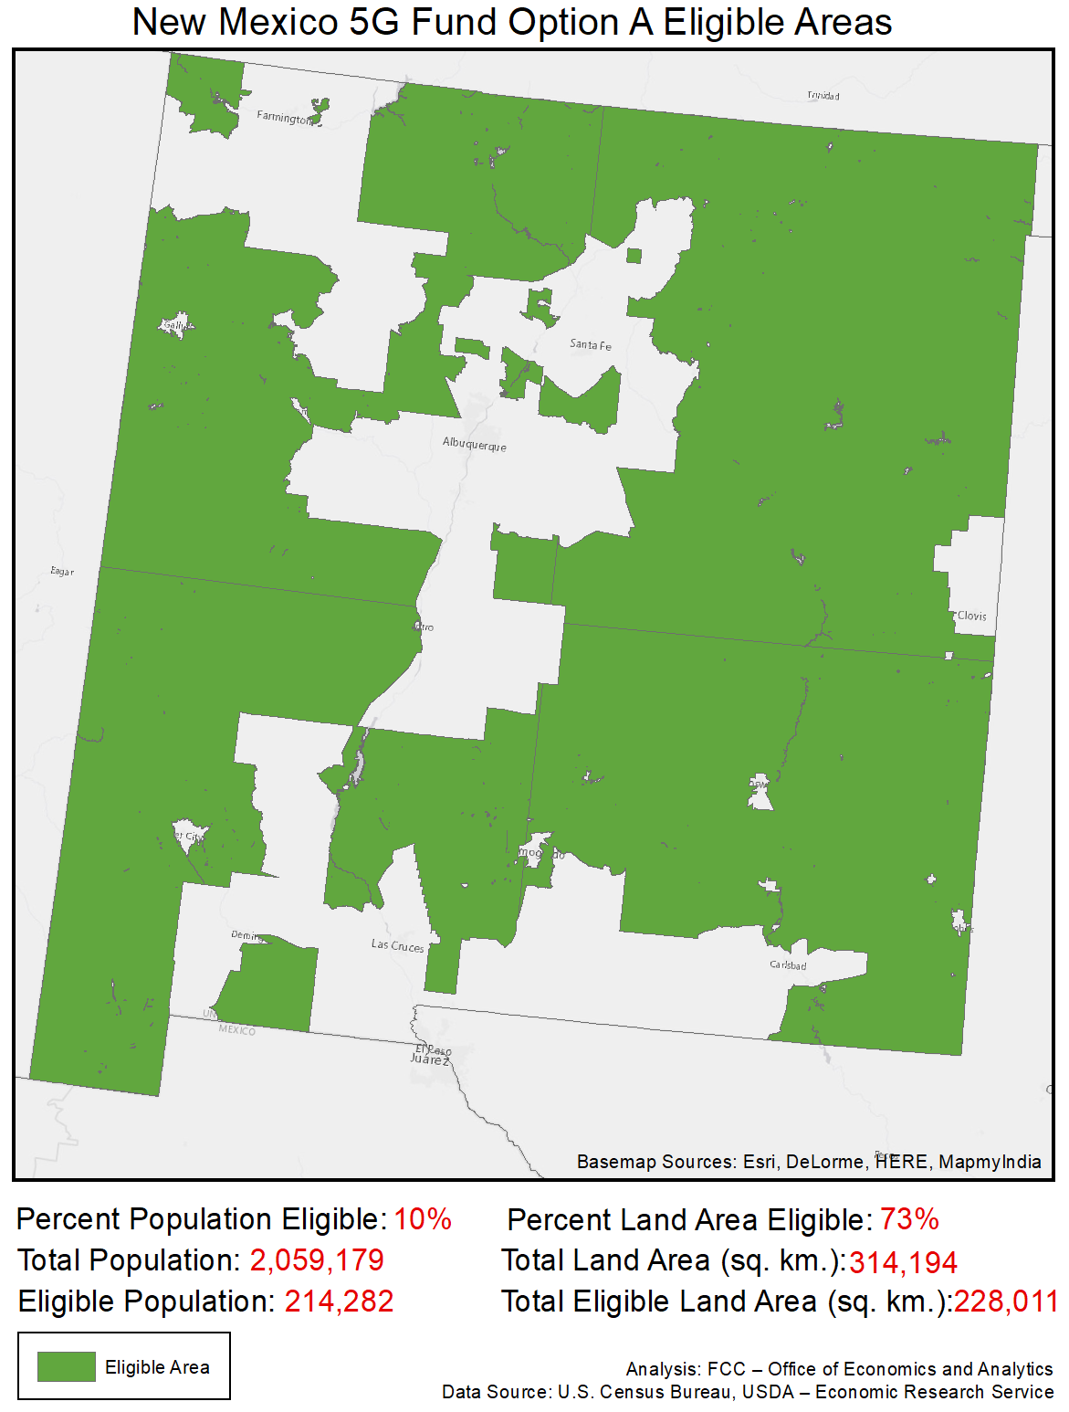

New York
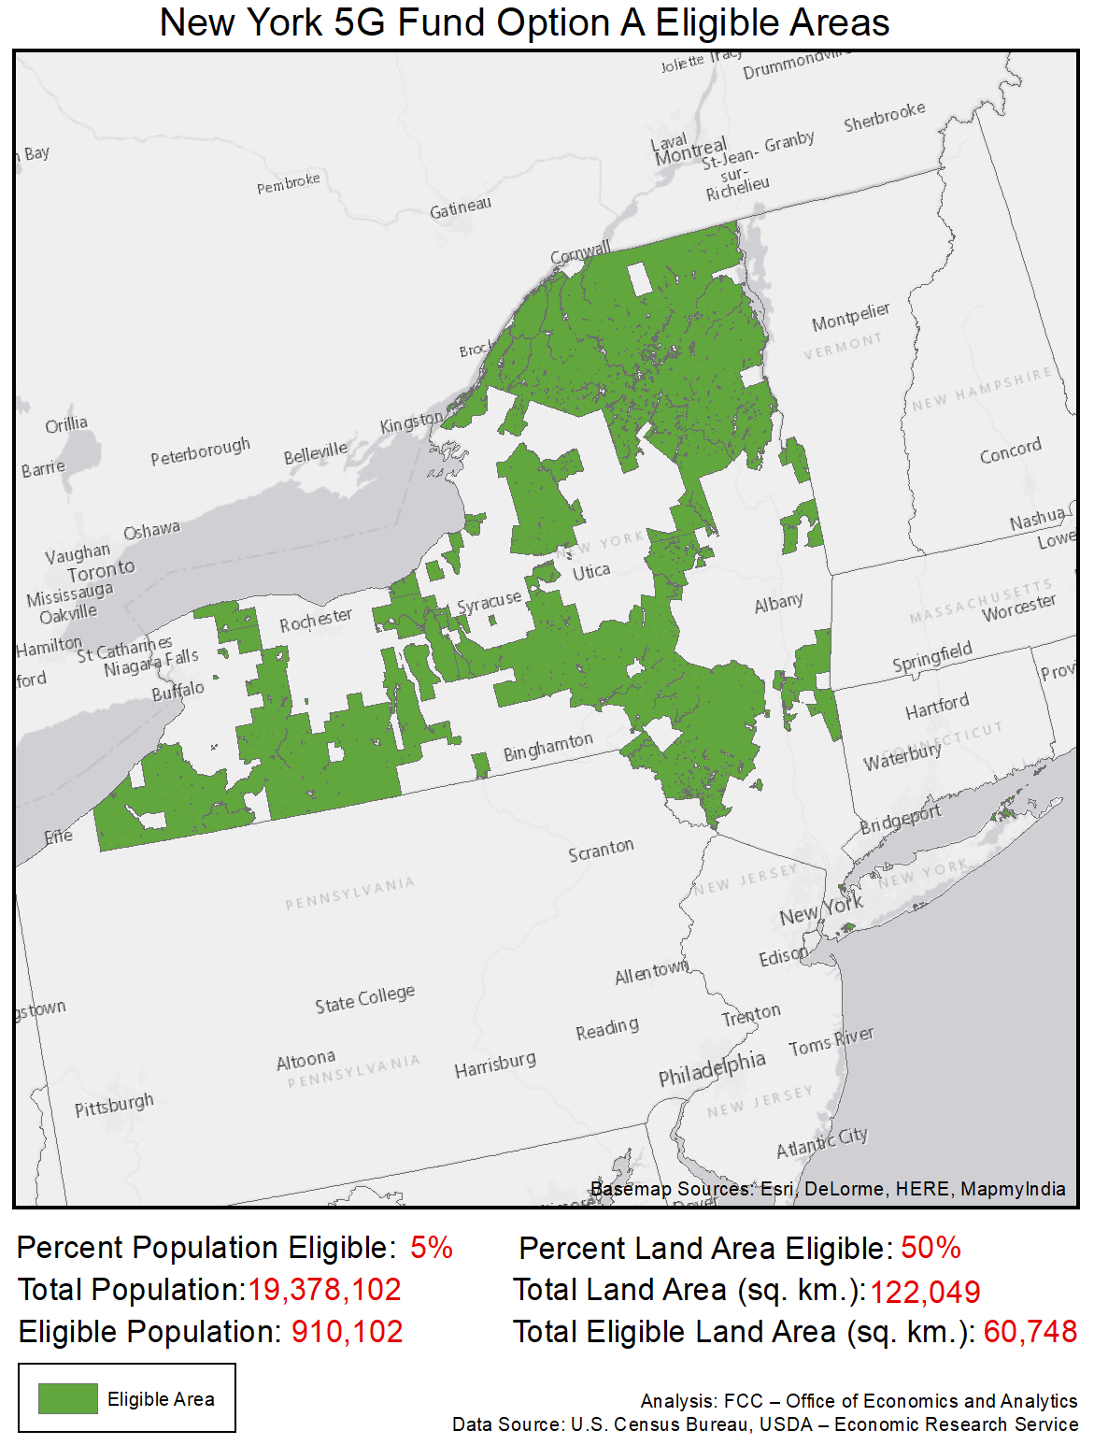

North Carolina
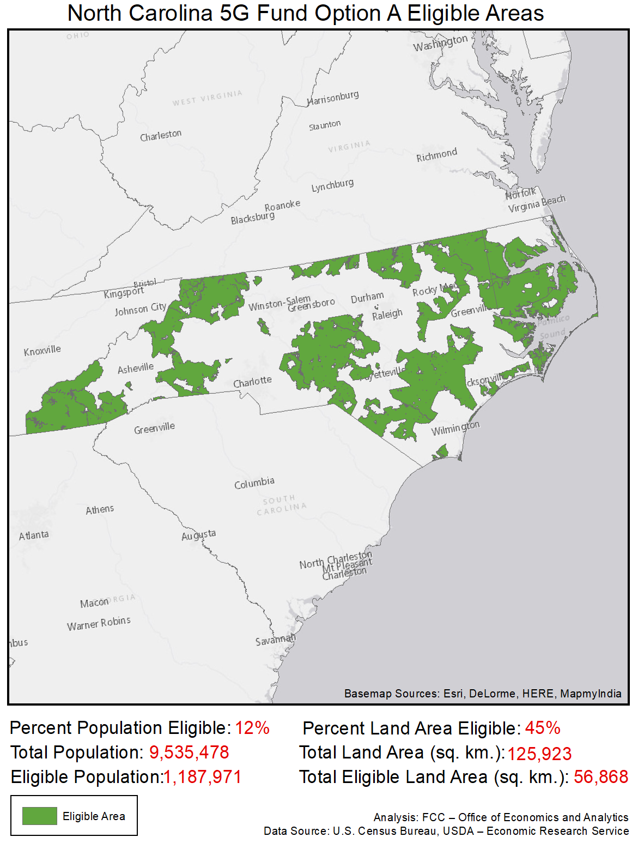

North Dakota
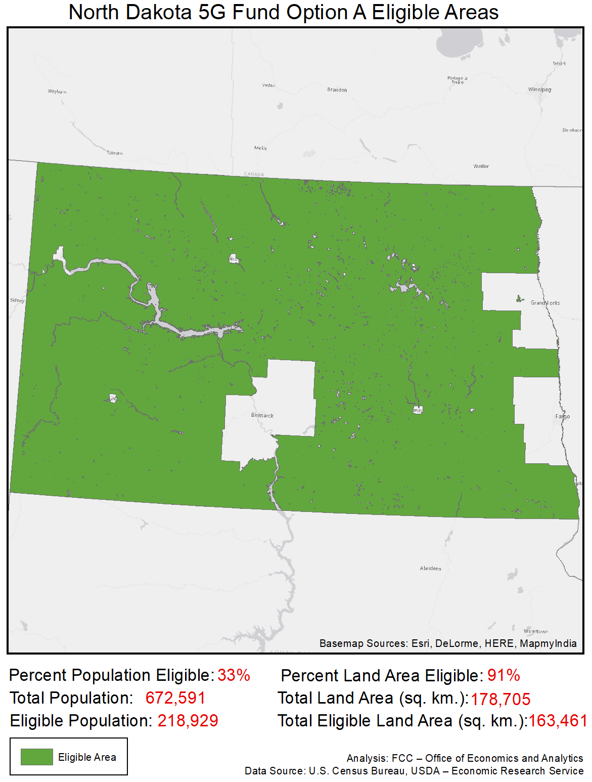

Ohio
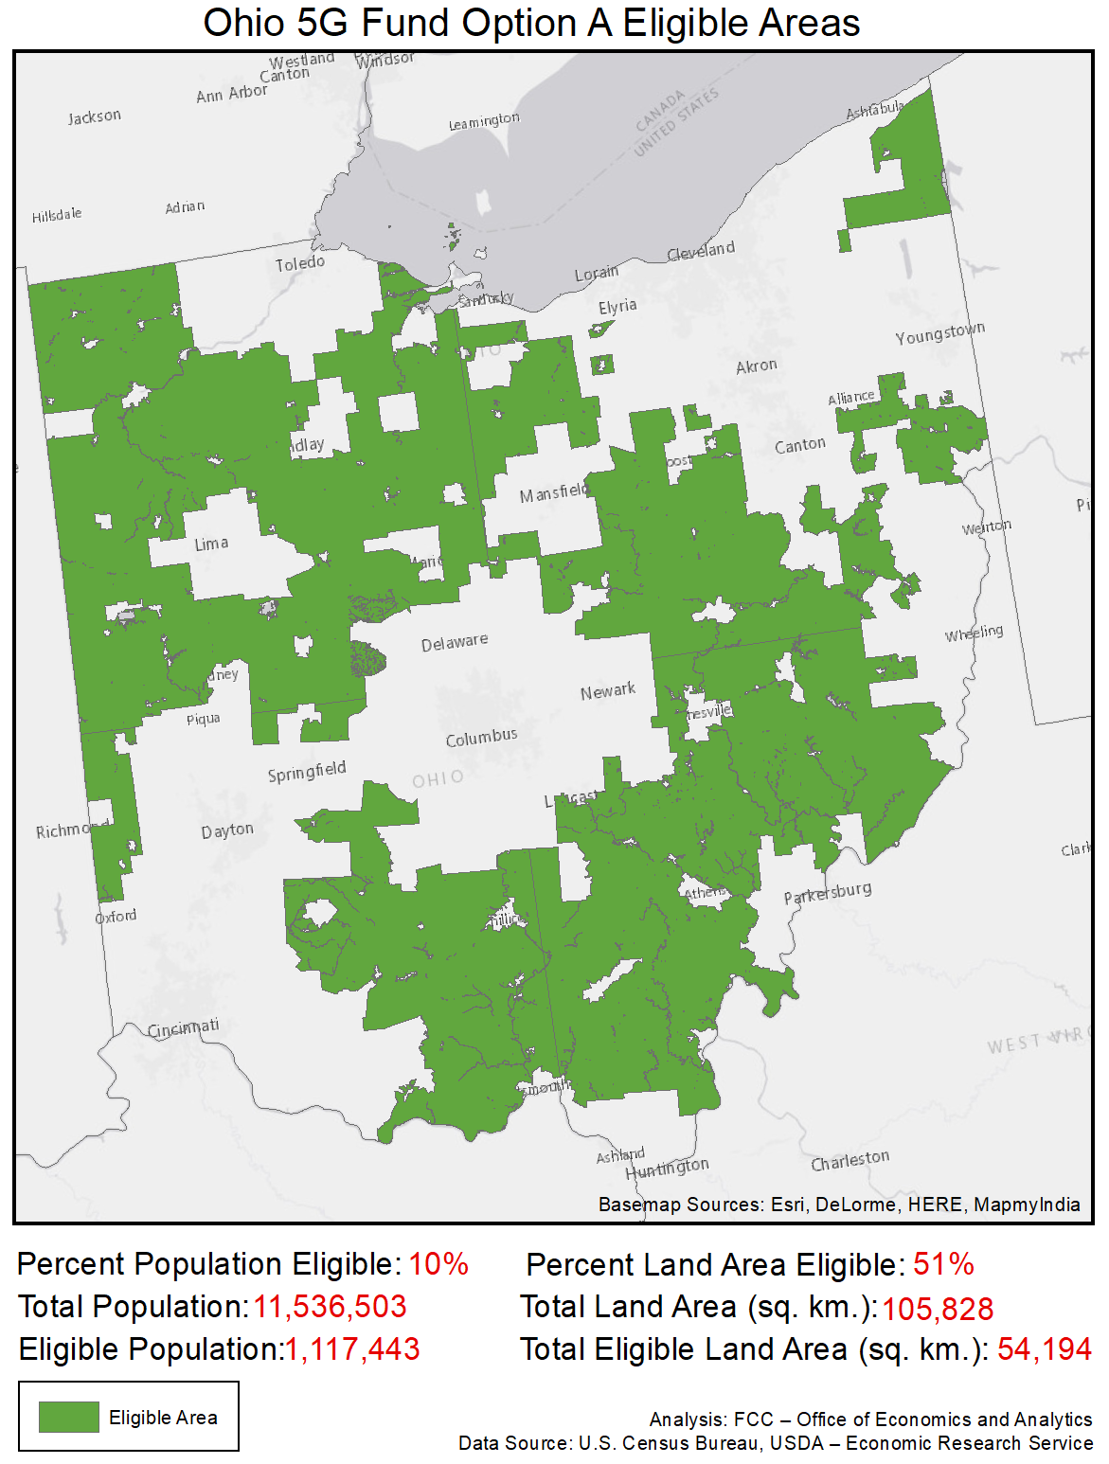

Oklahoma
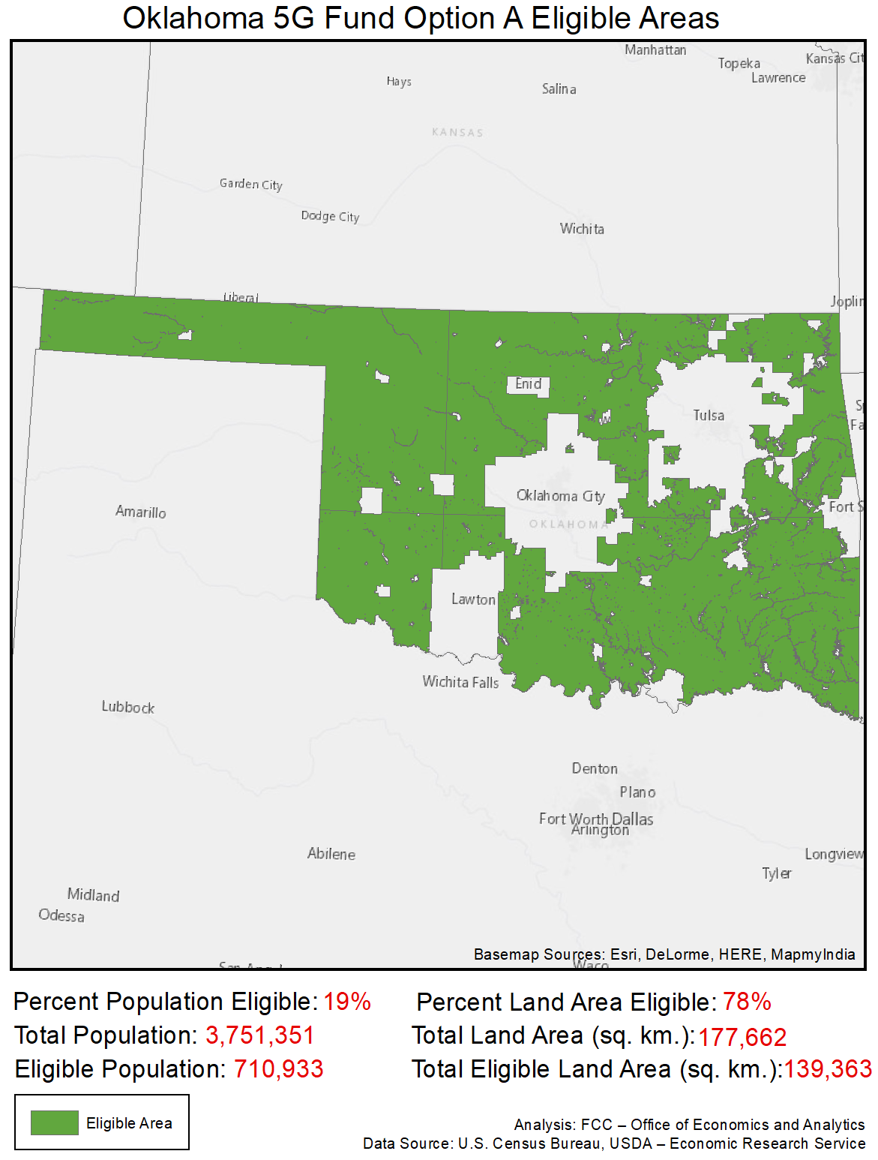

Oregon
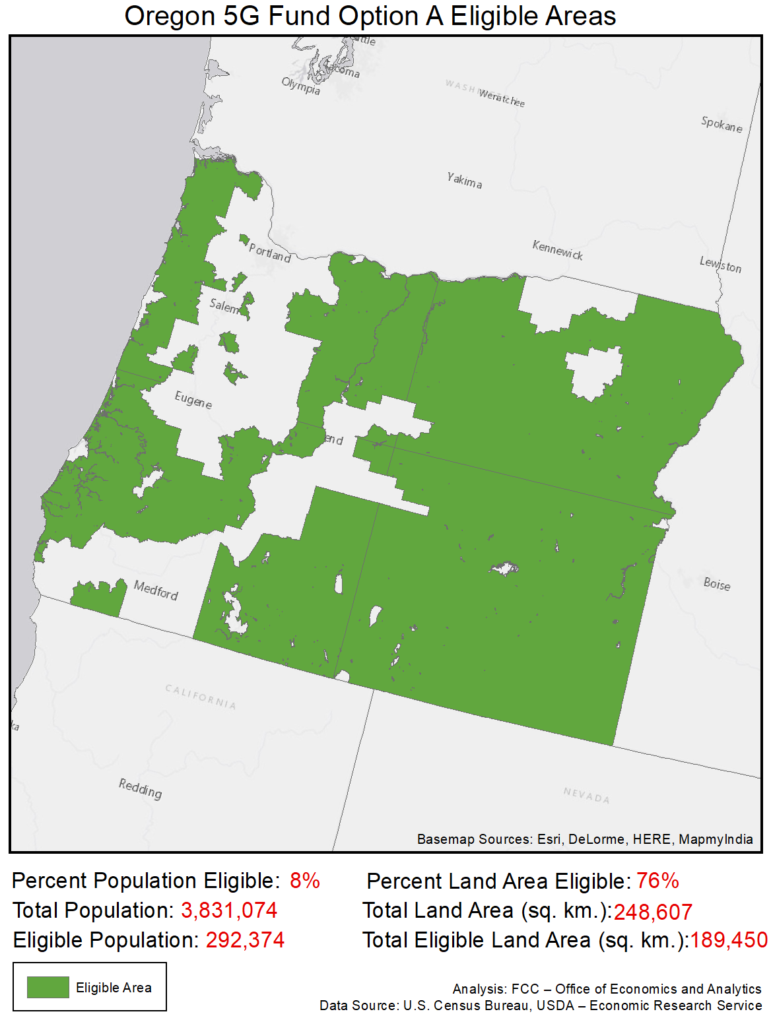

Pennsylvania
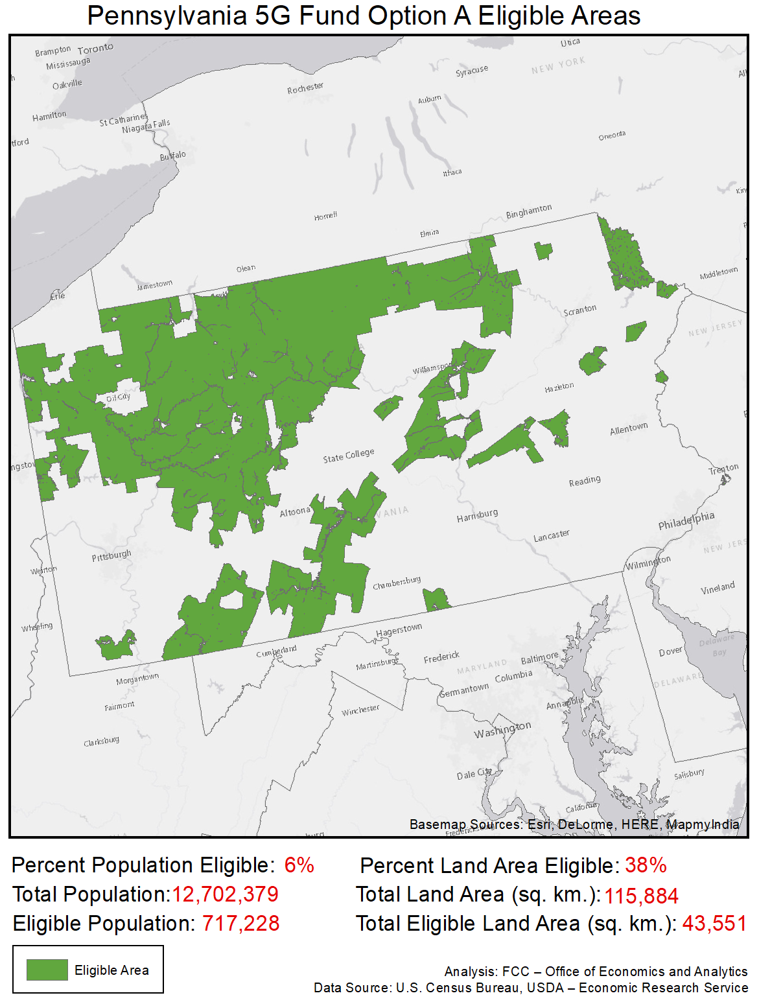

Rhode Island
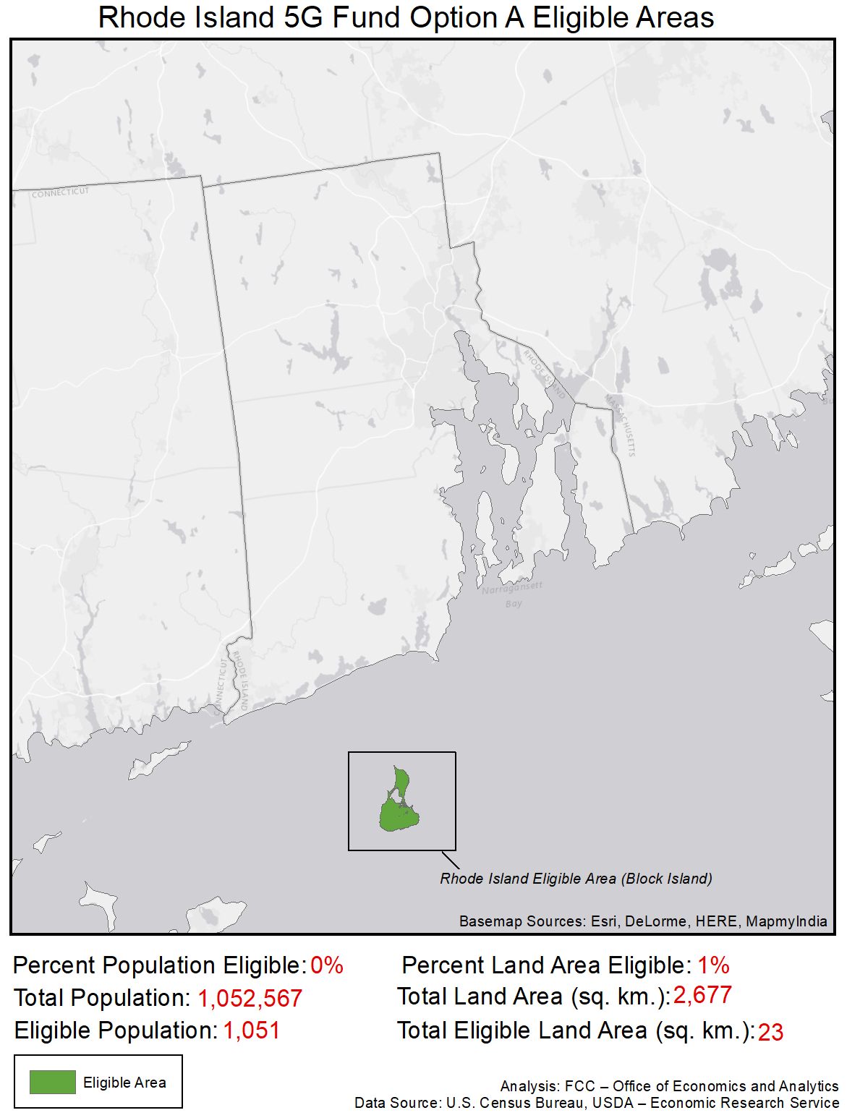

South Carolina
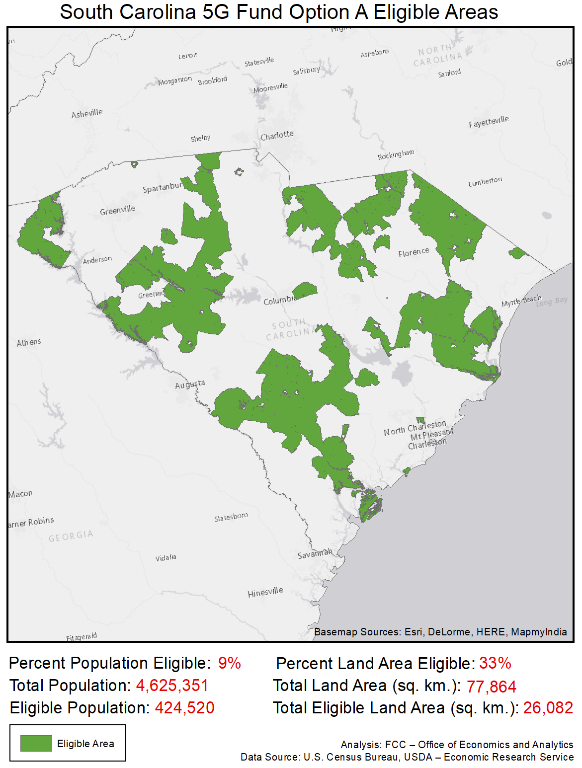

South Dakota
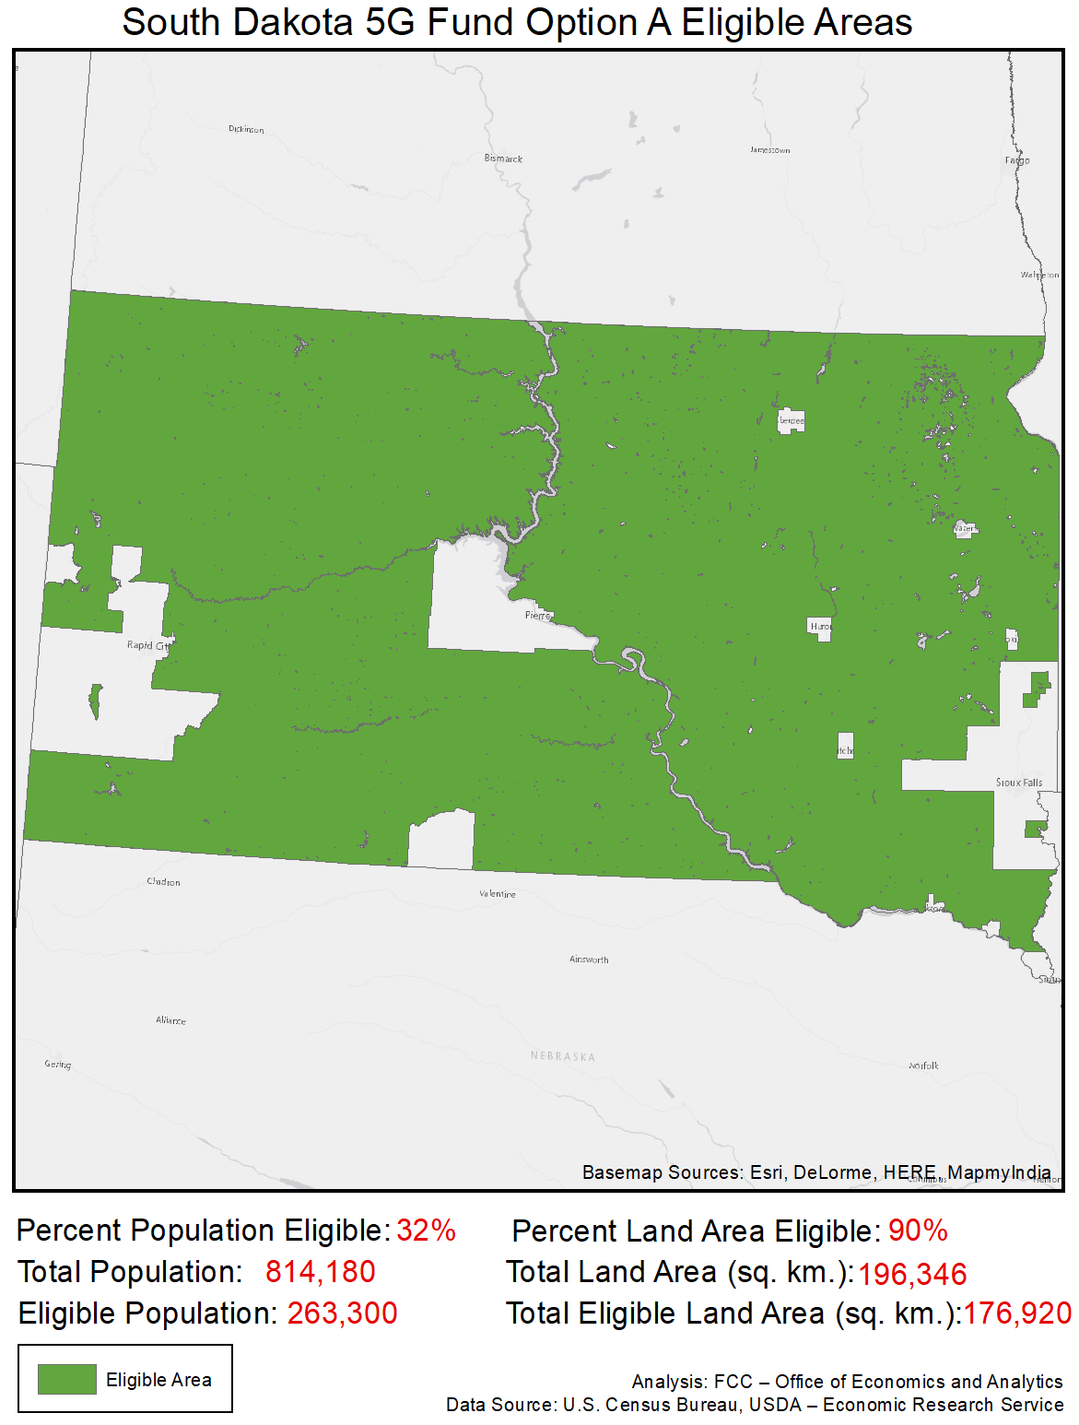

Tennessee
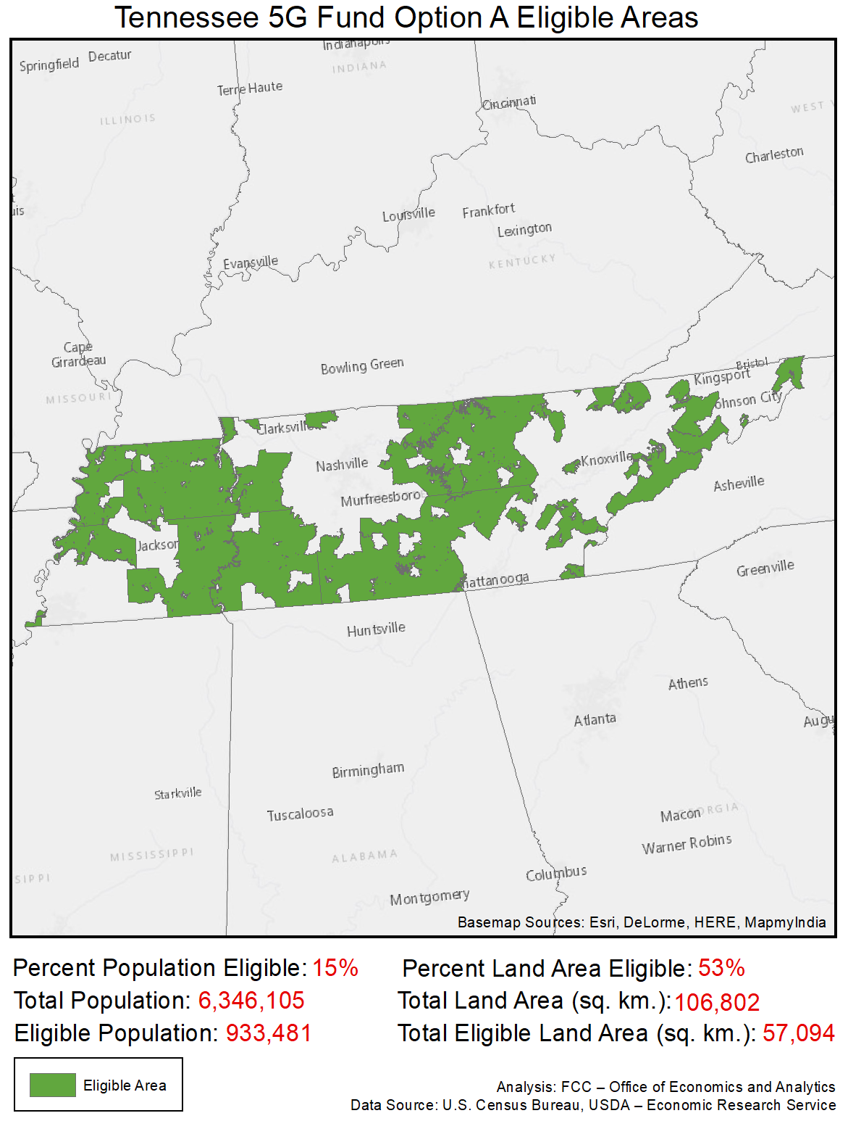

Texas
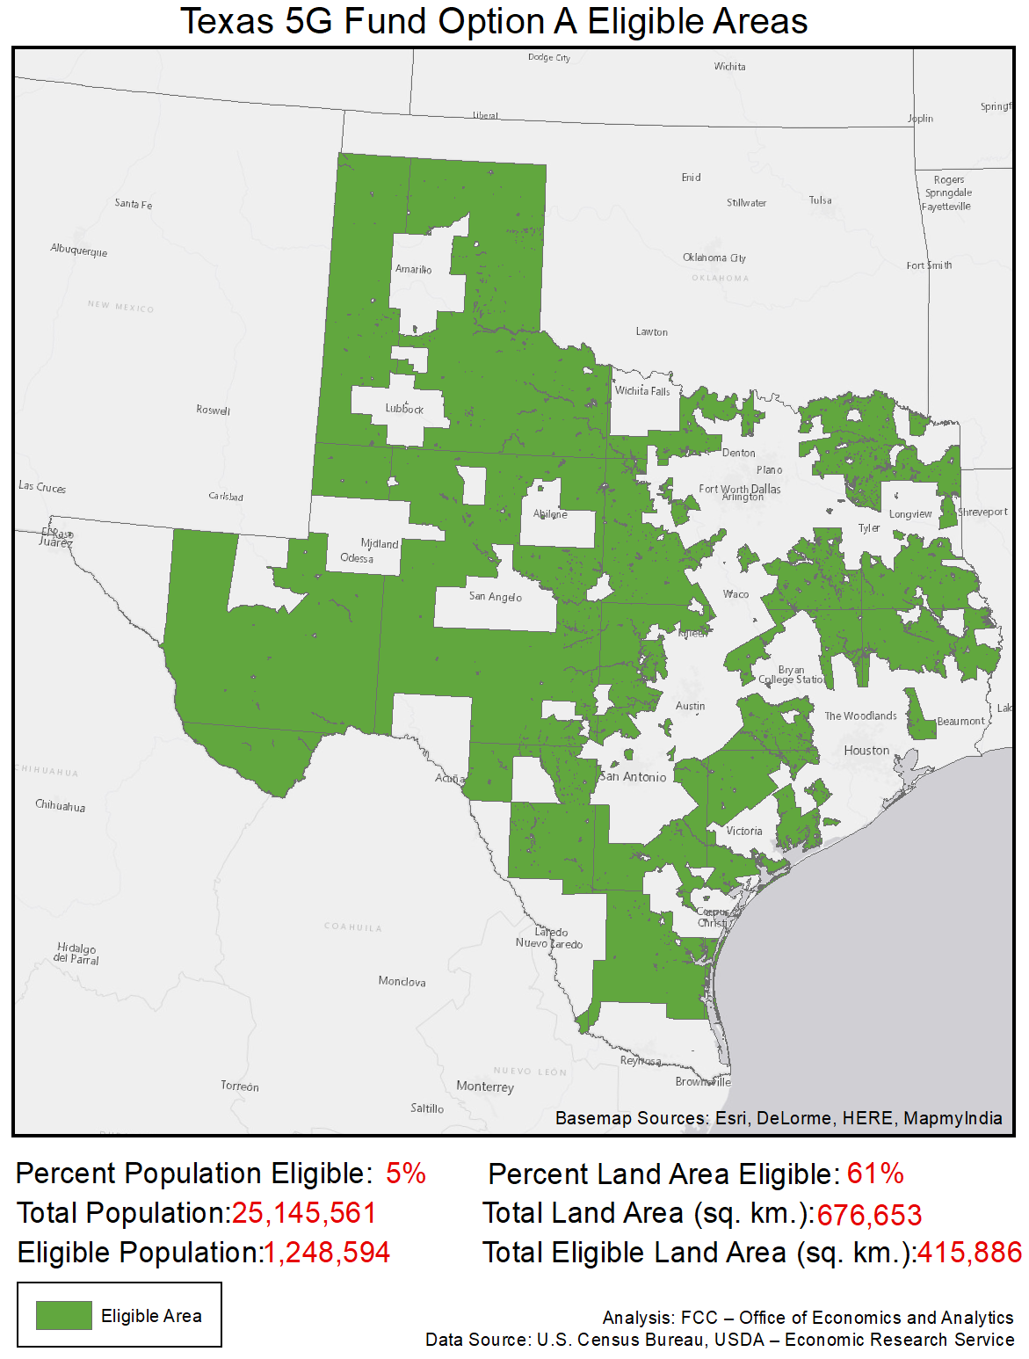

Utah
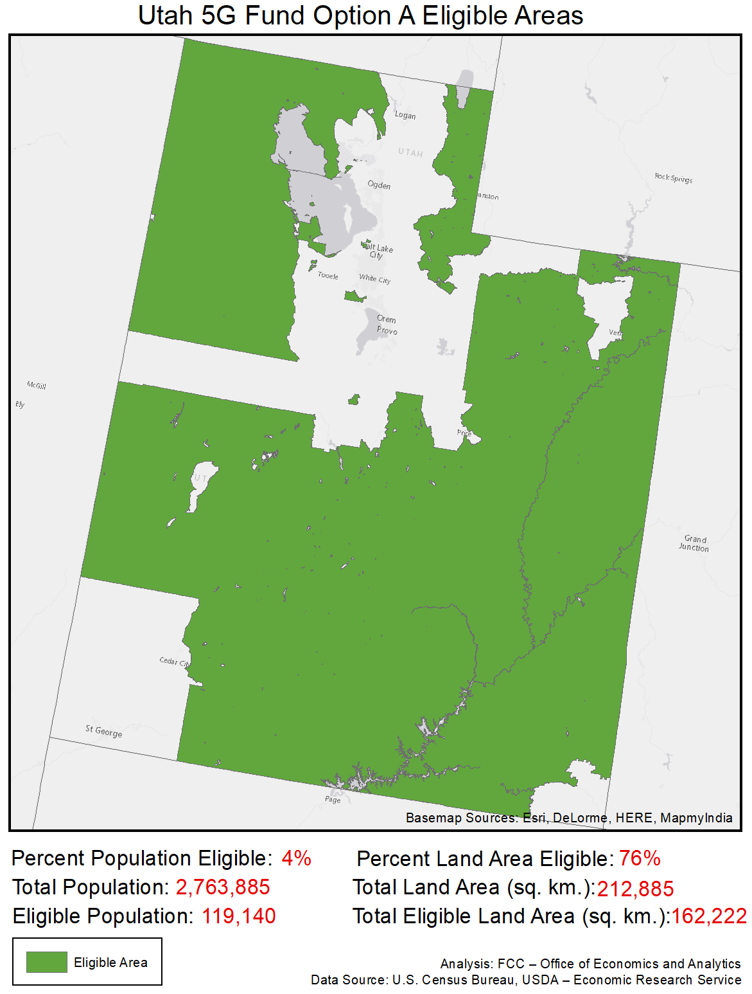

Vermont
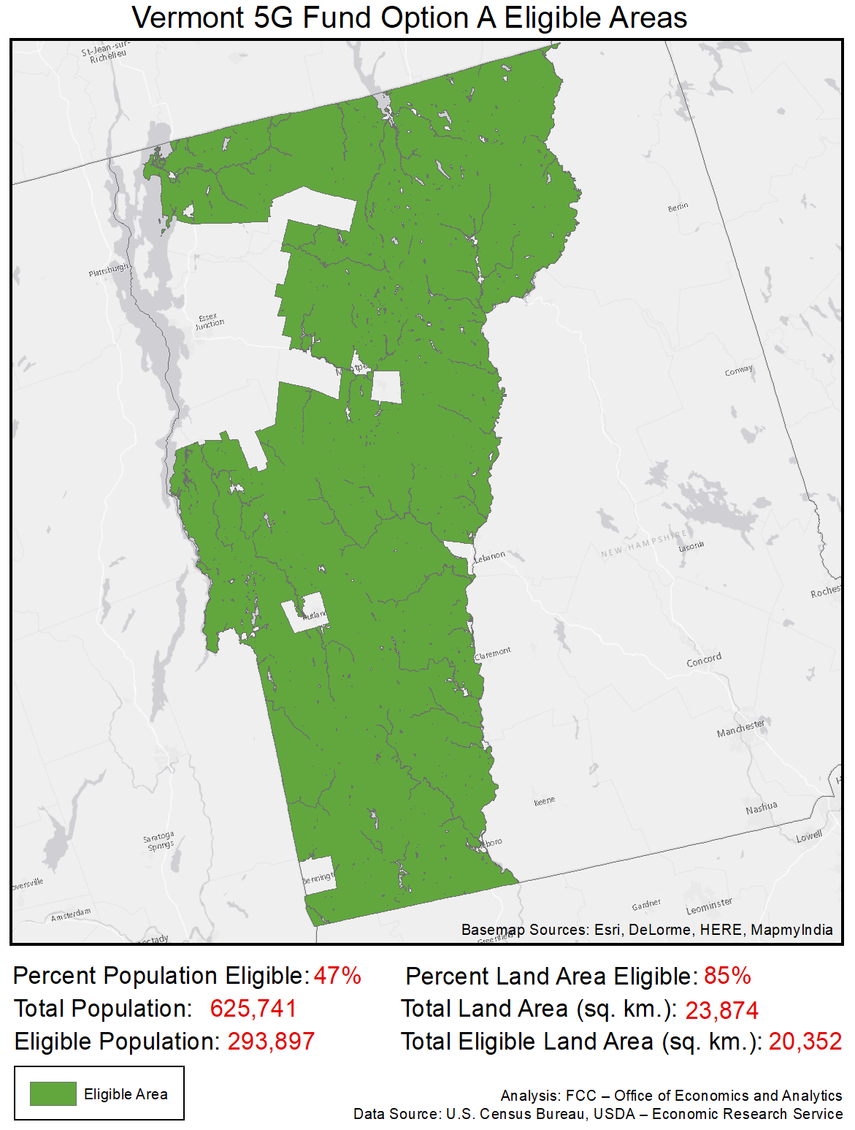

Virginia
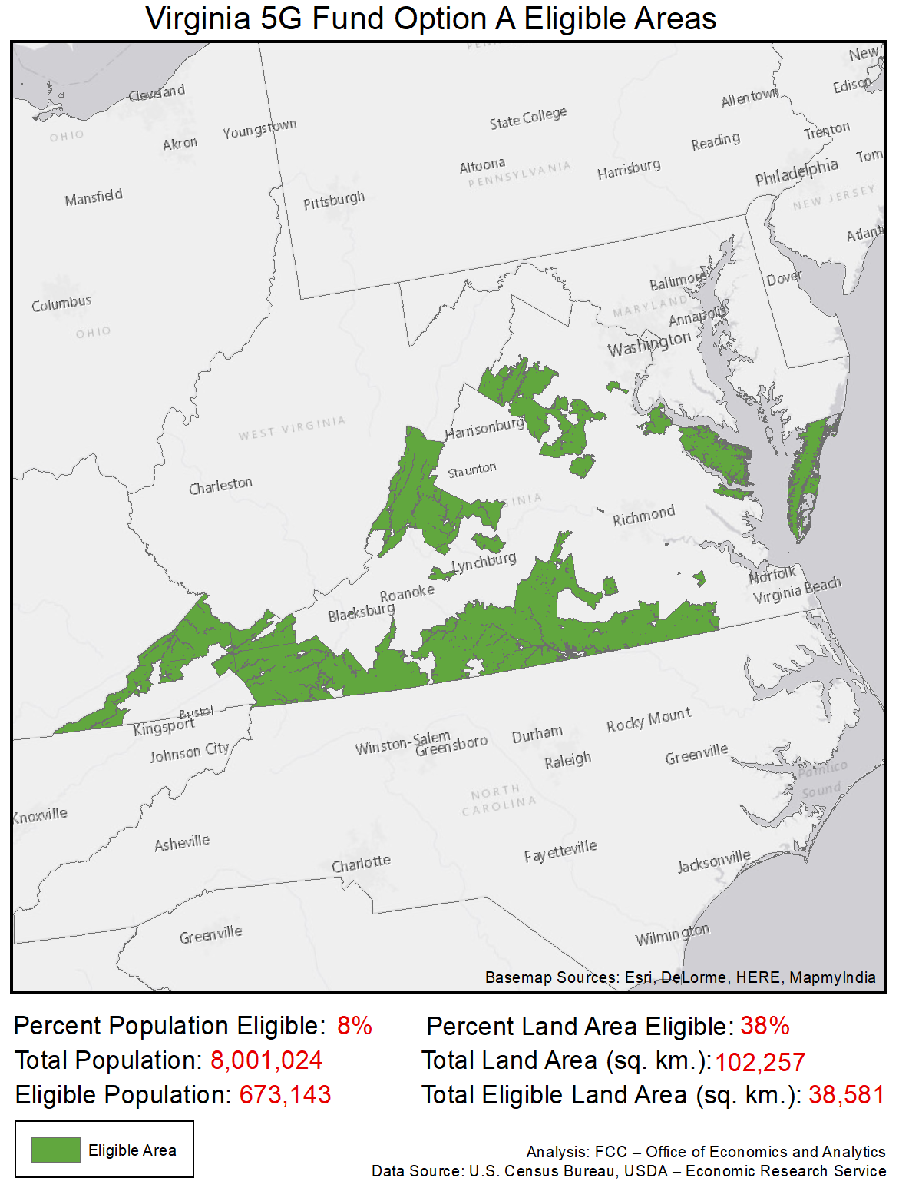

Washington
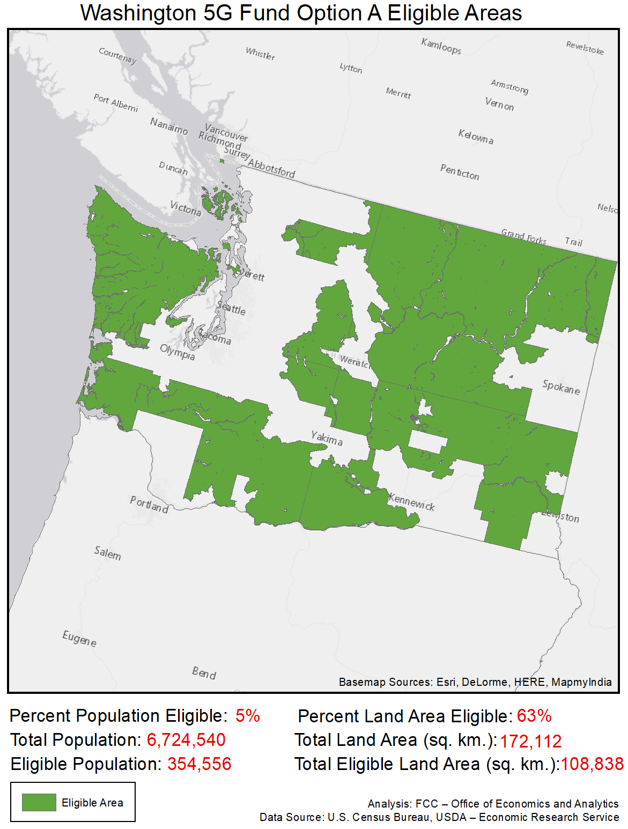

West Virginia
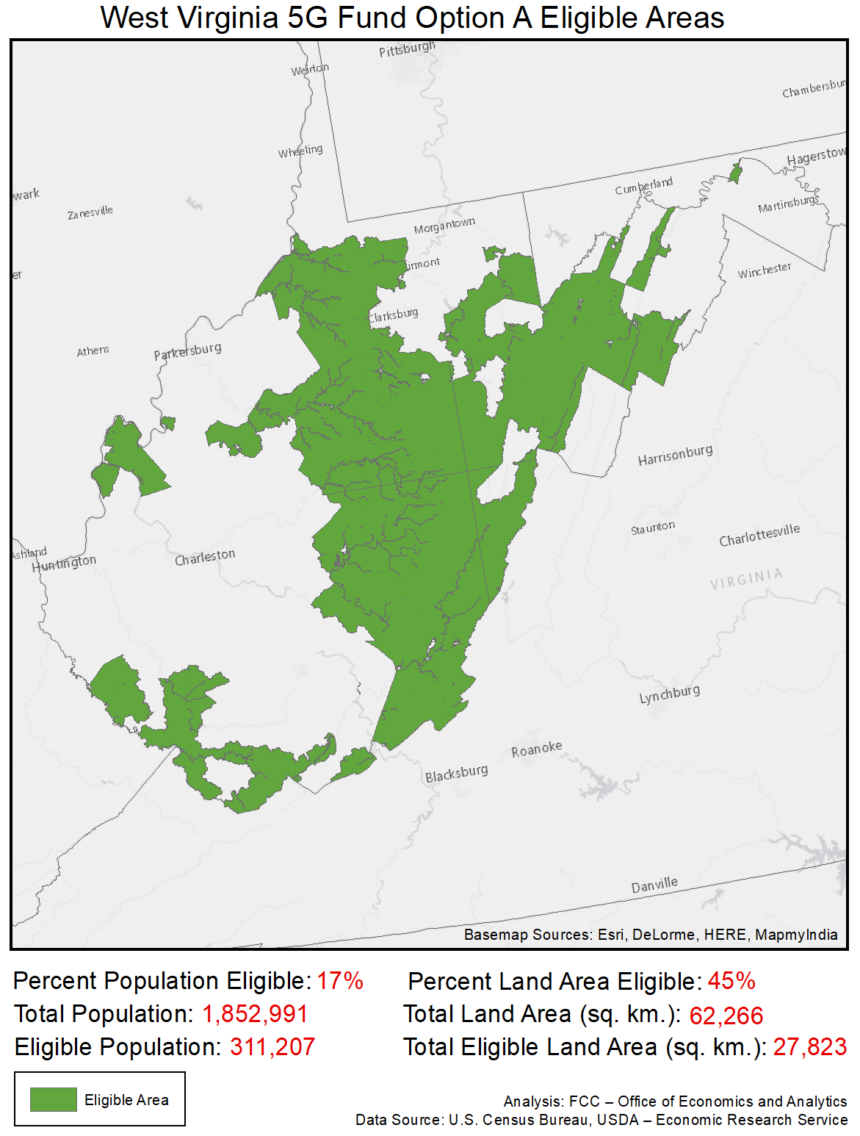

Wisconsin
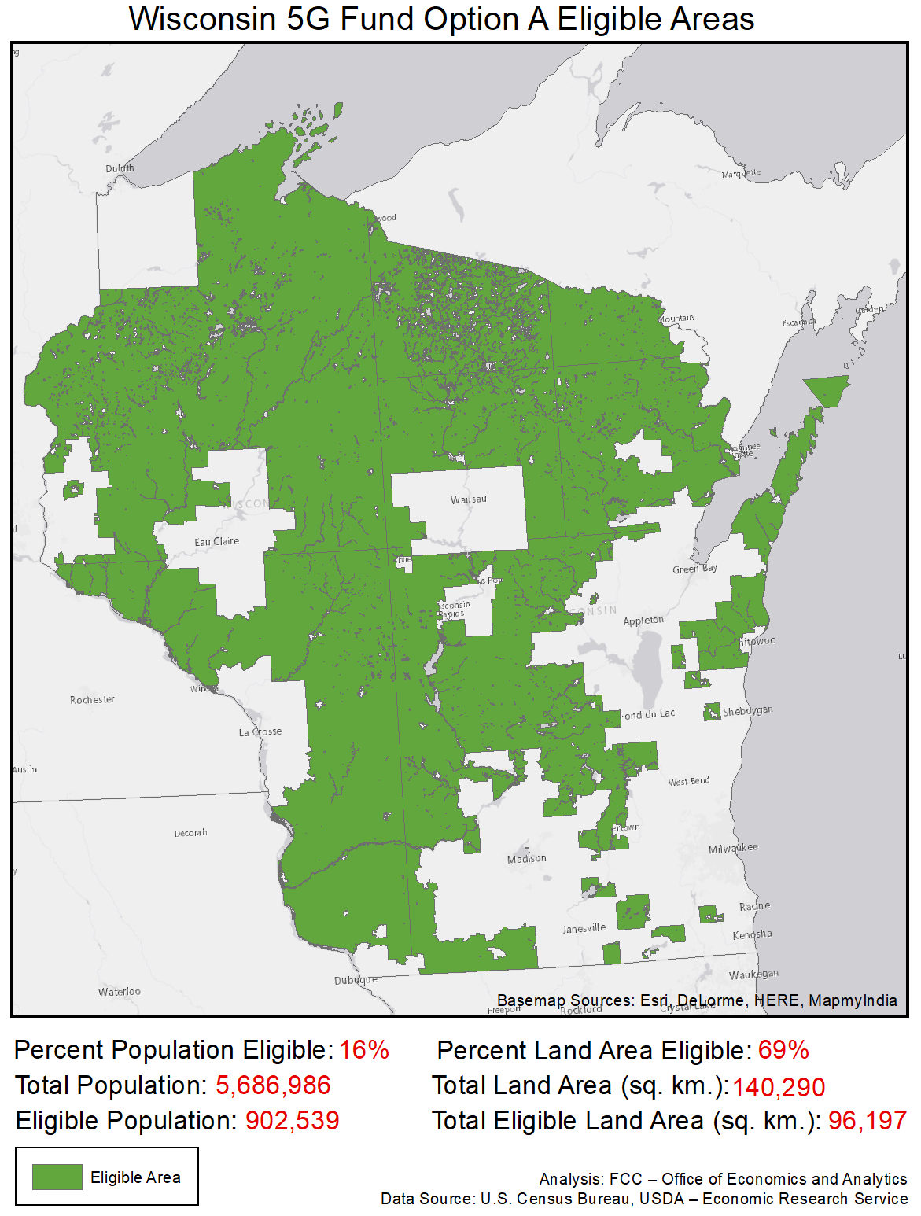

Wyoming
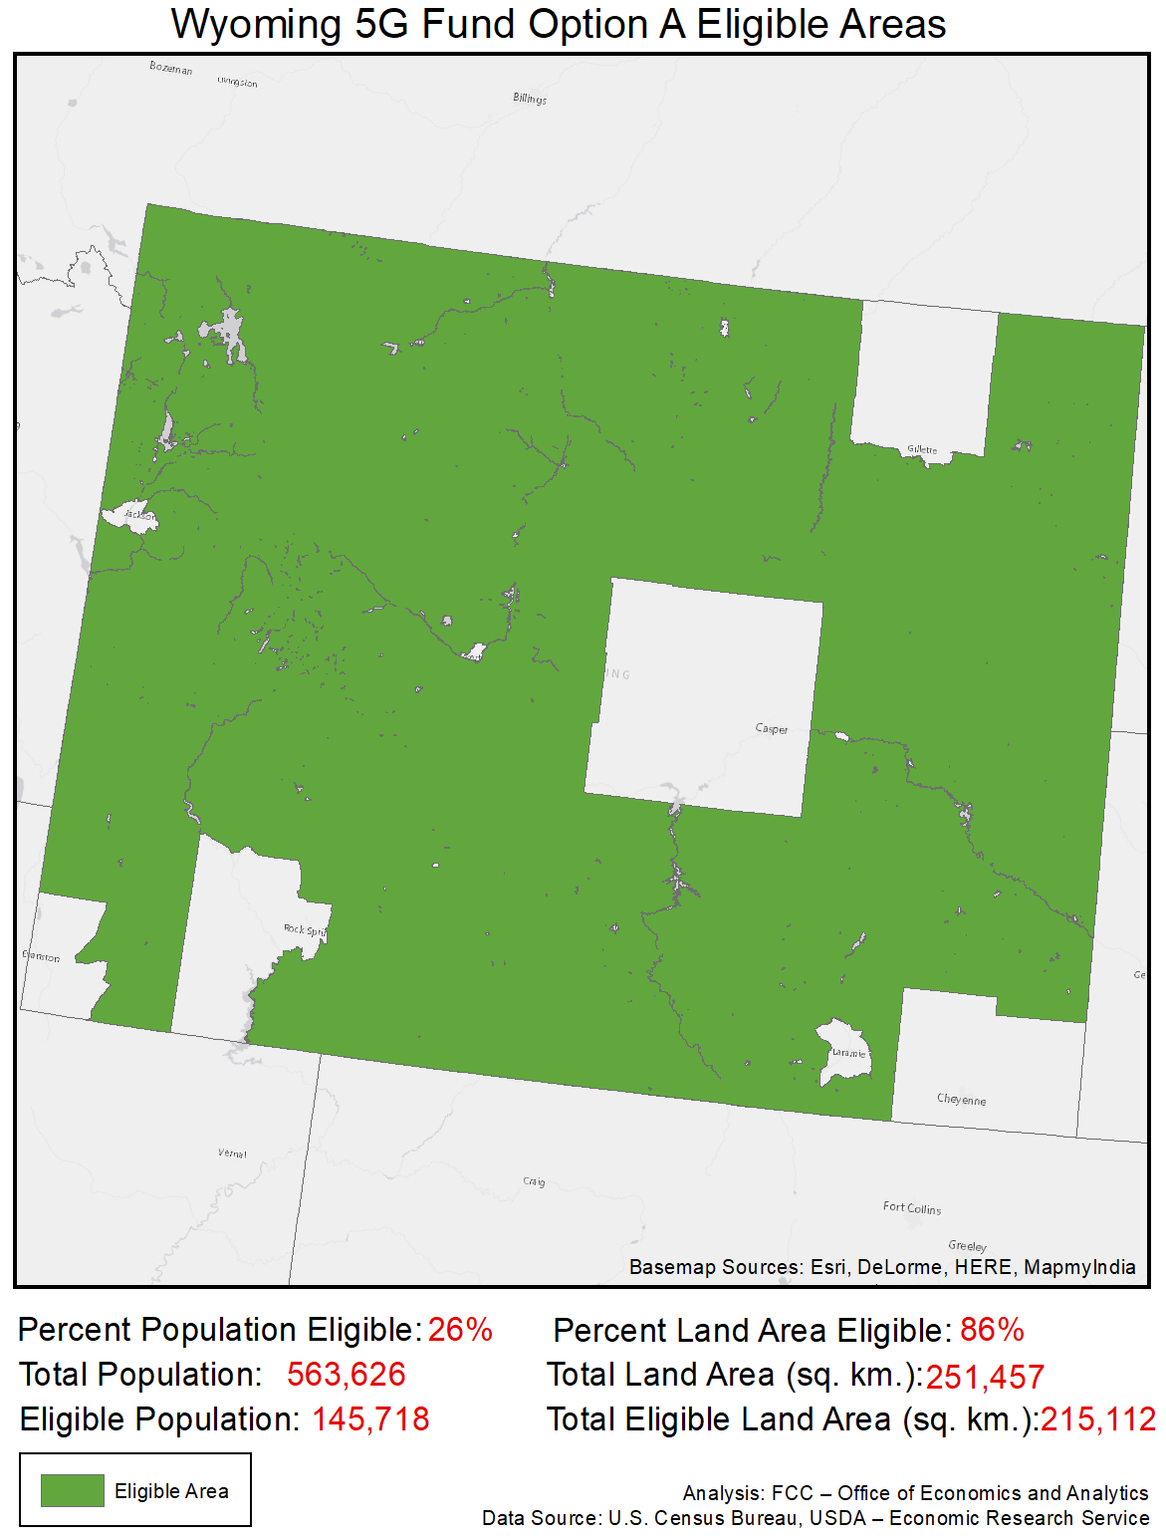

American Samoa
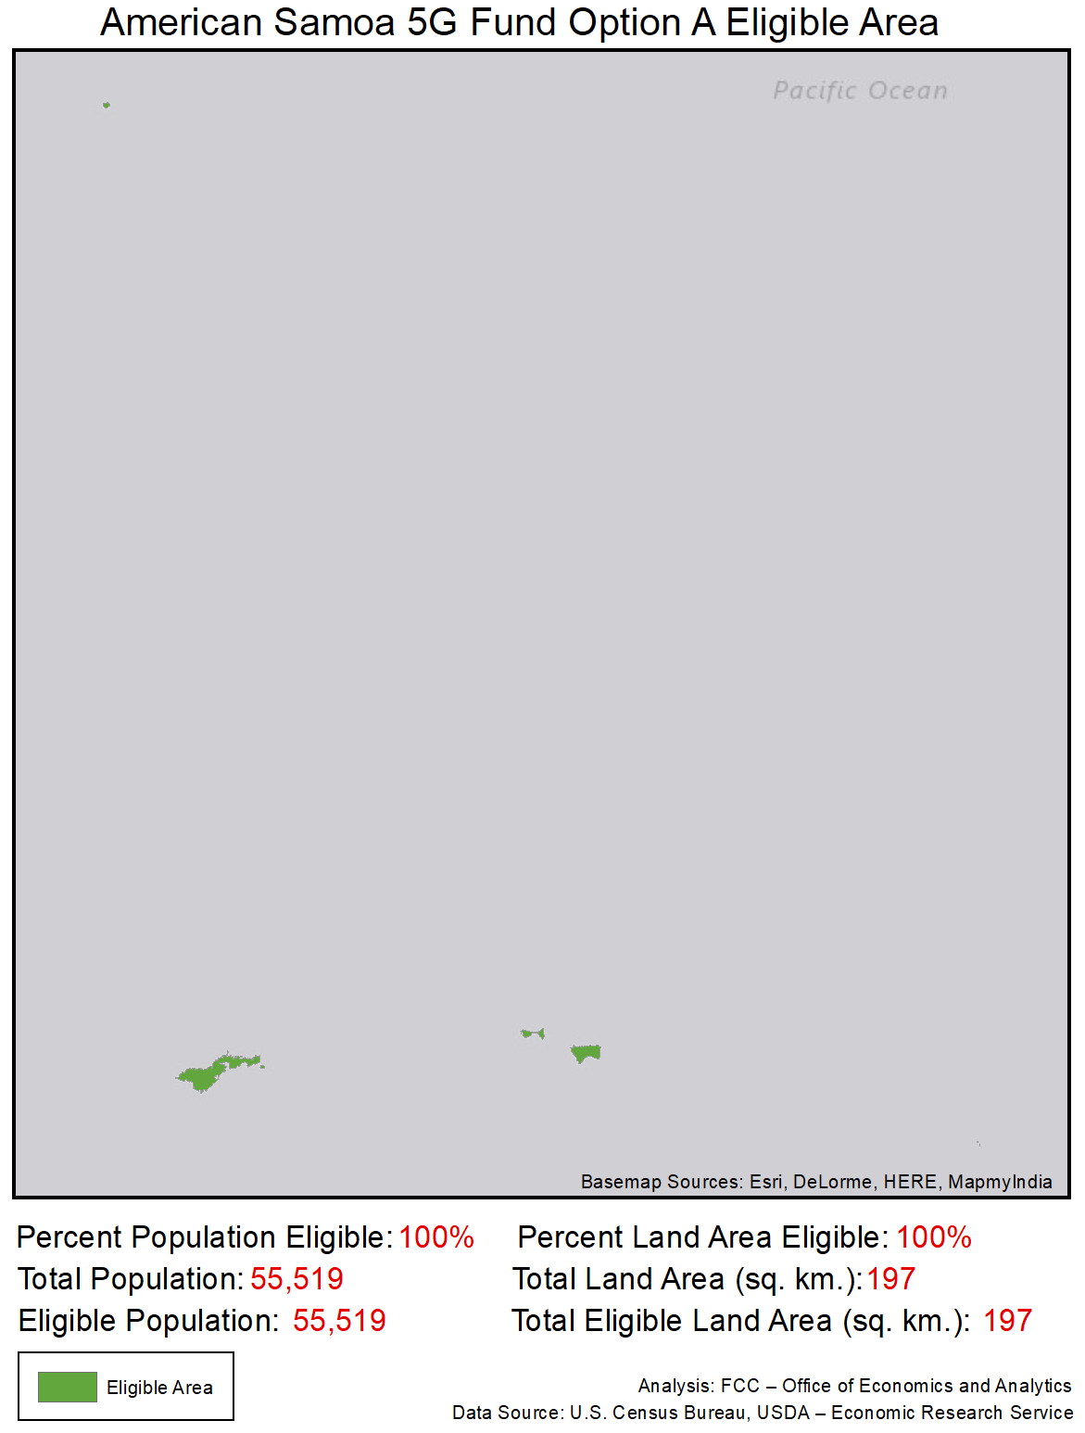

Northern Mariana Islands
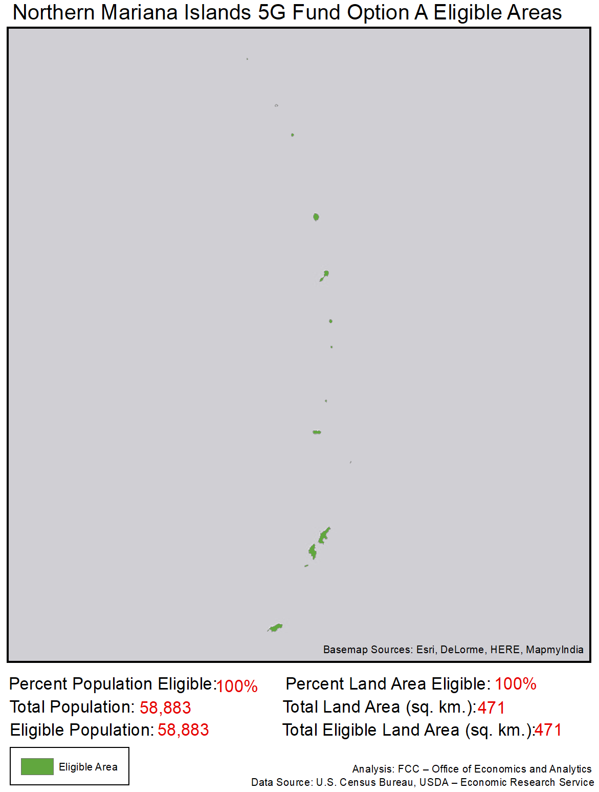

Guam
