NEW FEDERAL COMMUNICATIONS COMMISSION SEAL
In anticipation of the Federal Communications Commission (FCC)’s upcoming move, the agency has adopted a new FCC Seal. The redesigned seal is the product of an agency-wide contest that solicited proposals from Commission employees and contractors. The winning design was submitted by Umasankar Arumugam and selected by a vote of the agency’s employees and contractors.
The revised design incorporates the following elements:
- Communications technologies currently transforming our world;
- Four stars on the outer seal border, drawing from the legacy of the original seal of the Federal Radio Commission, the predecessor agency to the FCC;
- Eighteen stars on the shield, recognizing the current number of Bureaus and Offices; and
- The eagle and shield, identifying the FCC as an agency of the Federal Government.
Over the next few months, the FCC will incorporate the new seal on official stationery, business cards, publications, and other materials, including on its website and throughout its new Headquarters. The Commission will begin official use of this new seal after completion of the move from the Portals to its new Headquarters. The date of the move is to be determined and has been delayed due to COVID-19.

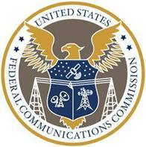

-FCC-

