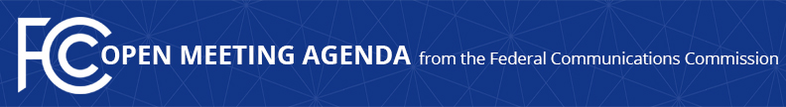

Media Contact:
Will Wiquist, (202) 418-0509
will.wiquist@fcc.gov

For Immediate Release

FCC ANNOUNCES TENTATIVE AGENDA FOR DECEMBER OPEN MEETING
--
WASHINGTON, November 19, 2020—Federal Communications Commission Chairman Ajit Pai announced that the items below are tentatively on the agenda for the December Open Commission Meeting scheduled for Thursday, December 10, 2020:

Securing the Communications Supply Chain – The Commission will consider a Report and Order that would require Eligible Telecommunications Carriers to remove equipment and services that pose an unacceptable risk to the national security of the United States or the security and safety of its people, would establish the Secure and Trusted Communications Networks Reimbursement Program, and would establish the procedures and criteria for publishing a list of covered communications equipment and services that must be removed. (WC Docket No. 18-89)

National Security Matter – The Commission will consider a national security matter.

National Security Matter – The Commission will consider a national security matter.

Allowing Earlier Equipment Marketing and Importation Opportunities – The Commission will consider a Notice of Proposed Rulemaking that would propose updates to its marketing and importation rules to permit, prior to equipment authorization, conditional sales of radiofrequency devices to consumers under certain circumstances and importation of a limited number of radiofrequency devices for certain pre-sale activities. (ET Docket No. 20-382)

Promoting Broadcast Internet Innovation Through ATSC 3.0 – The Commission will consider a Report and Order that would modify and clarify existing rules to promote the deployment of Broadcast Internet services as part of the transition to ATSC 3.0. (MB Docket No. 20-145)

The FCC publicly releases the draft text of each item expected to be considered at the next Open Commission Meeting. Drafts of items under consideration that involve specific national security or enforcement-related matters will not be publicly released. One-page cover sheets are included in the public drafts to help summarize each item. All these materials will be available on the FCC’s Open Meeting page: www.fcc.gov/openmeeting.

###
Media Relations: (202) 418-0500 / ASL: (844) 432-2275 / Twitter: @FCC / www.fcc.gov

This is an unofficial announcement of Commission action. Release of the full text of a Commission order constitutes official action. See MCI v. FCC, 515 F.2d 385 (D.C. Cir. 1974).

