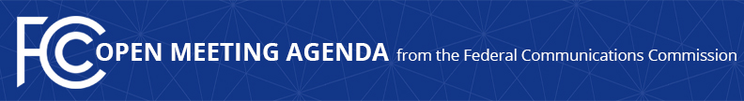

Media Contact:
Will Wiquist, (202) 418-0509
will.wiquist@fcc.gov

For Immediate Release

FCC ANNOUNCES TENTATIVE AGENDA FOR JANUARY OPEN MEETING
--
WASHINGTON, December 23, 2020—Federal Communications Commission Chairman Ajit Pai announced the tentative agenda for the January Open Commission Meeting scheduled for Wednesday, January 13, 2021. Bureau, Office, and Task Force leaders will summarize the work their teams have done over the last four years in a series of presentations:

Panel One – The Commission will hear presentations from the Wireless Telecommunications Bureau, International Bureau, Office of Engineering and Technology, and Office of Economics and Analytics.

Panel Two – The Commission will hear presentations from the Wireline Competition Bureau and the Rural Broadband Auctions Task Force.

Panel Three – The Commission will hear presentations from the Media Bureau and the Incentive Auction Task Force.

Panel Four – The Commission will hear presentations from the Consumer and Governmental Affairs Bureau, Enforcement Bureau, and Public Safety and Homeland Security Bureau.

Panel Five – The Commission will hear presentations from the Office of Communications Business Opportunities, Office of Managing Director, and Office of General Counsel.

All Open Meeting materials will become available and be archived on the FCC’s Open Meeting page: www.fcc.gov/openmeeting.

###
Media Relations: (202) 418-0500 / ASL: (844) 432-2275 / Twitter: @FCC / www.fcc.gov

This is an unofficial announcement of Commission action. Release of the full text of a Commission order constitutes official action. See MCI v. FCC, 515 F.2d 385 (D.C. Cir. 1974).

