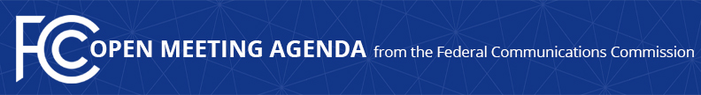

Media Contact:
Will Wiquist, (202) 418-0509
will.wiquist@fcc.gov

For Immediate Release

FCC ANNOUNCES TENTATIVE AGENDA FOR MAY OPEN MEETING
--
WASHINGTON, April 29, 2021—Federal Communications Commission Acting Chairwoman Jessica Rosenworcel announced that the items below are tentatively on the agenda for the May Open Commission Meeting scheduled for Thursday, May 20, 2021:

Reducing Interstate Rates and Charges for Incarcerated People – The Commission will consider a Third Report and Order, Order on Reconsideration, and Fifth Notice of Proposed Rulemaking that, among other actions, will lower interstate rates and charges for the vast majority of incarcerated people, limit international rates for the first time, and seek comment on further reforms to the Commission’s calling services rules, including for incarcerated people with disabilities. (WC Docket No. 12-375)

Strengthening Support for Video Relay Service – The Commission will consider a Notice of Proposed Rulemaking and Order to set Telecommunications Relay Services (TRS) Fund compensation rates for video relay service (VRS). (CG Docket Nos. 03-123, 10-51)

Shortening STIR/SHAKEN Extension for Small Providers Likely to Originate Robocalls – The Commission will consider a Further Notice of Proposed Rulemaking to fight illegal robocalls by proposing to accelerate the date by which small voice service providers that originate an especially large amount of call traffic must implement the STIR/SHAKEN caller ID authentication framework. (WC Docket No. No 17-97)

Section 214 Petition for Partial Reconsideration for Mixed USF Support Companies – The Commission will consider an Order on Reconsideration to relieve certain affiliates of merging companies that receive model-based and rate-of-return universal service support from a “mixed support” merger condition cap. (WC Docket No. 20-389)

Enforcement Bureau Action – The Commission will consider an enforcement action.

Enforcement Bureau Action – The Commission will consider an enforcement action.

The FCC publicly releases the draft text of each item expected to be considered at the next Open Commission Meeting. Drafts of items under consideration that involve specific, enforcement-related matters will not be publicly released. One-page cover sheets are included in the public drafts to help summarize each item. All these materials will be available on the FCC’s Open Meeting page: www.fcc.gov/openmeeting.

###
Media Relations: (202) 418-0500 / ASL: (844) 432-2275 / Twitter: @FCC / www.fcc.gov

This is an unofficial announcement of Commission action. Release of the full text of a Commission order constitutes official action. See MCI v. FCC, 515 F.2d 385 (D.C. Cir. 1974).

