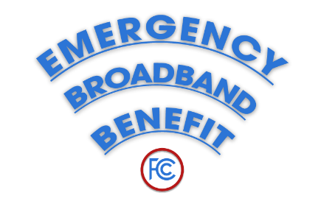
Program Contact:
Emergency Broadband Benefit Support Center
GetEmergencyBroadband.org
(833) 511-0311

FACT SHEET: The Emergency Broadband Benefit
How Does This Temporary Consumer Broadband & Computer Discount Work?
--
Starting on May 12, 2021, the FCC’s Emergency Broadband Benefit will make available to consumers substantial discounts on broadband service and computers. This pandemic-related program will continue until the $3.2 billion in federal funding runs out or six months after the Department of Health and Human Services declares an end to the pandemic.

The Emergency Broadband Benefit Program
- Funding - Congress dedicated $3.2 billion to the Emergency Broadband Benefit.
- Discounts – eligible households can receive discounts off monthly broadband service:
- Up to $50 per month for eligible households
- Up to $75 per month for households on qualifying Tribal lands.
- One-time discount of up to $100 to purchase a laptop, desktop computer, or tablet from participating providers if they contribute more than $10 and less than $50 toward the purchase price.
Please Note: This will be applied directly to the consumers’ monthly bill. There is a limit of one monthly service discount and one device discount per household.
- Eligibility – if one person in the household:
- Demonstrates low income, at or below 135% of the Federal Poverty level;
- Participates in assistance programs including SNAP, Medicaid, or Lifeline;
- Relies on free and reduced-price school meals;
- Received a Federal Pell Grant during the current award year;
- Suffered a large loss in income during pandemic due to job loss or furlough since February 29, 2020 and the household had a total income in 2020 at or below $99,000 for single filers and $198,000 for joint filers;
- Meets other eligibility criteria for a participating provider's existing low-income or COVID-19 program.
- Providers Near You – Over 825 broadband providers are taking part in the program. The benefit is available to eligible new, prior, and existing customers of participating providers.
- Sign Up – There are 3 ways to sign up:
1) contact a participating provider to sign up;
2) enroll online at www.getemergencybroadband.org; or
3) sign up via mail.
To learn more or get a mail-in application, call (833) 511-0311.
- Temporary – But remember, this is a temporary program. When it ends, participating providers must give notice to customers and inform them of the cost for their plan after the discount ends. Importantly, consumers will need to opt-in to continue with the service.
###
Media Relations: (202) 418-0500 / ASL: (844) 432-2275 / Twitter: @FCC / www.fcc.gov

This is an unofficial announcement of Commission action. Release of the full text of a Commission order constitutes official action. See MCI v. FCC, 515 F.2d 385 (D.C. Cir. 1974).

