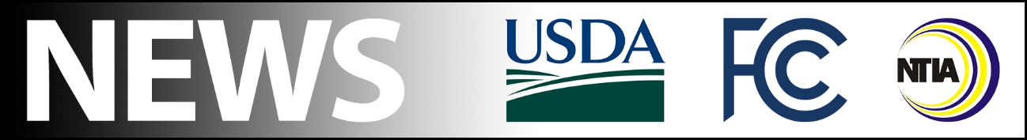

FCC Media Contact:
Paloma Perez
Paloma.perez@fcc.gov

NTIA Media Contact:
Stephen Yusko
syusko@ntia.gov

USDA Media Contact:
Jacqueline Susmann
jacqueline.susmann@usda.gov

For Immediate Release

FCC, NTIA AND USDA ANNOUNCE INTERAGENCY AGREEMENT TO COORDINATE BROADBAND FUNDING DEPLOYMENT
Agency Leaders Sign Pact to Formalize Information Sharing to Best Deploy Federal Broadband Funds
--
WASHINGTON, June 25, 2021—The Federal Communications Commission (FCC), the U.S. Department of Agriculture (USDA) and the National Telecommunications and Information Administration (NTIA), today announced an interagency agreement to share information about and coordinate the distribution of federal broadband deployment funds. In accordance with the Broadband Interagency Coordination Act, enacted as part of the Consolidated Appropriations Act of 2021, the respective Cabinet and agency leaders announced that their agencies will consult with one another and share information about the distribution of new funds from the FCC’s high-cost programs that support broadband buildout in rural areas, the USDA’s Rural Utilities Services grant and loan programs, and programs administered or coordinated by NTIA.

“The last fifteen months demonstrated like never before that broadband is no longer a luxury, but a necessity. Congress rightfully funded broadband deployment at levels we’ve seldom seen in recent years in response to the pandemic,” said FCC Acting Chairwoman Jessica Rosenworcel. “In order to be good stewards of funds supporting these projects, I’m proud to announce with my colleagues that the FCC, NTIA, and USDA will strengthen our coordination to ensure that we make the most effective use of these new funds. I thank Secretary Vilsack and Acting Assistant Secretary Remaley for their leadership and partnership. Working together, we’ll be better able to meet our shared goal of getting 100 percent of Americans connected to the high-speed internet access they need to thrive.”

“Generations ago, the federal government recognized that without affordable access to electricity, Americans couldn’t fully participate in modern society and the modern economy. Broadband internet is the new electricity. It is necessary for Americans to do their jobs, to participate equally in school learning, health care, and to stay connected,” Agriculture Secretary Vilsack said. “This is why, under the leadership of President Biden and Vice President Harris, USDA remains committed to being a strong partner with rural communities and our state and federal partners in building ‘future proof’ broadband infrastructure in unserved and underserved areas so that we finally reach 100 percent high-speed broadband coverage across the country.”

“Access to reliable, affordable high-speed broadband is critical to the economic well-being of communities and small businesses across America. Today’s announcement lays important groundwork for collaboration between agencies to ensure the federal government’s efforts to expand broadband access are as effective and efficient as possible, reaching every corner of the country,” said U.S. Secretary of Commerce Gina M. Raimondo. “President Biden has made it clear that bringing affordable, reliable, high-speed broadband to every American is a priority, and we can make it a reality through the historic investments in the American Jobs Plan. I want to thank Acting Chairwoman Rosenworcel and Secretary Vilsack for their continued leadership on our shared goal of connecting every American and look forward to continuing to work alongside them on this issue.”

As part of the signed agreement, each federal agency partner will share information about existing or planned projects that receive funding from the previously mentioned federal funding sources. Each partner will also, upon request, identify entities providing broadband service in a specified geographic area; the levels of broadband service in that area, including broadband speeds and technologies deployed; the geographic scope of broadband service in that area; and each entity in that area that has or will receive funds from these programs. The Agreement also requires the federal agency partners to consider basing the distribution of funds from the programs on standardized broadband coverage data. More information about what programs will now require explicit coordination among the FCC, NTIA, and USDA can be found at https://go.usa.gov/x6vrN. The agreement is effective at the date of its signing, June 25.

###
Media Relations: (202) 418-0500 / ASL: (844) 432-2275 / Twitter: @FCC / www.fcc.gov

This is an unofficial announcement of Commission action. Release of the full text of a Commission order constitutes official action. See MCI v. FCC, 515 F.2d 385 (D.C. Cir. 1974).

