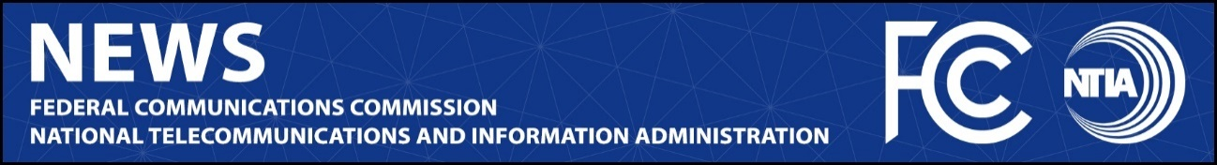

News Media Contact:
NTIA, Office of Public Affairs, press@ntia.gov
FCC, Office of Media Relations, mediarelations@fcc.gov

For Immediate Release

FCC, NTIA ESTABLISH SPECTRUM COORDINATION INITIATIVE
New Actions by Chairwoman and Assistant Secretary Advance U.S. Spectrum Policymaking through Updated Procedures, Closer Coordination, and Information Sharing

WASHINGTON, February 15, 2022—The Federal Communications Commission and National Telecommunications and Information Administration today announced a new initiative to improve U.S. government coordination on spectrum management. The Spectrum Coordination Initiative will involve actions by both agencies to strengthen the processes for decision making and information sharing and to work cooperatively to resolve spectrum policy issues. The FCC and NTIA jointly manage the nation’s radio spectrum resources, and the agencies have a long history of working together to ensure that spectrum policy decisions foster economic growth, ensure our national and homeland security, maintain U.S. global leadership, and advance other vital U.S. needs.

“Now more than ever we need a whole-of-government approach to spectrum policy,” said Chairwoman Rosenworcel. “Over the past few years we’ve seen the cost of not having one—and we need a non-stop effort to fix that. I appreciate Assistant Secretary Davidson’s leadership and his willingness to work with me to revitalize the interagency coordination process so that it once again is able to produce results for consumers and the economy.”

“The FCC and NTIA have an opportunity today to build a common vision for spectrum management and coordination that serves federal users, private actors, and the American people. I am excited to launch this initiative with Chairwoman Rosenworcel. I value her leadership on spectrum policy and her collaboration as we work to accomplish our shared goals,” said Assistant Secretary Davidson.

The Initiative will improve the two agencies’ ability to address gaps in governmental coordination.

Specifically, the Chairwoman and the Assistant Secretary have committed to the following initial actions:

- Reinstate High Level Meetings. For the first time, the Chair of the FCC and the Assistant Secretary will hold formal, regular meetings, beginning monthly, to conduct joint spectrum planning. This will go above and beyond the existing statutory requirement, as well as the existing Memorandum of Understanding between the agencies, which provides that the Chair and the Assistant Secretary meet twice each calendar year.

- Reaffirm Roles and Responsibilities. Building on NTIA’s statutory role as manager of the federal government’s use of spectrum, the FCC and NTIA will update the nearly twenty-year-old Memorandum of Understanding between the agencies to address gaps in government coordination and to better reflect today’s spectrum opportunities and challenges.

- Renew Efforts to Develop a National Spectrum Strategy. To secure America’s leadership, the FCC and NTIA will collaborate to help inform the development of a national spectrum strategy, increase transparency around spectrum use and needs, and establish long-term spectrum planning and coordination.

- Recommit to Scientific Integrity and Evidence-Based Policymaking. The FCC and NTIA will work cooperatively to develop processes for spectrum engineering compatibility analysis. These will include a compilation of principles, guidelines, accepted technical standards, interference protection criteria, propagation models, and other characteristics.

- Revamp Technical Collaboration. The FCC and NTIA will foster proactive technical exchange and engagement with industry and other federal agencies by participating in cross-agency advisory groups. To start, the FCC will participate as an observer in the Commerce Spectrum Management Advisory Committee, and NTIA will participate as an observer in the FCC’s Technological Advisory Council and the Communications Security, Reliability, and Interoperability Council.

###
Media Relations: (202) 418-0500 / ASL: (844) 432-2275 / Twitter: @FCC / www.fcc.gov

This is an unofficial announcement of Commission action. Release of the full text of a Commission order constitutes official action. See MCI v. FCC, 515 F.2d 385 (D.C. Cir. 1974).

