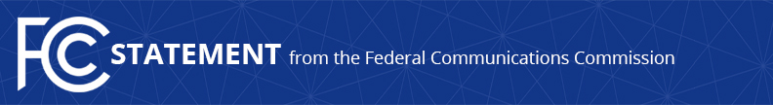

Media Contact:
Will Wiquist
will.wiquist@fcc.gov

For Immediate Release

FCC CHAIRWOMAN ROSENWORCEL SIGNS MOU WITH GEORGIAN COMMUNICATIONS REGULATOR
--
BARCELONA, Spain, March 2, 2022—Today, at the Mobile World Congress in Barcelona, Spain, the United States Federal Communications Commission and the National Communications Commission of Georgia signed a Memorandum of Understanding concerning bilateral cooperation in telecommunications and media policy. Chairwoman Jessica Rosenworcel signed for the FCC, and Commissioner Ekaterine Imedadze signed for NCC. Chairwoman Rosenworcel issued the following statement:

“Now more than ever it is essential that we come together and renew our commitment to communications that can build connections and help sustain peace. I am grateful to Chairman Kakhi Bekauri, Commissioner Imedadze, and the NCC team for working with the FCC on this agreement. I look forward to strengthening the ties between our agencies and cooperating on communications policies that deliver real results for both of our respective countries.”

The Memorandum of Understanding establishes a non-binding framework for the mutually beneficial exchange of ideas in the field of telecommunications regulatory policy, with the purpose of contributing to the development of advanced communications in the respective countries. The FCC and NCC also intend to carry out information exchange and technical cooperation in the field of telecommunications and related facilities/services under the new agreement.

###
Media Relations: (202) 418-0500 / ASL: (844) 432-2275 / Twitter: @FCC / www.fcc.gov

This is an unofficial announcement of Commission action. Release of the full text of a Commission order constitutes official action. See MCI v. FCC, 515 F.2d 385 (D.C. Cir. 1974).

