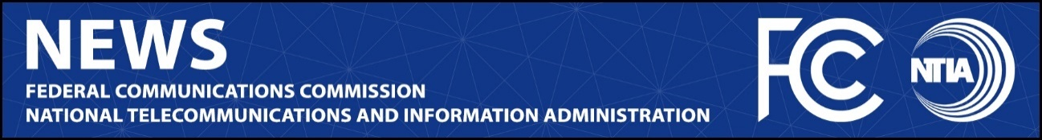

News Media Contact:
NTIA, Office of Public Affairs, press@ntia.gov
FCC, Office of Media Relations, mediarelations@fcc.gov

For Immediate Release

FCC, NTIA NAME STAFF REPRESENTATIVES TO ADVISORY COMMITTEES TO FURTHER TECHNICAL COLLABORATION
NTIA Representatives will join FCC’s Technological Advisory Committee and Communications Security, Reliability, and Interoperability Council; FCC Representative will participate in the Commerce Spectrum Management Advisory Committee
--
WASHINGTON, March 18, 2022—FCC Chairwoman Jessica Rosenworcel and Assistant Secretary of Commerce Alan Davidson today named staff representatives to participate on each other’s advisory committees. This is a critical component of the FCC and NTIA’s Spectrum Coordination Initiative under which they are taking actions to strengthen the processes for decision making and information sharing and to work cooperatively to resolve spectrum policy issues. As part of this initiative, the agencies committed to fostering proactive technical exchanges and engagement with industry and other federal agencies by participating in cross-agency advisory groups.

“To succeed as spectrum partners, the FCC and NTIA must hear from and listen to each other in both formal and informal ways. Today’s appointments ensure that these critical advisory bodies can hear from and more consistently communicate with other agency experts,” said Chairwoman Rosenworcel. “I thank the Assistant Secretary for his continued leadership and cooperation on critical spectrum issues.”

“A common understanding of spectrum engineering and market conditions is essential for the success of our efforts at the FCC and NTIA to manage the country’s spectrum resources. Today’s announcement will promote greater communication and understanding among our experts and advisors,” said Assistant Secretary Davidson. “Thank you to Chairwoman Rosenworcel for her cooperation and her demonstrated commitment to America’s continued leadership around spectrum policy.”

Chairwoman Rosenworcel named Jessica Quinley of the FCC’s Wireless Telecommunications Bureau to participate as an observer in NTIA’s Commerce Spectrum Management Advisory Committee. Quinley currently serves as an Acting Legal Advisor in the FCC’s Wireless Telecommunications Bureau where she has worked for nearly three years. Before joining the FCC, she was an Attorney Advisor at NTIA for more than four years. She earned her law degree from Catholic University of America, Columbus School of Law.

Assistant Secretary Davidson named Douglas Brake, a Spectrum Policy Specialist, and Timothy May, a Senior Advisor, to participate in the FCC’s Technological Advisory Council and its Communications Security, Reliability, and Interoperability Council, respectively.

Brake, a Spectrum Policy Specialist with NTIA, previously directed the broadband and spectrum policy work at the Information Technology and Innovation Foundation. He earned his law degree from University of Colorado Law School. May currently serves as a Senior Advisor in the Office of the Assistant Secretary where he has worked for four years. Before joining NTIA, he was a Policy Analyst in the FCC’s Public Safety and Homeland Security Bureau.

###
Media Relations: (202) 418-0500 / ASL: (844) 432-2275 / Twitter: @FCC / www.fcc.gov

This is an unofficial announcement of Commission action. Release of the full text of a Commission order constitutes official action. See MCI v. FCC, 515 F.2d 385 (D.C. Cir. 1974).

