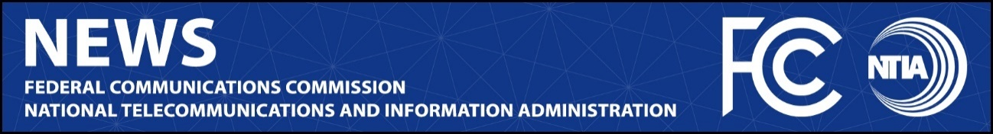

News Media Contact:
NTIA, Office of Public Affairs, press@ntia.gov
FCC, Office of Media Relations, mediarelations@fcc.gov

For Immediate Release

FCC, NTIA LEADERS HOLD INAUGURAL MONTHLY MEETING UNDER SPECTRUM COORDINATION INITIATIVE
Rosenworcel and Davidson Announce New Task Force to Update Memorandum of Understanding
--
WASHINGTON, March 30, 2022—FCC Chairwoman Jessica Rosenworcel and Assistant Secretary of Commerce Alan Davidson met on Tuesday to discuss spectrum policy efforts, the first monthly FCC/NTIA coordination meeting since the leaders launched their Spectrum Coordination Initiative. The leaders also announced today that they have launched a joint task force which met this week to begin discussing the details of a new Memorandum of Understanding between the agencies. Under the agencies’ new Spectrum Coordination Initiative, the FCC and NTIA are committed to updating the existing MOU for the first time in nearly twenty years to address gaps in government coordination and to better reflect today’s spectrum opportunities and challenges.

Chairwoman Rosenworcel and Assistant Secretary Davidson issued the following joint statement:

“A partnership requires clear communication, open doors, thoughtful listening, and mutual respect. Our agencies have very compatible and complimentary roles in American spectrum policy making. Congress has been clear about NTIA’s statutory role as manager of the federal government’s use of spectrum and the FCC as the independent agency responsible for non-federal spectrum policy. Our agencies have a long history of working together to ensure that spectrum policy decisions foster economic growth, ensure our national and homeland security, maintain U.S. global leadership, and advance other vital U.S. needs. That will only continue and grow as we build this new agreement.”

Monthly meetings between the Chairwoman and Assistant Secretary will help them coordinated their agencies’ work and conduct joint spectrum planning. Among the topics discussed in Tuesday’s meeting were the national spectrum strategy, mid-band and millimeter wave spectrum to support next-generation commercial networks, and the FCC’s upcoming receiver standards Notice of Inquiry. These monthly meetings will go above and beyond the existing statutory requirement, as well as the existing Memorandum of Understanding between the agencies, which provides that the Chair and the Assistant Secretary meet twice each calendar year.

This bilateral task force met by teleconference this week to begin working to develop recommendations for the Chairwoman and Assistant Secretary on revisions to the FCC-NTIA Memorandum of Understanding. The FCC’s team will be directed by the Office of the Chairwoman, with support from technical and policy experts from the Wireless Telecommunications Bureau, the Office of Engineering and Technology, and other parts of the Commission, as appropriate. Likewise, NTIA’s Office of the Assistant Secretary will be supported by technical and policy experts from its Office of Spectrum Management, and other offices, as appropriate. The teams expect to meet regularly to progress this important agreement for the present and future of American spectrum policy.

###
Media Relations: (202) 418-0500 / ASL: (844) 432-2275 / Twitter: @FCC / www.fcc.gov

This is an unofficial announcement of Commission action. Release of the full text of a Commission order constitutes official action. See MCI v. FCC, 515 F.2d 385 (D.C. Cir. 1974).

