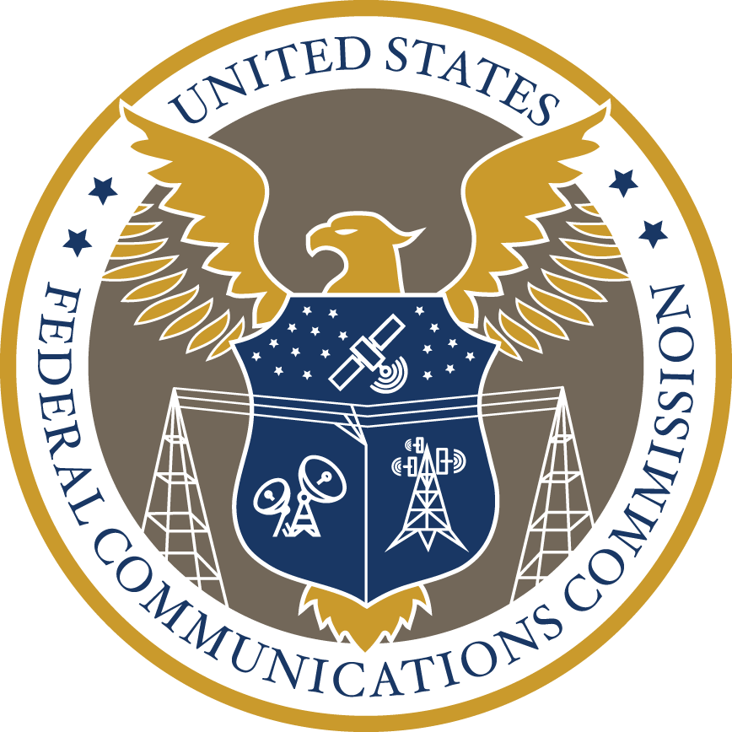

Federal Communications Commission

Equity Action Plan

Pursuant to the President's Executive Order On Advancing Racial Equity and Support for Underserved Communities Through the Federal Government

Executive Summary

Mission: The Federal Communications Commission (FCC or Commission), an independent regulatory agency of the United States Government, is charged with regulating interstate and international communications by radio, television, wire, satellite, and cable. The Commission also regulates the provision of telecommunications and advanced communication services and video programming for people with disabilities.

Summary of Action Plan: Executive Order 13985 strongly encourages participation by independent agencies. The FCC is publishing this Action Plan in support of the objectives of the Executive Order. This Action Plan focuses on concrete actions that the FCC is taking so that people across the country can count on and obtain access to the modern communications they need for work, learning, healthcare, and access to the information they require to make decisions about their lives, their communities, and their country.

First, the Commission was given the incredibly important responsibility in the Infrastructure Investment and Jobs Act (IIJA) to adopt rules to “facilitate equal access” to broadband, taking into account technical and economic feasibility, including by preventing digital discrimination of access based on income, race, ethnicity, color, religion, or national origin and identifying necessary steps to eliminate such discrimination. Consistent with the Communications Act and as directed by the IIJA, the FCC has established a Task Force to Prevent Digital Discrimination and is working towards a proceeding regarding the prevention of digital discrimination.

Second, the Commission recently launched the Affordable Connectivity Program (ACP), a $14.2 billion federal initiative that offers qualifying households discounts on their internet service bills and an opportunity to receive a discount on a computer or tablet from participating providers. The ACP is the congressionally created successor to the FCC's previous broadband affordability program, the Emergency Broadband Benefit (EBBP). To date, the ACP has successfully helped almost 10 million households afford internet service.

Third, as part of the American Rescue Plan Act of 2021, Congress authorized the Emergency Connectivity Fund (ECF), a $7.17 billion program that is helping schools and libraries provide the tools and services their communities need for remote learning during the COVID-19 emergency period. By providing these necessary services and tools, ECF is helping provide relief to millions of students, school staff, and library patrons and helping to close the Homework Gap for students who would otherwise lack necessary Internet access or the devices they need.

Fourth, the FCC is in the process of updating its current broadband maps with more detailed and precise information on the availability of fixed and mobile broadband services. Service providers and governments use broadband maps to make decisions about where service is needed and how to fund the expansion of broadband services. Further, the need for accurate information about availability of the services is necessary more than ever to ensure equal access to these critical technologies.

Summary of Early Accomplishments
During 2021, the Commission took several steps to advance equity through the Commission’s programs and activities. For starters, the FCC established a new strategic goal to Promote Diversity, Equity, Inclusion and Accessibility. Guided by this strategic goal, the FCC is seeking to gain a deeper understanding of how the agency’s rules, policies, and programs may promote or inhibit advances in diversity, equity, inclusion, and accessibility. To this end, the Commission began including an equity and inclusion inquiry within its notices of proposed rulemaking seeking specific comments on how its proposals may promote or inhibit advances in diversity, equity, inclusion, and accessibility.

In addition, the Commission re-chartered its Advisory Committee for Diversity and Digital Empowerment under a new name – the Communications Equity and Diversity Council. The Council’s mission has expanded from its initial focus on the media ecosystem to review more broadly critical diversity and equity issues across the tech sector. In turn, it is anticipated that the Council will make recommendations on advancing equity in the provision of and access to digital communication services and products for all people of the United States, without discrimination on the basis of race, color, religion, national origin, sex, or disability. It also will provide recommendations to the Commission on how to empower people of color and others who have been historically underserved, including persons who live in rural areas, and persons otherwise adversely affected by persistent poverty or inequality, to access, leverage, and benefit from the wide range of opportunities made possible by technology, communication services and next-generation networks.

At the start of 2021, the FCC did something truly historic. The Commission set up the largest-ever broadband affordability program in the United States, the EBBP. The EBBP was a short-term effort designed to help households struggling in the pandemic to afford high-speed Internet access at home. At the start of 2022, the FCC is making history again by putting in place a long-term effort to keep households everywhere connected, through the ACP. This $14.2 billion investment, a byproduct of the IIJA, is the biggest program the Commission has ever set up to help ensure that every family can afford the broadband services that are now essential for full participation in modern life. And thanks to this program, almost 10 million households were able to do so.

Since the launch of the ECF in the summer of 2021, the ECF program has helped over 12 million students across the nation get the digital tools they need to connect with teachers and online educational resources. The funding can be used to support off-campus learning, such as nightly homework, to ensure students across the country have the necessary support to keep up with their education. Total commitments to date are supporting over 10,800 schools, 875 libraries, and 125 consortia for nearly 9.9 million connected devices and over 4.9 million broadband connections.

In the area of Broadband Mapping, the Commission formed a Broadband Data Task Force to coordinate and expedite the design and construction of new systems for collecting and verifying data to carry out the FCC’s responsibilities under the Broadband DATA Act and to more accurately measure and reflect broadband needs across the United States. The Commission made significant progress on its broadband data collection efforts through this new Task Force.
Equity Action Plan

- Preventing Digital Discrimination Rulemaking

The Commission was given the incredibly important responsibility in the IIJA to adopt rules to “facilitate equal access” to broadband, taking into account technical and economic feasibility, including by preventing digital discrimination of access based on income, race, ethnicity, color, religion, or national origin and identifying necessary steps to eliminate such discrimination. The FCC announced the creation of the Task Force to Prevent Digital Discrimination, and consistent with the Communications Act along with consultation with the Attorney General as directed by the IIJA, the FCC is working towards a proceeding regarding the prevention of digital discrimination.

- Barrier to Equitable Outcome(s)

There currently exists a “digital divide,” in which people of color and others who have been historically underserved, persons who live in rural areas, persons with disabilities, and persons otherwise affected by persistent poverty, discrimination, or inequality disproportionately lack access to broadband internet service. Pursuant to the IIJA, it is the policy of the United States that, insofar as technically and economically feasible: (1) subscribers should benefit from equal access to broadband internet access service within the service area of a provider of such service; (2) the term equal access, for purposes of this policy, means the equal opportunity to subscribe to an offered service that provides comparable speeds, capacities, latency, and other quality of service metrics in a given area, for comparable terms and conditions; and (3) the Commission should take steps to ensure that all people of the United States benefit from equal access to broadband internet access service.

- Action and Intended Impact on Barrier

During 2021, the FCC took the action of directing its newly rechartered Communications Equity and Diversity Council (Council) to an updated mission to review more broadly critical diversity and equity issues across the tech sector. The FCC has established the Council’s leadership and its work is underway. The Council’s current work includes developing recommendations to the Commission on model policies and best practices that can be adopted by States and localities to ensure that broadband internet access service providers do not engage in digital discrimination. The Council’s mission also includes developing recommendations on how to accelerate the deployment of broadband internet access service in all communities by reducing and/or removing regulatory barriers to infrastructure and investment and by making recommendations on how to strengthen existing broadband networks and develop new ones. As the Commission awaits the Council’s recommendations, its examination of these issues is ongoing.

In 2022, the FCC took the further step of forming a cross-agency Task Force to Prevent Digital Discrimination. This Task Force, in conjunction with the work of the CEDC, will focus on creating the necessary rules and policies that will combat digital discrimination and promote equal access to broadband across the country, regardless of zip code, income level, ethnicity, race, religion, or national origin.

- Tracking Progress

Per the requirements of the IIJA, not later than 2 years after November 15, 2021, the Commission shall adopt final rules to facilitate equal access to broadband internet access service, taking into account the issues of technical and economic feasibility presented by that objective, including: (1) preventing digital discrimination of access based on income level, race, ethnicity, color, religion, or national origin; and (2) identifying necessary steps for the Commission to take to eliminate discrimination described in (1). While the Commission has not started a rulemaking proceeding yet to achieve this objective, the Commission is working to accomplish the task set forth in the IIJA in the timeline provided by the IIJA.

- Accountability

In 2021, the FCC established a new strategic goal to Promote Diversity, Equity, Inclusion and Accessibility. Guided by this strategic goal, the FCC is seeking to gain a deeper understanding of how the agency’s rules, policies, and programs may promote or inhibit advances in diversity, equity, inclusion, and accessibility. The FCC will also pursue focused action and investments to eliminate historical, systemic, and structural barriers that perpetuate disadvantaged or underserved individuals and communities. In so doing, the FCC will work to ensure equitable and inclusive access and facilitate the ability of underserved individuals and communities to leverage and benefit from the wide range of opportunities made possible by digital technologies, media, communication services, and next-generation networks. The rulemaking proceeding about preventing digital discrimination that is required by the IIJA will assist the Commission in fulfilling this strategic goal as well. Also, the rulemaking proceeding will be open for public comment which will hold the Commission accountable to the feedback and input of a wide array of voices and opinions from individuals and organizations throughout the United States.

- Affordable Connectivity Program

In January 2022, the Commission launched the ACP, a $14.2 billion federal initiative that offers qualifying households discounts on their internet service bills and an opportunity to receive a discount on a computer or tablet from participating providers. The ACP is the congressionally created successor to the FCC's broadband affordability program, the EBBP. To date the program successfully helped almost 10 million households afford internet access.

- Barrier to Equitable Outcome(s)

So much of day to day—work, education, healthcare and more—has migrated online. But there are far too many households across the country that are wrestling with how to pay for their living expenses and also keep up with the broadband bill. The ACP program, like its predecessor EBBP, can make a meaningful difference.

- Action and Intended Impact on Barrier

The ACP helps reduce the monthly cost of internet service for qualifying households around the country. Eligible households can receive discounts of up to $30 a month for broadband service, and up to $75 a month if the household is on Tribal lands or in certain high-cost areas. Eligible households also are able to receive up to $100 to offset the cost of a computer or tablet. The transition from EBBP to this more permanent program began at the end of 2021 and created a glide path for households in EBBP to move into the ACP. Under the IIJA, for a two-month period these households are authorized to receive support of up to $50 a month for their broadband connection. Recognizing that the transition to ACP entails a benefit reduction in March of 2022, the Commission has developed thoughtful guiderails for the transition of these households that put a premium on notifying them about this change and giving them the opportunity to adjust their services to avoid surprise charges or unexpected bills.

Congress also made a few key changes to the way a household qualifies for support for ACP. As a result, the FCC updated the income qualifications for ACP thereby opening the door for more families to receive support. The Commission also added new qualifications, including participation in the Department of Agriculture’s Special Supplemental Nutrition Program for Women, Infants, and Children, which is specifically designed to help low-income pregnant, postpartum, and breastfeeding women and their families who are at nutritional risk. These changes are important, but it is equally important to note that households participating in Lifeline, Medicaid, SNAP, and Federal Public Housing Assistance programs remain eligible for ACP, as they were for EBBP. In addition, households with children receiving free and reduced-price lunch or school breakfast continue to be eligible, as do Pell Grant recipients. Furthermore, households that participate in Indian Affairs General Assistance, Tribal, TANF, and the Food Distribution Program on Indian Reservations also remain eligible.

- Tracking Progress

The FCC, working with the Universal Service Administrative Company, maintains transparent ongoing statistics about enrollment and claims at: https://www.usac.org/about/affordable-connectivity-program/acp-enrollment-and-claims-tracker/. By tracking these figures, the Commission is able to see if the program is successfully enrolling eligible households.

In addition, outreach for this program is crucial when it comes to ensuring that eligible households that need support enroll. Community groups, faith-based institutions, schools, libraries, and other trusted local voices are essential when it comes to getting the word out about this program. In the IIJA, Congress provided the agency with the ability to devote resources to outreach efforts designed to enroll eligible households in the ACP. The Commission is planning efforts to expand awareness of this program, build an outreach grants program, and utilize focus groups and research to improve the enrollment process for those who qualify, and find ways to build trust in the process. The Commission should be able to track the progress and clearly see the benefits of its outreach efforts through increased participation in the program.

- Accountability

With the ACP, Congress encouraged the FCC to adopt new consumer protection policies. As such, the Commission put in place new rules restricting abusive upselling and downselling practices so households are not required to subscribe to more or less than they need just to enroll in the program. The FCC has also made clear that credit checks and past debts are not a barrier for participation. In addition, the Commission established a dedicated complaint process specifically for the ACP, so participants can let the FCC know when they have run into difficulties or are being mistreated, and the FCC can take action to fix it.
Furthermore, the FCC has committed to continuing to learn from the policies and practices used for the EBBP. From past efforts, the Commission has learned that trusted navigators are often essential for effective outreach and assistance with enrollment. As a result, the FCC is going to explore ways to lean on trusted government navigators at the state and local level who can help members of their community work their way through the application process.
Finally, as with EBBP, the Commission is setting up a risk assessment of the program’s controls and payment processes as well as an assessment of fraud risk. The FCC will also be testing payments and performing audits to ensure carriers are complying with the FCC’s rules and to prevent fraud, waste, abuse, and improper payments.

- Emergency Connectivity Fund – Addressing the Homework Gap

In the summer of 2021, the FCC launched the ECF program, which was authorized by Congress as part of the American Rescue Plan Act of 2021. ECF is a $7.17 billion program that is helping schools and libraries provide the tools and services their communities need for remote learning during the COVID-19 emergency period. For eligible schools and libraries, the ECF Program covers the reasonable costs of laptop and tablet computers, Wi-Fi hotspots, modems, routers, and broadband connectivity purchases for off-campus use by students, school staff, and library patrons. By providing these necessary services and tools, ECF is helping provide relief to millions of students, school staff, and library patrons and helping to close the Homework Gap for students who would otherwise lack necessary Internet access or the devices they need to connect to classrooms.

- Barrier to Equitable Outcome(s)

During the COVID-19 pandemic, many of the Nation’s children have struggled without the broadband access they need for learning. They are unable to head to virtual classrooms and participate in online education. Even when in-person class is in session, children wrestle with nightly schoolwork that requires internet access. As a result, in rural and urban communities, many children have found it necessary to identify public spaces (sometimes parking lots) where the wireless signal is free just to connect and keep up with their education. This lack of broadband access and the necessary devices to take advantage of the benefits of broadband is an especially cruel part of the digital divide, known as the Homework Gap.

- Action and Intended Impact on Barrier

Through the ECF, schools, libraries, and consortia of schools and libraries (e.g., regional or statewide groups of schools or libraries that apply together) that are eligible for support under the FCC's E-Rate Program as well as Tribal libraries that are eligible for support under the Library Services and Technology Act may request and receive support. Eligible equipment includes Wi-Fi hotspots, modems (including air cards), routers, devices that combine a modem and router, and connected devices (laptop and tablet computers). Schools and libraries can also receive funding for commercially available broadband service that provides a fixed or mobile broadband connection for off-campus use by students, school staff or library patrons. In limited instances, a school or library that can demonstrate it has no available service options sufficient to support remote learning may seek funding for the construction of new networks to provide remote learning and the equipment needed for datacasting services.

- Tracking Progress

The initial application filing window for ECF closed on August 13, 2021, and the second application filing window closed on October 13, 2021. The FCC is reviewing and processing applications on a rolling basis. The FCC maintains a detailed list of current funding commitment information organized both by congressional district and by state online at: https://www.fcc.gov/ecf-current-funding-commitments. Since the launch of the ECF in the summer of 2021, the ECF program has helped over 12 million students across the nation get the digital tools they need to connect with teachers and online educational resources. Total commitments to date are supporting over 10,800 schools, 875 libraries, and 125 consortia for
nearly 9.9 million connected devices and over 4.9 million broadband connections.

- Accountability

In 2021, the FCC updated its strategic goals to include a strategic goal to Pursue a “100 Percent” Broadband Policy. In furtherance of this strategic goal, the FCC has established performance goals and targets to ensure that students as well as school staff and library patrons with unmet needs have access to connected devices and broadband services for off campus use through implementation of the ECF. Furthermore, the Commission has completed a risk assessment of the ECF program’s controls and payment processes; the FCC will also be testing payments and performing audits to ensure program participants are complying with the FCC’s rules and to prevent fraud, waste, abuse, and improper payments.

- Broadband Mapping

The FCC is in the process of updating its current broadband maps with more detailed and precise information on the availability of fixed and mobile broadband services. Service providers and governments use broadband maps to make decisions about where service is needed and how to fund the expansion of broadband services. Further, the need for accurate information about availability of the services is necessary to ensure equal access to these critical technologies.

- Barrier to Equitable Outcome(s)

Now more than ever, it is apparent that broadband is no longer nice to have; it’s a need to have. Yet, the FCC knows that in some parts of the United States finding a reliable connection to the online world is not easy. The barriers have been determining how many people face these problems, determining where they live, and identifying what technologies could work best to connect them.

- Action and Intended Impact on Barrier

In passing the Broadband DATA Act, Congress directed the FCC to update its data collection practices and improve its broadband maps. The Commission is working to allow consumers, as well as state, local, and Tribal governments to provide feedback about the availability and quality of broadband services. The Commission is gathering this information so the FCC can find ways to close the gap between the digital haves and have nots. To do this, the FCC is working to design and build its most accurate broadband maps ever. The FCC has set up a new method for collecting information to build a comprehensive, user-friendly dataset on broadband availability using public input that will supplement the information the FCC gathers from carriers. The FCC is also developing, testing, and launching information technology systems to collect and verify these data. From there, the FCC will create, for the first time, a publicly accessible, data-base driven nationwide map of locations where broadband is truly available throughout the United States.

- Tracking Progress

The Commission formed a Broadband Data Task Force to coordinate and expedite the design and construction of new systems for collecting and verifying data to carry out the Broadband DATA Act and more accurately measure and reflect the Nation’s broadband needs. The Commission has made significant progress on its broadband data collection efforts, including launching a new webpage, www.fcc.gov/BroadbandData, to serve as a central location for information about the FCC’s broadband data collection initiative. The webpage also provides access to a new portal through which consumers can share their experiences about the quality and availability of broadband services in their area. Through the FCC’s Broadband Task Force, the Commission will continue to track its progress in this area through regular broadband map updates and other public reporting mechanisms.

- Accountability

In 2021, the FCC updated its strategic goals to include a strategic goal to Pursue a “100 Percent” Broadband Policy. In furtherance of this strategic goal, the FCC has established performance goals and targets to ensure that the FCC implements the requirements of the Broadband DATA Act by collecting and mapping broadband coverage data submitted by providers and incorporating public feedback through the FCC’s challenge process. There is also considerable public and Congressional interest in the FCC’s efforts to update its broadband maps as this initiative directly impacts how federal broadband investments will be made in the future. The FCC's recent map updates demonstrate the Commission's progress in its efforts to implement the Broadband DATA Act and its commitment to build next-generation broadband maps that can help to connect 100 percent of Americans.

