Communications Status Report for
Areas Impacted by the Wildfires in New Mexico
May 10, 2022

The following is a report on the status of communications services in geographic areas impacted by wildfires in New Mexico as of May 10, 2022 at 11:00 a.m. EDT. This report incorporates network outage data submitted by communications providers to the Federal Communications Commission’s (FCC) Disaster Information Reporting System (DIRS). Note that the operational status of communications services during an event may evolve rapidly, and this report represents a snapshot in time. This report also summarizes certain regulatory actions taken by the FCC to assist areas impacted by the wildfires in New Mexico.
The following counties in New Mexico are in the current geographic area that is part of DIRS (the “disaster area”) for today’s report.
New Mexico: Colfax, Mora, San Miguel and Santa Fe

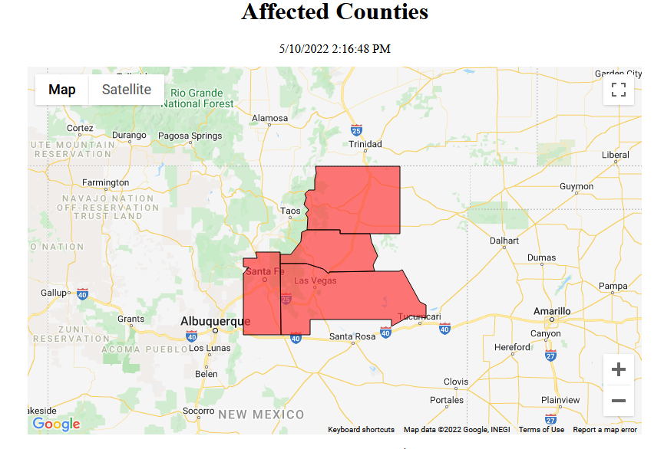

911 Services

The Public Safety and Homeland Security Bureau (PSHSB) learns the status of each Public Safety Answering Point (PSAP) through the filings of 911 Service Providers in DIRS, reporting to the FCC’s Public Safety Support Center, coordination with state 911 Administrators and, if necessary, direct contact with individual PSAPs.

New Mexico: No PSAPs are reported as being affected.

Wireless Services

The following section describes the status of wireless communications services and restoration in the disaster area.

The current status of wireless communications services and restoration by county is shown by the following chart and map.

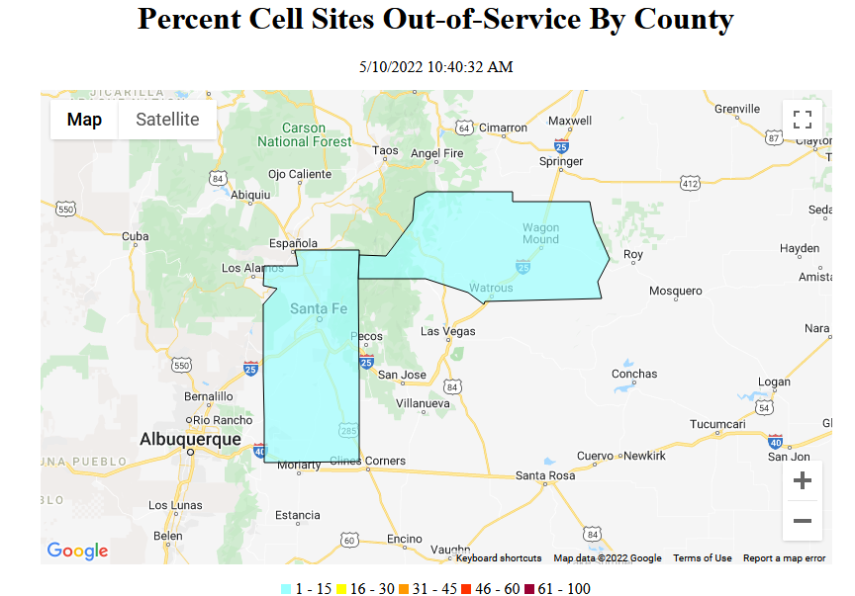

The following table provides cell sites out of service by county. 0.9% of the cell sites in the affected area in New Mexico are out of service. The information shown was provided by the signatories to the Wireless Network Resiliency Framework Cooperative Agreement.

New Mexico

State | Affected Counties | Cell Sites Served | Cell Sites Out | Percent Out | Cell Sites Out Due to Damage | Cell Sites Out Due to Transport | Cell Sites Out Due to Power
NM | MORA | 41 | 2 | 4.9% | 1 | 0 | 1
NM | SAN MIGUEL | 79 | 0 | 0.0% | 0 | 0 | 0
NM | SANTA FE | 171 | 1 | 0.6% | 1 | 0 | 0
NM | COLFAX | 25 | 0 | 0.0% | 0 | 0 | 0
TOTAL |  | 316 | 3 | 0.9% | 2 | 0 | 1

The number of cell site outages in a specific area does not necessarily correspond to the availability of wireless service to consumers in that area. See Improving the Resiliency of Mobile Wireless Communications Networks, Order, 31 FCC Rcd 13745, para. 10 (2016) (recognizing the difficulties in accurately depicting the ongoing status of a wireless provider’s service during emergencies). Wireless networks are often designed with numerous, overlapping cell sites that provide maximum capacity and continuity of service even when an individual site is inoperable. In addition, wireless providers frequently use temporary facilities such as cells-on-wheels (also known as COWs), increased power at operational sites, roaming agreements, or take other actions to maintain service to affected consumers during emergencies or other events that result in cell site outages.

Cable Systems and Wireline (Combined)

Cable and wireline companies reported no subscribers out of service in the disaster area in New Mexico; this includes the loss of telephone, television, and/or Internet services:

Broadcast:

Television stations status:

- No TV stations reported as being out of service.

FM Radio stations status:
- No FM stations reported as being out of service. One station (KTEG) reported transmitting from an alternate tower.

AM Radio stations status:
- No AM stations reported being out of service.
Special Temporary Authority (STA)/Waivers/Extensions

The Federal Communications Commission (FCC) may grant Special Temporary Authority (STA) to permit immediate or temporary operation of certain radio facilities during emergencies or other urgent conditions, as well as waivers to support emergency communications and service restoration.

For the wildfires in New Mexico, there have been no STAs or waivers granted.

