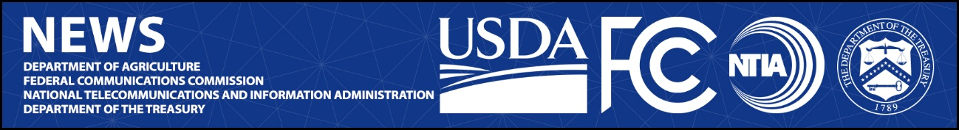

Media Contact:
Paloma Perez
paloma.perez@fcc.gov

NTIA Media Contact:
Charlie Meisch
cmeisch@ntia.gov

USDA Media Contact:
Jacqueline Susmann
jacqueline.susmann@usda.gov

Treasury Department Media Contact:
Liz Bourgeois
elizabethbourgeois@treasury.gov

For Immediate Release

FCC, NTIA, USDA AND TREASURY ANNOUNCE INTERAGENCY AGREEMENT TO COLLABORATE ON FEDERAL BROADBAND FUNDING
Agency Leaders Sign Pact to Formalize Information Sharing on Broadband Deployment Projects
--
WASHINGTON, May 12, 2022—The Federal Communications Commission (FCC), the U.S. Department of Agriculture (USDA), the National Telecommunications and Information Administration (NTIA), and the U.S. Department of the Treasury (Treasury) today announced an interagency agreement to share information about and collaborate regarding the collection and reporting of certain data and metrics relating to broadband deployment.

The respective Cabinet and Agency leaders announced that their agencies will consult with one another and share information on data collected from programs administered by the FCC, the USDA’s Rural Utilities Service, programs administered or coordinated by NTIA, and Treasury’s Coronavirus Capital Projects Fund and State and Local Fiscal Recovery Fund.

“No matter who you are or where you live in this country, you need access to high-speed internet to have a fair shot at 21st century success. The FCC, NTIA, USDA and Treasury are working together like never before to meet this shared goal,” said FCC Chairwoman Jessica Rosenworcel. “Our new interagency agreement will allow us to collaborate more efficiently and deepen our current data sharing relationships. I thank Secretary Vilsack, Assistant Secretary Davidson, and Secretary Yellen for their continued partnership, so we can get everyone, everywhere connected to the high-speed internet they need.”

Agriculture Secretary Vilsack said, “When we invest in rural infrastructure, we invest in the livelihoods and health of people in rural America. High-speed internet is the new electricity. It is necessary for Americans to do their jobs, to participate equally in school learning, to have access to health care and to stay connected. This is why, under the leadership of President Biden and Vice President Harris, USDA remains committed to being a strong partner with rural communities and our state, Tribal and federal partners in building ‘future-proof’ broadband infrastructure in unserved and underserved areas so that we finally reach 100 percent high-speed broadband coverage across the country.”

“Our whole-of-government effort to expand broadband adoption must be coordinated and efficient if we are going to achieve our mission,” said Alan Davidson, Assistant Secretary of Commerce for Communications and Information. “Our agencies have already been collaborating at an unprecedented level, and today’s announcement ensures that coordination will continue as we build out high-speed internet across the country. This MOU will allow us to build the tools we need for even better data-sharing and transparency in the future. Thank you to Chairwoman Rosenworcel, Secretary Yellen, and Secretary Vilsack for their continued leadership on our shared goal of connecting every American.”

“Treasury is proud to work with our federal agency partners to achieve President Biden’s goal of closing the nation’s digital divide,” said U.S. Treasury Secretary Janet L. Yellen. “Access to affordable, high-speed internet is critical to the continued strength of our economy and a necessity for every American household, school, and business.”

As part of the signed agreement, each federal agency partner will share information about projects that have received or will receive funding from the previously mentioned federal funding sources. More information on what the interagency Memorandum of Understanding entails can be found on the FCC's website. The agreement is effective at the date of its signing, May 11, 2022.

The agreement is the latest development in federal efforts to coordinate high-speed internet spending. In June 2021, the FCC, NTIA and USDA signed a Memorandum of Understanding to coordinate the distribution of federal high-speed internet funds. The June 2021 Memorandum of Understanding remains in effect.

###
Media Relations: (202) 418-0500 / ASL: (844) 432-2275 / Twitter: @FCC / www.fcc.gov

This is an unofficial announcement of Commission action. Release of the full text of a Commission order constitutes official action. See MCI v. FCC, 515 F.2d 385 (D.C. Cir. 1974).

