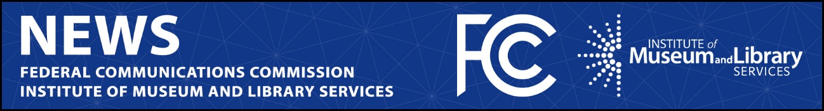

FCC Media Contact:
Anne Veigle
anne.veigle@fcc.gov

IMLS Media Contact:
Erica Jaros
ejaros@imls.gov

For Immediate Release

FCC AND INSTITUTE OF MUSEUM AND LIBRARY SERVICES SIGN AGREEMENT TO PROMOTE BROADBAND ACCESS
Partnership to Focus on Expanding Digital Inclusion
--
WASHINGTON, June 24, 2022—Federal Communications Commission Chairwoman Jessica Rosenworcel and Crosby Kemper, Director of the Institute of Museum and Library Services, today announced a Memorandum of Understanding to jointly promote public awareness of federal funding opportunities for broadband. The partnership will work to generate efforts to promote the availability of affordable broadband programs, in light of the significant role that libraries and other community anchor institutions play in promoting digital access and inclusion.

“Libraries are some of our most trusted institutions—and rightfully so. They serve as community hubs connecting library patrons to a host of services, including providing internet access that many may lack at home. The FCC has long enjoyed working side by side with them to support digital access opportunities, which is why I’m excited about this expanded partnership to raise awareness of broadband funding programs,” said Chairwoman Rosenworcel. “Internet access is essential for modern life. We need to make sure everyone, everywhere, has a chance to connect. This new partnership with help us do that. Working with IMLS to spread the word about these important programs, will help meet the connectivity needs of communities across the country.”

“The FCC’s E-Rate program, its Emergency Connectivity Fund, and so many other initiatives have benefited libraries and their communities, particularly the most underserved and under resourced, that it has always been needful for IMLS to work closely with FCC staff and Commissioners,” said IMLS Director Crosby Kemper. “We are honored to work with Chairwoman Rosenworcel to make sure the generous funding provided by Congress and the administration, as well as targeted universal service support, reaches many, even most, of those who historically have been unable even to apply for the funds available to them.”

The FCC and IMLS have previously worked together informally to share information about their individual funding programs to support the broadband access needs of libraries and library patrons, including during the COVID-19 pandemic. And in February, the two institutions worked together to raise awareness in Tribal communities of updated rules that make it easier for Tribal libraries to access broadband funding opportunities through the FCC’s E-Rate program. A copy of the letter is available here: https://www.fcc.gov/document/fcc-partners-imls-address-digital-divide-tribal-lands

Through this MOU, the FCC and IMLS will focus on communities where broadband access is particularly challenging, such as rural areas and Tribal lands. The joint effort will include commitments to:

- Share data about participation in the FCC’s E-Rate and Emergency Connectivity Fund programs, IMLS’ grant programs and availability of high-speed broadband services;
- Publicize information about federal broadband funding opportunities and resources available through the Parties’ respective outreach channels;
- Partner on the development of broadband-related outreach materials and events;
- Explore users’ experiences and technical assistance needs related to federal broadband funding opportunities;
- Expand and leverage the use of mobile services and other points of access;
- Connect underserved communities to digital resources and services.

A copy of the Memorandum of Understanding is available here: https://www.fcc.gov/document/fcc-and-library-agency-sign-agreement-promote-broadband-access

###
Media Relations: (202) 418-0500 / ASL: (844) 432-2275 / Twitter: @FCC / www.fcc.gov

This is an unofficial announcement of Commission action. Release of the full text of a Commission order constitutes official action. See MCI v. FCC, 515 F.2d 385 (D.C. Cir. 1974).

