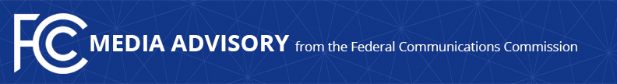

Media Contact:
Paloma Perez
Paloma.Perez@fcc.gov

FCC CHAIRWOMAN TO JOIN TRIBAL REPRESENTATIVES IN NEW MEXICO TO PROMOTE TRIBAL LIBRARY CONNECTIVITY EFFORTS
Rosenworcel to Meet with Tribal Library Representatives to Discuss How Tribal Libraries Can Receive E-Rate Support Following Commission Rule Change
--
WASHINGTON, December 6, 2022—Today, Federal Communications Commission Chairwoman Jessica Rosenworcel will visit Isleta and Laguna Pueblos in northern New Mexico and meet with Tribal library representatives and Tribal leaders from several Pueblos and Navajo Nation, as part of agency efforts to ensure everyone, everywhere has the internet connections they need. She will tour the Laguna Public Library, the Pueblo of Isleta Public Library, and the Indian Pueblo Cultural Center to kick off the FCC’s Tribal Libraries E-Rate re-engagement tour.

The tour aims to amplify agency efforts to ensure Tribal library institutions have equitable access to E-Rate, an FCC-supported program that connects schools and libraries to high-speed internet, ahead of the 2023 E-Rate funding window. For example, the agency recently launched the Tribal Libraries Pilot Program, through which the Universal Service Administrative Company will directly assist Tribal libraries in completing their applications to the funding year 2023 E-Rate Program.

“I’m excited to kick off our efforts to ensure more Tribal libraries receive support through the E-Rate program. For too long, some Tribal libraries were shut off from E-Rate support because they didn’t meet the technical definition of a library in the Commission’s rules,” said Chairwoman Rosenworcel. “We’ve changed that so more Tribal libraries can get the funding they need. The Tribal Libraries Pilot Program will provide one-on-one help to Tribal libraries throughout the sign-up and benefit process and help make participating in E-Rate easier. We want to do everything possible to make sure Tribal communities have full access to the digital age, and I look forward to learning from Tribal leaders and library representatives on what else the FCC can do to help.”

For more information on the FCC’s latest efforts to support Native communities, please visit: https://www.fcc.gov/office-native-affairs-and-policy

###
Media Relations: (202) 418-0500 / ASL: (844) 432-2275 / Twitter: @FCC / www.fcc.gov

This is an unofficial announcement of Commission action. Release of the full text of a Commission order constitutes official action. See MCI v. FCC, 515 F.2d 385 (D.C. Cir. 1974).

