Media Release

Infocomm Media Development Authority (IMDA) of Singapore and the United States Federal Communications Commission signed Memorandum of Understanding (MOU) to promote bilateral cooperation

27 FEBRUARY 2023 – The Infocomm Media Development Authority (IMDA) of Singapore and the United States Federal Communications Commission (FCC) have signed a Memorandum of Understanding (MOU) to enhance cooperation between both countries.

The MOU aims to promote bilateral cooperation on telecommunications regulatory policies. It covers regulatory cooperation and information exchange in emergent areas of communications and connectivity. IMDA and the FCC will also explore technical cooperation and capacity building in the field of telecommunications.

Mr Lew Chuen Hong, Chief Executive of IMDA, said, “Regulatory cooperation and alignment is key to building a framework of support for the growth of the digital economy and inclusive digital societies. We look forward to working with like-minded regulators like the FCC to strengthen our collective capacity for agile response to evolving challenges in technology and connectivity. This will enable us to push global norms forward and build a better digital future.”

Ms Jessica Rosenworcel, Chairwoman of the FCC, said, “The United States and Singapore have a long-standing, important, and expansive partnership. Today, I am very pleased to officially carry that partnership into the telecommunications space with this partnership between IMDA and the FCC. From satellite communications to spectrum management, from protecting consumers to promoting secure networks, there is so much we can do together to support strong economies and safe communities. Thank you to our friends and partners at IMDA.”

The MOU was signed by the Chief Executive of IMDA, Mr Lew Chuen Hong and Chairwoman of the FCC, Ms Jessica Rosenworcel on the sidelines of the Mobile World Conference 2023 in Barcelona, Spain.

__________________________________________________________________________

Photos of the MOU Signing

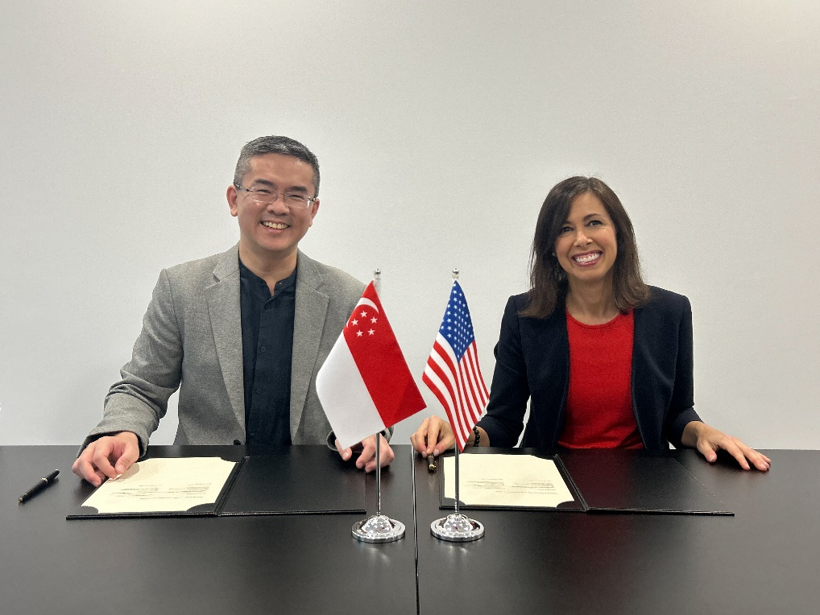

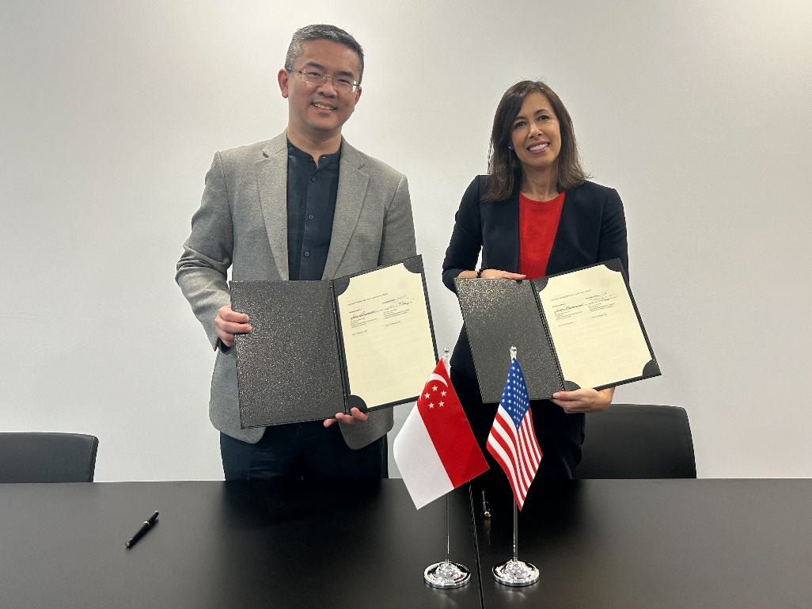

Caption: Chief Executive of IMDA, Mr Lew Chuen Hong and Chairwoman of the FCC, Ms Jessica Rosenworcel signed a Memorandum of Understanding to promote bilateral cooperation.

About the Infocomm Media Development Authority of Singapore

The Infocomm Media Development Authority (IMDA) leads Singapore’s digital transformation by developing a vibrant digital economy and an inclusive digital society. As Architects of Singapore’s Digital Future, we foster growth in Infocomm Technology and Media sectors in concert with progressive regulations, harnessing frontier technologies, and developing local talent and digital infrastructure ecosystems to establish Singapore as a digital metropolis.

For more news and information, visit www.imda.gov.sg or follow IMDA on Facebook (IMDAsg) and Twitter (@IMDAsg).

About the United States Federal Communications Commission

The Federal Communications Commission regulates interstate and international communications by radio, television, wire, satellite, and cable in all 50 states, the District of Columbia and U.S. territories. An independent U.S. government agency overseen by Congress, the Commission is the federal agency responsible for implementing and enforcing America’s communications law and regulations.

For more news and information, visit www.fcc.gov or follow the FCC on Facebook, Twitter, and Instagram.

For media clarification, please contact:

Veronica Lim (Ms)
Communications and Marketing, IMDA
Mobile: (65) 9761 4007
Email: veronica_lim@imda.gov.sg

William Wiquist (Mr)
Media Relations, FCC
Mobile: (202) 418-0509
Email: will_wiquist@fcc.gov

