Communications Status Report for
Areas Impacted by Super Typhoon Mawar
May 24, 2023

The following is a report on the status of communications services in geographic areas impacted by Super Typhoon Mawar as of May 24, 2023, at 8:00 a.m. EDT. This report incorporates network outage data submitted by communications providers to the Federal Communications Commission (FCC) Disaster Information Reporting System (DIRS). Note that the operational status of communications services during an event may evolve rapidly, and this report represents a snapshot in time.
While the FCC activated the DIRS with a modified reporting time of 10:00 p.m., Chamorro Standard Time / 8:00 a.m. (EDT), this reporting time coincided with the Typhoon Mawar striking the northern edge of Guam. Reporting received by the FCC to date is insufficient to produce a comprehensive analysis. The FCC intends to produce greater analyses as information is reported once the storm has passed and it is safe for service providers to assess the status of their networks.
The following territories in Guam and the Commonwealth of the Northern Mariana Islands are in the current geographic area that is part of DIRS (the “disaster area”) for today’s report.
Guam
Commonwealth of the Northern Mariana Islands:
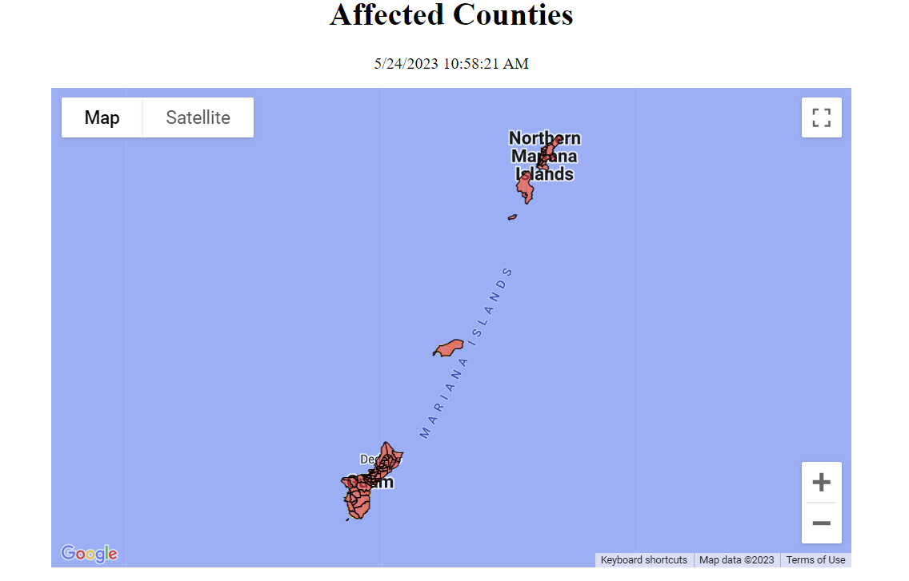
Rota, Saipan, Tinian
Affected Islands

911 Services

The Public Safety and Homeland Security Bureau (PSHSB) learns the status of each Public Safety Answering Point (PSAP) through the filings of 911 Service Providers in DIRS, reporting to the FCC’s Public Safety Support Center, coordination with state 911 Administrators, and, if necessary, direct contact with individual PSAPs.

There have been no reports of PSAPs affected.
Wireless Services

There have been no wireless reports.

Cable Systems and Wireline (Combined)

There have been no cable or wireline reports.

Broadcast:

Television stations status:

- No TV stations reported as being out of service.

FM Radio stations status:
- No FM stations reported as being out of service.

AM Radio stations status:
- No AM stations reported as being out of service.
Special Temporary Authority (STA)/Waivers/Extensions

The Federal Communications Commission (FCC) may grant Special Temporary Authority (STA) to permit immediate or temporary operation of certain radio facilities during emergencies or other urgent conditions, as well as waivers to support emergency communications and service restoration.

