**Communications Status Report for**

**Areas Impacted by Super Typhoon Mawar**

**May 26, 2023**

The following is a report on the status of communications services in geographic areas impacted by Super Typhoon Mawar as of May 26, 2023 at 10:00 p.m. Chamorro Standard Time (CHST) / 8:00 a.m. Eastern Daylight Time (EDT). This report incorporates network outage data submitted by communications providers to the Federal Communications Commission (FCC) Disaster Information Reporting System (DIRS). Note that the operational status of communications services during an event may evolve rapidly, and this report represents a snapshot in time.

The FCC activated the DIRS with a modified reporting time of 10:00 p.m. CHST / 8:00 a.m. EDT, to coincide with Super Typhoon Mawar impacting the northern edge of Guam.

The following territories in Guam and the Commonwealth of the Northern Marianas Islands (CNMI) are in the current geographic area that is part of DIRS (the “disaster area”) for today’s report.

**Guam**

**Commonwealth of the Northern Mariana Islands:**

Rota, Saipan, Tinian



**911 Services**

The Public Safety and Homeland Security Bureau (PSHSB) learns the status of each Public Safety Answering Point (PSAP) through the filings of 911 Service Providers in DIRS, reporting to the FCC’s Public Safety Support Center, coordination with state 911 Administrators, and, if necessary, direct contact with individual PSAPs.

There have been no reports of PSAPs affected.

**Wireless Services**

The following section describes the status of wireless communications services in the disaster area as reported in DIRS.

**Cell Sites Down by Island**

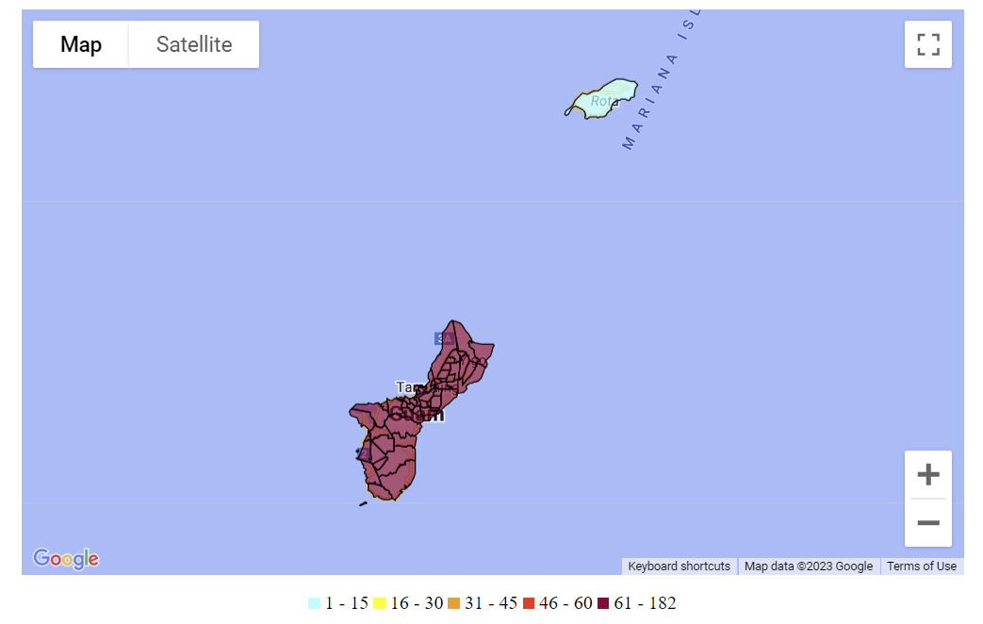

The following chart shows the changes over time in the percent of cell sites out of service:

The following table provides cell sites out of service by island. 51.5% of the cell sites in the affected area are out of service. The information shown was provided by communications carriers providing services in Guam and in the CNMI.

|  |  |  |  |  |  |  |  |  |
| --- | --- | --- | --- | --- | --- | --- | --- | --- |
| **State** | **Affected Counties** | **Cell Sites Served** | **Cell Sites Out** | **Percent Out** | **Cell Sites Out Due to Damage** | **Cell Sites Out Due to Transport** | **Cell Sites Out Due to Power** | **Cell Sites Up but On Back-up Power** |
| GU | GUAM | 313 | 182 | 58.1% | 10 | 15 | 157 | 96 |
| CNMI | SAIPAN | 36 | 0 | 0.0% | 0 | 0 | 0 | 0 |
| CNMI | TINIAN | 3 | 0 | 0.0% | 0 | 0 | 0 | 0 |
| CNMI | ROTA | 5 | 2 | 40.0% | 0 | 0 | 2 | 3 |
| **TOTAL** |  | **357** | **184** | **51.5%** | **10** | **15** | **159** | **99** |

The number of cell site outages in a specific area does not necessarily correspond to the availability of wireless service to consumers in that area. *See* Improving the Resiliency of Mobile Wireless Communications Networks, Order, 31 FCC Rcd 13745, para. 10 (2016) (recognizing the difficulties in accurately depicting the ongoing status of a wireless provider’s service during emergencies). Wireless networks are often designed with numerous, overlapping cell sites that provide maximum capacity and continuity of service even when an individual site is inoperable. In addition, wireless providers may use temporary facilities, such as cells-on-wheels (COWs), increase power at operational sites, initiate roaming agreements, or take other actions to maintain service to affected consumers during emergencies or other events that result in cell site outages.

**Cable Systems and Wireline (Combined)**

There have been no cable or wireline reports.

**Broadcast**:

Television stations status:

* No TV stations reported as being out of service.

FM Radio stations status:

* No FM stations reported as being out of service.

AM Radio stations status:

* No AM stations reported as being out of service.

**Special Temporary Authority (STA)/Waivers/Extensions**

The FCC may grant Special Temporary Authority (STA) to permit immediate or temporary operation of certain radio facilities during emergencies or other urgent conditions, as well as waivers to support emergency communications and service restoration.

There are currently no waivers, STAs, or extensions issued for this event.