Communications Status Report for
Areas Impacted by Super Typhoon Mawar
June 13, 2023

The following is a report on the status of communications services in geographic areas impacted by Super Typhoon Mawar as of June 13, 2023 at 10:00 p.m. Chamorro Standard Time (CHST) / 8:00 a.m. Eastern Daylight Time (EDT). This report incorporates network outage data submitted by communications providers to the Federal Communications Commission (FCC) Disaster Information Reporting System (DIRS). Note that the operational status of communications services during an event may evolve rapidly, and this report represents a snapshot in time.
The FCC activated the DIRS on May 23, 2023 with a modified reporting time of 10:00 p.m. CHST / 8:00 a.m. EDT, to coincide with Super Typhoon Mawar impacting the northern edge of Guam.
On June 5, 2023 the FCC released a Public Notice announcing the narrowing of the DIRS reporting area, deactivating DIRS for the Commonwealth of the Northern Mariana Islands. DIRS remains activated in Guam.
The following territories in Guam are in the current geographic area that is part of DIRS (the “disaster area”) for today’s report.
Guam
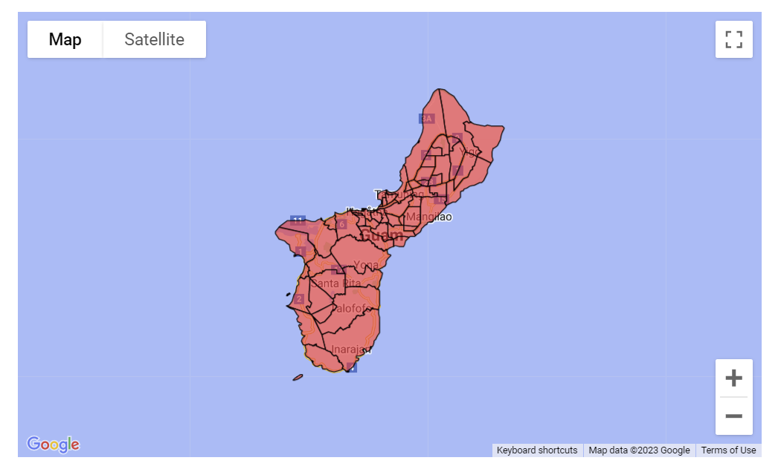

911 Services

The Public Safety and Homeland Security Bureau (PSHSB) learns the status of each Public Safety Answering Point (PSAP) through the filings of 911 Service Providers in DIRS, reporting to the FCC’s Public Safety Support Center, coordination with state 911 Administrators, and, if necessary, direct contact with individual PSAPs.

There have been no reports of PSAPs affected.
Wireless Services

The following section describes the status of wireless communications services in the disaster area as reported in DIRS.

Percent of Cell Sites Down in Guam

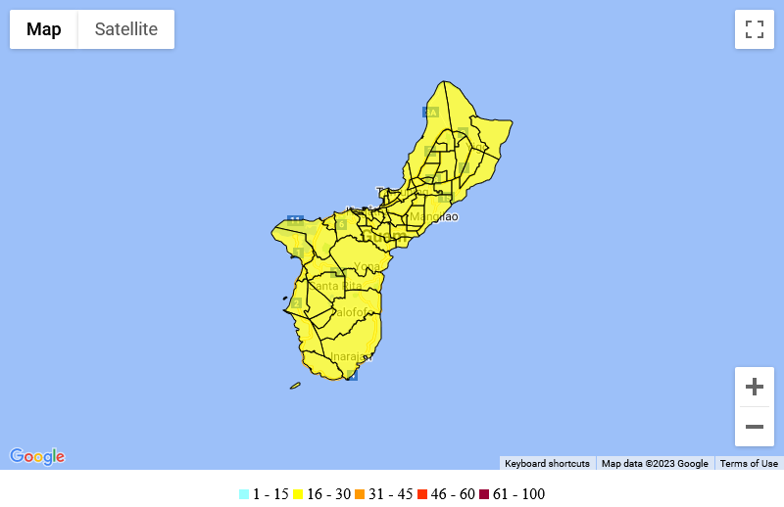

The following chart shows the changes over time in the percent of cell sites out of service:

The following chart shows the reasons wireless service has been out of service:

The following table provides cell sites out of service. 19.9% of the cell sites in the affected area are out of service. The information shown was provided by communications carriers providing services in Guam.

State | Affected Counties | Cell Sites Served | Cell Sites Out | Percent Out | Cell Sites Out Due to Damage | Cell Sites Out Due to Transport | Cell Sites Out Due to Power | Cell Sites Up but On Back-up Power
GU | GUAM | 327 | 65 | 19.9% | 7 | 10 | 51 | 131
TOTAL |  | 327 | 65 | 19.9% | 7 | 10 | 51 | 131

The number of cell site outages in a specific area does not necessarily correspond to the availability of wireless service to consumers in that area. See Improving the Resiliency of Mobile Wireless Communications Networks, Order, 31 FCC Rcd 13745, para. 10 (2016) (recognizing the difficulties in accurately depicting the ongoing status of a wireless provider’s service during emergencies). Wireless networks are often designed with numerous, overlapping cell sites that provide maximum capacity and continuity of service even when an individual site is inoperable. In addition, wireless providers may use temporary facilities, such as cells-on-wheels (COWs), increase power at operational sites, initiate roaming agreements, or take other actions to maintain service to affected consumers during emergencies or other events that result in cell site outages.

Cable Systems and Wireline (Combined)

Cable and wireline companies reported 2,326 subscribers out of service the disaster area; this may include the loss of telephone, television, and/or Internet services.

Broadcast:

Television stations status:

- 1 TV station reported as being out of service (KGTF).

FM Radio stations status:
- 3 FM stations reported as being out of service (KSTO, KISH, K290CR).

AM Radio stations status:
- 1 AM station reported as being out of service (KTWG).

Special Temporary Authority (STA)/Waivers/Extensions

The FCC may grant Special Temporary Authority (STA) to permit immediate or temporary operation of certain radio facilities during emergencies or other urgent conditions, as well as waivers to support emergency communications and service restoration.

- May 25, 2023, Office of International Relations granted STA to Trans World Radio Pacific (KTWR).

- May 28, 2023, Media Bureau granted emergency STA to Nimitz Carrier Group to broadcast on commercial FM in Guam until May 31, 2023. On May 30, 2023 Media Bureau granted an extension until June 30, 2023.

- May 29, 2023, Media Bureau granted STA to Good News Broadcasting Corporation (KSDA-FM).

- May 30, 2023, Wireless Telecommunications Bureau, Mobility Division, conditionally granted an emergency waiver of sections 96.67(c)(2) and (3) of the Commission’s rules governing the Citizens Broadband Radio Service.

- May 31, 2023, Media Bureau granted STA to Guam Education Telecommunications Corporation (KGTF).

- On June 5, 2023, Office of Engineering and Technology, Experimental Licensing Branch, granted Oceus Networks a STA.

- On June 9, 2023, Wireless Telecommunications Bureau, Mobility Division granted T-Mobile a 60-day STA.

