Before the
Federal Communications Commission
Washington, D.C. 20554

In the Matter of  Amendment of the Commission’s Rules Regarding Implementation of the Final Acts of the World Radiocommunications Conference (Sharm el-Sheik, 2019) (WRC-19), Other Allocation Issues, and Related Rule Updates | )  )  )  )  )  )  )  ) | ET Docket No. 23-121

ERRATUM

Released: October 11, 2023

By the Managing Director and the Chief, Office of Engineering and Technology:

On April 21, 2023, the Commission released an Order and Notice of Proposed Rulemaking, FCC 23-26, in the above-captioned proceeding. To conform to the publishing conventions of the National Archives and Records Administration’s Office of the Federal Register, the Managing Director and the Chief of the Office of Engineering and Technology find that it is necessary to revise the Order to effect publication in the Federal Register. Doing so is also necessary to reconcile the Order with revisions to 47 CFR 2.106 that became effective after adoption of the Order. Pursuant to 47 CFR §§ 0.31, 0.231(b), and 0.241(a)(1)(ii), (b), and (i), this Erratum replaces Appendix A of the Order and Notice of Proposed Rulemaking with a new Appendix A, which contains non-substantive modifications to the amendatory language that describes the revisions to section 2.106(a) through (e); it also contains minor modifications to the codified text, including the numbering of footnotes to Table of Frequency Allocations, that do not affect its meaning.

FEDERAL COMMUNICATIONS COMMISSION

Mark Stephens
Managing Director

Ronald T. Repasi
Chief
Office of Engineering and Technology

APPENDIX A

Final Rules

The Federal Communications Commission amends 47 CFR part 2 as follows:

PART 2 – FREQUENCY ALLOCATIONS AND RADIO TREATY MATTERS; GENERAL RULES AND REGULATIONS

1. The authority citation for part 2 continues to read as follows:
Authority: 47 U.S.C. 154, 302a, 303, and 336, unless otherwise noted.
2. Amend § 2.106 as follows:
a. Revise pages 3, 4, 19 through 28, 30, 33, 34, 38 through 42, 50, 52 through 56, 58 through 60, 62, 66, and 68 in paragraph (a);
b. Revise paragraphs (b)(67) introductory text, (b)(67)(ii), and (b)(70);
c. Remove and reserve paragraph (b)(71);
d. Revise paragraphs (b)(77) and (79);
e. Add paragraph (b)(82)(i) and reserved paragraph (b)(82)(ii);
f. Revise paragraphs (b)(87), (107), (109) through (112), (114), (117), (118), (123), and (128), (b)(132) introductory text, (b)(132)(ii), (b)(133)(i) and (ii), (b)(134), (b)(141)(ii), (b)(145) introductory text, (b)(145)(ii), (b)(146) and (147), (b)(149) through (155), (b)(156) introductory text, (b)(156)(i), (b)(157) through (159), (b)(161)(i) and (ii), (b)(162)(i), and (b)(163) through (165);
g. Add paragraph (b)(166);
h. Revise paragraphs (b)(169), (171), (194), (201), and (202);
i. Add paragraph (b)(203);
j. Revise paragraphs (b)(204) and (b)(208)(i) and (ii);
k. Add paragraph (b)(209)(i) and reserved (b)(209)(ii);
l. Revise paragraphs (b)(211), (212), and (214);
m. Add paragraph (b)(218)(i) and reserved (b)(218)(ii);
n. Revise paragraphs (219) and (221);
o. Redesignate paragraphs (b)(228)(i) through (vii) as paragraphs (b)(228)(iii) through (ix) and add new paragraphs (b)(228)(i) and (ii);
p. Revise paragraphs (b)(242) and (252);
r. Add paragraphs (b)(260) and (b)(264)(i) and (ii);
s. Revise paragraphs (b)(265), (275), (277), and (278), (b)(279) introductory text, (b)(279)(i), (b)(280), (b)(286)(ii), (b)(287), (288), and (295), (b)(296) introductory text, (b)(296)(i), (b)(297), (b)(308) introductory text, and (b)(308)(i);
t. Remove and reserve paragraph (b)(311);
u. Revise paragraphs (b)(312) introductory text, (b)(312)(i), (b)(313) and (316), (b)(317)(i), (b)(323), (b)(325)(i), (b)(328)(ii) and (iii), (b)(329) and (331), (b)(338)(i), (b)(341)(i) through (iii), (b)(345), (346), (349), and (350), (b)(351)(i), (b)(352), (359), (368), and (372);
t. Add paragraph (b)(373);
u. Revise paragraphs (b)(382), (b)(384)(i), (b)(388) introductory text, (b)(388)(ii), (b)(389)(i) and (iv), and (b)(393);
v. Remove and reserve paragraph (b)(396);
w. Revise paragraphs (b)(401), (418), and (428), (b)(429) introductory text, (b)(429)(i) through (iv) and (vi), (b)(430) introductory text, (b)(430)(i), (b)(431) introductory text, (b)(432), (b)(433)(i), (b)(434), (b)(441)(i) and (ii), (b)(444)(ii), and (b)(446)(i) and (iii);
x. Add paragraph (b)(446)(iv);
y. Revise paragraphs (b)(447) introductory text, (b)(447)(vi), (b)(448), (b)(450)(i), (b)(453), (455), (458), and (468), (b)(473) introductory text, (b)(474)(iv), (b)(477), (b)(478) introductory text, (b)(479) through (481) and (483), (b)(484)(ii), (b)(495) and (505), (b)(508) introductory text, (b)(509)(iii), and (b)(516)(ii);
z. Add paragraph (b)(517)(i) and reserved paragraph (b)(517)(ii);
aa. Revise paragraph (b)(530)(ii);
bb. Redesignate paragraph (b)(532)(ii) as paragraph (b)(532)(iv) and add new paragraph (b)(532)(ii) and paragraph (b)(532)(iii);
cc. Add paragraph (b)(534);
dd. Revise paragraphs (b)(536)(i) and (ii), (b)(537)(i), (b)(543)(i), and (b)(546) and (547);
ee. Add paragraphs (b)(550)(ii) through (v);
ff. Revise paragraph (b)(552)(i).
gg. Add paragraphs (b)(553)(i) and (ii), and (b)(555)(ii);
hh. Revise paragraph (b)(559)(i);
ii. Add paragraph (b)(559)(ii);
jj. Revise paragraph (b)(562)(ii);
kk. Remove and reserve paragraphs (b)(562)(vi) and (vii);
ll. Add paragraph (b)(564);
mm. Revise paragraph (c)(1)
nn. Redesignate Note 2 to paragraph (c)(22)(ii)(B) as Note 4 to § 2.106(c)(22)(ii)(B);
oo. Revise paragraph (c)(52);
pp. Add paragraph (c)(79)(iii);
qq. Revise paragraph (c)(82);
rr. Redesignate Note 3 to table 4 to paragraph (c)(83) as Note 5 to table 4 to § 2.106(c)(83);
ss. Redesignate Note 4 to paragraph (c)(88)(ii) as Note 6 to § 2.106(c)(88)(ii);
tt. Redesignate Note 5 to paragraph (c)(91)(ii)(B) as Note 7 to § 2.106(c)(91)(ii)(B);
uu. Redesignate Note 6 to paragraph (c)(91)(ii)(C) as Note 8 to § 2.106(c)(91)(ii)(C);
vv. Redesignate Note 7 to paragraph (c)(97) as Note 9 to § 2.106(c)(97);
ww. Revise paragraph (c)(100);
xx. Redesignate Note 8 to paragraph (c)(136)(ii) as Note 10 to § 2.106(c)(136)(ii);
yy. Redesignate Note 9 to paragraph (c)(161)(ii) as Note 11 to § 2.106(c)(161)(ii);
zz. Revise paragraphs (c)(247), (281), (283), (296), (312), and (342), and (c)(444)(ii);
aaa. Redesignate Note 10 to paragraph (c)(565) as Note 12 to § 2.106(c)(565);
bbb. Revise paragraph (d)(33);
ccc. Redesignate Note 11 to paragraph (d)(53) as Note 13 to paragraph (d)(53);
ddd. Revise paragraph (d)(169);
eee. Remove and reserve paragraph (d)(185); and
fff. Revise paragraphs (e)(2), (32), (115), and (132).
The revisions and additions read as follows:

§ 2.106 Table of Frequency Allocations.

(a) * * *

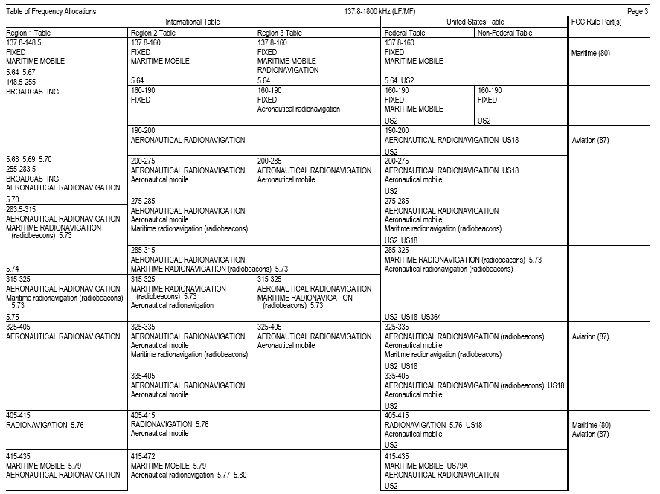

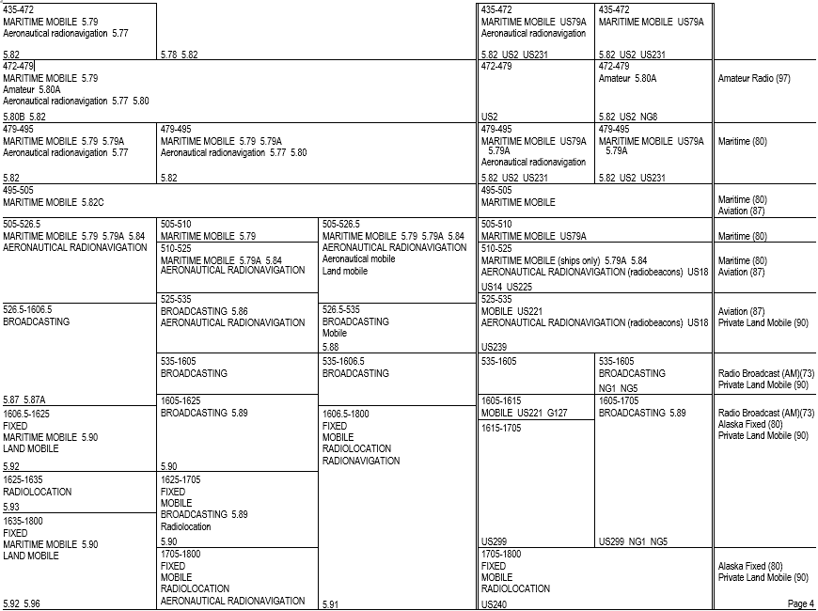
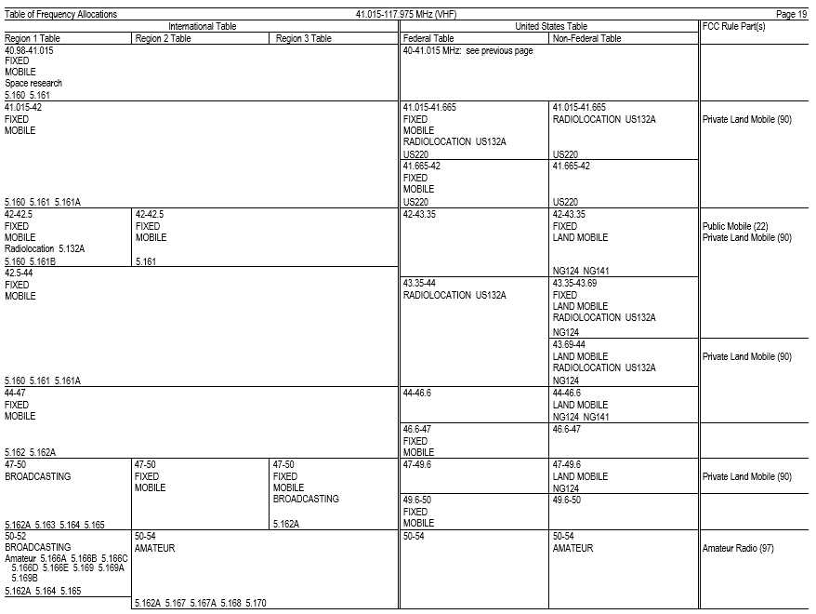
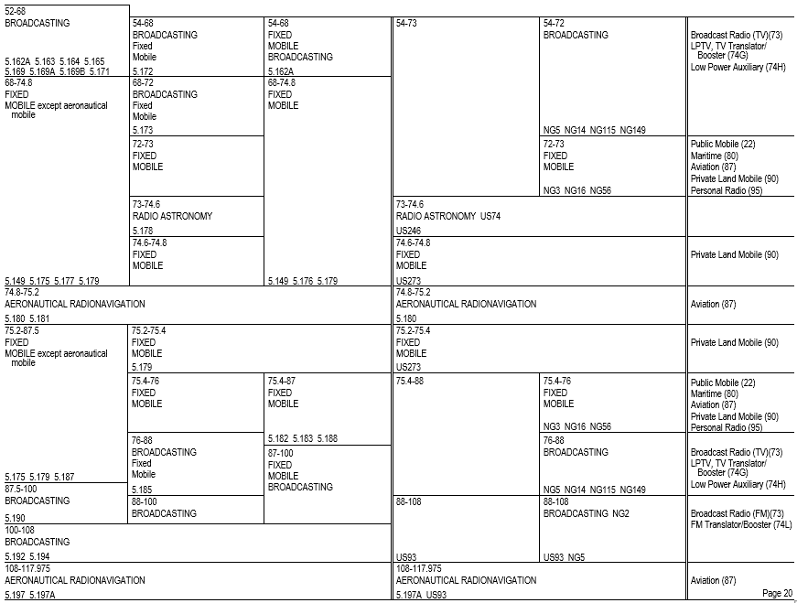
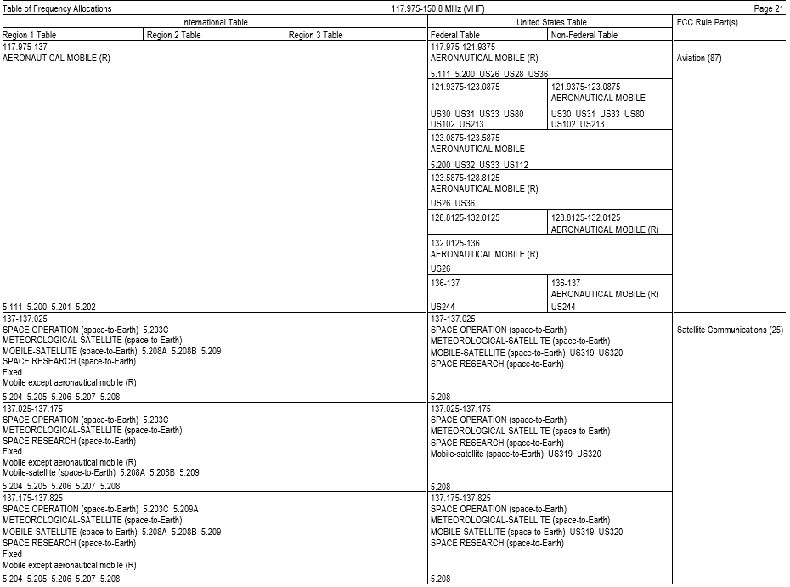
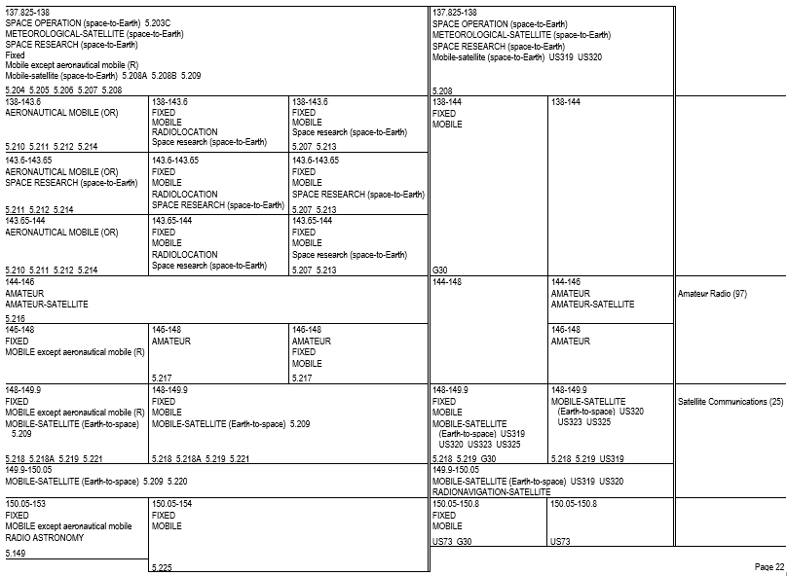
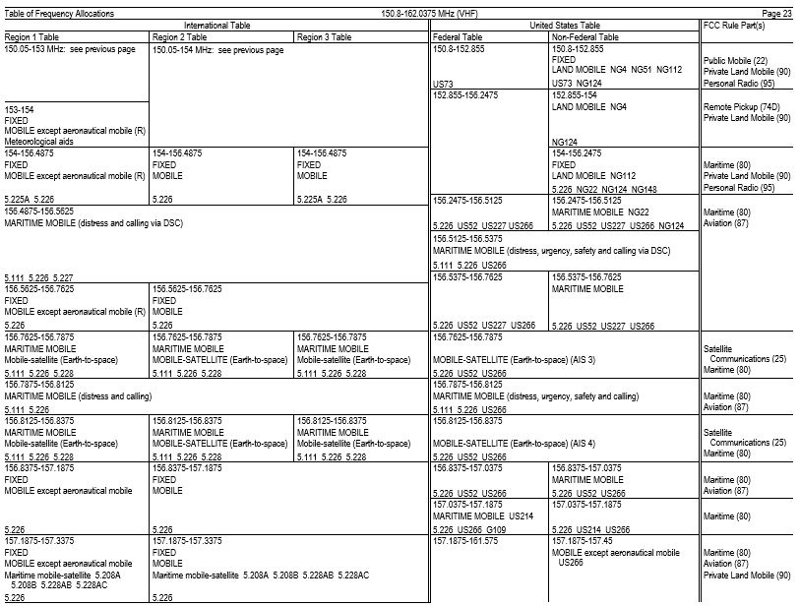

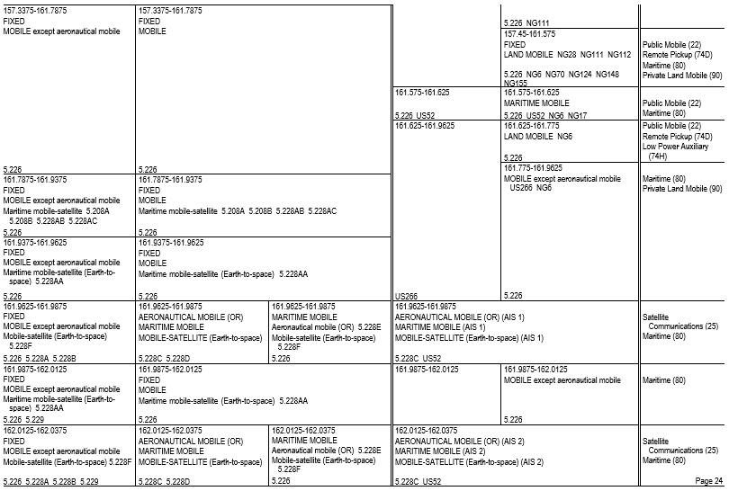
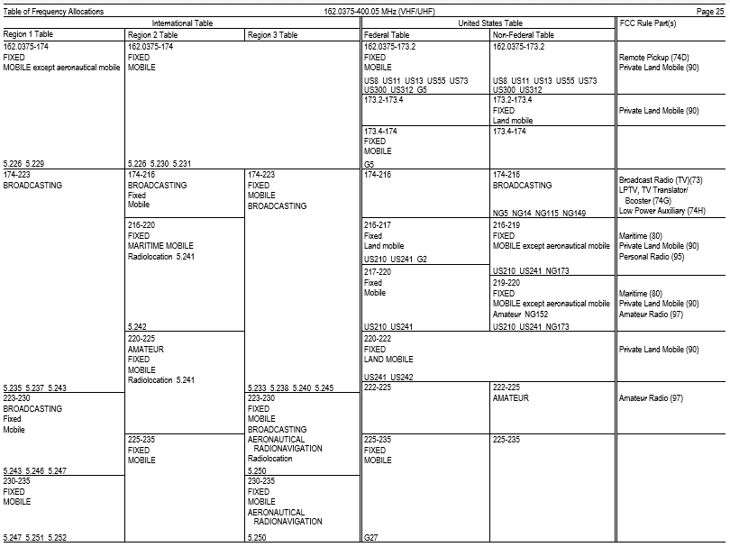

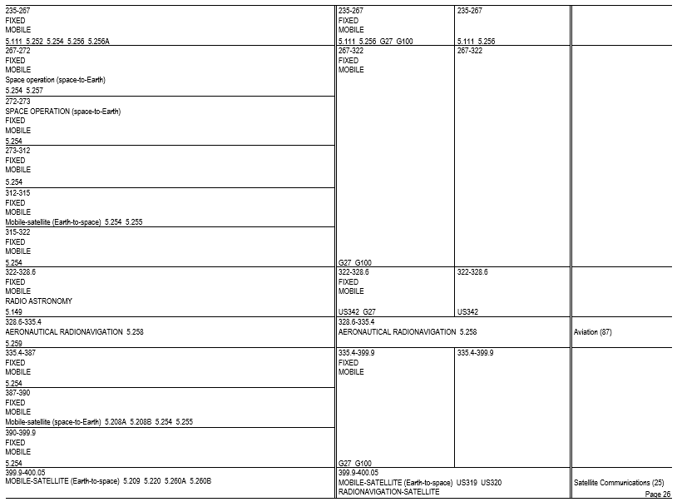

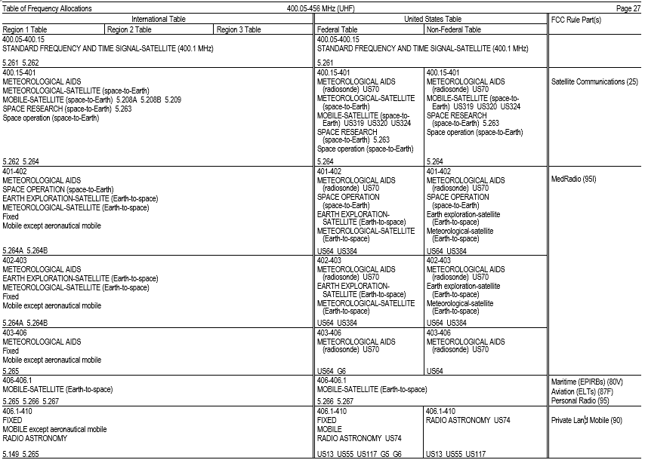
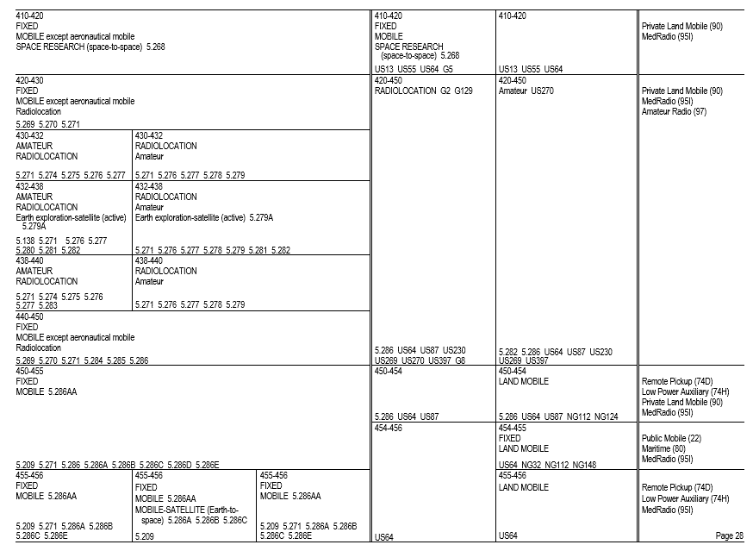

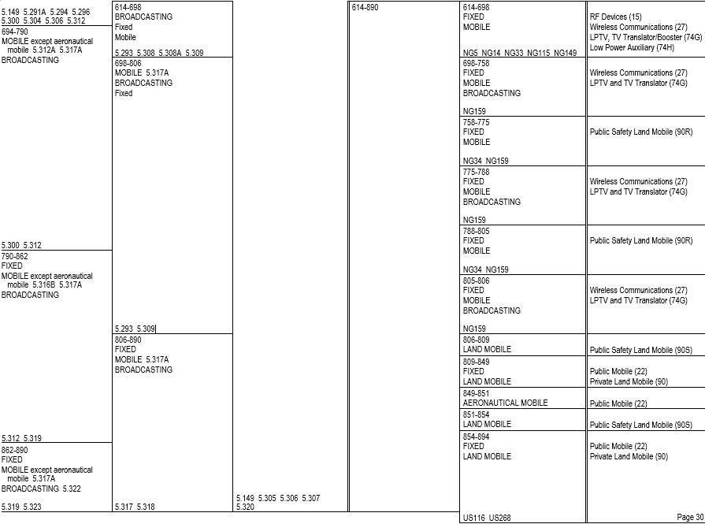

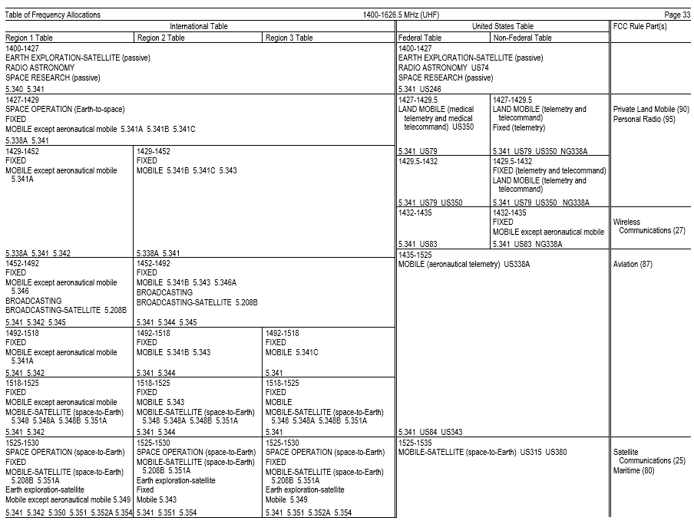

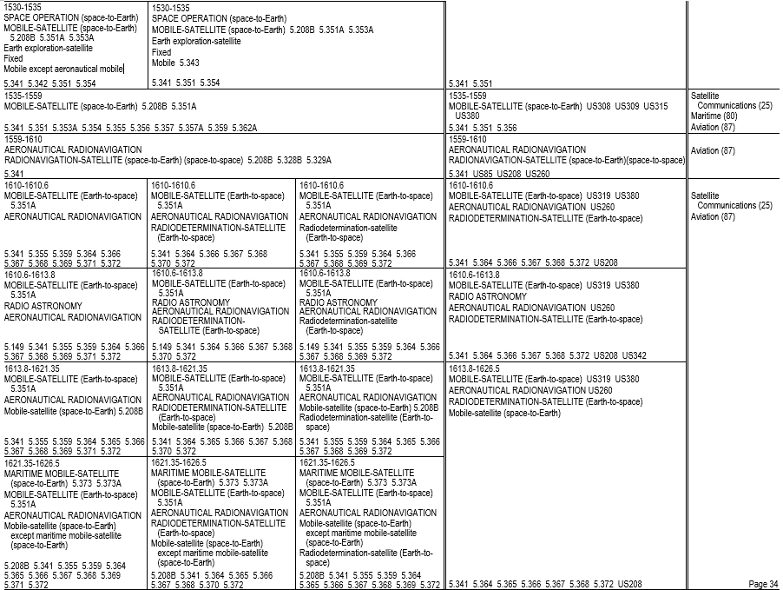

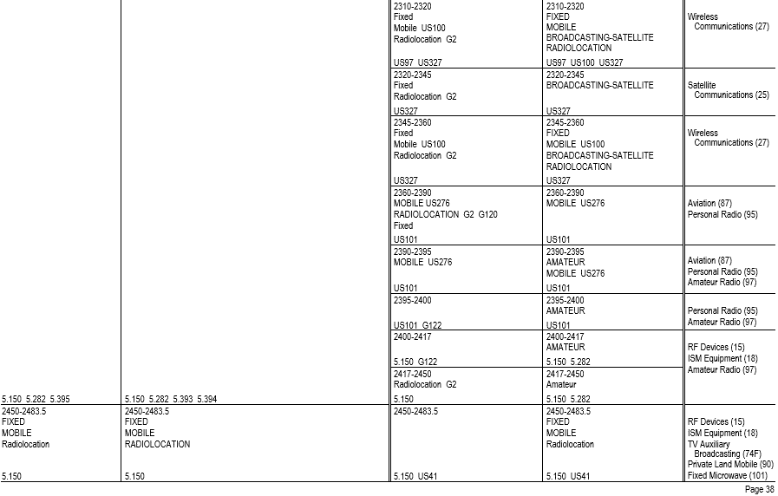
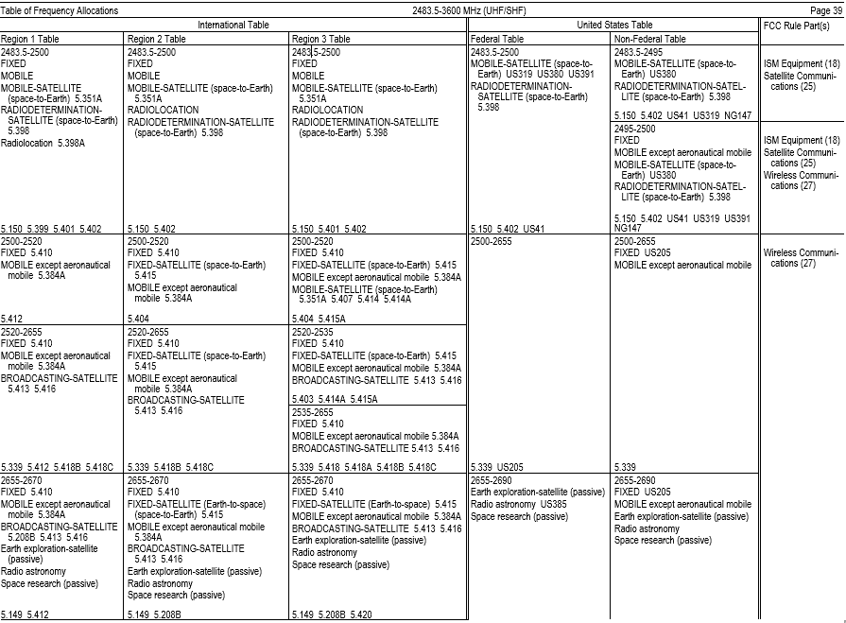

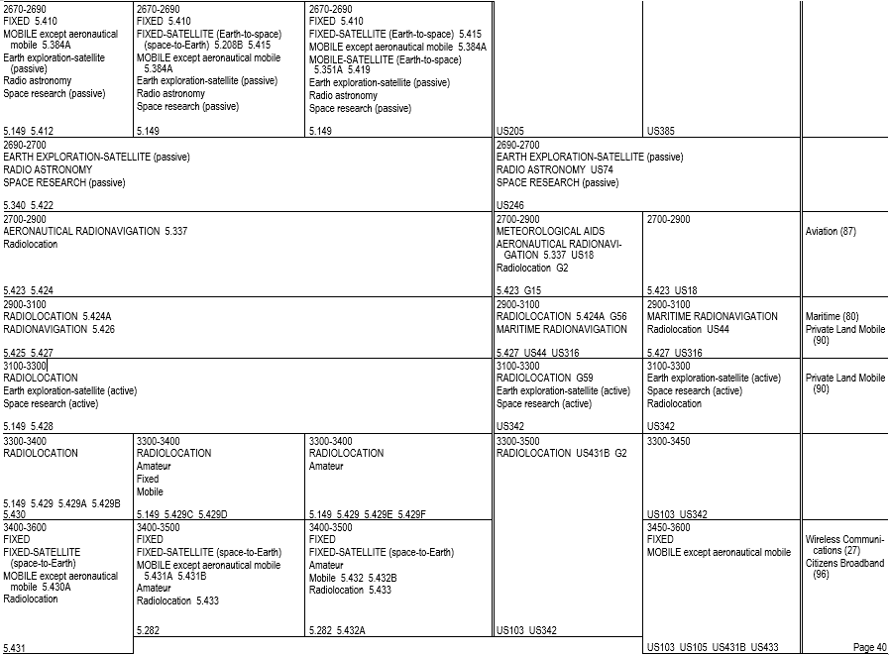

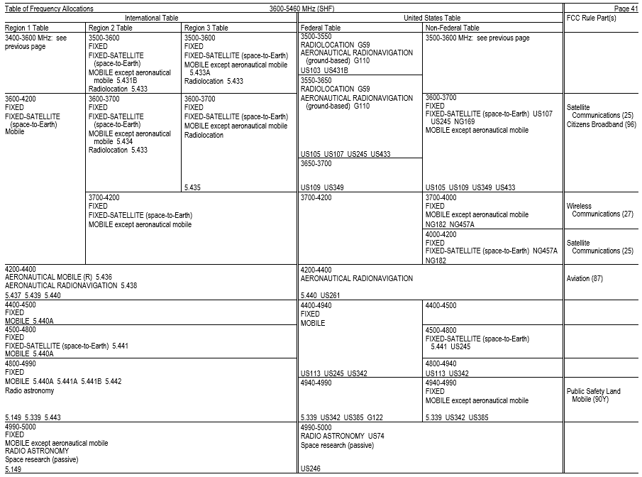

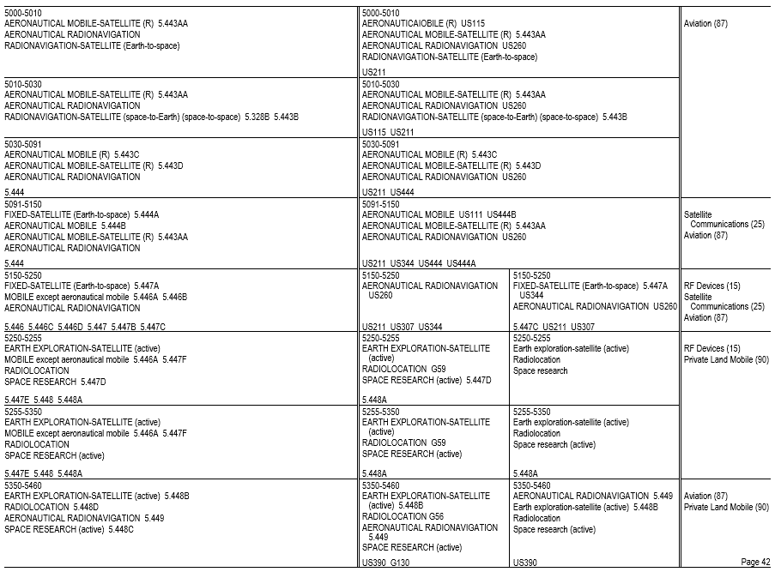

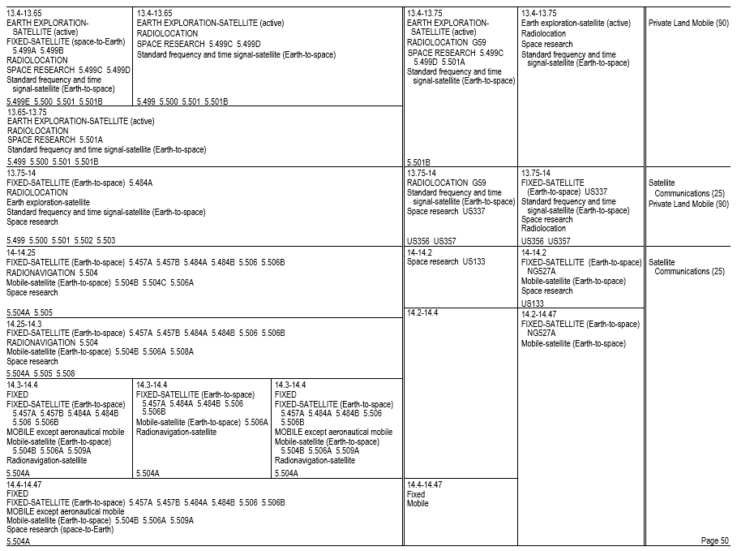
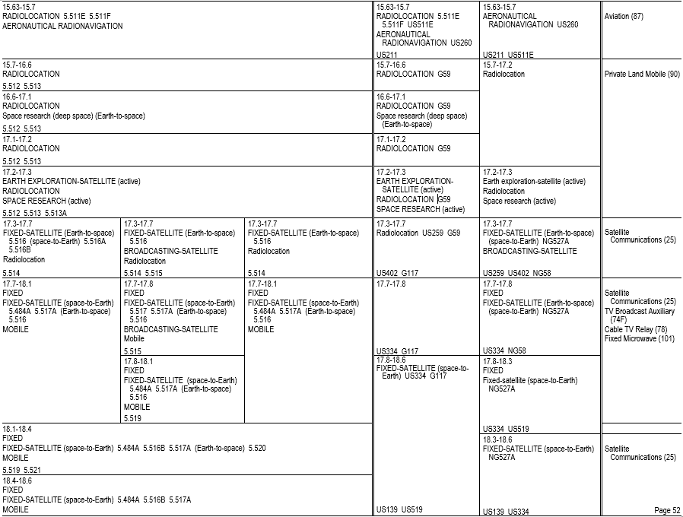

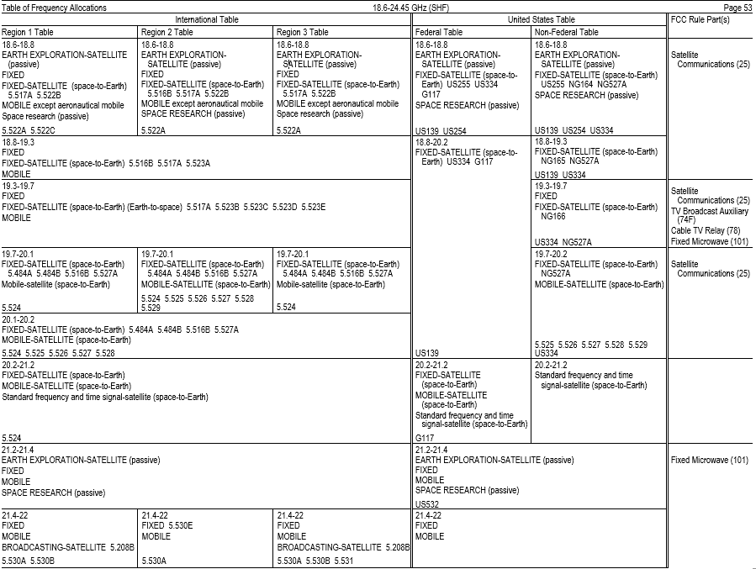

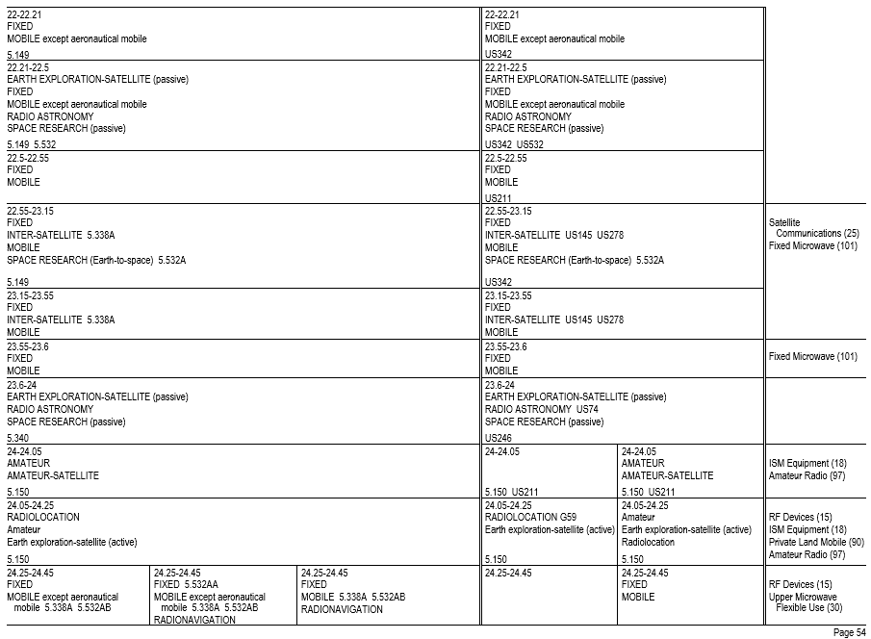
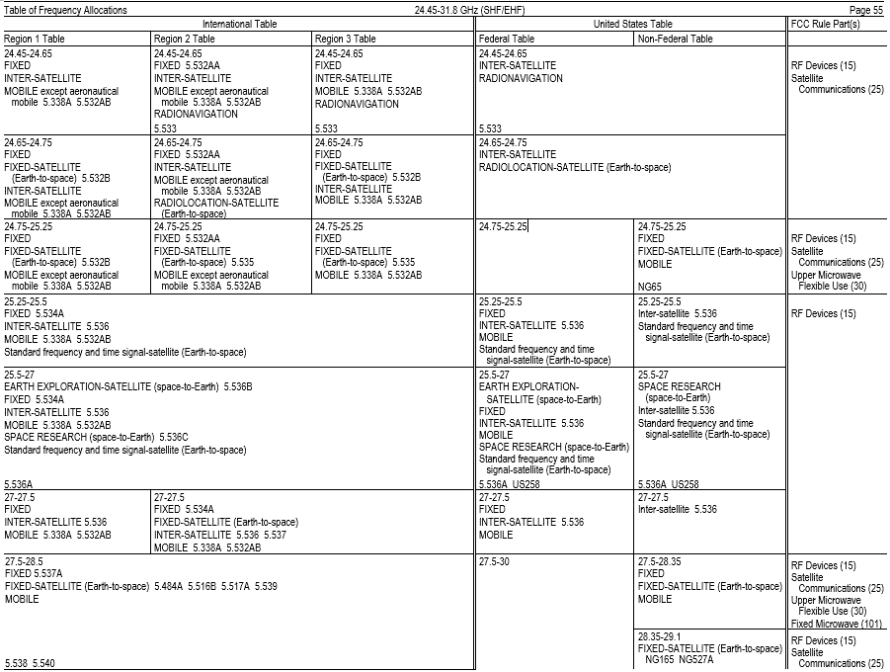

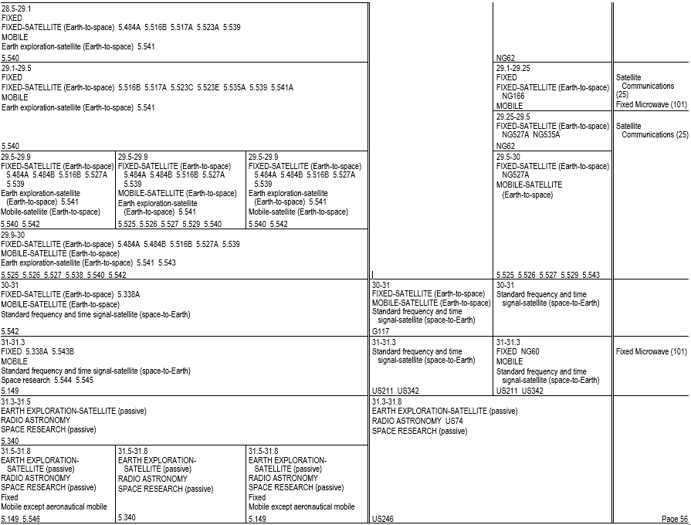

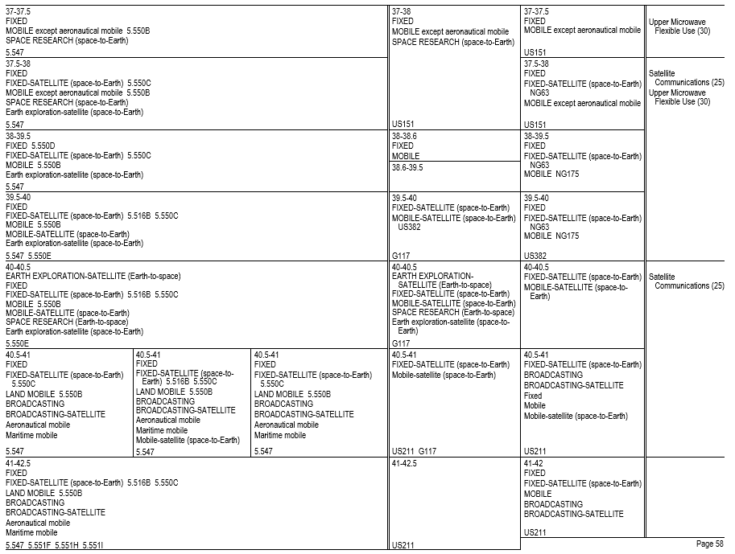

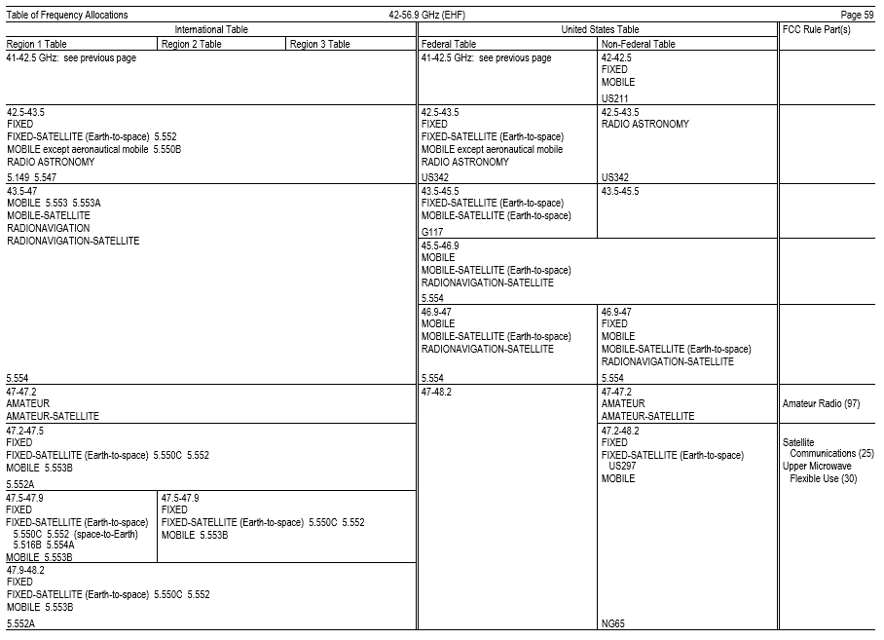

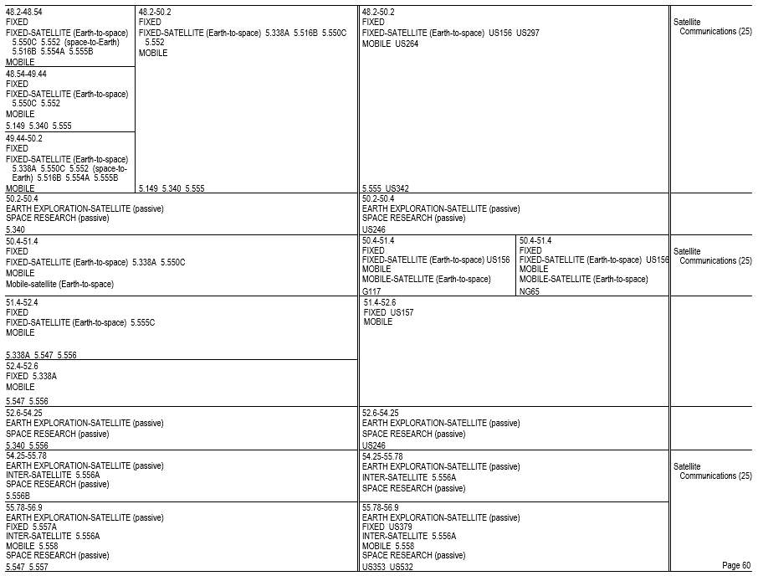

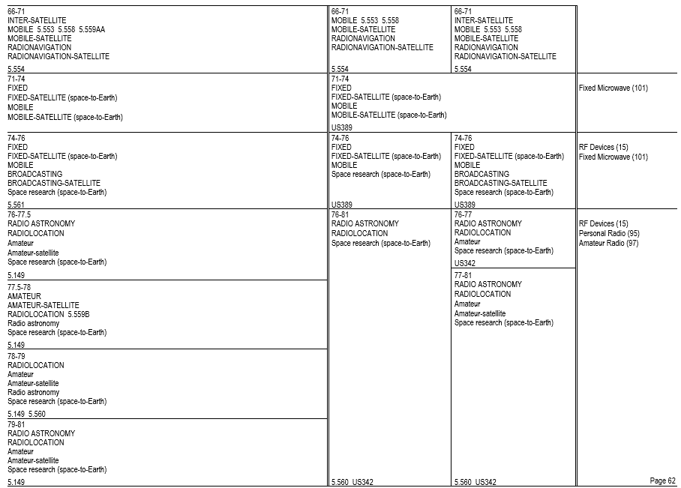

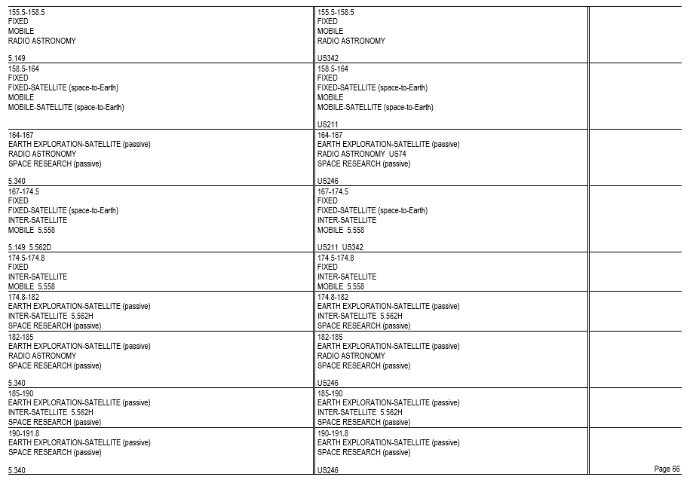
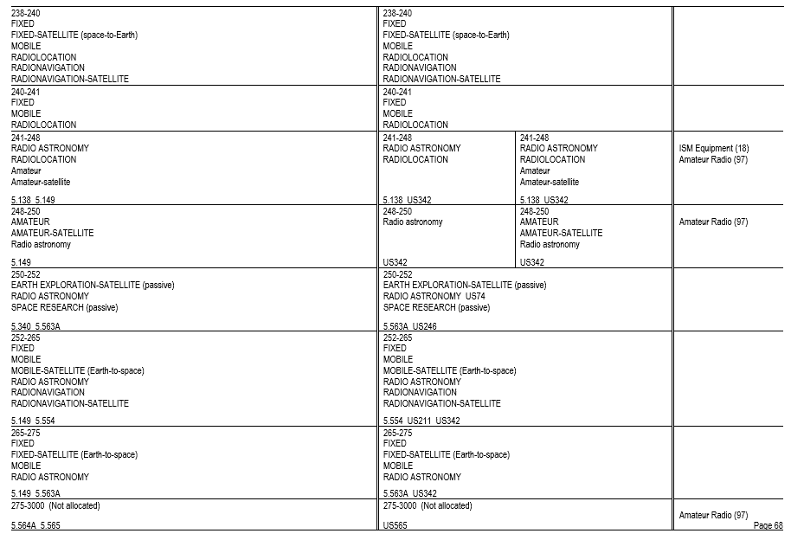
* * * * *
(b) * * *
(67) 5.67 Additional allocation: in Kyrgyzstan and Turkmenistan, the frequency band 130-148.5 kHz is also allocated to the radionavigation service on a secondary basis. Within and between these countries this service shall have an equal right to operate.
* * * * *
(ii) 5.67B The use of the frequency band 135.7-137.8 kHz in Algeria, Egypt, Iraq, Lebanon, Syrian Arab Republic, Sudan, South Sudan and Tunisia is limited to the fixed and maritime mobile services. The amateur service shall not be used in the previously-mentioned countries in the frequency band 135.7-137.8 kHz, and this should be taken into account by the countries authorizing such use.
* * * * *
(70) 5.70 Alternative allocation: in Angola, Botswana, Burundi, the Central African Rep., Congo (Rep. of the), Eswatini, Ethiopia, Kenya, Lesotho, Madagascar, Malawi, Mozambique, Namibia, Nigeria, Oman, the Dem. Rep. of the Congo, South Africa, Tanzania, Chad, Zambia and Zimbabwe, the frequency band 200-283.5 kHz is allocated to the aeronautical radionavigation service on a primary basis.
* * * * *
(77) 5.77 Different category of service: in Australia, China, the French overseas communities of Region 3, Korea (Rep. of), India, Iran (Islamic Republic of), Japan, Pakistan, Papua New Guinea, the Dem. People’s Rep. of Korea and Sri Lanka, the allocation of the frequency band 415-495 kHz to the aeronautical radionavigation service is on a primary basis. In Armenia, Azerbaijan, Belarus, the Russian Federation, Kazakhstan, Latvia, Uzbekistan and Kyrgyzstan, the allocation of the frequency band 435-495 kHz to the aeronautical radionavigation service is on a primary basis. Administrations in all the aforementioned countries shall take all practical steps necessary to ensure that aeronautical radionavigation stations in the frequency band 435-495 kHz do not cause interference to reception by coast stations of transmissions from ship stations on frequencies designated for ship stations on a worldwide basis.
* * * * *
(79) 5.79 In the maritime mobile service, the frequency bands 415-495 kHz and 505-526.5 kHz are limited to radiotelegraphy and may also be used for the NAVDAT system in accordance with the most recent version of Recommendation ITU-R M.2010, subject to agreement between interested and affected administrations. NAVDAT transmitting stations are limited to coast stations.
* * * * *
(82) * * *
(i) 5.82C The frequency band 495-505 kHz is used for the international NAVDAT system as described in the most recent version of Recommendation ITU-R M.2010. NAVDAT transmitting stations are limited to coast stations.
(ii) [Reserved]
* * * * *
(87) 5.87 Additional allocation: in Angola, Botswana, Eswatini, Lesotho, Malawi, Mozambique, Namibia and Niger, the frequency band 526.5-535 kHz is also allocated to the mobile service on a secondary basis.
* * * * *
(107) 5.107 Additional allocation: in Saudi Arabia, Eritrea, Eswatini, Ethiopia, Iraq, Libya and Somalia, the frequency band 2160-2170 kHz is also allocated to the fixed and mobile, except aeronautical mobile (R), services on a primary basis. The mean power of stations in these services shall not exceed 50 W.
* * * * *
(109) 5.109 The frequencies 2187.5 kHz, 4207.5 kHz, 6312 kHz, 8414.5 kHz, 12 577 kHz and 16 804.5 kHz are international distress frequencies for digital selective calling. The conditions for the use of these frequencies are prescribed in Article 31.
(110) 5.110 The frequencies 2174.5 kHz, 4177.5 kHz, 6268 kHz, 8376.5 kHz, 12 520 kHz and 16 695 kHz are international distress frequencies for narrow-band direct-printing telegraphy. The conditions for the use of these frequencies are prescribed in Article 31.
(111) 5.111 The carrier frequencies 2182 kHz, 3023 kHz, 5680 kHz, 8364 kHz and the frequencies 121.5 MHz, 156.525 MHz, 156.8 MHz and 243 MHz may also be used, in accordance with the procedures in force for terrestrial radiocommunication services, for search and rescue operations concerning manned space vehicles. The conditions for the use of the frequencies are prescribed in Article 31. The same applies to the frequencies 10 003 kHz, 14 993 kHz and 19 993 kHz, but in each of these cases emissions must be confined in a band of ± 3 kHz about the frequency.
(112) 5.112 Alternative allocation: in Sri Lanka, the frequency band 2194-2300 kHz is allocated to the fixed and mobile, except aeronautical mobile, services on a primary basis.
* * * * *
(114) 5.114 Alternative allocation: in Iraq, the frequency band 2502-2625 kHz is allocated to the fixed and mobile, except aeronautical mobile, services on a primary basis.
* * * * *
(117) 5.117 Alternative allocation: in Côte d'Ivoire, Egypt, Liberia, Sri Lanka and Togo, the frequency band 3155-3200 kHz is allocated to the fixed and mobile, except aeronautical mobile, services on a primary basis.
(118) 5.118 Additional allocation: in the United States, Mexico and Peru, the frequency band 3230-3400 kHz is also allocated to the radiolocation service on a secondary basis.
* * * * *
(123) 5.123 Additional allocation: in Botswana, Eswatini, Lesotho, Malawi, Mozambique, Namibia, South Africa, Zambia and Zimbabwe, the frequency band 3900-3950 kHz is also allocated to the broadcasting service on a primary basis, subject to agreement obtained under No. 9.21.
* * * * *
(128) 5.128 Frequencies in the frequency bands 4063-4123 kHz and 4130-4438 kHz may be used exceptionally by stations in the fixed service, communicating only within the boundary of the country in which they are located, with a mean power not exceeding 50 W, on condition that harmful interference is not caused to the maritime mobile service. In addition, in Afghanistan, Argentina, Armenia, Belarus, Botswana, Burkina Faso, the Central African Rep., China, the Russian Federation, Georgia, India, Kazakhstan, Mali, Niger, Pakistan, Kyrgyzstan, Tajikistan, Chad, Turkmenistan and Ukraine, in the frequency bands 4063-4123 kHz, 4130-4133 kHz and 4408-4438 kHz, stations in the fixed service, with a mean power not exceeding 1 kW, can be operated on condition that they are situated at least 600 km from the coast and that harmful interference is not caused to the maritime mobile service.
* * * * *
(132) 5.132 The frequencies 4210 kHz, 6314 kHz, 8416.5 kHz, 12579 kHz, 16 806.5 kHz, 19 680.5 kHz, 22 376 kHz and 26 100.5 kHz are the international frequencies for the transmission of maritime safety information (MSI) (see Appendix 17).
* * * * *
(ii) 5.132B Alternative allocation: in Armenia, Belarus, Moldova and Kyrgyzstan, the frequency band 4438-4488 kHz is allocated to the fixed and mobile, except aeronautical mobile (R), services on a primary basis.
(133) * * *
(i) 5.133A Alternative allocation: in Armenia, Belarus, Moldova and Kyrgyzstan, the frequency bands 5250-5275 kHz and 26 200-26 350 kHz are allocated to the fixed and mobile, except aeronautical mobile, services on a primary basis.
(ii) 5.133B Stations in the amateur service using the frequency band 5351.5-5366.5 kHz shall not exceed a maximum radiated power of 15 W (e.i.r.p.). However, in Region 2 in Mexico, stations in the amateur service using the frequency band 5351.5-5366.5 kHz shall not exceed a maximum radiated power of 20 W (e.i.r.p.). In the following Region 2 countries: Antigua and Barbuda, Argentina, Bahamas, Barbados, Belize, Bolivia, Brazil, Chile, Colombia, Costa Rica, Cuba, Dominican Republic, Dominica, El Salvador, Ecuador, Grenada, Guatemala, Guyana, Haiti, Honduras, Jamaica, Nicaragua, Panama, Paraguay, Peru, Saint Lucia, Saint Kitts and Nevis, Saint Vincent and the Grenadines, Suriname, Trinidad and Tobago, Uruguay, Venezuela, as well as the overseas countries and territories within the Kingdom of the Netherlands in Region 2, stations in the amateur service using the frequency band 5351.5-5366.5 kHz shall not exceed a maximum radiated power of 25 W (e.i.r.p.).
(134) 5.134 The use of the frequency bands 5900-5950 kHz, 7300-7350 kHz, 9400-9500 kHz, 11 600-11 650 kHz, 12 050-12 100 kHz, 13 570-13 600 kHz, 13 800-13 870 kHz, 15 600-15 800 kHz, 17 480-17 550 kHz and 18 900-19 020 kHz by the broadcasting service is subject to the application of the procedure of Article 12. Administrations are encouraged to use these frequency bands to facilitate the introduction of digitally modulated emissions in accordance with the provisions of Resolution 517 (Rev.WRC-19).
* * * * *
(141) * * *
(ii) 5.141B Additional allocation: in Algeria, Saudi Arabia, Australia, Bahrain, Botswana, Brunei Darussalam, China, Comoros, Korea (Rep. of), Diego Garcia, Djibouti, Egypt, United Arab Emirates, Eritrea, Guinea, Indonesia, Iran (Islamic Republic of), Japan, Jordan, Kuwait, Libya, Mali, Morocco, Mauritania, Niger, New Zealand, Oman, Papua New Guinea, Qatar, the Syrian Arab Republic, the Dem. People’s Rep. of Korea, Singapore, Sudan, South Sudan, Tunisia, Viet Nam and Yemen, the frequency band 7100-7200 kHz is also allocated to the fixed and the mobile, except aeronautical mobile (R), services on a primary basis.
* * * * *
(145) 5.145 The conditions for the use of the carrier frequencies 8291 kHz, 12 290 kHz and 16 420 kHz are prescribed in Articles 31 and 52.
* * * * *
(ii) 5.145B Alternative allocation: in Armenia, Belarus, Moldova and Kyrgyzstan, the frequency bands 9305-9355 kHz and 16 100-16 200 kHz are allocated to the fixed service on a primary basis.
(146) 5.146 Additional allocation: frequencies in the bands 9400-9500 kHz, 11 600-11 650 kHz, 12 050-12 100 kHz, 15 600-15 800 kHz, 17 480-17 550 kHz and 18 900-19 020 kHz may be used by stations in the fixed service, communicating only within the boundary of the country in which they are located, on condition that harmful interference is not caused to the broadcasting service. When using frequencies in the fixed service, administrations are urged to use the minimum power required and to take account of the seasonal use of frequencies by the broadcasting service published in accordance with the Radio Regulations.
(147) 5.147 On condition that harmful interference is not caused to the broadcasting service, frequencies in the bands 9775-9900 kHz, 11 650-11 700 kHz and 11 975-12 050 kHz may be used by stations in the fixed service communicating only within the boundary of the country in which they are located, each station using a total radiated power not exceeding 24 dBW.
* * * * *
(149) 5.149 In making assignments to stations of other services to which the bands listed in table 1 to paragraph (b)(149) of this section are allocated, administrations are urged to take all practicable steps to protect the radio astronomy service from harmful interference. Emissions from spaceborne or airborne stations can be particularly serious sources of interference to the radio astronomy service (see Nos. 4.5 and 4.6 and Article 29).
Table 1 to Paragraph (b)(149) Introductory Text
13 360-13 410 kHz,  25 550-25 670 kHz,  37.5-38.25 MHz,  73-74.6 MHz in Regions 1 and 3,  150.05-153 MHz in Region 1,  322-328.6 MHz,  406.1-410 MHz,  608-614 MHz in Regions 1 and 3,  1330-1400 MHz,  1610.6-1613.8 MHz,  1660-1670 MHz,  1718.8-1722.2 MHz,  2655-2690 MHz,  3260-3267 MHz,  3332-3339 MHz,  3345.8-3352.5 MHz,  4825-4835 MHz,  4950-4990 MHz,  4990-5000 MHz,  6650-6675.2 MHz,  10.6-10.68 GHz,  14.47-14.5 GHz,  22.01-22.21 GHz,  22.21-22.5 GHz,  22.81-22.86 GHz, | 23.07-23.12 GHz,  31.2-31.3 GHz,  31.5-31.8 GHz in Regions 1 and 3,  36.43-36.5 GHz,  42.5-43.5 GHz,  48.94-49.04 GHz,  76-86 GHz,  92-94 GHz,  94.1-100 GHz,  102-109.5 GHz,  111.8-114.25 GHz,  128.33-128.59 GHz,  129.23-129.49 GHz,  130-134 GHz,  136-148.5 GHz,  151.5-158.5 GHz,  168.59-168.93 GHz,  171.11-171.45 GHz,  172.31-172.65 GHz,  173.52-173.85 GHz,  195.75-196.15 GHz,  209-226 GHz,  241-250 GHz,  252-275 GHz

(i) 5.149A Alternative allocation: in Armenia, Belarus, Moldova and Kyrgyzstan, the frequency band 13 450-13 550 kHz is allocated to the fixed service on a primary basis and to the mobile, except aeronautical mobile (R), service on a secondary basis.
(ii) [Reserved]
(150) 5.150 The following bands: 13 553-13 567 kHz (centre frequency 13 560 kHz), 26 957-27 283 kHz (centre frequency 27 120 kHz), 40.66-40.70 MHz (centre frequency 40.68 MHz), 902-928 MHz in Region 2 (centre frequency 915 MHz), 2400-2500 MHz (centre frequency 2450 MHz), 5725-5875 MHz (centre frequency 5800 MHz), and 24-24.25 GHz (centre frequency 24.125 GHz) are also designated for industrial, scientific and medical (ISM) applications. Radiocommunication services operating within these bands must accept harmful interference which may be caused by these applications. ISM equipment operating in these bands is subject to the provisions of No. 15.13.
(151) 5.151 Additional allocation: frequencies in the bands 13 570-13 600 kHz and 13 800-13 870 kHz may be used by stations in the fixed service and in the mobile except aeronautical mobile (R) service, communicating only within the boundary of the country in which they are located, on the condition that harmful interference is not caused to the broadcasting service. When using frequencies in these services, administrations are urged to use the minimum power required and to take account of the seasonal use of frequencies by the broadcasting service published in accordance with the Radio Regulations.
(152) 5.152 Additional allocation: in Armenia, Azerbaijan, China, Côte d’Ivoire, the Russian Federation, Georgia, Iran (Islamic Republic of), Kazakhstan, Uzbekistan, Kyrgyzstan, Tajikistan, Turkmenistan and Ukraine, the band 14 250-14 350 kHz is also allocated to the fixed service on a primary basis. Stations of the fixed service shall not use a radiated power exceeding 24 dBW.
(153) 5.153 In Region 3, the stations of those services to which the band 15 995-16 005 kHz is allocated may transmit standard frequency and time signals.
(154) 5.154 Additional allocation: in Armenia, Azerbaijan, the Russian Federation, Georgia, Kazakhstan, Kyrgyzstan, Tajikistan, Turkmenistan and Ukraine, the band 18 068-18 168 kHz is also allocated to the fixed service on a primary basis for use within their boundaries, with a peak envelope power not exceeding 1 kW.
(155) 5.155 Additional allocation: in Armenia, Azerbaijan, Belarus, the Russian Federation, Georgia, Kazakhstan, Moldova, Mongolia, Uzbekistan, Kyrgyzstan, Slovakia, Tajikistan, Turkmenistan and Ikraine, the band 21 850-21 870 kHz is also allocated to the aeronautical mobile (R) service on a primary basis.
(i) 5.155A In Armenia, Azerbaijan, Belarus, the Russian Federation, Georgia, Kazakhstan, Moldova, Mongolia, Uzbekistan, Kyrgyzstan, Slovakia, Tajikistan, Turkmenistan and Ukraine, the use of the band 21 850-21 870 kHz by the fixed service is limited to provision of services related to aircraft flight safety.
(ii) 5.155B The band 21 870-21 924 kHz is used by the fixed service for provision of services related to aircraft flight safety.
(156) 5.156 Additional allocation: in Nigeria, the band 22 720-23 200 kHz is also allocated to the meteorological aids service (radiosondes) on a primary basis.
(i) 5.156A The use of the band 23 200-23 350 kHz by the fixed service is limited to provision of services related to aircraft flight safety.
* * * * *
(157) 5.157 The use of the band 23 350-24 000 kHz by the maritime mobile service is limited to inter-ship radiotelegraphy.
(158) 5.158 Alternative allocation: in Armenia, Belarus, Moldova and Kyrgyzstan, the frequency band 24 450-24 600 kHz is allocated to the fixed and land mobile services on a primary basis.
(159) 5.159 Alternative allocation: in Armenia, Belarus, Moldova and Kyrgyzstan, the frequency band 39-39.5 MHz is allocated to the fixed and mobile services on a primary basis.
* * * * *
(161) * * *
(i) 5.161A Additional allocation: in Korea (Rep. of), the United States and Mexico, the frequency bands 41.015-41.665 MHz and 43.35-44 MHz are also allocated to the radiolocation service on a primary basis. Stations in the radiolocation service shall not cause harmful interference to, or claim protection from, stations operating in the fixed or mobile services. Applications of the radiolocation service are limited to oceanographic radars operating in accordance with Resolution 612 (Rev.WRC-12).
(ii) 5.161B Alternative allocation: in Albania, Germany, Armenia, Austria, Belarus, Belgium, Bosnia and Herzegovina, Cyprus, Vatican, Croatia, Denmark, Spain, Estonia, Finland, France, Greece, Hungary, Ireland, Iceland, Italy, Latvia, Liechtenstein, Lithuania, Luxembourg, North Macedonia, Malta, Moldova, Monaco, Montenegro, Norway, Uzbekistan, Netherlands, Portugal, Kyrgyzstan, Slovakia, Czech Rep., Romania, United Kingdom, San Marino, Slovenia, Sweden, Switzerland, Turkey and Ukraine, the frequency band 42-42.5 MHz is allocated to the fixed and mobile services on a primary basis.
(162) * * *
(i) 5.162A Additional allocation: in Germany, Austria, Belgium, Bosnia and Herzegovina, China, Vatican, Denmark, Spain, Estonia, the Russian Federation, Finland, France, Ireland, Iceland, Italy, Latvia, Liechtenstein, Lithuania, Luxembourg, North Macedonia, Monaco, Montenegro, Norway, the Netherlands, Poland, Portugal, the Czech Rep., the United Kingdom, Serbia, Slovenia, Sweden and Switzerland the frequency band 46-68 MHz is also allocated to the radiolocation service on a secondary basis. This use is limited to the operation of wind profiler radars in accordance with Resolution 217 (WRC-97).
* * * * *
(163) 5.163 Additional allocation: in Armenia, Belarus, the Russian Federation, Georgia, Kazakhstan, Latvia, Moldova, Uzbekistan, Kyrgyzstan, Tajikistan, Turkmenistan and Ukraine, the frequency bands 47-48.5 MHz and 56.5-58 MHz are also allocated to the fixed and land mobile services on a secondary basis.
(164) 5.164 Additional allocation: in Albania, ’lgeria, Germany, Austria, Belgium, Bosnia and Herzegovina, Botswana, Bulgaria, Côte d'Ivoire, Croatia, Denmark, Spain, Estonia, Eswatini, Finland, France, Gabon, Greece, Hungary, Ireland, Israel, Italy, Jordan, Lebanon, Libya, Liechtenstein, Lithuania, Luxembourg, Madagascar, Mali, Malta, Morocco, Mauritania, Monaco, Montenegro, Nigeria, Norway, the Netherlands, Poland, Syrian Arab Republic, Slovakia, Czech Rep., Romania, the United Kingdom, Serbia, Slovenia, Sweden, Switzerland, Chad, Togo, Tunisia and Turkey, the frequency band 47-68 MHz, in South Africa the frequency band 47-50 MHz, and in Latvia the frequency bands 48.5-56.5 MHz and 58-68 MHz, are also allocated to the land mobile service on a primary basis. However, stations of the land mobile service in the countries mentioned in connection with each frequency band referred to in this footnote shall not cause harmful interference to, or claim protection from, existing or planned broadcasting stations of countries other than those mentioned in connection with the frequency band.
(165) 5.165 Additional allocation: in Angola, Cameroon, Congo (Rep. of the), Egypt, Madagascar, Mozambique, Niger, Somalia, Sudan, South Sudan, Tanzania and Chad, the frequency band 47-68 MHz is also allocated to the fixed and mobile, except aeronautical mobile, services on a primary basis.
(166)(i) 5.166A Different category of service: in Austria, Cyprus, the Vatican, Croatia, Denmark, Spain, Finland, Hungary, Latvia, the Netherlands, the Czech Republic, the United Kingdom, Slovakia and Slovenia, the frequency band 50.0-50.5 MHz is allocated to the amateur service on a primary basis. Stations in the amateur service in these countries shall not cause harmful interference to, or claim protection from, stations of the broadcasting, fixed and mobile services operating in accordance with the Radio Regulations in the frequency band 50.0-50.5 MHz in the countries not listed in this provision. For a station of these services, the protection criteria in paragraph (b)(169)(ii) of this section shall also apply. In Region 1, with the exception of those countries listed in paragraph (b)(169) of this section, wind profiler radars operating in the radiolocation service under paragraph (b)(162)(i) of this section are authorized to operate on the basis of equality with stations in the amateur service in the frequency band 50.0-50.5 MHz.
(ii) 5.166B In Region 1, stations in the amateur service operating on a secondary basis shall not cause harmful interference to, or claim protection from, stations of the broadcasting service. The field strength generated by an amateur station in Region 1 in the frequency band 50-52 MHz shall not exceed a calculated value of +6 dB(μV/m) at a height of 10 m above ground for more than 10% of time along the border of a country with operational analogue broadcasting stations in Region 1 and of neighbouring countries with broadcasting stations in Region 3 listed in paragraphs (b)(167) and (b)(168) of this section.
(iii) 5.166C In Region 1, stations in the amateur service in the frequency band 50-52 MHz, with the exception of those countries listed in paragraph (b)(169) of this section, shall not cause harmful interference to, or claim protection from, wind profiler radars operating in the radiolocation service under paragraph (b)(162)(i) of this section.
(iv) 5.166D Different category of service: in Lebanon, the frequency band 50-52 MHz is allocated to the amateur service on a primary basis. Stations in the amateur service in Lebanon shall not cause harmful interference to, or claim protection from, stations of the broadcasting, fixed and mobile services operating in accordance with the Radio Regulations in the frequency band 50-52 MHz in the countries not listed in this provision.
(v) 5.166E In the Russian Federation, only the frequency band 50.080-50.280 MHz is allocated to the amateur service on a secondary basis. The protection criteria for the other services in the countries not listed in this provision are specified in paragraphs (b)(166)(ii) and (b)(169)(ii) of this section.
* * * * *
(169) 5.169 Alternative allocation: in Botswana, Eswatini, Lesotho, Malawi, Namibia, Rwanda, South Africa, Zambia and Zimbabwe, the frequency band 50-54 MHz is allocated to the amateur service on a primary basis. In Senegal, the frequency band 50-51 MHz is allocated to the amateur service on a primary basis.
(i) 5.169A Alternative allocation: in the following countries in Region 1: Angola, Saudi Arabia, Bahrain, Burkina Faso, Burundi, the United Arab Emirates, Gambia, Jordan, Kenya, Kuwait, Mauritius, Mozambique, Oman, Uganda, Qatar, South Sudan and Tanzania, the frequency band 50-54 MHz is allocated to the amateur service on a primary basis. In Guinea-Bissau, the frequency band 50.0-50.5 MHz is allocated to the amateur service on a primary basis. In Djibouti, the frequency band 50-52 MHz is allocated to the amateur service on a primary basis. With the exception of those countries listed in this paragraph (b)(169), stations in the amateur service operating in Region 1 under this footnote, in all or part of the frequency band 50-54 MHz, shall not cause harmful interference to, or claim protection from, stations of other services operating in accordance with the Radio Regulations in Algeria, Egypt, Iran (Islamic Republic of), Iraq, Israel, Libya, Palestine, the Syrian Arab Republic, the Dem. People’s Republic of Korea, Sudan and Tunisia. The field strength generated by an amateur station in the frequency band 50-54 MHz shall not exceed a value of +6 dB(μV/m) at a height of 10 m above ground for more than 10% of time along the borders of listed countries requiring protection.
Note 1 to § 2.106(b)(169)(i): Pursuant to Resolution 99 (Rev. Dubai, 2018) and taking into account the Israeli-Palestinian Interim Agreement of 28 September 1995.
(ii) 5.169B Except countries listed under this paragraph (b)(169), stations in the amateur service used in Region 1, in all or part of the 50-54 MHz frequency band, shall not cause harmful interference to, or claim protection from, stations of other services used in accordance with the Radio Regulations in Algeria, Armenia, Azerbaijan, Belarus, Egypt, Russian Federation, Iran (Islamic Republic of), Iraq, Kazakhstan, Kyrgyzstan, Libya, Uzbekistan, Palestine, the Syrian Arab Republic, Sudan, Tunisia and Ukraine. The field strength generated by an amateur station in the frequency band 50-54 MHz shall not exceed a value of +6 dB(μV/m) at a height of 10 m above ground for more than 10% of time along the borders of the countries listed in this provision.
Note 2 to § 2.106(b)(169)(ii): Pursuant to Resolution 99 (Rev. Dubai, 2018) and taking into account the Israeli-Palestinian Interim Agreement of 28 September 1995.
* * * * *
(171) 5.171 Additional allocation: in Botswana, Eswatini, Lesotho, Malawi, Mali, Namibia, Dem. Rep. of the Congo, Rwanda, South Africa, Zambia and Zimbabwe, the frequency band 54-68 MHz is also allocated to the fixed and mobile, except aeronautical mobile, services on a primary basis.
* * * * *
(194) 5.194 Additional allocation: in Kyrgyzstan, Somalia and Turkmenistan, the frequency band 104-108 MHz is also allocated to the mobile, except aeronautical mobile (R), service on a secondary basis.
* * * * *
(201) 5.201 Additional allocation: in Armenia, Azerbaijan, Belarus, Bulgaria, Estonia, the Russian Federation, Georgia, Hungary, Iran (Islamic Republic of), Iraq (Republic of), Japan, Kazakhstan, Mali, Mongolia, Mozambique, Uzbekistan, Papua New Guinea, Poland, Kyrgyzstan, Romania, Senegal, Tajikistan, Turkmenistan and Ukraine, the frequency band 132-136 MHz is also allocated to the aeronautical mobile (OR) service on a primary basis. In assigning frequencies to stations of the aeronautical mobile (OR) service, the administration shall take account of the frequencies assigned to stations in the aeronautical mobile (R) service.
(202) 5.202 Additional allocation: in Saudi Arabia, Armenia, Azerbaijan, Bahrain, Belarus, Bulgaria, the United Arab Emirates, the Russian Federation, Georgia, Iran (Islamic Republic of), Jordan, Mali, Oman, Uzbekistan, Poland, the Syrian Arab Republic, Kyrgyzstan, Romania, Senegal, Tajikistan, Turkmenistan and Ukraine, the frequency band 136-137 MHz is also allocated to the aeronautical mobile (OR) service on a primary basis. In assigning frequencies to stations of the aeronautical mobile (OR) service, the administration shall take account of the frequencies assigned to stations in the aeronautical mobile (R) service.
(203) 5.203C The use of the space operation service (space-to-Earth) with non-geostationary satellite short-duration mission systems in the frequency band 137-138 MHz is subject to Resolution 660 (WRC-19). Resolution 32 (WRC-19) applies. These systems shall not cause harmful interference to, or claim protection from, the existing services to which the frequency band is allocated on a primary basis.
(204) 5.204 Different category of service: in Afghanistan, Saudi Arabia, Bahrain, Bangladesh, Brunei Darussalam, China, Cuba, the United Arab Emirates, India, Indonesia, Iran (Islamic Republic of), Iraq, Kuwait, Montenegro, Oman, Pakistan, the Philippines, Qatar, Singapore, Thailand and Yemen, the frequency band 137-138 MHz is allocated to the fixed and mobile, except aeronautical mobile (R), services on a primary basis (see No. 5.33).
* * * * *
(208) * * *
(i) 5.208A In making assignments to space stations in the mobile-satellite service in the frequency bands 137-138 MHz, 387-390 MHz and 400.15-401 MHz and in the maritime mobile-satellite service (space-to-Earth) in the frequency bands 157.1875-157.3375 MHz and 161.7875-161.9375 MHz, administrations shall take all practicable steps to protect the radio astronomy service in the frequency bands 150.05-153 MHz, 322-328.6 MHz, 406.1-410 MHz and 608-614 MHz from harmful interference from unwanted emissions as shown in the most recent version of Recommendation ITU-R RA.769.
(ii) 5.208B In the frequency bands 137-138 MHz, 157.1875-157.3375 MHz, 161.7875-161.9375 MHz, 387-390 MHz, 400.15-401 MHz, 1452-1492 MHz, 1525-1610 MHz, 1613.8-1626.5 MHz, 2655-2690 MHz, 21.4-22 GHz, Resolution 739 (Rev.WRC-19) applies.
(209) * * *
(i) 5.209A The use of the frequency band 137.175-137.825 MHz by non-geostationary-satellite systems in the space operation service identified as short-duration mission in accordance with Appendix 4 is not subject to No. 9.11A.
(ii) [Reserved]
* * * * *
(211) 5.211 Additional allocation: in Germany, Saudi Arabia, Austria, Bahrain, Belgium, Denmark, the United Arab Emirates, Spain, Finland, Greece, Guinea, Ireland, Israel, Kenya, Kuwait, Lebanon, Liechtenstein, Luxembourg, North Macedonia, Mali, Malta, Montenegro, Norway, the Netherlands, Qatar, Slovakia, the United Kingdom, Serbia, Slovenia, Somalia, Sweden, Switzerland, Tanzania, Tunisia and Turkey, the frequency band 138-144 MHz is also allocated to the maritime mobile and land mobile services on a primary basis.
(212) 5.212 Alternative allocation: in Angola, Botswana, Cameroon, the Central African Rep., Congo (Rep. of the), Eswatini, Gabon, Gambia, Ghana, Guinea, Iraq, Jordan, Lesotho, Liberia, Libya, Malawi, Mozambique, Namibia, Niger, Oman, Uganda, Syrian Arab Republic, the Dem. Rep. of the Congo, Rwanda, Sierra Leone, South Africa, Chad, Togo, Zambia and Zimbabwe, the frequency band 138-144 MHz is allocated to the fixed and mobile services on a primary basis.
* * * * *
(214) 5.214 Additional allocation: in Eritrea, Ethiopia, Kenya, North Macedonia, Montenegro, Serbia, Somalia, Sudan, South Sudan and Tanzania, the frequency band 138-144 MHz is also allocated to the fixed service on a primary basis.
* * * * *
(218) * * *
(i) 5.218A The frequency band 148-149.9 MHz in the space operation service (Earth-to-space) may be used by non-geostationary-satellite systems with short-duration missions. Non-geostationary-satellite systems in the space operation service used for a short-duration mission in accordance with Resolution 32 (WRC-19) of the Radio Regulations are not subject to agreement under No. 9.21. At the stage of coordination, the provisions of Nos. 9.17 and 9.18 also apply. In the frequency band 148-149.9 MHz, non-geostationary-satellite systems with short-duration missions shall not cause unacceptable interference to, or claim protection from, existing primary services within this frequency band, or impose additional constraints on the space operation and mobile-satellite services. In addition, earth stations in non-geostationary-satellite systems in the space operation service with short-duration missions in the frequency band 148-149.9 MHz shall ensure that the power flux-density does not exceed −149 dB(W/(m² · 4 kHz)) for more than 1% of time at the border of the territory of the following countries: Armenia, Azerbaijan, Belarus, China, Korea (Rep. of), Cuba, Russian Federation, India, Iran (Islamic Republic of), Japan, Kazakhstan, Malaysia, Uzbekistan, Kyrgyzstan, Thailand and Viet Nam. In case this power flux-density limit is exceeded, agreement under No. 9.21 is required to be obtained from countries mentioned in this footnote.
(ii) [Reserved]
(219) 5.219 The use of the frequency band 148-149.9 MHz by the mobile-satellite service is subject to coordination under No. 9.11A. The mobile-satellite service shall not constrain the development and use of the fixed, mobile and space operation services in the frequency band 148-149.9 MHz. The use of the frequency band 148-149.9 MHz by non-geostationary-satellite systems in the space operation service identified as short-duration mission is not subject to No. 9.11A.
* * * * *
(221) 5.221 Stations of the mobile-satellite service in the frequency band 148-149.9 MHz shall not cause harmful interference to, or claim protection from, stations of the fixed or mobile services operating in accordance with the Table of Frequency Allocations in the following countries: Albania, Algeria, Germany, Saudi Arabia, Australia, Austria, Bahrain, Bangladesh, Barbados, Belarus, Belgium, Benin, Bosnia and Herzegovina, Botswana, Brunei Darussalam, Bulgaria, Cameroon, China, Cyprus, Congo (Rep. of the), Korea (Rep. of), Côte d'Ivoire, Croatia, Cuba, Denmark, Djibouti, Egypt, the United Arab Emirates, Eritrea, Spain, Estonia, Eswatini, Ethiopia, the Russian Federation, Finland, France, Gabon, Georgia, Ghana, Greece, Guinea, Guinea Bissau, Hungary, India, Iran (Islamic Republic of), Ireland, Iceland, Israel, Italy, Jamaica, Japan, Jordan, Kazakhstan, Kenya, Kuwait, Lesotho, Latvia, Lebanon, Libya, Liechtenstein, Lithuania, Luxembourg, North Macedonia, Malaysia, Mali, Malta, Mauritania, Moldova, Mongolia, Montenegro, Mozambique, Namibia, Norway, New Zealand, Oman, Uganda, Uzbekistan, Pakistan, Panama, Papua New Guinea, Paraguay, the Netherlands, the Philippines, Poland, Portugal, Qatar, the Syrian Arab Republic, Kyrgyzstan, Dem. People’s Rep. of Korea, Slovakia, Romania, the United Kingdom, Senegal, Serbia, Sierra Leone, Singapore, Slovenia, Sudan, Sri Lanka, South Africa, Sweden, Switzerland, Tanzania, Chad, Togo, Tonga, Trinidad and Tobago, Tunisia, Turkey, Ukraine, Viet Nam, Yemen, Zambia and Zimbabwe.
* * * * *
(228) * * *
(i) 5.228AB The use of the frequency bands 157.1875-157.3375 MHz and 161.7875-161.9375 MHz by the maritime mobile-satellite service (Earth-to-space) is limited to non-geostationary-satellite systems operating in accordance with Appendix 18.
(ii) 5.228AC The use of the frequency bands 157.1875-157.3375 MHz and 161.7875-161.9375 MHz by the maritime mobile-satellite service (space-to-Earth) is limited to non-geostationary-satellite systems operating in accordance with Appendix 18. Such use is subject to agreement obtained under No. 9.21 with respect to the terrestrial services in Azerbaijan, Belarus, China, Korea (Rep. of), Cuba, the Russian Federation, the Syrian Arab Republic, the Dem. People’s Rep. of Korea, South Africa and Viet Nam.
* * * * *
(242) 5.242 Additional allocation: in Canada and Mexico, the frequency band 216-220 MHz is also allocated to the land mobile service on a primary basis.
* * * * *
(252) 5.252 Alternative allocation: in Botswana, Eswatini, Lesotho, Malawi, Mozambique, Namibia, South Africa, Zambia and Zimbabwe, the frequency bands 230-238 MHz and 246-254 MHz are allocated to the broadcasting service on a primary basis, subject to agreement obtained under No. 9.21.
* * * * *
(260)(i) 5.260A In the frequency band 399.9-400.05 MHz, the maximum e.i.r.p. of any emission of earth stations in the mobile-satellite service shall not exceed 5 dBW in any 4 kHz band and the maximum e.i.r.p. of each earth station in the mobile-satellite service shall not exceed 5 dBW in the whole 399.9-400.05 MHz frequency band. Until 22 November 2022, this limit shall not apply to satellite systems for which complete notification information has been received by the Radiocommunication Bureau by 22 November 2019 and that have been brought into use by that date. After 22 November 2022, these limits shall apply to all systems within the mobile-satellite service operating in this frequency band. In the frequency band 399.99-400.02 MHz, the e.i.r.p. limits as specified in this paragraph (b)(260)(i) shall apply after 22 November 2022 to all systems within the mobile-satellite service. Administrations are requested that their mobile-satellite service satellite links in the 399.99-400.02 MHz frequency band comply with the e.i.r.p. limits as specified in this paragraph (b)(260)(i), after 22 November 2019.
(ii) 5.260B In the frequency band 400.02-400.05 MHz, the provisions of paragraph (b)(169)(i) of this section are not applicable for telecommand uplinks within the mobile-satellite service.

(264) * * *
(i) 5.264A In the frequency band 401-403 MHz, the maximum e.i.r.p. of any emission of each earth station in the meteorological-satellite service and the Earth exploration-satellite service shall not exceed 22 dBW in any 4 kHz band for geostationary-satellite systems and non-geostationary-satellite systems with an orbit of apogee equal or greater than 35 786 km. The maximum e.i.r.p. of any emission of each earth station in the meteorological-satellite service and the Earth exploration-satellite service shall not exceed 7 dBW in any 4 kHz band for non-geostationary-satellite systems with an orbit of apogee lower than 35 786 km. The maximum e.i.r.p. of each earth station in the meteorological-satellite service and the Earth exploration-satellite service shall not exceed 22 dBW for geostationary-satellite systems and non-geostationary-satellite systems with an orbit of apogee equal or greater than 35 786 km in the whole 401-403 MHz frequency band. The maximum e.i.r.p. of each earth station in the meteorological-satellite service and the Earth exploration-satellite service shall not exceed 7 dBW for non-geostationary-satellite systems with an orbit of apogee lower than 35 786 km in the whole 401-403 MHz frequency band. Until 22 November 2029, these limits shall not apply to satellite systems for which complete notification information has been received by the Radiocommunication Bureau by 22 November 2019 and that have been brought into use by that date. After 22 November 2029, these limits shall apply to all systems within the meteorological-satellite service and the Earth exploration-satellite service operating in this frequency band.
(ii) 5.264B Non-geostationary-satellite systems in the meteorological-satellite service and the Earth exploration-satellite service for which complete notification information has been received by the Radiocommunication Bureau before 28 April 2007 are exempt from provisions of paragraph (b)(264)(i) of this section and may continue to operate in the frequency band 401.898-402.522 MHz on a primary basis without exceeding a maximum e.i.r.p. level of 12 dBW.
(265) 5.265 In the frequency band 403-410 MHz, Resolution 205 (Rev.WRC-19) applies.
* * * * *
(275) 5.275 Additional allocation: in Croatia, Estonia, Finland, Libya, North Macedonia, Montenegro and Serbia, the frequency bands 430-432 MHz and 438-440 MHz are also allocated to the fixed and mobile, except aeronautical mobile, services on a primary basis.
* * * * *
(277) 5.277 Additional allocation: in Angola, Armenia, Azerbaijan, Belarus, Cameroon, Congo (Rep. of the), Djibouti, the Russian Federation, Georgia, Hungary, Israel, Kazakhstan, Mali, Uzbekistan, Poland, the Dem. Rep. of the Congo, Kyrgyzstan, Slovakia, Romania, Rwanda, Tajikistan, Chad, Turkmenistan and Ukraine, the frequency band 430-440 MHz is also allocated to the fixed service on a primary basis.
(278) 5.278 Different category of service: in Argentina, Brazil, Colombia, Costa Rica, Cuba, Guyana, Honduras, Panama, Paraguay, Uruguay and Venezuela, the allocation of the frequency band 430-440 MHz to the amateur service is on a primary basis (see No. 5.33).
(279) 5.279 Additional allocation: in Mexico, the frequency bands 430-435 MHz and 438-440 MHz are also allocated on a primary basis to the mobile, except aeronautical mobile, service, and on a secondary basis to the fixed service, subject to agreement obtained under No. 9.21.
(i) 5.279A The use of the frequency band 432-438 MHz by sensors in the Earth exploration-satellite service (active) shall be in accordance with Recommendation ITU-R RS.1260-2. Additionally, the Earth exploration-satellite service (active) in the frequency band 432-438 MHz shall not cause harmful interference to the aeronautical radionavigation service in China. The provisions of this footnote in no way diminish the obligation of the Earth exploration-satellite service (active) to operate as a secondary service in accordance with Nos. 5.29 and 5.30.
* * * * *
(280) 5.280 In Germany, Austria, Bosnia and Herzegovina, Croatia, Liechtenstein, North Macedonia, Montenegro, Portugal, Serbia, Slovenia and Switzerland, the frequency band 433.05-434.79 MHz (centre frequency 433.92 MHz) is designated for industrial, scientific and medical (ISM) applications. Radiocommunication services of these countries operating within this frequency band must accept harmful interference which may be caused by these applications. ISM equipment operating in this frequency band is subject to the provisions of No. 15.13.
* * * * *
(286) * * *
(ii) 5.286AA The frequency band 450-470 MHz is identified for use by administrations wishing to implement International Mobile Telecommunications (IMT) – see Resolution 224 (Rev.WRC-19). This identification does not preclude the use of this frequency band by any application of the services to which it is allocated and does not establish priority in the Radio Regulations.
* * * * *
(287) 5.287 Use of the frequency bands 457.5125-457.5875 MHz and 467.5125-467.5875 MHz by the maritime mobile service is limited to on-board communication stations. The characteristics of the equipment and the channelling arrangement shall be in accordance with Recommendation ITU-R M.1174-4. The use of these frequency bands in territorial waters is subject to the national regulations of the administration concerned.
(288) 5.288 In the territorial waters of the United States and the Philippines, the preferred frequencies for use by on-board communication stations shall be 457.525 MHz, 457.550 MHz, 457.575 MHz and 457.600 MHz paired, respectively, with 467.750 MHz, 467.775 MHz, 467.800 MHz and 467.825 MHz. The characteristics of the equipment used shall conform to those specified in Recommendation ITU-R M.1174-4.
* * * * *
(295) 5.295 In the Bahamas, Barbados, Canada, the United States and Mexico, the frequency band 470-608 MHz, or portions thereof, is identified for International Mobile Telecommunications (IMT) – see Resolution 224 (Rev.WRC-19). This identification does not preclude the use of these frequency bands by any application of the services to which they are allocated and does not establish priority in the Radio Regulations. Mobile service stations of the IMT system within the frequency band are subject to agreement obtained under No. 9.21 and shall not cause harmful interference to, or claim protection from, the broadcasting service of neighbouring countries. Nos. 5.43 and 5.43A apply.
(296) 5.296 Additional allocation: in Albania, Germany, Angola, Saudi Arabia, Austria, Bahrain, Belgium, Benin, Bosnia and Herzegovina, Botswana, Bulgaria, Burkina Faso, Burundi, Cameroon, Vatican, Congo (Rep. of the), Côte d’Ivoire, Croatia, Denmark, Djibouti, Egypt, United Arab Emirates, Spain, Estonia, Eswatini, Finland, France, Gabon, Georgia, Ghana, Hungary, Iraq, Ireland, Iceland, Israel, Italy, Jordan, Kenya, Kuwait, Lesotho, Latvia, Lebanon, Libya, Liechtenstein, Lithuania, Luxembourg, North Macedonia, Malawi, Mali, Malta, Morocco, Mauritius, Mauritania, Moldova, Monaco, Mozambique, Namibia, Niger, Nigeria, Norway, Oman, Uganda, the Netherlands, Poland, Portugal, Qatar, the Syrian Arab Republic, Slovakia, the Czech Republic, Romania, the United Kingdom, Rwanda, San Marino, Serbia, Sudan, South Africa, Sweden, Switzerland, Tanzania, Chad, Togo, Tunisia, Turkey, Ukraine, Zambia and Zimbabwe, the frequency band 470-694 MHz is also allocated on a secondary basis to the land mobile service, intended for applications ancillary to broadcasting and programme-making. Stations of the land mobile service in the countries listed in this footnote shall not cause harmful interference to existing or planned stations operating in accordance with the Table in countries other than those listed in this footnote.
(i) 5.296A In Micronesia, the Solomon Islands, Tuvalu and Vanuatu, the frequency band 470-698 MHz, or portions thereof, and in Bangladesh, Maldives and New Zealand, the frequency band 610-698 MHz, or portions thereof, are identified for use by these administrations wishing to implement International Mobile Telecommunications (IMT) – see Resolution 224 (Rev.WRC-19). This identification does not preclude the use of these frequency bands by any application of the services to which they are allocated and does not establish priority in the Radio Regulations. The mobile allocation in this frequency band shall not be used for IMT systems unless subject to agreement obtained under No. 9.21 and shall not cause harmful interference to, or claim protection from, the broadcasting service of neighbouring countries. Nos. 5.43 and 5.43A apply.
* * * * *
(297) 5.297 Additional allocation: in Canada, Costa Rica, Cuba, El Salvador, the United States, Guatemala, Guyana and Jamaica, the frequency band 512-608 MHz is also allocated to the fixed and mobile services on a primary basis, subject to agreement obtained under No. 9.21. In the Bahamas, Barbados and Mexico, the frequency band 512-608 MHz is also allocated to the mobile service on a primary basis, subject to agreement obtained under No. 9.21. In Mexico, the frequency band 512-608 MHz is also allocated on a secondary basis to the fixed service (see No. 5.32).
* * * * *
(308) 5.308 Additional allocation: in Belize, Colombia and Guatemala, the frequency band 614-698 MHz is also allocated to the mobile service on a primary basis. Stations of the mobile service within the frequency band are subject to agreement obtained under No. 9.21.
(i) 5.308A In the Bahamas, Barbados, Belize, Canada, Colombia, the United States, Guatemala and Mexico, the frequency band 614-698 MHz, or portions thereof, is identified for International Mobile Telecommunications (IMT) – see Resolution 224 (Rev.WRC-19). This identification does not preclude the use of these frequency bands by any application of the services to which they are allocated and does not establish priority in the Radio Regulations. Mobile service stations of the IMT system within the frequency band are subject to agreement obtained under No. 9.21 and shall not cause harmful interference to, or claim protection from, the broadcasting service of neighbouring countries. Nos. 5.43 and 5.43A apply.
* * * * *
(312) 5.312 Additional allocation: in Armenia, Azerbaijan, Belarus, the Russian Federation, Georgia, Kazakhstan, Uzbekistan, Kyrgyzstan, Tajikistan, Turkmenistan and Ukraine, the frequency band 645-862 MHz, and in Bulgaria the frequency bands 646-686 MHz, 726-753 MHz, 778-811 MHz and 822-852 MHz, are also allocated to the aeronautical radionavigation service on a primary basis.
(i) 5.312A In Region 1, the use of the frequency band 694-790 MHz by the mobile, except aeronautical mobile, service is subject to the provisions of Resolution 760 (Rev.WRC-19). See also Resolution 224 (Rev.WRC-19).
* * * * *
(313) 5.313A The frequency band, or portions of the frequency band 698-790 MHz, in Australia, Bangladesh, Brunei Darussalam, Cambodia, China, Korea (Rep. of), Fiji, India, Indonesia, Japan, Kiribati, Lao P.D.R., Malaysia, Myanmar (Union of), New Zealand, Pakistan, Papua New Guinea, the Philippines, the Dem. People’s Rep. of Korea, Solomon Islands, Samoa, Singapore, Thailand, Tonga, Tuvalu, Vanuatu and Viet Nam, are identified for use by these administrations wishing to implement International Mobile Telecommunications (IMT). This identification does not preclude the use of these frequency bands by any application of the services to which they are allocated and does not establish priority in the Radio Regulations.
* * * * *
(316) 5.316B In Region 1, the allocation to the mobile, except aeronautical mobile, service in the frequency band 790-862 MHz is subject to agreement obtained under No. 9.21 with respect to the aeronautical radionavigation service in countries mentioned in No. 5.312. For countries party to the GE06 Agreement, the use of stations of the mobile service is also subject to the successful application of the procedures of that Agreement. Resolutions 224 (Rev.WRC-19) and 749 (Rev.WRC-19) shall apply, as appropriate.
(317) * * *
(i) 5.317A The parts of the frequency band 698-960 MHz in Region 2 and the frequency bands 694-790 MHz in Region 1 and 790-960 MHz in Regions 1 and 3 which are allocated to the mobile service on a primary basis are identified for use by administrations wishing to implement International Mobile Telecommunications (IMT) – see Resolutions 224 (Rev.WRC-19), 760 (Rev.WRC-19) and 749 (Rev.WRC-19), where applicable. This identification does not preclude the use of these frequency bands by any application of the services to which they are allocated and does not establish priority in the Radio Regulations.
* * * * *
(323) 5.323 Additional allocation: in Armenia, Azerbaijan, Belarus, the Russian Federation, Kazakhstan, Uzbekistan, Kyrgyzstan, Tajikistan, Turkmenistan and Ukraine, the frequency band 862-960 MHz, in Bulgaria the frequency bands 862-880 MHz and 915-925 MHz, and in Romania the frequency bands 862-880 MHz and 915-925 MHz, are also allocated to the aeronautical radionavigation service on a primary basis. Such use is subject to agreement obtained under No. 9.21 with administrations concerned and limited to ground-based radiobeacons in operation on 27 October 1997 until the end of their lifetime.
* * * * *
(325) * * *
(i) 5.325A Different category of service: in Argentina, Brazil, Costa Rica, Cuba, Dominican Republic, El Salvador, Ecuador, the French overseas departments and communities in Region 2, Guatemala, Paraguay, Uruguay and Venezuela, the frequency band 902-928 MHz is allocated to the land mobile service on a primary basis. In Mexico, the frequency band 902-928 MHz is allocated to the mobile, except aeronautical mobile, service on a primary basis. In Colombia, the frequency band 902-905 MHz is allocated to the land mobile service on a primary basis.
* * * * *
(328) * * *
(ii) 5.328AA The frequency band 1087.7-1092.3 MHz is also allocated to the aeronautical mobile-satellite (R) service (Earth-to-space) on a primary basis, limited to the space station reception of Automatic Dependent Surveillance-Broadcast (ADS-B) emissions from aircraft transmitters that operate in accordance with recognized international aeronautical standards. Stations operating in the aeronautical mobile-satellite (R) service shall not claim protection from stations operating in the aeronautical radionavigation service. Resolution 425 (Rev.WRC-19) shall apply.
(iii) 5.328B The use of the bands 1164-1300 MHz, 1559-1610 MHz and 5010-5030 MHz by systems and networks in the radionavigation-satellite service for which complete coordination or notification information, as appropriate, is received by the Radiocommunication Bureau after 1 January 2005 is subject to the application of the provisions of Nos. 9.12, 9.12A and 9.13. Resolution 610 (Rev.WRC-19) shall also apply; however, in the case of radionavigation-satellite service (space-to-space) networks and systems, Resolution 610 (Rev.WRC-19) shall only apply to transmitting space stations. In accordance with No. 5.329A, for systems and networks in the radionavigation-satellite service (space-to-space) in the bands 1215-1300 MHz and 1559-1610 MHz, the provisions of Nos. 9.7, 9.12, 9.12A and 9.13 shall only apply with respect to other systems and networks in the radionavigation-satellite service (space-to-space).
(329) 5.329 Use of the radionavigation-satellite service in the frequency band 1215-1300 MHz shall be subject to the condition that no harmful interference is caused to, and no protection is claimed from, the radionavigation service authorized under paragraph (b)(331) of this section. Furthermore, the use of the radionavigation-satellite service in the frequency band 1215-1300 MHz shall be subject to the condition that no harmful interference is caused to the radiolocation service. No. 5.43 shall not apply in respect of the radiolocation service. Resolution 608 (Rev.WRC-19) shall apply.
* * * * *
(331) 5.331 Additional allocation: in Algeria, Germany, Saudi Arabia, Australia, Austria, Bahrain, Belarus, Belgium, Benin, Bosnia and Herzegovina, Brazil, Burkina Faso, Burundi, Cameroon, China, Korea (Rep. of), Croatia, Denmark, Egypt, the United Arab Emirates, Estonia, the Russian Federation, Finland, France, Ghana, Greece, Guinea, Equatorial Guinea, Hungary, India, Indonesia, Iran (Islamic Republic of), Iraq, Ireland, Israel, Jordan, Kenya, Kuwait, Lesotho, Latvia, Lebanon, Liechtenstein, Lithuania, Luxembourg, North Macedonia, Madagascar, Mali, Mauritania, Montenegro, Nigeria, Norway, Oman, Pakistan, the Kingdom of the Netherlands, Poland, Portugal, Qatar, the Syrian Arab Republic, Dem. People’s Rep. of Korea, Slovakia, the United Kingdom, Serbia, Slovenia, Somalia, Sudan, South Sudan, Sri Lanka, South Africa, Sweden, Switzerland, Thailand, Togo, Turkey, Venezuela and Viet Nam, the frequency band 1215-1300 MHz is also allocated to the radionavigation service on a primary basis. In Canada and the United States, the frequency band 1240-1300 MHz is also allocated to the radionavigation service, and use of the radionavigation service shall be limited to the aeronautical radionavigation service.
* * * * *
(338) * * *
(i) 5.338A In the frequency bands 1350-1400 MHz, 1427-1452 MHz, 22.55-23.55 GHz, 24.25-27.5 GHz, 30-31.3 GHz, 49.7-50.2 GHz, 50.4-50.9 GHz, 51.4-52.4 GHz, 52.4-52.6 GHz, 81-86 GHz and 92-94 GHz, Resolution 750 (Rev.WRC-19) applies.
* * * * *
(341) * * *
(i) 5.341A In Region 1, the frequency bands 1427-1452 MHz and 1492-1518 MHz are identified for use by administrations wishing to implement International Mobile Telecommunications (IMT) in accordance with Resolution 223 (Rev.WRC-19). This identification does not preclude the use of these frequency bands by any other application of the services to which it is allocated and does not establish priority in the Radio Regulations. The use of IMT stations is subject to agreement obtained under No. 9.21 with respect to the aeronautical mobile service used for aeronautical telemetry in accordance with paragraph (b)(342) of this section.
(ii) 5.341B In Region 2, the frequency band 1427-1518 MHz is identified for use by administrations wishing to implement International Mobile Telecommunications (IMT) in accordance with Resolution 223 (Rev.WRC-19). This identification does not preclude the use of this frequency band by any application of the services to which they are allocated and does not establish priority in the Radio Regulations.
(iii) 5.341C The frequency bands 1427-1452 MHz and 1492-1518 MHz are identified for use by administrations in Region 3 wishing to implement International Mobile Telecommunications (IMT) in accordance with Resolution 223 (Rev.WRC-19). The use of these frequency bands by the referenced administrations for the implementation of IMT in the frequency bands 1429-1452 MHz and 1492-1518 MHz is subject to agreement obtained under No. 9.21 from countries using stations of the aeronautical mobile service. This identification does not preclude the use of these frequency bands by any application of the services to which it is allocated and does not establish priority in the Radio Regulations.
* * * * *
(345) 5.345 Use of the frequency band 1452-1492 MHz by the broadcasting-satellite service, and by the broadcasting service, is limited to digital audio broadcasting and is subject to the provisions of Resolution 528 (Rev.WRC-19).
(346) 5.346 In Algeria, Angola, Saudi Arabia, Bahrain, Benin, Botswana, Burkina Faso, Burundi, Cameroon, Central African Republic, Congo (Rep. of the), Côte d'Ivoire, Djibouti, Egypt, United Arab Emirates, Eswatini, Gabon, Gambia, Ghana, Guinea, Iraq, Jordan, Kenya, Kuwait, Lesotho, Lebanon, Liberia, Madagascar, Malawi, Mali, Morocco, Mauritius, Mauritania, Mozambique, Namibia, Niger, Nigeria, Oman, Uganda, Palestine, Qatar, Dem. Rep. of the Congo, Rwanda, Senegal, Seychelles, Sudan, South Sudan, South Africa, Tanzania, Chad, Togo, Tunisia, Zambia, and Zimbabwe, the frequency band 1452-1492 MHz is identified for use by administrations listed in this paragraph (b)(346) wishing to implement International Mobile Telecommunications (IMT) in accordance with Resolution 223 (Rev.WRC-19). This identification does not preclude the use of this frequency band by any other application of the services to which it is allocated and does not establish priority in the Radio Regulations. The use of this frequency band for the implementation of IMT is subject to agreement obtained under No. 9.21 with respect to the aeronautical mobile service used for aeronautical telemetry in accordance with paragraph (b)(342) of this section. See also Resolution 761 (Rev.WRC-19).
Note 3 to § 2.16(b)(346) introductory text: The use by Palestine of the allocation to the mobile service in the frequency band 1452-1492 MHz identified for IMT is noted, pursuant to Resolution 99 (Rev. Dubai, 2018) and taking into account the Israeli-Palestinian Interim Agreement of 28 September 1995.
(i) 5.346A The frequency band 1452-1492 MHz is identified for use by administrations in Region 3 wishing to implement International Mobile Telecommunications (IMT) in accordance with Resolution 223 (Rev.WRC-19) and Resolution 761 (Rev.WRC-19). The use of this frequency band by the above administrations for the implementation of IMT is subject to agreement obtained under No. 9.21 from countries using stations of the aeronautical mobile service. This identification does not preclude the use of this frequency band by any application of the services to which it is allocated and does not establish priority in the Radio Regulations.
(ii) [Reserved]
* * * * *
(349) 5.349 Different category of service: in Saudi Arabia, Azerbaijan, Bahrain, Cameroon, Egypt, Iran (Islamic Republic of), Iraq, Israel, Kazakhstan, Kuwait, Lebanon, North Macedonia, Morocco, Qatar, Syrian Arab Republic, Kyrgyzstan, Turkmenistan and Yemen, the allocation of the frequency band 1525-1530 MHz to the mobile, except aeronautical mobile, service is on a primary basis (see No. 5.33).
(350) 5.350 Additional allocation: in Kyrgyzstan and Turkmenistan, the frequency band 1525-1530 MHz is also allocated to the aeronautical mobile service on a primary basis.
(351) * * *
(i) 5.351A For the use of the bands 1518-1544 MHz, 1545-1559 MHz, 1610-1645.5 MHz, 1646.5-1660.5 MHz, 1668-1675 MHz, 1980-2010 MHz, 2170-2200 MHz, 2483.5-2520 MHz and 2670-2690 MHz by the mobile-satellite service, see Resolutions 212 (Rev.WRC-19) and 225 (Rev.WRC-12).
* * * * *
(352) 5.352A In the frequency band 1525-1530 MHz, stations in the mobile-satellite service, except stations in the maritime mobile-satellite service, shall not cause harmful interference to, or claim protection from, stations of the fixed service in Algeria, Saudi Arabia, Egypt, Guinea, India, Israel, Italy, Jordan, Kuwait, Mali, Morocco, Mauritania, Nigeria, Oman, Pakistan, the Philippines, Qatar, Syrian Arab Republic, Viet Nam and Yemen notified prior to 1 April 1998.
* * * * *
(359) 5.359 Additional allocation: in Germany, Saudi Arabia, Armenia, Azerbaijan, Belarus, Cameroon, the Russian Federation, Georgia, Guinea, Guinea-Bissau, Jordan, Kazakhstan, Kuwait, Lithuania, Mauritania, Uganda, Uzbekistan, Pakistan, Poland, the Syrian Arab Republic, Kyrgyzstan, the Dem. People’s Rep. of Korea, Romania, Tajikistan, Tunisia, Turkmenistan and Ukraine, the frequency bands 1550-1559 MHz, 1610-1645.5 MHz and 1646.5-1660 MHz are also allocated to the fixed service on a primary basis. Administrations are urged to make all practicable efforts to avoid the implementation of new fixed-service stations in these frequency bands.
* * * * *
(368) 5.368 The provisions of No. 4.10 do not apply with respect to the radiodetermination-satellite and mobile-satellite services in the frequency band 1610-1626.5 MHz. However, No. 4.10 applies in the frequency band 1610-1626.5 MHz with respect to the aeronautical radionavigation-satellite service when operating in accordance with paragraph (b)(366) of this section, the aeronautical mobile satellite (R) service when operating in accordance with paragraph (b)(367) of this section, and in the frequency band 1621.35-1626.5 MHz with respect to the maritime mobile-satellite service when used for GMDSS.
* * * * *
(372) 5.372 Harmful interference shall not be caused to stations of the radio astronomy service using the frequency band 1610.6-1613.8 MHz by stations of the radiodetermination-satellite and mobile-satellite services (No. 29.13 applies). The equivalent power flux-density (epfd) produced in the frequency band 1610.6-1613.8 MHz by all space stations of a non-geostationary-satellite system in the mobile-satellite service (space-to-Earth) operating in frequency band 1613.8-1626.5 MHz shall be in compliance with the protection criteria provided in Recommendations ITU-R RA.769-2 and ITU-R RA.1513-2, using the methodology given in Recommendation ITU-R M.1583-1, and the radio astronomy antenna pattern described in Recommendation ITU-R RA.1631-0.
(373) 5.373 Maritime mobile earth stations receiving in the frequency band 1621.35-1626.5 MHz shall not impose additional constraints on earth stations operating in the maritime mobile-satellite service or maritime earth stations of the radiodetermination-satellite service operating in accordance with the Radio Regulations in the frequency band 1610-1621.35 MHz or on earth stations operating in the maritime mobile-satellite service operating in accordance with the Radio Regulations in the frequency band 1626.5-1660.5 MHz, unless otherwise agreed between the notifying administrations.
(i) 5.373A Maritime mobile earth stations receiving in the frequency band 1621.35-1626.5 MHz shall not impose constraints on the assignments of earth stations of the mobile-satellite service (Earth-to-space) and the radiodetermination-satellite service (Earth-to-space) in the frequency band 1621.35-1626.5 MHz in networks for which complete coordination information has been received by the Radiocommunication Bureau before 28 October 2019.
(ii) [Reserved]
* * * * *
(382) 5.382 Different category of service: in Saudi Arabia, Armenia, Azerbaijan, Bahrain, Belarus, Congo (Rep. of the), Egypt, the United Arab Emirates, Eritrea, Ethiopia, the Russian Federation, Guinea, Iraq, Israel, Jordan, Kazakhstan, Kuwait, Lebanon, North Macedonia, Mauritania, Moldova, Mongolia, Oman, Uzbekistan, Poland, Qatar, the Syrian Arab Republic, Kyrgyzstan, Somalia, Tajikistan, Turkmenistan, Ukraine and Yemen, the allocation of the frequency band 1690-1700 MHz to the fixed and mobile, except aeronautical mobile, services is on a primary basis (see No. 5.33), and in the Dem. People’s Rep. of Korea, the allocation of the frequency band 1690-1700 MHz to the fixed service is on a primary basis (see No. 5.33) and to the mobile, except aeronautical mobile, service on a secondary basis.
* * * * *
(384) * * *
(i) 5.384A The frequency bands 1710-1885 MHz, 2300-2400 MHz and 2500-2690 MHz, or portions thereof, are identified for use by administrations wishing to implement International Mobile Telecommunications (IMT) in accordance with Resolution 223 (Rev.WRC-19). This identification does not preclude the use of these frequency bands by any application of the services to which they are allocated and does not establish priority in the Radio Regulations.
* * * * *
(388) 5.388 The frequency bands 1885-2025 MHz and 2110-2200 MHz are intended for use, on a worldwide basis, by administrations wishing to implement International Mobile Telecommunications (IMT). Such use does not preclude the use of these frequency bands by other services to which they are allocated. The frequency bands should be made available for IMT in accordance with Resolution 212 (Rev.WRC-19) (see also Resolution 223 (Rev.WRC-19)).
* * * * *
(ii) 5.388B In Algeria, Saudi Arabia, Bahrain, Benin, Burkina Faso, Cameroon, Comoros, Côte d’Ivoire, China, Cuba, Djibouti, Egypt, United Arab Emirates, Eritrea, Ethiopia, Gabon, Ghana, India, Iran (Islamic Republic of), Israel, Jordan, Kenya, Kuwait, Lebanon, Libya, Mali, Morocco, Mauritania, Nigeria, Oman, Uganda, Pakistan, Qatar, the Syrian Arab Republic, Senegal, Singapore, Sudan, South Sudan, Tanzania, Chad, Togo, Tunisia, Yemen, Zambia and Zimbabwe, for the purpose of protecting fixed and mobile services, including IMT mobile stations, in their territories from co-channel interference, a high altitude platform station (HAPS) operating as an IMT base station in neighbouring countries, in the frequency bands referred to in paragraph (b)(388)(i) of this section, shall not exceed a co-channel power flux-density of −127 dB(W/(m² · MHz)) at the Earth’s surface outside a country’s borders unless explicit agreement of the affected administration is provided at the time of the notification of HAPS.
(389) * * *
(i) 5.389B The use of the frequency band 1980-1990 MHz by the mobile-satellite service shall not cause harmful interference to or constrain the development of the fixed and mobile services in Argentina, Brazil, Canada, Chile, Ecuador, the United States, Honduras, Jamaica, Mexico, Paraguay, Peru, Suriname, Trinidad and Tobago, Uruguay and Venezuela.
* * * * *
(iv) 5.389F In Algeria, Cape Verde, Egypt, Iran (Islamic Republic of), Mali, Syrian Arab Republic and Tunisia, the use of the frequency bands 1980-2010 MHz and 2170-2200 MHz by the mobile-satellite service shall neither cause harmful interference to the fixed and mobile services, nor hamper the development of those services prior to 1 January 2005, nor shall the former service request protection from the latter services.
* * * * *
(393) 5.393 Additional allocation: in Canada, the United States and India, the frequency band 2310-2360 MHz is also allocated to the broadcasting-satellite service (sound) and complementary terrestrial sound broadcasting service on a primary basis. Such use is limited to digital audio broadcasting and is subject to the provisions of Resolution 528 (Rev.WRC-19), with the exception of resolves 3 in regard to the limitation on broadcasting-satellite systems in the upper 25 MHz. Complementary terrestrial sound broadcasting stations shall be subject to bilateral coordination with neighbouring countries prior to their bringing into use.
* * * * *
(401) 5.401 In Angola, Australia, Bangladesh, China, Eritrea, Eswatini, Ethiopia, India, Lebanon, Liberia, Libya, Madagascar, Mali, Pakistan, Papua New Guinea, Syrian Arab Republic, Dem. Rep. of the Congo, Sudan, Togo and Zambia, the frequency band 2483.5-2500 MHz was already allocated on a primary basis to the radiodetermination-satellite service before WRC-12, subject to agreement obtained under No. 9.21 from countries not listed in this provision. Systems in the radiodetermination-satellite service for which complete coordination information has been received by the Radiocommunication Bureau before 18 February 2012 will retain their regulatory status, as of the date of receipt of the coordination request information.
* * * * *
(418) 5.418 Additional allocation: in India, the frequency band 2535-2655 MHz is also allocated to the broadcasting-satellite service (sound) and complementary terrestrial broadcasting service on a primary basis. Such use is limited to digital audio broadcasting and is subject to the provisions of Resolution 528 (Rev.WRC-19). The provisions of paragraph (b)(416) of this section and Table 21-4 of Article 21 do not apply to this additional allocation. Use of non-geostationary-satellite systems in the broadcasting-satellite service (sound) is subject to Resolution 539 (Rev.WRC-19). Geostationary broadcasting-satellite service (sound) systems for which complete Appendix 4 coordination information has been received after 1 June 2005 are limited to systems intended for national coverage. The power flux-density at the Earth’s surface produced by emissions from a geostationary broadcasting-satellite service (sound) space station operating in the frequency band 2630-2655 MHz, and for which complete Appendix 4 coordination information has been received after 1 June 2005, shall not exceed the following limits, for all conditions and for all methods of modulation: −130 dB(W/(m² · MHz)) for 0° ≤ θ ≤ 5°, −130 + 0.4 (θ - 5) dB(W/(m² · MHz)) for 5° < θ ≤ 25°, −122 dB(W/(m² · MHz)) for 25° < θ ≤ 90°, where θ is the angle of arrival of the incident wave above the horizontal plane, in degrees. These limits may be exceeded on the territory of any country whose administration has so agreed. As an exception to the limits provided in this paragraph (b)(418), the pfd value of −122 dB(W/(m² · MHz)) shall be used as a threshold for coordination under No. 9.11 in an area of 1500 km around the territory of the administration notifying the broadcasting-satellite service (sound) system. In addition, an administration listed in this provision shall not have simultaneously two overlapping frequency assignments, one under this provision and the other under paragraph (b)(416) of this section for systems for which complete Appendix 4 coordination information has been received after 1 June 2005.
* * * * *
(428) 5.428 Additional allocation: in Kyrgyzstan and Turkmenistan, the frequency band 3100-3300 MHz is also allocated to the radionavigation service on a primary basis.
(429) 5.429 Additional allocation: in Saudi Arabia, Bahrain, Bangladesh, Benin, Brunei Darussalam, Cambodia, Cameroon, China, Congo (Rep. of the), Korea (Rep. of), Côte d'Ivoire, Egypt, the United Arab Emirates, India, Indonesia, Iran (Islamic Republic of), Iraq, Japan, Jordan, Kenya, Kuwait, Lebanon, Libya, Malaysia, New Zealand, Oman, Uganda, Pakistan, Qatar, the Syrian Arab Republic, the Dem. Rep. of the Congo, the Dem. People’s Rep. of Korea, Sudan and Yemen, the frequency band 3300-3400 MHz is also allocated to the fixed and mobile services on a primary basis. New Zealand and the countries bordering the Mediterranean shall not claim protection for their fixed and mobile services from the radiolocation service.
(i) 5.429A Additional allocation: in Angola, Benin, Botswana, Burkina Faso, Burundi, Djibouti, Eswatini, Ghana, Guinea, Guinea-Bissau, Lesotho, Liberia, Malawi, Mauritania, Mozambique, Namibia, Niger, Nigeria, Rwanda, Sudan, South Sudan, South Africa, Tanzania, Chad, Togo, Zambia and Zimbabwe, the frequency band 3300-3400 MHz is allocated to the mobile, except aeronautical mobile, service on a primary basis. Stations in the mobile service operating in the frequency band 3300-3400 MHz shall not cause harmful interference to, or claim protection from, stations operating in the radiolocation service.
(ii) 5.429B In the following countries of Region 1 south of 30° parallel north: Angola, Benin, Botswana, Burkina Faso, Burundi, Cameroon, Congo (Rep. of the), Côte d’Ivoire, Egypt, Eswatini, Ghana, Guinea, Guinea-Bissau, Kenya, Lesotho, Liberia, Malawi, Mauritania, Mozambique, Namibia, Niger, Nigeria, Uganda, the Dem. Rep. of the Congo, Rwanda, Sudan, South Sudan, South Africa, Tanzania, Chad, Togo, Zambia and Zimbabwe, the frequency band 3300-3400 MHz is identified for the implementation of International Mobile Telecommunications (IMT). The use of this frequency band shall be in accordance with Resolution 223 (Rev.WRC-19). The use of the frequency band 3300-3400 MHz by IMT stations in the mobile service shall not cause harmful interference to, or claim protection from, systems in the radiolocation service, and administrations wishing to implement IMT shall obtain the agreement of neighbouring countries to protect operations within the radiolocation service. This identification does not preclude the use of this frequency band by any application of the services to which it is allocated and does not establish priority in the Radio Regulations.
(iii) 5.429C Different category of service: in Argentina, Belize, Brazil, Chile, Colombia, Costa Rica, the Dominican Republic, El Salvador, Ecuador, Guatemala, Mexico, Paraguay and Uruguay, the frequency band 3300-3400 MHz is allocated to the mobile, except aeronautical mobile, service on a primary basis. In Argentina, Brazil, the Dominican Republic, Guatemala, Mexico, Paraguay and Uruguay, the frequency band 3300-3400 MHz is also allocated to the fixed service on a primary basis. Stations in the fixed and mobile services operating in the frequency band 3300-3400 MHz shall not cause harmful interference to, or claim protection from, stations operating in the radiolocation service.
(iv) 5.429D In the following countries in Region 2: Argentina, Belize, Brazil, Chile, Colombia, Costa Rica, the Dominican Republic, El Salvador, Ecuador, Guatemala, Mexico, Paraguay and Uruguay, the use of the frequency band 3300-3400 MHz is identified for the implementation of International Mobile Telecommunications (IMT). Such use shall be in accordance with Resolution 223 (Rev.WRC-19). This use in Argentina, Paraguay and Uruguay is subject to the application of No. 9.21. The use of the frequency band 3300-3400 MHz by IMT stations in the mobile service shall not cause harmful interference to, or claim protection from, systems in the radiolocation service, and administrations wishing to implement IMT shall obtain the agreement of neighbouring countries to protect operations within the radiolocation service. This identification does not preclude the use of this frequency band by any application of the services to which it is allocated and does not establish priority in the Radio Regulations.
* * * * *
(vi) 5.429F In the following countries in Region 3: Cambodia, India, Indonesia, Lao P.D.R., Pakistan, the Philippines and Viet Nam, the use of the frequency band 3300-3400 MHz is identified for the implementation of International Mobile Telecommunications (IMT). Such use shall be in accordance with Resolution 223 (Rev.WRC-19). The use of the frequency band 3300-3400 MHz by IMT stations in the mobile service shall not cause harmful interference to, or claim protection from, systems in the radiolocation service. Before an administration brings into use a base or mobile station of an IMT system in this frequency band, it shall seek agreement under No. 9.21 with neighbouring countries to protect the radiolocation service. This identification does not preclude the use of this frequency band by any application of the services to which it is allocated and does not establish priority in the Radio Regulations.
(430) 5.430 Additional allocation: in Kyrgyzstan and Turkmenistan, the frequency band 3300-3400 MHz is also allocated to the radionavigation service on a primary basis.
(i) 5.430A The allocation of the frequency band 3400-3600 MHz to the mobile, except aeronautical mobile, service is subject to agreement obtained under No. 9.21. This frequency band is identified for International Mobile Telecommunications (IMT). This identification does not preclude the use of this frequency band by any application of the services to which it is allocated and does not establish priority in the Radio Regulations. The provisions of Nos. 9.17 and 9.18 shall also apply in the coordination phase. Before an administration brings into use a (base or mobile) station of the mobile service in this frequency band, it shall ensure that the power flux-density (pfd) produced at 3 m above ground does not exceed −154.5 dB(W/(m² 4 kHz)) for more than 20% of time at the border of the territory of any other administration. This limit may be exceeded on the territory of any country whose administration has so agreed. In order to ensure that the pfd limit at the border of the territory of any other administration is met, the calculations and verification shall be made, taking into account all relevant information, with the mutual agreement of both administrations (the administration responsible for the terrestrial station and the administration responsible for the earth station) and with the assistance of the Bureau if so requested. In case of disagreement, calculation and verification of the pfd shall be made by the Bureau, taking into account the information referred to above. Stations of the mobile service in the frequency band 3400-3600 MHz shall not claim more protection from space stations than that provided in Table 21-4 of the Radio Regulations (Edition of 2004).
* * * * *
(431) 5.431 Additional allocation: in Germany, the frequency band 3400-3475 MHz is also allocated to the amateur service on a secondary basis.
* * * * *
(432) 5.432 Different category of service: in Korea (Rep. of), Japan, Pakistan and the Dem. People’s Rep. of Korea, the allocation of the frequency band 3400-3500 MHz to the mobile, except aeronautical mobile, service is on a primary basis (see No. 5.33).
(i) 5.432A In Korea (Rep. of), Japan, Pakistan and the Dem. People’s Rep. of Korea, the frequency band 3400-3500 MHz is identified for International Mobile Telecommunications (IMT). This identification does not preclude the use of this frequency band by any application of the services to which it is allocated and does not establish priority in the Radio Regulations. At the stage of coordination the provisions of Nos. 9.17 and 9.18 also apply. Before an administration brings into use a (base or mobile) station of the mobile service in this frequency band it shall ensure that the power flux-density (pfd) produced at 3 m above ground does not exceed −154.5 dB(W/(m² 4 kHz)) for more than 20% of time at the border of the territory of any other administration. This limit may be exceeded on the territory of any country whose administration has so agreed. In order to ensure that the pfd limit at the border of the territory of any other administration is met, the calculations and verification shall be made, taking into account all relevant information, with the mutual agreement of both administrations (the administration responsible for the terrestrial station and the administration responsible for the earth station), with the assistance of the Bureau if so requested. In case of disagreement, the calculation and verification of the pfd shall be made by the Bureau, taking into account the information referred to in this paragraph (i). Stations of the mobile service in the frequency band 3400-3500 MHz shall not claim more protection from space stations than that provided in Table 21-4 of the Radio Regulations (Edition of 2004).
(ii) 5.432B Different category of service: in Australia, Bangladesh, Brunei Darussalam, China, French overseas communities of Region 3, India, Indonesia, Iran (Islamic Republic of), Malaysia, New Zealand, the Philippines, Singapore and Thailand, the frequency band 3400-3500 MHz is allocated to the mobile, except aeronautical mobile, service on a primary basis, subject to agreement obtained under No. 9.21 with other administrations and is identified for International Mobile Telecommunications (IMT). This identification does not preclude the use of this frequency band by any application of the services to which it is allocated and does not establish priority in the Radio Regulations. At the stage of coordination the provisions of Nos. 9.17 and 9.18 also apply. Before an administration brings into use a (base or mobile) station of the mobile service in this frequency band it shall ensure that the power flux-density (pfd) produced at 3 m above ground does not exceed −154.5 dB(W/(m² 4 kHz)) for more than 20% of time at the border of the territory of any other administration. This limit may be exceeded on the territory of any country whose administration has so agreed. In order to ensure that the pfd limit at the border of the territory of any other administration is met, the calculations and verification shall be made, taking into account all relevant information, with the mutual agreement of both administrations (the administration responsible for the terrestrial station and the administration responsible for the earth station), with the assistance of the Bureau if so requested. In case of disagreement, the calculation and verification of the pfd shall be made by the Bureau, taking into account the information referred to in this paragraph (ii). Stations of the mobile service in the frequency band 3400-3500 MHz shall not claim more protection from space stations than that provided in Table 21-4 of the Radio Regulations (Edition of 2004).
(433) * * *
(i) 5.433A In Australia, Bangladesh, Brunei Darussalam, China, French overseas communities of Region 3, Korea (Rep. of), India, Indonesia, Iran (Islamic Republic of), Japan, New Zealand, Pakistan, the Philippines and the Dem. People’s Rep. of Korea, the frequency band 3500-3600 MHz is identified for International Mobile Telecommunications (IMT). This identification does not preclude the use of this frequency band by any application of the services to which it is allocated and does not establish priority in the Radio Regulations. At the stage of coordination the provisions of Nos. 9.17 and 9.18 also apply. Before an administration brings into use a (base or mobile) station of the mobile service in this frequency band it shall ensure that the power flux-density (pfd) produced at 3 m above ground does not exceed −154.5 dB (W/(m² 4 kHz)) for more than 20% of time at the border of the territory of any other administration. This limit may be exceeded on the territory of any country whose administration has so agreed. In order to ensure that the pfd limit at the border of the territory of any other administration is met, the calculations and verification shall be made, taking into account all relevant information, with the mutual agreement of both administrations (the administration responsible for the terrestrial station and the administration responsible for the earth station), with the assistance of the Bureau if so requested. In case of disagreement, the calculation and verification of the pfd shall be made by the Bureau, taking into account the information referred to in this paragraph (i). Stations of the mobile service in the frequency band 3500-3600 MHz shall not claim more protection from space stations than that provided in Table 21-4 of the Radio Regulations (Edition of 2004).
* * * * *
(434) 5.434 In Canada, Chile, Colombia, Costa Rica, El Salvador, the United States and Paraguay, the frequency band 3600-3700 MHz, or portions thereof, is identified for use by these administrations wishing to implement International Mobile Telecommunications (IMT). This identification does not preclude the use of this frequency band by any application of the services to which it is allocated and does not establish priority in the Radio Regulations. At the stage of coordination the provisions of Nos. 9.17 and 9.18 also apply. Before an administration brings into use a base or mobile station of an IMT system, it shall seek agreement under No. 9.21 with other administrations and ensure that the power flux-density (pfd) produced at 3 m above ground does not exceed −154.5 dB(W/(m² 4 kHz)) for more than 20% of time at the border of the territory of any other administration. This limit may be exceeded on the territory of any country whose administration has so agreed. In order to ensure that the pfd limit at the border of the territory of any other administration is met, the calculations and verification shall be made, taking into account all relevant information, with the mutual agreement of both administrations (the administration responsible for the terrestrial station and the administration responsible for the earth station), with the assistance of the Bureau if so requested. In case of disagreement, the calculation and verification of the pfd shall be made by the Bureau, taking into account the information referred to in this paragraph (434). Stations of the mobile service, including IMT systems, in the frequency band 3600-3700 MHz shall not claim more protection from space stations than that provided in Table 21-4 of the Radio Regulations (Edition of 2004).
* * * * *
(441) * * *
(i) 5.441A In Brazil, Paraguay and Uruguay, the frequency band 4800-4900 MHz, or portions thereof, is identified for the implementation of International Mobile Telecommunications (IMT). This identification does not preclude the use of this frequency band by any application of the services to which it is allocated and does not establish priority in the Radio Regulations. The use of this frequency band for the implementation of IMT is subject to agreement obtained with neighbouring countries, and IMT stations shall not claim protection from stations of other applications of the mobile service. Such use shall be in accordance with Resolution 223 (Rev.WRC-19).
(ii) 5.441B In Angola, Armenia, Azerbaijan, Benin, Botswana, Brazil, Burkina Faso, Burundi, Cambodia, Cameroon, China, Côte d’Ivoire, Djibouti, Eswatini, Russian Federation, Gambia, Guinea, Iran (Islamic Republic of), Kazakhstan, Kenya, Lao P.D.R., Lesotho, Liberia, Malawi, Mauritius, Mongolia, Mozambique, Nigeria, Uganda, Uzbekistan, the Dem. Rep. of the Congo, Kyrgyzstan, the Dem. People's Rep. of Korea, Sudan, South Africa, Tanzania, Togo, Viet Nam, Zambia and Zimbabwe, the frequency band 4800-4990 MHz, or portions thereof, is identified for use by administrations wishing to implement International Mobile Telecommunications (IMT). This identification does not preclude the use of this frequency band by any application of the services to which it is allocated and does not establish priority in the Radio Regulations. The use of IMT stations is subject to agreement obtained under No. 9.21 with concerned administrations, and IMT stations shall not claim protection from stations of other applications of the mobile service. In addition, before an administration brings into use an IMT station in the mobile service, it shall ensure that the power flux-density (pfd) produced by this station does not exceed −155 dB(W/(m² · 1 MHz)) produced up to 19 km above sea level at 20 km from the coast, defined as the low-water mark, as officially recognized by the coastal State. This pfd criterion is subject to review at WRC-23. Resolution 223 (Rev.WRC-19) applies. This identification shall be effective after WRC-19.
* * * * *
(444) * * *
(ii) 5.444B The use of the frequency band 5091-5150 MHz by the aeronautical mobile service is limited to: systems operating in the aeronautical mobile (R) service and in accordance with international aeronautical standards, limited to surface applications at airports. Such use shall be in accordance with Resolution 748 (Rev.WRC-19); aeronautical telemetry transmissions from aircraft stations (see No. 1.83) in accordance with Resolution 418 (Rev.WRC-19).
* * * * *
(446) * * *
(i) 5.446A The use of the frequency bands 5150-5350 MHz and 5470-5725 MHz by the stations in the mobile, except aeronautical mobile, service shall be in accordance with Resolution 229 (Rev.WRC-19).
* * * * *
(iii) 5.446C Additional allocation: in Region 1 (except in Algeria, Saudi Arabia, Bahrain, Egypt, United Arab Emirates, Iraq, Jordan, Kuwait, Lebanon, Morocco, Oman, Qatar, Syrian Arab Republic, Sudan, South Sudan and Tunisia), the frequency band 5150-5250 MHz is also allocated to the aeronautical mobile service on a primary basis, limited to aeronautical telemetry transmissions from aircraft stations (see No. 1.83), in accordance with Resolution 418 (Rev.WRC-19). These stations shall not claim protection from other stations operating in accordance with Article 5. No. 5.43A does not apply.
(iv) 5.446D Additional allocation: in Brazil, the band 5150-5250 MHz is also allocated to the aeronautical mobile service on a primary basis, limited to aeronautical telemetry transmissions from aircraft stations (see No. 1.83), in accordance with Resolution 418 (Rev.WRC-19).
(447) 5.447 Additional allocation: in Côte d'Ivoire, Egypt, Lebanon, the Syrian Arab Republic and Tunisia, the frequency band 5150-5250 MHz is also allocated to the mobile service, on a primary basis, subject to agreement obtained under No. 9.21. In this case, the provisions of Resolution 229 (Rev.WRC-19) do not apply.
* * * * *
(vi) 5.447F In the frequency band 5250-5350 MHz, stations in the mobile service shall not claim protection from the radiolocation service, the Earth exploration-satellite service (active) and the space research service (active). The radiolocation service, the Earth exploration-satellite service (active) and the space research service (active) shall not impose more stringent conditions upon the mobile service than those stipulated in Resolution 229 (Rev.WRC-19).
(448) 5.448 Additional allocation: in Kyrgyzstan, Romania and Turkmenistan, the frequency band 5250-5350 MHz is also allocated to the radionavigation service on a primary basis.
* * * * *
(450) * * *
(i) 5.450A In the frequency band 5470-5725 MHz, stations in the mobile service shall not claim protection from radiodetermination services. The radiodetermination services shall not impose more stringent conditions upon the mobile service than those stipulated in Resolution 229 (Rev.WRC-19).
* * * * *
(453) 5.453 Additional allocation: in Saudi Arabia, Bahrain, Bangladesh, Brunei Darussalam, Cameroon, China, Congo (Rep. of the), Korea (Rep. of), Côte d’Ivoire, Djibouti, Egypt, the United Arab Emirates, Eswatini, Gabon, Guinea, Equatorial Guinea, India, Indonesia, Iran (Islamic Republic of), Iraq, Japan, Jordan, Kenya, Kuwait, Lebanon, Libya, Madagascar, Malaysia, Niger, Nigeria, Oman, Uganda, Pakistan, the Philippines, Qatar, the Syrian Arab Republic, the Dem. People’s Rep. of Korea, Singapore, Sri Lanka, Tanzania, Chad, Thailand, Togo, Viet Nam and Yemen, the frequency band 5650-5850 MHz is also allocated to the fixed and mobile services on a primary basis. In this case, the provisions of Resolution 229 (Rev.WRC-19) do not apply. In addition, in Afghanistan, Angola, Benin, Bhutan, Botswana, Burkina Faso, Burundi, Dem. Rep. of the Congo, Fiji, Ghana, Kiribati, Lesotho, Malawi, Maldives, Mauritius, Micronesia, Mongolia, Mozambique, Myanmar, Namibia, Nauru, New Zealand, Papua New Guinea, Rwanda, Solomon Islands, South Sudan, South Africa, Tonga, Vanuatu, Zambia and Zimbabwe, the frequency band 5725-5850 MHz is allocated to the fixed service on a primary basis, and stations operating in the fixed service shall not cause harmful interference to and shall not claim protection from other primary services in the frequency band.
* * * * *
(455) 5.455 Additional allocation: in Armenia, Azerbaijan, Belarus, Cuba, the Russian Federation, Georgia, Hungary, Kazakhstan, Moldova, Uzbekistan, Kyrgyzstan, Romania, Tajikistan, Turkmenistan and Ukraine, the frequency band 5670-5850 MHz is also allocated to the fixed service on a primary basis.
* * * * *
(458) 5.458 In the band 6425-7075 MHz, passive microwave sensor measurements are carried out over the oceans. In the band 7075-7250 MHz, passive microwave sensor measurements are carried out. Administrations should bear in mind the needs of the Earth exploration-satellite (passive) and space research (passive) services in their future planning of the bands 6425-7075 MHz and 7075-7250 MHz.
* * * * *
(468) 5.468 Additional allocation: in Saudi Arabia, Bahrain, Bangladesh, Brunei Darussalam, Burundi, Cameroon, China, Congo (Rep. of the), Djibouti, Egypt, the United Arab Emirates, Eswatini, Gabon, Guyana, Indonesia, Iran (Islamic Republic of), Iraq, Jamaica, Jordan, Kenya, Kuwait, Lebanon, Libya, Malaysia, Mali, Morocco, Mauritania, Nepal, Nigeria, Oman, Uganda, Pakistan, Qatar, Syrian Arab Republic, the Dem. People’s Rep. of Korea, Senegal, Singapore, Somalia, Sudan, Chad, Togo, Tunisia and Yemen, the frequency band 8500-8750 MHz is also allocated to the fixed and mobile services on a primary basis.
* * * * *
(473) 5.473 Additional allocation: in Armenia, Austria, Azerbaijan, Belarus, Cuba, the Russian Federation, Georgia, Hungary, Uzbekistan, Poland, Kyrgyzstan, Romania, Tajikistan, Turkmenistan and Ukraine, the frequency bands 8850-9000 MHz and 9200-9300 MHz are also allocated to the radionavigation service on a primary basis.
* * * * *
(474) * * *
(iv) 5.474D Stations in the Earth exploration-satellite service (active) shall not cause harmful interference to, or claim protection from, stations of the maritime radionavigation and radiolocation services in the frequency band 9200-9300 MHz, the radionavigation and radiolocation services in the frequency band 9900-10 000 MHz and the radiolocation service in the frequency band 10.0-10.4 GHz.
* * * * *
(477) 5.477 Different category of service: in Algeria, Saudi Arabia, Bahrain, Bangladesh, Brunei Darussalam, Cameroon, Djibouti, Egypt, the United Arab Emirates, Eritrea, Ethiopia, Guyana, India, Indonesia, Iran (Islamic Republic of), Iraq, Jamaica, Japan, Jordan, Kuwait, Lebanon, Liberia, Malaysia, Nigeria, Oman, Uganda, Pakistan, Qatar, Syrian Arab Republic, the Dem. People’s Rep. of Korea, Singapore, Somalia, Sudan, South Sudan, Trinidad and Tobago, and Yemen, the allocation of the frequency band 9800-10 000 MHz to the fixed service is on a primary basis (see No. 5.33).
(478) 5.478 Additional allocation: in Azerbaijan, Kyrgyzstan, Romania, Turkmenistan and Ukraine, the frequency band 9800-10 000 MHz is also allocated to the radionavigation service on a primary basis.
* * * * *
(479) 5.479 The band 9975-10 025 MHz is also allocated to the meteorological-satellite service on a secondary basis for use by weather radars.
(480) 5.480 Additional allocation: in Argentina, Brazil, Chile, Cuba, El Salvador, Ecuador, Guatemala, Honduras, Paraguay, the overseas countries and territories within the Kingdom of the Netherlands in Region 2, Peru and Uruguay, the frequency band 10-10.45 GHz is also allocated to the fixed and mobile services on a primary basis. In Colombia, Costa Rica, Mexico and Venezuela, the frequency band 10-10.45 GHz is also allocated to the fixed service on a primary basis.
(481) 5.481 Additional allocation: in Algeria, Germany, Angola, Brazil, China, Côte d'Ivoire, Egypt, El Salvador, Ecuador, Spain, Guatemala, Hungary, Japan, Kenya, Morocco, Nigeria, Oman, Uzbekistan, Pakistan, Paraguay, Peru, the Dem. People’s Rep. of Korea, Romania, Tunisia and Uruguay, the frequency band 10.45-10.5 GHz is also allocated to the fixed and mobile services on a primary basis. In Costa Rica, the frequency band 10.45-10.5 GHz is also allocated to the fixed service on a primary basis.
* * * * *
(483) 5.483 Additional allocation: in Saudi Arabia, Armenia, Azerbaijan, Bahrain, Belarus, China, Colombia, Korea (Rep. of), Egypt, the United Arab Emirates, Georgia, Iran (Islamic Republic of), Iraq, Israel, Jordan, Kazakhstan, Kuwait, Lebanon, Mongolia, Qatar, Kyrgyzstan, the Dem. People’s Rep. of Korea, Tajikistan, Turkmenistan and Yemen, the frequency band 10.68-10.7 GHz is also allocated to the fixed and mobile, except aeronautical mobile, services on a primary basis. Such use is limited to equipment in operation by 1 January 1985.
(484) * * *
(ii) 5.484B Resolution 155 (Rev.WRC-19) shall apply.
* * * * *
(495) 5.495 Additional allocation: in Greece, Monaco, Montenegro, Uganda and Tunisia, the frequency band 12.5-12.75 GHz is also allocated to the fixed and mobile, except aeronautical mobile, services on a secondary basis.
* * * * *
(505) 5.505 Additional allocation: in Algeria, Saudi Arabia, Bahrain, Botswana, Brunei Darussalam, Cameroon, China, Congo (Rep. of the), Korea (Rep. of), Djibouti, Egypt, the United Arab Emirates, Eswatini, Gabon, Guinea, India, Indonesia, Iran (Islamic Republic of), Iraq, Israel, Japan, Jordan, Kuwait, Lebanon, Malaysia, Mali, Morocco, Mauritania, Oman, the Philippines, Qatar, the Syrian Arab Republic, the Dem. People’s Rep. of Korea, Singapore, Somalia, Sudan, South Sudan, Chad, Viet Nam and Yemen, the frequency band 14-14.3 GHz is also allocated to the fixed service on a primary basis.
* * * * *
(508) 5.508 Additional allocation: in Germany, France, Italy, Libya, North Macedonia and the United Kingdom, the frequency band 14.25-14.3 GHz is also allocated to the fixed service on a primary basis.
* * * * *
(509) * * *
(iii) 5.509D Before an administration brings into use an earth station in the fixed-satellite service (Earth-to-space) not for feeder links for the broadcasting-satellite service in the frequency bands 14.5-14.75 GHz (in countries listed in Resolution 163 (WRC-15)) and 14.5-14.8 GHz (in countries listed in Resolution 164 (WRC-15)), it shall ensure that the power flux-density produced by this earth station does not exceed −151.5 dB(W/(m² · 4 kHz)) produced at all altitudes from 0 m to 19 000 m above sea level at 22 km seaward from all coasts, defined as the low-water mark, as officially recognized by each coastal State.
* * * * *
(516) * * *
(ii) 5.516B The following bands are identified for use by high-density applications in the fixed-satellite service: 17.3-17.7 GHz (space-to-Earth) in Region 1, 18.3-19.3 GHz (space-to-Earth) in Region 2, 19.7-20.2 GHz (space-to-Earth) in all Regions, 39.5-40 GHz (space-to-Earth) in Region 1, 40-40.5 GHz (space-to-Earth) in all Regions,40.5-42 GHz (space-to-Earth) in Region 2, 47.5-47.9 GHz (space-to-Earth) in Region 1, 48.2-48.54 GHz (space-to-Earth) in Region 1, 49.44-50.2 GHz (space-to-Earth) in Region 1, and 27.5-27.82 GHz (Earth-to-space) in Region 1, 28.35-28.45 GHz (Earth-to-space) in Region 2, 28.45-28.94 GHz (Earth-to-space) in all Regions, 28.94-29.1 GHz (Earth-to-space) in Regions 2 and 3,
29.25-29.46 GHz (Earth-to-space) in Region 2, 29.46-30 GHz (Earth-to-space) in all Regions, 48.2-50.2 GHz (Earth-to-space) in Region 2. This identification does not preclude the use of these frequency bands by other fixed-satellite service applications or by other services to which these frequency bands are allocated on a co-primary basis and does not establish priority in these Radio Regulations among users of the frequency bands. Administrations should take this into account when considering regulatory provisions in relation to these frequency bands. See Resolution 143 (Rev.WRC-19).
* * * * *
(517) * * *
(i) 5.517A The operation of earth stations in motion communicating with geostationary fixed-satellite service space stations within the frequency bands 17.7-19.7 GHz (space-to-Earth) and 27.5-29.5 GHz (Earth-to-space) shall be subject to the application of Resolution 169 (WRC-19).
(ii) [Reserved]
* * * * *
(530) * * *
(ii) 5.530E The allocation to the fixed service in the frequency band 21.4-22 GHz is identified for use in Region 2 by high-altitude platform stations (HAPS). This identification does not preclude the use of this frequency band by other fixed-service applications or by other services to which it is allocated on a co-primary basis, and does not establish priority in the Radio Regulations. Such use of the fixed-service allocation by HAPS is limited to the HAPS-to-ground direction, and shall be in accordance with the provisions of Resolution 165 (WRC-19).
* * * * *
(532) * * *
(ii) 5.532AA The allocation to the fixed service in the frequency band 24.25-25.25 GHz is identified for use in Region 2 by high-altitude platform stations (HAPS). This identification does not preclude the use of this frequency band by other fixed-service applications or by other services to which this frequency band is allocated on a co-primary basis, and does not establish priority in the Radio Regulations. Such use of the fixed-service allocation by HAPS is limited to the HAPS-to-ground direction and shall be in accordance with the provisions of Resolution 166 (WRC-19).
(iii) 5.532AB The frequency band 24.25-27.5 GHz is identified for use by administrations wishing to implement the terrestrial component of International Mobile Telecommunications (IMT). This identification does not preclude the use of this frequency band by any application of the services to which it is allocated and does not establish priority in the Radio Regulations. Resolution 242 (WRC-19) applies.
* * * * *
(534) 5.534A The allocation to the fixed service in the frequency band 25.25-27.5 GHz is identified in Region 2 for use by high-altitude platform stations (HAPS) in accordance with the provisions of Resolution 166 (WRC-19). Such use of the fixed-service allocation by HAPS shall be limited to the ground-to-HAPS direction in the frequency band 25.25-27.0 GHz and to the HAPS-to-ground direction in the frequency band 27.0-27.5 GHz. Furthermore, the use of the frequency band 25.5-27.0 GHz by HAPS shall be limited to gateway links. This identification does not preclude the use of this frequency band by other fixed-service applications or by other services to which this band is allocated on a co-primary basis, and does not establish priority in the Radio Regulations.
* * * * *
(536) * * *
(i) 5.536A Administrations operating earth stations in the Earth exploration-satellite service or the space research service shall not claim protection from stations in the fixed and mobile services operated by other administrations. In addition, earth stations in the Earth exploration-satellite service or in the space research service should be operated taking into account the most recent version of Recommendation ITU-R SA.1862. Resolution 242 (WRC-19) applies.
(ii) 5.536B In Algeria, Saudi Arabia, Austria, Bahrain, Belgium, Brazil, China, Korea (Rep. of), Denmark, Egypt, United Arab Emirates, Estonia, Finland, Hungary, India, Iran (Islamic Republic of), Iraq, Ireland, Israel, Italy, Jordan, Kenya, Kuwait, Lebanon, Libya, Lithuania, Moldova, Norway, Oman, Uganda, Pakistan, the Philippines, Poland, Portugal, Qatar, the Syrian Arab Republic, Dem. People’s Rep. of Korea, Slovakia, the Czech Rep., Romania, the United Kingdom, Singapore, Slovenia, Sudan, Sweden, Tanzania, Turkey, Viet Nam and Zimbabwe, earth stations operating in the Earth exploration-satellite service in the frequency band 25.5-27 GHz shall not claim protection from, or constrain the use and deployment of, stations of the fixed and mobile services. Resolution 242 (WRC-19) applies.
* * * * *
(537) * * *
(i) 5.537A In Bhutan, Cameroon, China, Korea (Rep. of), the Russian Federation, India, Indonesia, Iran (Islamic Republic of), Iraq, Japan, Kazakhstan, Malaysia, Maldives, Mongolia, Myanmar, Uzbekistan, Pakistan, the Philippines, Kyrgyzstan, the Dem. People’s Rep. of Korea, Sudan, Sri Lanka, Thailand and Viet Nam, the allocation to the fixed service in the frequency band 27.9-28.2 GHz may also be used by high altitude platform stations (HAPS) within the territory of these countries. Such use of 300 MHz of the fixed-service allocation by HAPS in the above countries is further limited to operation in the HAPS-to-ground direction and shall not cause harmful interference to, nor claim protection from, other types of fixed-service systems or other co-primary services. Furthermore, the development of these other services shall not be constrained by HAPS. See Resolution 145 (Rev.WRC-19).
* * * * *
(543) * * *
(i) 5.543B The allocation to the fixed service in the frequency band 31-31.3 GHz is identified for worldwide use by high-altitude platform stations (HAPS). This identification does not preclude the use of this frequency band by other fixed-service applications or by other services to which this frequency band is allocated on a co-primary basis, and does not establish priority in the Radio Regulations. Such use of the fixed-service allocation by HAPS shall be in accordance with the provisions of Resolution 167 (WRC-19).
* * * * *
(546) 5.546 Different category of service: in Saudi Arabia, Armenia, Azerbaijan, Bahrain, Belarus, Egypt, the United Arab Emirates, Spain, Estonia, the Russian Federation, Georgia, Hungary, Iran (Islamic Republic of), Israel, Jordan, Lebanon, Moldova, Mongolia, Oman, Uzbekistan, Poland, the Syrian Arab Republic, Kyrgyzstan, Romania, the United Kingdom, South Africa, Tajikistan, Turkmenistan and Turkey, the allocation of the frequency band 31.5-31.8 GHz to the fixed and mobile, except aeronautical mobile, services is on a primary basis (see No. 5.33).
(547) 5.547 The bands 31.8-33.4 GHz, 37-40 GHz, 40.5-43.5 GHz, 51.4-52.6 GHz, 55.78-59 GHz and 64-66 GHz are available for high-density applications in the fixed service (see Resolution 75 (Rev.WRC-12)). Administrations should take this into account when considering regulatory provisions in relation to these bands. Because of the potential deployment of high-density applications in the fixed-satellite service in the bands 39.5-40 GHz and 40.5-42 GHz (see para. (b)(516)(ii) of this section), administrations should further take into account potential constraints to high-density applications in the fixed service, as appropriate.
* * * * *
(550) * * *
(ii) 5.550B The frequency band 37-43.5 GHz, or portions thereof, is identified for use by administrations wishing to implement the terrestrial component of International Mobile Telecommunications (IMT). This identification does not preclude the use of this frequency band by any application of the services to which it is allocated and does not establish priority in the Radio Regulations. Because of the potential deployment of FSS earth stations within the frequency range 37.5-42.5 GHz and high-density applications in the fixed-satellite service in the frequency bands 39.5-40 GHz in Region 1, 40-40.5 GHz in all Regions and 40.5-42 GHz in Region 2 (see paragraph (b)(516)(ii) of this section), administrations should further take into account potential constraints to IMT in these frequency bands, as appropriate. Resolution 243 (WRC-19) applies.
(iii) 5.550C The use of the frequency bands 37.5-39.5 GHz (space-to-Earth), 39.5-42.5 GHz (space-to-Earth), 47.2-50.2 GHz (Earth-to-space) and 50.4-51.4 GHz (Earth-to-space) by a non-geostationary-satellite system in the fixed-satellite service is subject to the application of the provisions of No. 9.12 for coordination with other non-geostationary-satellite systems in the fixed-satellite service but not with non-geostationary-satellite systems in other services. Resolution 770 (WRC-19) shall also apply, and No. 22.2 shall continue to apply.
(iv) 5.550D The allocation to the fixed service in the frequency band 38-39.5 GHz is identified for worldwide use by administrations wishing to implement high-altitude platform stations (HAPS). In the HAPS-to-ground direction, the HAPS ground station shall not claim protection from stations in the fixed, mobile and fixed-satellite services; and No. 5.43A does not apply. This identification does not preclude the use of this frequency band by other fixed-service applications or by other services to which this frequency band is allocated on a co-primary basis and does not establish priority in the Radio Regulations. Furthermore, the development of the fixed-satellite, fixed and mobile services shall not be unduly constrained by HAPS. Such use of the fixed-service allocation by HAPS shall be in accordance with the provisions of Resolution 168 (WRC-19).
(v) 5.550E The use of the frequency bands 39.5-40 GHz and 40-40.5 GHz by non-geostationary-satellite systems in the mobile-satellite service (space-to-Earth) and by non-geostationary-satellite systems in the fixed-satellite service (space-to-Earth) is subject to the application of the provisions of No. 9.12 for coordination with other non-geostationary-satellite systems in the fixed-satellite and mobile-satellite services but not with non-geostationary-satellite systems in other services. No. 22.2 shall continue to apply for non-geostationary-satellite systems.
* * * * *
(552) * * *
(i) 5.552A The allocation to the fixed service in the frequency bands 47.2-47.5 GHz and 47.9-48.2 GHz is identified for use by high-altitude platform stations (HAPS). This identification does not preclude the use of this frequency band by any application of the services to which it is allocated on a co-primary basis, and does not establish priority in the Radio Regulations. Such use of the fixed-service allocation in the frequency bands 47.2-47.5 GHz and 47.9-48.2 GHz by HAPS shall be in accordance with the provisions of Resolution 122 (Rev.WRC-19).
* * * * *
(553) * * *
(i) 5.553A In Algeria, Angola, Bahrain, Belarus, Benin, Botswana, Brazil, Burkina Faso, Cabo Verde, Korea (Rep. of), Côte d’Ivoire, Croatia, United Arab Emirates, Estonia, Eswatini, Gabon, Gambia, Ghana, Greece, Guinea, Guinea-Bissau, Hungary, Iran (Islamic Republic of), Iraq, Jordan, Kuwait, Lesotho, Latvia, Liberia, Lithuania, Madagascar, Malawi, Mali, Morocco, Mauritius, Mauritania, Mozambique, Namibia, Niger, Nigeria, Oman, Qatar, Senegal, Seychelles, Sierra Leone, Slovenia, Sudan, South Africa, Sweden, Tanzania, Togo, Tunisia, Zambia and Zimbabwe, the frequency band 45.5-47 GHz is identified for use by administrations wishing to implement the terrestrial component of International Mobile Telecommunications (IMT), taking into account paragraph (b)(553) of this section. With respect to the aeronautical mobile service and radionavigation service, the use of this frequency band for the implementation of IMT is subject to agreement obtained under No. 9.21 with concerned administrations and shall not cause harmful interference to, or claim protection from these services. This identification does not preclude the use of this frequency band by any application of the services to which it is allocated and does not establish priority in the Radio Regulations. Resolution 244 (WRC-19) applies.
(ii) 5.553B In Region 2 and Algeria, Angola, Saudi Arabia, Australia, Bahrain, Benin, Botswana, Burkina Faso, Burundi, Cameroon, Central African Rep., Comoros, Congo (Rep. of the), Korea (Rep. of), Côte d’Ivoire, Djibouti, Egypt, United Arab Emirates, Eswatini, Ethiopia, Gabon, Gambia, Ghana, Guinea, Guinea-Bissau, Equatorial Guinea, India, Iran (Islamic Republic of), Iraq, Japan, Jordan, Kenya, Kuwait, Lesotho, Liberia, Libya, Lithuania, Madagascar, Malaysia, Malawi, Mali, Morocco, Mauritius, Mauritania, Mozambique, Namibia, Niger, Nigeria, Oman, Uganda, Qatar, the Syrian Arab Republic, the Dem. Rep. of the Congo, Rwanda, Sao Tome and Principe, Senegal, Seychelles, Sierra Leone, Singapore, Slovenia, Somalia, Sudan, South Sudan, South Africa, Sweden, Tanzania, Chad, Togo, Tunisia, Zambia and Zimbabwe, the frequency band 47.2-48.2 GHz is identified for use by administrations wishing to implement International Mobile Telecommunications (IMT). This identification does not preclude the use of this frequency band by any application of the services to which it is allocated, and does not establish any priority in the Radio Regulations. Resolution 243 (WRC-19) applies.
* * * * *
(555) * * *
(ii) 5.555C The use of the frequency band 51.4-52.4 GHz by the fixed-satellite service (Earth-to-space) is limited to geostationary-satellite networks. The earth stations shall be limited to gateway earth stations with a minimum antenna diameter of 2.4 metres.
* * * * *
(559) * * *
(i) 5.559AA The frequency band 66-71 GHz is identified for use by administrations wishing to implement the terrestrial component of International Mobile Telecommunications (IMT). This identification does not preclude the use of this frequency band by any application of the services to which this frequency band is allocated and does not establish priority in the Radio Regulations. Resolution 241 (WRC-19) applies.
(ii) 5.559B The use of the frequency band 77.5-78 GHz by the radiolocation service shall be limited to short-range radar for ground-based applications, including automotive radars. The technical characteristics of these radars are provided in the most recent version of Recommendation ITU-R M.2057. The provisions of No. 4.10 do not apply.
* * * * *
(562) * * *
(ii) 5.562B In the frequency bands 105-109.5 GHz, 111.8-114.25 GHz and 217-226 GHz, the use of this allocation is limited to space-based radio astronomy only.
* * * * *
(564) 5.564A For the operation of fixed and land mobile service applications in frequency bands in the range 275-450 GHz: The frequency bands 275-296 GHz, 306-313 GHz, 318-333 GHz and 356-450 GHz are identified for use by administrations for the implementation of land mobile and fixed service applications, where no specific conditions are necessary to protect Earth exploration-satellite service (passive) applications. The frequency bands 296-306 GHz, 313-318 GHz and 333-356 GHz may only be used by fixed and land mobile service applications when specific conditions to ensure the protection of Earth exploration-satellite service (passive) applications are determined in accordance with Resolution 731 (Rev.WRC-19). In those portions of the frequency range 275-450 GHz where radio astronomy applications are used, specific conditions (e.g. minimum separation distances and/or avoidance angles) may be necessary to ensure protection of radio astronomy sites from land mobile and/or fixed service applications, on a case-by-case basis in accordance with Resolution 731 (Rev.WRC-19). The use of the above-mentioned frequency bands by land mobile and fixed service applications does not preclude use by, and does not establish priority over, any other applications of radio services in the range of 275-450 GHz.
* * * * *
(c) * * *
(1) US1 The bands 2501-2502 kHz, 5003-5005 kHz, 10.003-10.005 MHz, 15.005-15.01 MHz, 19.99-19.995 MHz, 20.005-20.01 MHz, and 25.005-25.01 MHz are also allocated to the space research service on a secondary basis for Federal use. In the event of interference to the reception of the standard frequency and time broadcasts, these space research transmissions are subject to immediate temporary or permanent shutdown.
* * * * *
(52) US52 In the VHF maritime mobile band (156-162 MHz), the following provisions apply:
(i) Except as provided for below, the use of the bands 161.9625-161.9875 MHz (AIS 1 with center frequency 161.975 MHz) and 162.0125-162.0375 MHz (AIS 2 with center frequency 162.025 MHz) by the maritime mobile and mobile-satellite (Earth-to-space) services is restricted to Automatic Identification Systems (AIS). The use of these bands by the aeronautical mobile (OR) service is restricted to AIS emissions from search and rescue aircraft operations. Frequencies in the AIS 1 band may continue to be used by non-Federal base, fixed, and land mobile stations until March 2, 2024.
(ii) The use of the bands 156.7625-156.7875 MHz (AIS 3 with center frequency 156.775 MHz) and 156.8125-156.8375 MHz (AIS 4 with center frequency 156.825 MHz) by the mobile-satellite service (Earth-to-space) is restricted to the reception of long-range AIS broadcast messages from ships (Message 27; see most recent version of Recommendation ITU-R M.1371).
(iii) The frequency 156.3 MHz may also be used by aircraft stations for the purpose of search and rescue operations and other safety-related communication.
(iv) Federal stations in the maritime mobile service may also be authorized as follows:
(A) Vessel traffic services under the control of the U.S. Coast Guard on a simplex basis by coast and ship stations on the frequencies 156.25, 156.55, 156.6 and 156.7 MHz;
(B) Inter-ship use of the frequency 156.3 MHz on a simplex basis;
(C) Navigational bridge-to-bridge and navigational communications on a simplex basis by coast and ship stations on the frequencies 156.375 and 156.65 MHz;
(D) Port operations use on a simplex basis by coast and ship stations on the frequencies 156.6 and 156.7 MHz;
(E) Environmental communications on the frequency 156.75 MHz in accordance with the national plan; and
(F) Duplex port operations use of the frequencies 157 MHz for ship stations and 161.6 MHz for coast stations.
* * * * *
(79) * * *
(iii) US79A The use of the bands 415-472 kHz, 479-495 kHz, and 505-510 kHz by the maritime mobile service is limited to radiotelegraphy.
* * * * *
(82) US82 In the bands 4146-4152 kHz, 6224-6233 kHz, 8294-8300 kHz, 12.353-12.368 MHz, 16.528-16.549 MHz, 18.825-18.846 MHz, 22.159-22.18 MHz, and 25.1-25.121 MHz, the assignable frequencies may be authorized on a shared non-priority basis to Federal and non-Federal ship and coast stations (SSB telephony, with peak envelope power not to exceed 1 kW).
* * * * *
(100) US100 The bands 2310-2320 and 2345-2360 MHz are available for Federal aeronautical telemetering and associated telecommand operations for flight testing of manned or unmanned aircraft, missiles, or major components thereof, on a secondary basis to the Wireless Communications Service (WCS). The frequencies 2312.5 MHz and 2352.5 MHz are shared on a co-equal basis by Federal stations for telemetering and associated telecommand operations of expendable and reusable launch vehicles, irrespective of whether such operations involve flight testing. Other Federal mobile telemetering uses may be provided in the bands 2310-2320 and 2345-2360 MHz on a non-interference basis to all other uses authorized pursuant to this paragraph (c)(100).
* * * * *
(247) US247 The band 10.1-10.15 MHz is allocated to the fixed service on a primary basis outside the United States and its insular areas. Transmissions from stations in the amateur service must not cause harmful interference to this fixed service use and stations in the amateur service must make all necessary adjustments (including termination of transmission) if harmful interference is caused.
* * * * *
(281) US281 In the band 25.07-25.21 MHz, non-Federal stations in the Industrial/Business Pool must not cause harmful interference to, and must accept interference from, stations in the maritime mobile service operating in accordance with the Table of Frequency Allocations.
* * * * *
(283) US283 In the bands 2850-3025 kHz, 3400-3500 kHz, 4650-4700 kHz, 5450-5680 kHz, 6525-6685 kHz, 10.005-10.1 MHz, 11.275-11.4 MHz, 13.26-13.36 MHz, and 17.9-17.97 MHz, frequencies may be authorized for non-Federal flight test purposes on the condition that harmful interference will not be caused to services operating in accordance with the Table of Frequency Allocations.
* * * * *
(296) US296 In the bands designated for ship wide-band telegraphy, facsimile and special transmission systems, the following assignable frequencies are available to non-Federal stations on a shared basis with Federal stations: 2070.5 kHz, 2072.5 kHz, 2074.5 kHz, 2076.5 kHz, 4154 kHz, 4170 kHz, 6235 kHz, 6259 kHz, 8302 kHz, 8338 kHz, 12.37 MHz, 12.418 MHz, 16.551 MHz, 16.615 MHz, 18.848 MHz, 18.868 MHz, 22.182 MHz, 22.238 MHz, 25.123 MHz, and 25.159 MHz.
* * * * *
(312) US312 The frequency 173.075 MHz may also be authorized on a primary basis to non-Federal stations in the Public Safety Radio Pool, limited to police licensees and an authorized bandwidth not to exceed 12.5 kHz, for stolen vehicle recovery systems.
* * * * *
(342) US342 In making assignments to stations of other services to which the bands in table 17 to paragraph (c)(342) of this section are allocated (*indicates radio astronomy use for spectral line observations), all practicable steps must be taken to protect the radio astronomy service from harmful interference. Emissions from spaceborne or airborne stations can be particularly serious sources of interference to the radio astronomy service (see ITU Radio Regulations at Nos. 4.5 and 4.6 and Article 29).
Table 17 to paragraph (c)(342)
13.36-13.41 MHz | 42.77-42.87 GHz*
25.55-25.67 MHz | 43.07-43.17 GHz*
37.5-38.25 MHz | 43.37-43.47 GHz*
322-328.6 MHz* | 48.94-49.04 GHz*
1330-1400 MHz* | 76-86 GHz
1610.6-1613.8 MHz* | 92-94 GHz
1660-1660.5 MHz* | 94.1-100 GHz
1668.4-1670 MHz* | 102-109.5 GHz
3260-3267 MHz* | 111.8-114.25 GHz
3332-3339 MHz* | 128.33-128.59 GHz*
3345.8-3352.5 MHz* | 129.23-129.49 GHz*
4825-4835 MHz* | 130-134 GHz
4950-4990 MHz | 136-148.5 GHz
6650-6675.2 MHz* | 151.5-158.5 GHz
14.47-14.5 GHz* | 168.59-168.93 GHz*
22.01-22.21 GHz* | 171.11-171.45 GHz*
22.21-22.5 GHz | 172.31-172.65 GHz*
22.81-22.86 GHz* | 173.52-173.85 GHz*
23.07-23.12 GHz* | 195.75-196.15 GHz*
31.2-31.3 GHz | 209-226 GHz
36.43-36.5 GHz* | 241-250 GHz
42.5-43.5 GHz | 252-275 GHz
* * * * *
(444) * * *
(ii) US444B In the band 5091-5150 MHz, the following provisions apply to the aeronautical mobile service:
(A) Use is restricted to:
(1) Systems operating in the aeronautical mobile (R) service (AM(R)S) in accordance with international aeronautical standards, limited to surface applications at airports, and in accordance with Resolution 748 (Rev.WRC-12) (i.e., AeroMACS); and
(2) Aeronautical telemetry transmissions from aircraft stations (AMT) in accordance with Resolution 418 (Rev.WRC-19).
(B) Consistent with Radio Regulation No. 4.10, airport surface wireless systems operating in the AM(R)S have priority over AMT systems in the band.
(C) Operators of AM(R)S and AMT systems at the following airports are urged to cooperate with each other in the exchange of information about planned deployments of their respective systems so that the prospects for compatible sharing of the band are enhanced:
(1) Boeing Field/King County Intl Airport, Seattle, WA;
(2) Lambert-St. Louis Intl Airport, St. Louis, MO;
(3) Charleston AFB/Intl Airport, Charleston, SC;
(4) Wichita Dwight D. Eisenhower National Airport, Wichita, KS;
(5) Roswell Intl Air Center Airport, Roswell, NM; and
(6) William P. Gwinn Airport, Jupiter, FL. Other airports may be addressed on a case-by-case basis.
(D) Aeronautical fixed communications that are an integral part of the AeroMACS system authorized in paragraph (c)(444)(ii)(A)(1) of this section are also authorized on a primary basis.
* * * * *
(d) * * *
(33) NG33 In the band 614-698 MHz, the following provisions apply. In the sub-bands 617-652 MHz and 663-698 MHz, low power television and TV translator stations may operate on a secondary basis to stations in the fixed and mobile services until required to terminate their operations in accordance with § 73.3700(g)(4) of this chapter, and white space devices may also operate in these sub-bands, except in those areas where their use is prohibited in accordance with §§ 15.707(a)(5) and 15.713(b)(2)(iv) of this chapter. In addition, white space devices may operate in the sub-band 657-663 MHz in accordance with § 15.707(a)(2) of this chapter, low power auxiliary stations may operate in the sub-band 653-657 MHz, and unlicensed wireless microphones may operate in the sub-bands 614-616 MHz and 657-663 MHz.
* * * * *

(169) NG169 In the band 3650-3700 MHz, use of the non-Federal fixed-satellite service (space-to-Earth) is limited to international inter-continental systems and, after December 1, 2000, primary operations are limited to grandfathered earth stations. All other earth station operations in the band 3650-3700 MHz are authorized on a secondary basis. Grandfathered earth stations are those authorized prior to December 1, 2000, or granted as a result of an application filed prior to December 1, 2000, and constructed within 12 months of initial authorization. License applications for primary operations for new earth stations, major amendments to pending earth station applications, or applications for major modifications to earth station facilities filed on or after December 18, 1998, and prior to December 1, 2000, will not be accepted unless the proposed facilities are within 16.1 kilometers (10 miles) of an authorized primary earth station operating in the band 3650-3700 MHz. License applications for primary operations by new earth stations, major amendments to pending earth station applications, and applications for major modifications to earth station facilities, filed after December 1, 2000, will not be accepted, except for changes in polarization, antenna orientation or ownership of a grandfathered earth station.
* * * * *
(e) * * *
(2) G2 In the bands 216.965-216.995 MHz, 420-450 MHz (except as provided for in G129), 890-902 MHz, 928-942 MHz, 1300-1390 MHz, 2310-2390 MHz, 2417-2450 MHz, 2700-2900 MHz, 3300-3500 MHz, 5650-5925 MHz, and 9000-9200 MHz, use of the Federal radiolocation service is restricted to the military services.
* * * * *
(32) G32 Except for weather radars on meteorological satellites in the band 9.975-10.025 GHz and for Federal survey operations (see paragraph (c)(108) of this section), Federal radiolocation in the band 10-10.5 GHz is limited to the military services.
* * * * *
(115) G115 In the band 13.36-13.41 MHz, the fixed service is allocated on a primary basis outside the conterminous United States. Within the conterminous United States, assignments in the fixed service are permitted, and will be protected for national defense purposes or, if they are to be used only in an emergency jeopardizing life, public safety, or important property under conditions calling for immediate communication where other means of communication do not exist.
* * * * *
(132) G132 Use of the radionavigation-satellite service in the band 1215-1240 MHz shall be subject to the condition that no harmful interference is caused to, and no protection is claimed from, the radionavigation service authorized under paragraph (b)(331) of this section. Furthermore, the use of the radionavigation-satellite service in the band 1215-1240 MHz shall be subject to the condition that no harmful interference is caused to the radiolocation service. ITU Radio Regulation No. 5.43 shall not apply in respect of the radiolocation service. ITU Resolution 608 (Rev.WRC-19) shall apply.
* * * * *

See Amendment of the Commission’s Rules to Make Non-Substantive Editorial Revisions to Part 2, ET Docket No. 23-108, Order, DA 23-241 (OET Mar. 31, 2023); Second Erratum (OMD & OET June 8, 2023).

