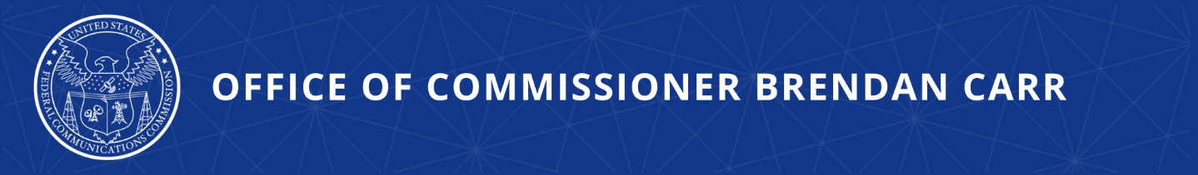
The FCC’s Plan to Take Over the Internet

Commissioner Carr to Hold Press Avail Before Title II Vote
Carr Talk Tuesday: 1:00pm on October 17th

WASHINGTON, DC, October 13, 2023—Ahead of the FCC’s October 19 vote on the Title II Notice of Proposed Rulemaking, FCC Commissioner Carr will hold a press call to take questions from the press.

WHAT: Press Avail

WHEN: Tuesday, October 17 at 1:00pm eastern

WHERE: Dial-in information for the audioconference line will be provided to press by emailing Inquiry.Carr@fcc.gov before 10:00am on the day of the call.

###

Office of Commissioner Brendan Carr  www.fcc.gov/about/leadership/brendan-carr | Media Contact  Inquiry.Carr@fcc.gov

