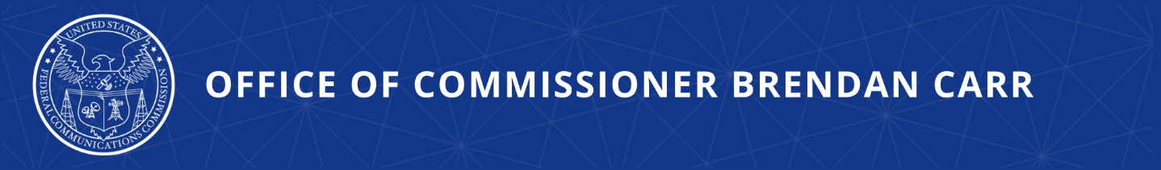
The FCC’s Plan to Take Over the Internet

The Title II Debate Was Settled When the Internet Didn’t Break

WASHINGTON, DC, October 18, 2023—FCC Commissioner Carr issued the following statement:
Here we go again. Tomorrow, the FCC will begin implementing President Biden’s plan for increasing government control of the Internet. It will do so by proposing to classify broadband as a utility service under Title II of the Communications Act of 1934. There will be lots of talk about “net neutrality” and virtually none about the core issue before the agency: namely, whether the FCC should claim for itself the freewheeling power to micromanage nearly every aspect of how the Internet functions—from the services that consumers can access to the prices that can be charged.

The entire debate over whether Title II regulations are necessary or justified was settled years ago. Indeed, when my FCC colleagues and I voted in 2017 to overturn the Obama Administration’s failed, two-year experiment with Title II, activists and politicians alike guaranteed the American public that the Internet would quite literally break without it. They predicted that prices for broadband would spike, that you would be charged for each website you wanted to visit, and that the Internet itself would slow down.

Did any one of those predictions come to pass? Of course not. Since the FCC’s 2017 decision to return the Internet to the same successful and bipartisan regulatory framework under which it thrived for decades, broadband speeds in the U.S. have increased, prices are down, competition has intensified, and record-breaking new broadband builds have brought millions of Americans across the digital divide.

Here are just some of the facts:

- Internet Speeds are up:

  - Average fixed download speeds in the U.S. have increased over 3.5-fold or nearly 260% since 2017, as shown by Ookla data.

  - Average mobile download speeds have increased over 6-fold or 456% since 2017, as shown by Ookla data.

  - The United States now has one of the highest average fixed broadband download speeds in the world, as shown by Ookla data.

- Prices are down:

  - In real terms, prices for Internet services are down and, on a price per megabyte basis, they have fallen substantially since 2017.

- Competition has intensified:

  - The percentage of Americans with access to two or more high-speed, fixed ISPs has increased by about 30% since 2017—up from 229 million in 2017 to approximately 295 million in 2022, according to FCC measures.

  - New forms of intermodal competition have also emerged and increased since 2017.

    - The new generation of low-earth orbit satellites is one example. Starlink, which launched its first satellite in 2019, now offers high-speed broadband throughout the entire United States.

    - New fixed wireless services represent additional competition as well. The number of Americans that can now choose fixed, high-speed or 5G for home broadband as an alternative to fiber or other wired connections has grown exponentially from effectively zero in 2017. 5G fixed wireless providers now cover more than 94 million homes and businesses. Indeed, fixed wireless services accounted for 90% of net broadband additions in 2022.

- The Digital Divide is narrowing:

  - Telecom crews recently set records for new high-speed fiber builds—with builders adding over 400,000 route miles in 2022 alone—which represents more than a 50% increase over 2016 numbers and enough new fiber to wrap around the Earth over 16 times.

  - In 2017, there were about 100,000 outdoor small cell nodes and that number has now increased over four-fold to 452,000 by year end 2022.

In other words, utility-style regulation of the Internet was never about improving your online experience—that was just the sheep’s clothing. It was always about government control.

So no matter what you hear tomorrow and beyond, the Internet is not broken and the FCC does not need Title II to fix it. I would encourage the agency to reverse course and focus on the important issues that Congress has authorized the FCC to advance.

###

Office of Commissioner Brendan Carr  www.fcc.gov/about/leadership/brendan-carr | Media Contact:  Inquiry.Carr@fcc.gov

