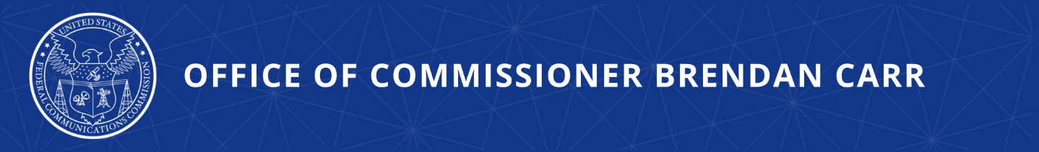

Carr Welcomes Arpan Sura as Legal Advisor

WASHINGTON, DC, January 4, 2024—Today, FCC Commissioner Brendan Carr announced that Arpan Sura has joined his office as Legal Advisor.

Commissioner Carr issued the following statement:

“I am very pleased to welcome Arpan to the office as Legal Advisor. Arpan is a true lawyer’s lawyer as well as an experienced advisor on a range of policy issues. His wealth of experience on wireless, satellite, consumer protection, media, technology, and litigation issues will be a tremendous asset to the office. I look forward to drawing on his advice and counsel.”

Arpan previously served as Senior Counsel to the Chief of the FCC’s Wireless Telecommunications Bureau, where he focused on spectrum policy, emerging technologies, and infrastructure matters. Before joining the Commission, Arpan spent more than a decade representing clients in the telecommunications and technology sectors, most recently as Counsel in the Communications, Internet, and Media practice at Hogan Lovells. Arpan received his bachelor degrees from the University of Texas at Austin and his J.D. from William & Mary Law School, where he served on the William & Mary Law Review.
###
Office of Commissioner Brendan Carr  www.fcc.gov/about/leadership/brendan-carr | Media Contact: Greg Watson  greg.watson@fcc.gov

