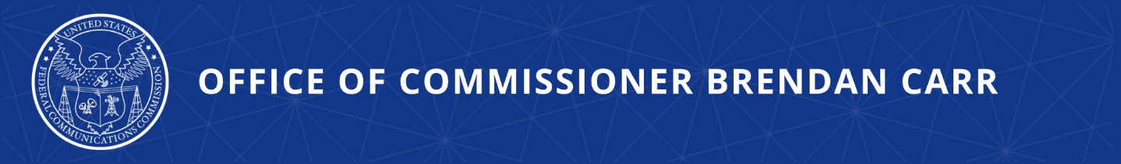
Carr Visits India for Bilateral Meetings
Discussions Focus on Security, Supply Chain, and Connectivity Matters

NEW DELHI, INDIA, February 21, 2024—Today, FCC Commissioner Brendan Carr is in New Delhi, India, for a series of bilateral meetings focused on security, supply chain, and connectivity matters. Over the course of two days, Carr will meet with his Indian counterparts, including officials at the Telecom Regulatory Authority of India, the Department of Telecommunications, the Ministry of Electronics and Information Technology, and the National Cyber Coordination Centre.

Carr will also deliver remarks at the Raisina Dialogue, India’s flagship multilateral conference on geopolitics, which is hosted in partnership with India’s Ministry of External Affairs. Carr will also participate in a roundtable discussion hosted by the U.S.–India Business Council (USIBC) where he will be joined by a range of communications and technology leaders.

Commissioner Carr issued the following statement:

“The strong bond between the world’s oldest democracy and its largest has never been more important. It is a special partnership that is working to advance our shared interests in economic opportunity, trusted supply chains, and secure networks. I am honored by the opportunity to meet with my counterparts in India and to discuss the important work that our agencies are accomplishing. I am particularly interested in the important series of steps that India has taken to address the serious threats posed by the Communist Party of China, including India’s decision in 2020 to ban TikTok.”

“I want to express my thanks and appreciation to my Indian counterparts for their warm hospitality and the opportunity to further deepen our ties. I am also very much looking forward to participating in the Raisina Dialogue and the USIBC roundtable, which will provide valuable opportunities to engage with a range of leaders on ways to strengthen innovation and security while promoting greater connectivity.”
###
Office of Commissioner Brendan Carr  www.fcc.gov/about/leadership/brendan-carr | Media Contact: Greg Watson  greg.watson@fcc.gov

