Media Contact:
Raven Hill
raven.hill@fcc.gov

For Immediate Release

FCC CHAIRWOMAN HOSTS PUBLIC SAFETY ROUNDTABLE ON NET NEUTRALITY
Emergency Responders, Technology Experts and Advocates Emphasize Importance of
Restoring FCC Oversight to Ensure Open and Fair Internet Access
--
SANTA CLARA, CA, April 9, 2024—FCC Chairwoman Jessica Rosenworcel, joined by Santa Clara County Fire Department Fire Chief Suwanna Kerdkaew, Santa Clara County Supervisor Otto Lee, public safety officials, public interest groups, disability rights advocates, and technology experts, highlighted the importance of restoring Net Neutrality during a roundtable discussion Monday to preview the agency’s upcoming vote at the agency’s April Open Meeting. If adopted, the Chairwoman’s proposal would restore Federal Communications Commission oversight of broadband services, an increasingly essential resource for public safety and first responders.

“Net neutrality rules protect internet openness by prohibiting broadband providers from playing favorites with internet traffic. These policies are popular and court-tested,” said Chairwoman Rosenworcel. “When our firefighters are going into dangerous environments, they want to know their ability to access digital technology is consistent, reliable and resilient.”

Among those in attendance at this event included Santa Clara County Fire Department officials, Santa Clara County Supervisor Otto Lee, Sonic Telecom CEO Dane Jasper, Stanford Law Professor Barbara van Schewick, Center for Accessible Technology Legal Director Melissa Kasnitz, and representatives for Mozilla, the New America Foundation’s Open Technology Institute, and TURN.

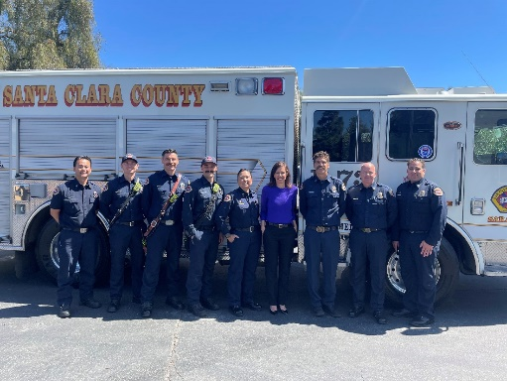

PHOTO CAPTION: On April 8, 2024, FCC Chairwoman Jessica Rosenworcel (center in blue) meets with Santa Clara County Fire Department and public safety officials in Santa Clara, California to learn firsthand about their experiences with data throttling ahead of the agency's forthcoming Net Neutrality vote at its April Open Meeting.

The Chairwoman’s trip to the Bay Area highlighted a 2018 incident involving the Santa Clara County Fire Department, whose internet access was throttled while responding to the largest fire in California history. California is one of roughly a dozen states that created its own Net Neutrality rules in response to the previous Administration’s repeal of national standards.

For a link to the Chairwoman’s remarks as prepared for delivery, click here or by visiting the FCC’s website. To watch the media availability, click here or visit the FCC’s YouTube page.

###
Media Relations: (202) 418-0500 / ASL: (844) 432-2275 / Twitter: @FCC / www.fcc.gov

This is an unofficial announcement of Commission action. Release of the full text of a Commission order constitutes official action. See MCI v. FCC, 515 F.2d 385 (D.C. Cir. 1974).

