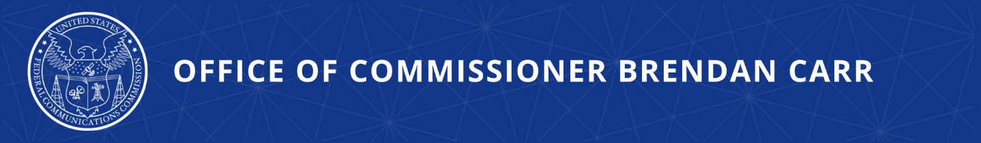

Carr Applauds Congress on Final Passage of TikTok Legislation

WASHINGTON, DC, April 23, 2024—FCC Commissioner Brendan Carr issued the following statement:

The Communist Party of China made a bet that it could control TikTok—use it to surveil Americans, sweep up troves of sensitive data for Beijing, and openly advance the CCP’s malign goals—and the U.S. would not show the resolve necessary to safeguard our national security. Today, Congress has proved the CCP wrong. This legislation definitively resolves the threats posed by the CCP’s control of TikTok by requiring it to genuinely break ties with Beijing. The legislation is smart, targeted, and on sound legal footing.

I want to applaud in particular the strong leadership and hard, bipartisan work of the House Select Committee on the CCP Chairman Gallagher and Ranking Member Krishnamoorthi who worked alongside Energy and Commerce Chair Rodgers and Ranking Member Pallone to advance this critical legislation over the past several months. Their efforts have culminated in one of the most significant legislative accomplishments of the 118th Congress heading to President Biden’s desk for signature.

I am grateful for the bipartisan coalition that both recognized and acted on TikTok’s threats. As one of many people that worked for this result, I am very pleased that those combined efforts helped contribute to this win.

Background
- June 24, 2022: Carr called on Apple and Google to remove TikTok from their app stores due to TikTok’s national security risk.
- July 13, 2022: Carr testified before the U.S. House Committee on Oversight and Reform’s Subcommittee on National Security about TikTok’s risk and the need for action.
- September 26, 2022: Carr met with E.U. counterparts in Brussels to discuss TikTok’s threats.
- November 2, 2022: In an interview on his way to Taiwan, Carr stated that he sees no path forward in the U.S. for TikTok in its current form.
- February 13, 2023: Carr provided testimony to the Australian Senate’s Select Committee on Foreign Interference through Social Media regarding TikTok’s risk.
- March 5, 2024: Carr applauded the introduction of H.R. 7521, the “Protecting Americans from Foreign Adversary Controlled Applications Act.” An amended version of H.R. 7521 was included in the national security supplemental enacted by Congress on April 23.

###

Office of Commissioner Brendan Carr  www.fcc.gov/about/leadership/brendan-carr | Media Contact:  Greg.Watson@fcc.gov

