ORAL DISSENTING STATEMENT OF
COMMISSIONER BRENDAN CARR*

Re: Safeguarding and Securing the Open Internet, Declaratory Ruling, Order, Report and Order, and Order on Reconsideration, WC Docket Nos. 23-320, 17-108 (as delivered on Apr. 25, 2024)

The Internet in America has thrived in the absence of 1930s command and control regulation by the government. Indeed, bipartisan consensus emerged early on that the government should not regulate the Internet like Ma Bell’s copper line telephone monopoly.

In the Telecommunications Act of 1996, a Republican Congress and a Democrat President came together and agreed “to preserve the vibrant and competitive free market that presently exists for the Internet . . . unfettered by Federal or State regulation.” One year later, Congress directed the FCC to issue a report definitively reviewing the terms Congress added to the Communications Act of 1934 in that 1996 enactment—including the distinction Congress had drawn between a lightly regulated Title I “information service” and a heavily regulated Title II “telecommunications service.” The FCC, chaired at the time by a Democrat and President Clinton appointee, did so in its 1998 Stevens Report. The FCC’s Stevens Report determined that Internet access service is a Title I information service under the statute.

For decades, that bipartisan position held. It held through the remainder of the Clinton Administration. It held through all eight years of the Bush Administration. And it held through the first six years of the Obama Administration. Every FCC Chair across those nearly 20 years, Republican and Democrat alike, repeatedly affirmed that broadband Internet access service (BIAS) remained a Title I information service, not a Title II telecommunications service. The FCC did so again and again and again and again. And it even did so while pursuing a variety of “net neutrality” initiatives.

Indeed, while activists on the political fringe lobbied for years to persuade the FCC to change course and regulate the Internet as a public utility under Title II, the FCC never wavered. Not once. Classifying the Internet as a Title II service remained the third rail of communications policy—both unlawful and misguided.

All of that changed in a flash. In fact, the years of bipartisan consensus vanished over the course of just 117 seconds. On November 10, 2014, President Obama published a YouTube video calling on the FCC to label broadband Internet access service a Title II telecommunications service for the first time ever and to impose sweeping new government controls on the Internet in the name of “net neutrality.”

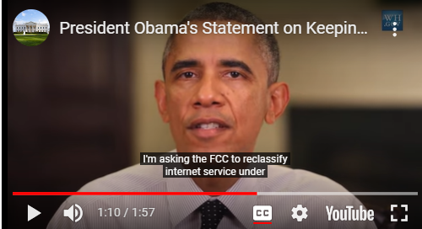

President Obama’s one minute and 57 second video was the culmination of an unprecedented and coordinated effort by the Executive Branch to pressure an independent agency into grabbing power that the Legislative Branch never said it had delegated. Indeed, on the very same morning that President Obama released his video calling for Title II, activists showed up at the home of the FCC Chairman and used their bodies to blockade his driveway, demanding that he classify the Internet as a Title II service or else they would not let him leave. They returned to his home again that same night. Chairman Wheeler would later write an email suggesting that he believed those activists that showed up at his home did not act independently from the White House.

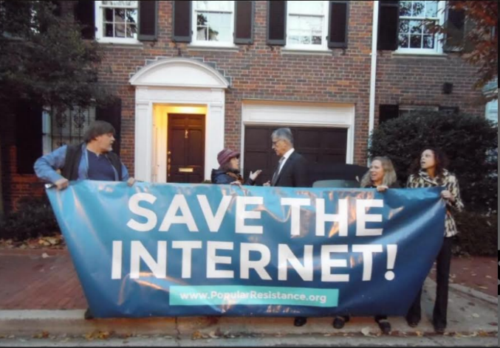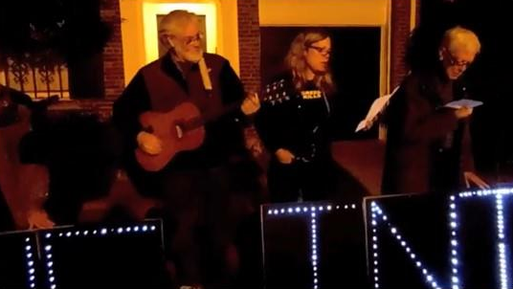

The pressure campaign continued to mount. Just weeks later, Title II activists rushed the dais during the FCC’s monthly Commission meeting—obstructing an official proceeding—and unfurled a “Reclassify Now” banner behind the heads of FCC Commissioners before FCC security intervened.

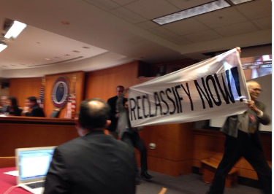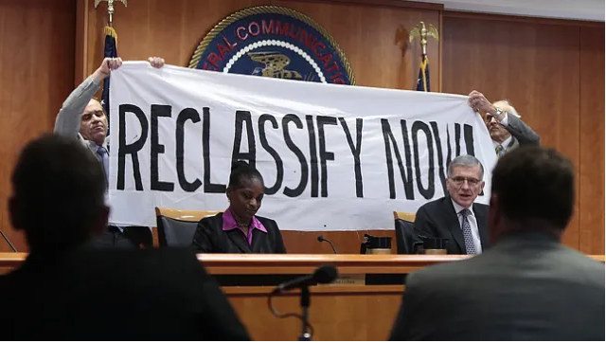

And just days before President Obama released his Title II video, Jeff Zients—who serves today as President Biden’s Chief of Staff, but was serving then as President Obama’s Director of the National Economic Council—took the unprecedented step of visiting the FCC Chairman in his FCC office so that he could deliver a message about President Obama’s upcoming announcement on Title II.

Why this flurry of pressure from the White House in November of 2014? As FCC emails show, the FCC Chairman was just days away from circulating a draft decision that would have adopted net neutrality rules but stopped short of full Title II classification. The White House decided that it had to stop this FCC plan before the FCC Chairman took it public. So it acted to derail the compromise path that the FCC Chair had been charting.

The Wall Street Journal ran a deeply reported story on all of this, titled “Net Neutrality: How White House Thwarted FCC Chief.” It describes “an unusual, secretive effort inside the White House, led by two aides . . . [a]cting like a parallel version of the FCC itself.” Internal FCC communications later obtained by Congress only confirmed and added additional concerning details to this reporting.

The Legislative Branch caught wind of the Executive Branch’s power play. It did not sit idly by. The Chief of Staff to then Senate Majority Leader Harry Reid wrote the FCC Chair. He said that he had spoken to the White House again and “told them to back off Title II. Went through once again the problems its creates for us.” Majority Leader Reid’s Chief of Staff followed up adding: “My main point to the WH is how can you declare that regulations written in the 1930’s will work fine for 2014 technology. Let Tom do his job and this will be fine.”

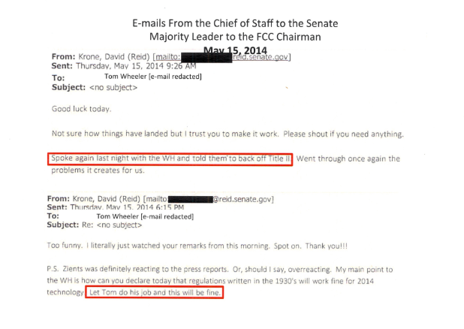
Except the White House did not let the FCC Chair do his job. The President intervened. He flipped him.

Reflecting on the White House campaign while testifying before Congress, FCC Chairman Wheeler was asked about President Obama’s November 10 announcement and whether it had an impact on the Title II debate at the FCC. “Of course it did,” Chairman Wheeler testified. “[W]hen Jeff Zients came to see me and said this is what the President is going to do. That was substantial significance.” That testimony is true. Emails confirm that the FCC stopped the presses on its compromise or hybrid approach, delayed the vote, and quickly drafted a decision that went full Title II—just as the President had demanded. Chairman Wheeler would refer to the episode in an email as his “Damascus Road experience.”

Ever since President Obama flipped FCC Chairman Wheeler, there has been no turning back. Title II is now a matter of civic religion for activists on the left. They demand that the FCC go full Title II whenever a Democrat is President. Everyone knows what is expected. Indeed, President Biden made restoring Title II a campaign promise, and Jeff Zients is back in the White House.

So, yes, millions of comments have been filed at the FCC on Title II and net neutrality over the years. But none of them mattered. None of them persuaded the FCC to go full Title II. Only the President mattered. This also explains why the FCC has never been able to come up with a credible reason or policy rationale for Title II. It’s all shifting sands. And that’s because the agency is just doing what it has been told to do by the Executive Branch and cobbling together post hoc rationalizations as it goes along.

* * *
Now, you may wonder why I am starting out my statement by recounting this bit of FCC history. Well, for starters, I think it tells an important part of the Title II story. The FCC’s position on Title II did not simply evolve over the course of years. The Overton window on Title II did not just naturally shift. President Obama forced the FCC’s hand. I understand that there are many people that would like to sweep that entire episode under the rug and forget about it. I am not one of them.

But I am also starting out my statement here for a more fundamental reason. After all, it is not surprising that the Executive Branch tried to pressure another component of the government into doing something the President thought would benefit him politically. In many ways, that is a story as old as the republic itself. But what is surprising is that it succeeded—that the courts sanctioned the power grab.

You see, the Framers understood the nature of those in power, and they set up a series of checks and balances to avoid government overreach. Chief among them is the Constitution’s separation of powers. In Article I, “the People” vested “[a]ll” federal “legislative powers . . . in Congress.” As Chief Justice Marshall put it, this means that “important subjects . . . must be entirely regulated by the legislature itself,” even if Congress may leave the Executive Branch to “fill up the details.” That did not happen here. Congress never passed a law saying that the Internet should be heavily regulated like a utility, nor did it pass one giving the FCC authority to make that monumental determination. The Executive Branch pressured the agency into claiming a power that remained—and remains—with the Legislative Branch.

Fundamentally, I would argue, much of the fault lies with the judiciary’s application of Chevron. The Supreme Court’s decision in Chevron created a situation where the Executive Branch could engage in the type of pressure campaigns that we witnessed with Title II. That is because Chevron, at least as applied by some courts, has allowed agencies to seize big, new powers without an express grant of authority from Congress. If a statute were ambiguous, Chevron held, an agency could go ahead and regulate. In cases of vast economic or political significance at least, Chevron not only creates an environment in which agencies push beyond the bounds of their authority, it creates an incentive for the Executive Branch or other political actors to pressure them into doing so.

That is why the Supreme Court’s decision in West Virginia v. EPA is so important. It makes clear that on matters of enormous significance, like the one before us today, administrative agencies must point to far more than an ambiguous statute to persuade a reviewing court that Congress authorized the agency to act. After all, as a constitutional matter, Congress does not operate like a sieve—inadvertently spilling grants of massive new authorities. After West Virginia, Congress’s delegation of authority in these types of cases can no longer be implicit; it must be explicit. Properly applied, West Virgina will stop the flip-flopping and eliminate the incentives for the Executive Branch to engage in the type of pressure campaigns we have seen on Title II. It will help improve administrative agency decisions, too, by ensuring that they are driven by the facts, the law, and the record. It will allow the natural forces of compromise to work their will on legislating, rather than winner-take-all party line votes at agencies. And it will ensure that the legislative powers will remain with Congress unless and until the Legislature decides to delegate them.

If that weren’t enough, today’s Order independently violates the Supreme Court’s command in West Virginia through its unrestrained use of forbearance. Although the FCC may forbear from parts of Title II, the Order indiscriminately applies that authority to fundamentally rewrite the 1996 Act by line-item vetoing more than a dozen provisions central to Title II’s legislative design. As multiple Supreme Court decisions confirm, that unrestrained application of forbearance is illegitimate. Indeed, just last year, the Supreme Court struck down the Biden Administration’s use of analogous waiver authority after the Education Department tried to use it to wipe away student loan debt. As a matter of statutory construction and implied delegation, the FCC is not presumed to have the sweeping power to refashion Title II into an entirely new legislative scheme by picking and choosing which parts of Title II will apply.

* * *
The FCC’s flip-flopping also informs how seriously one should take the Order’s policy arguments. The FCC tries to dress up its latest power grab in a 400-plus page Order that offers a laundry list of bogus justifications. Few of them rely on actual evidence. Virtually none point to real problems. All fall apart under casual scrutiny. Indeed, it’s not even clear the FCC believes the reasons it offers today for Title II.
Today’s Order is not about “net neutrality.” When we abandoned Title II in 2017, proponents of greater government control flooded the zone with apocalyptic rhetoric. Media outlets and politicians mindlessly parroted their claims. They predicted “the end of the Internet as we know it” and that “you’ll get the Internet one word at a time.” Consumers would have to pay to reach websites. None of it happened. Americans were subjected to one of the greatest hoaxes in regulatory history.
Nor is today’s Order about preventing Internet “gatekeepers” from squashing innovation and free expression. Again, check the receipts. After 2017, it was not the ISPs that abused their positions in the Internet ecosystem. It was not the ISPs that blocked links to the New York Post’s Hunter Biden laptop story, old Twitter did that. It was not the ISPs that just one day after lobbying the FCC on this Order blocked all posts from a newspaper and removed all links to the outlet after it published a critical article, Facebook did that. It was not the ISPs that earlier this month blocked the links of California-based news organizations from showing up in search results to protest a state law, Google did that. And it was not the ISPs that blocked Beeper Mini, an app that enabled interoperability between iOS and Android messaging, Apple did that.
Since 2017, we have learned that the real abusers of gatekeeper power were not ISPs operating at the physical layer, but Big Tech companies at the application layer. Perversely, today’s Order makes Big Tech behemoths even stronger than before.
And today’s Order is not about correcting a market failure. Broadband access is more vibrant and competitive than ever, no matter how you slice the reams of data. Americans benefited from lower prices, faster speeds, broader and deeper coverage, increased competition, and accelerated Internet builds.
Here’s what the data show. Internet speeds are up 430% since 2017 on the fixed broadband side, and they are up 647% on the mobile side. In real terms, the prices for Internet services have dropped by about 9% since the beginning of 2018, according to BLS CPI data. On the mobile broadband side alone, real prices have dropped by roughly 18% since 2017, according to BLS and industry data. And for the most popular broadband speed tiers, real prices are down 54%, and for the fastest broadband speed tiers, prices are down 55%, over the past 8 years, according to BLS and industry data.
The FCC realizes that the old justifications for Title II will no longer cut it. So, as if nothing ever happened, as if the old predictions were not disproven, the agency invents new justifications. The FCC throws whatever it can think of against the wall to see if anything sticks. The Order now claims Title II is necessary for national security, for public safety, for law enforcement, for pole attachments, for accessibility, for privacy and cybersecurity—the list goes on and on.
But the FCC’s latest set of claims fare no better than those trotted out back in 2015. They are simply new pretext to justify an old power grab.
Take national security. The FCC has identified no gap in national security that Title II is necessary to fill. Rather, the FCC record makes clear that Congress has already empowered agencies with national security expertise—including the Departments of Homeland Security, Justice, Commerce, and Treasury—to address these issues in the communications sector. Indeed, the Biden Administration’s own filing in this proceeding confirms national security agencies already have and “exercise substantial authorities with respect to the information and communications sectors.”
In particular, the Biden Administration already has the authority to prohibit entities controlled by the Chinese Communist Party (CCP) from operating in the U.S. today. Indeed, the Commerce Department codified one such set of authorities back in 2021. So Title II fills no gap in authority. Indeed, as to those specific CCP-aligned companies, the FCC’s own database of ISPs shows that they are not offering any broadband services that would be subject to Title II even after reclassification.
Or take consumer privacy. The FTC already regulates ISPs and their privacy practices. Indeed, at this very moment, broadband consumers benefit from the same set of federal privacy rules that protect consumers across the economy. But those federal rules go away with respect to broadband if the FCC votes for Title II. That is because, by law, the FTC loses 100% of its authority over any service that is regulated by the FCC under Title II. In turn, the FCC’s Title II decision would leave broadband consumers with no federal privacy rules to protect them because Congress prohibited the FCC from applying its own privacy rules or any substantially similar ones to ISPs back in 2017. While the FCC claims that there would still be some residual Section 222 statutory privacy provisions that could apply to ISPs, that assertion is dubious at best given the 2017 law. So, far from filling a gap in consumer privacy rules, an FCC decision to apply Title II to broadband would create one.
Or take cybersecurity. Once again, the agency makes no serious attempt to argue that Title II is necessary to promote cybersecurity. For one, Congress and the Executive Branch have already formulated a comprehensive cybersecurity regime that is solidly grounded in existing law. That effort is led, not by the FCC, but by the Cybersecurity & Infrastructure Security Agency, which is part of DHS. Nothing in Title II gives the FCC any additional authorities when it comes to participating in the federal government’s CISA-led process. For another, Title II does not authorize the FCC to adopt national cybersecurity standards. Indeed, even under the FCC’s reading, Title II does not even apply to the vast range of cyber targets, like cloud providers and tech platforms, further undermining any claim that Title II is necessary to ensure America’s cybersecurity.
Or take network resiliency and outage reporting. Here, too, the FCC makes no coherent case for Title II advancing any of these interests. For one, the FCC already collects outage reports, operational status, and restoration information from broadband service providers. For another, America’s broadband networks are more robust and resilient than those in countries with far more heavy-handed or Title II-like regulatory regimes. And with respect to 911 in particular, the FCC already has specific rules in place today that address outages that impact this public safety service.
Or take public safety. The FCC rests this claim on a single event that, it turns out, has nothing to do with Title II or net neutrality. In that 2018 incident, a fire department purchased a data-limited plan and experienced reduced speeds after exceeding its limits. The ISP made an exception and lifted the reduction. Although it constantly invokes this event, the FCC studiously avoids stating that this type of issue would be prevented by Title II. Under today’s Order, it would remain lawful for multiple reasons.
* * *
Misleading the American people is one thing, but the Order also leaves them worse off.
Everything we love about the Internet comes from investment. Our broadband networks are built on private capital, and those investment decisions in turn depend on a company’s best guess of the long-term financial horizon. Will ISPs invest as intensively when the rules of the road are opaque, when business choices can be second-guessed without notice, when regulators reserve the right to dictate the rate of return, or when upgrades and innovations require more and more paperwork and approvals?
Uncertainty riddles every aspect of this Order. Will consumers pay new broadband taxes? Not today, but maybe tomorrow. Can ISPs offer customized plans for consumers with unique data, speed, or cost needs? Possibly, but it depends. What about intelligent networks to prevent congestion? Sure, but only if a handful of indeterminate factors are met. Does the FCC intend to issue new regulations? Definitely, but you will have to wait and see what the agency does.
By all indications, things will get worse before they get better. Apart from this Order, the Biden Administration is on a spree of unchecked regulatory excess. At President Biden’s urging, the FCC adopted a Digital Equity Order that hands the Administrative State veto power over every decision about the provision of Internet service in the country. Elsewhere, the FCC is laser focused on nullifying private contracts, micromanaging advertising, dictating rates, blindsiding companies by enforcing legal expectations that aren’t on the books, and stepping into the swim lanes traditionally occupied by other federal agencies.
The FCC apparently doesn’t understand—or doesn’t care—how this volatile and punitive climate of regulation will deter investment in broadband networks. This isn’t just heady economic theory. Again, let’s go to the tape. Broadband investment slowed down after the FCC imposed Title II in 2015, and it picked back up after we restored Title I in 2017. Or look at Europe, where regulators have long applied centralized, utility-style controls to their continent’s Internet infrastructure. While America’s digital economy is the envy of the world, sluggish European networks suffer from chronic underinvestment.
Without greater investment, the Biden Administration’s broader policy objectives fall apart. The Administration wants ISPs to opt into federal support programs so they can bring broadband to high-cost, unserved communities. But who will take that financial risk when an ISP’s returns can be wiped away with a stroke of a bureaucrat’s pen? This Administration has pushed ISPs to deploy open, interoperable networks to offer competitive options beyond the dominant Chinese equipment manufacturers. But who will invest in Open RAN when its core functionalities—virtualization and network slicing—might violate an amorphous rule against “impairing” or “degrading” traffic?
While misrepresenting Title II’s benefits, the Order takes an ostrich-like approach to its documented harms. It is a textbook example of “arbitrary and capricious” agency action to reach a predetermined outcome.
In the end, though, I remain optimistic. I am confident that we will right the ship. And I am certain that the courts will overturn this unlawful power grab.
For now, I dissent. My full written statement for the record will follow.

* This text substantially represents the oral remarks that Commissioner Carr delivered at the FCC’s April 25, 2024 open meeting. The full text of Commissioner Carr’s entire written dissent will be published soon.
See Telecommunications Act of 1996, § 509, P.L. 104-104, 100 Stat. 56, 137 (1996) (1996 Act); see 47 U.S.C. § 230(b)(2).
See Federal-State Joint Board on Universal Service, Report to Congress, 13 FCC Rcd 11501 (1998) (Stevens Report) (classifying Internet access service); see also Dissenting Statement of Commissioner Ajit Pai, at 33-35, Protecting and Promoting the Open Internet, Order on Remand, Order and Declaratory Ruling, 30 FCC Rcd 5601 (rel. Mar. 12, 2015), https://docs.fcc.gov/public/attachments/FCC-15-24A5.pdf (Pai 2015 Title II Dissent).
See Inquiry Concerning High-Speed Access to the Internet Over Cable & Other Facilities; Internet Over Cable Declaratory Ruling; Appropriate Regulatory Treatment for Broadband Access to the Internet Over Cable Facilities, Declaratory Ruling and Notice of Proposed Rulemaking, 17 FCC Rcd 4798 (2002) (classifying broadband Internet access service over cable systems), aff’d sub nom. Nat’l Cable & Telecomms. Ass’n v. Brand X Internet Servs., 545 U.S. 967 (2005).
See Appropriate Framework for Broadband Access to the Internet Over Wireline Facilities et al., Report and Order and Notice of Proposed Rulemaking, 20 FCC Rcd 14853 (2005) (classifying broadband Internet access service over wireline facilities).
See United Power Line Council’s Petition for Declaratory Ruling Regarding the Classification of Broadband over Power Line Internet Access Service as an Information Service, Memorandum Opinion and Order, 21 FCC Rcd 13281 (2006) (classifying broadband Internet access service over power lines).
See Appropriate Regulatory Treatment for Broadband Access to the Internet Over Wireless Networks, Declaratory Ruling, 22 FCC Rcd 5901 (2007) (classifying broadband Internet access service over wireless networks).
Preserving the Open Internet; Broadband Industry Practices, 25 FCC Rcd 17905, 17972-80, 17981, paras. 124-35, 137 (2010) (2010 Open Internet Order); Appropriate Framework for Broadband Access to the Internet over Wireline Facilities et al., Policy Statement, 20 FCC Rcd 14986 (2005).
See Ezra Mechaber, President Obama Urges FCC to Implement Stronger Net Neutrality Rules, White House Blog (Nov. 10, 2014), https://obamawhitehouse.archives.gov/blog/2014/11/10/president-obama-urges-fcc-implement-stronger-net-neutrality-rules.
See Hearing before the Committee on Oversight and Government Reform, House of Representatives, FCC: Process and Transparency, at 14-19 (Mar. 17, 2015), https://oversight.house.gov/wp-content/uploads/2016/04/3-17-15-FCC-Process-and-Transparency.pdf (2015 FCC Process and Transparency Hearing); see also Hearing before the Committee on Oversight and Government Reform, House of Representatives, FCC: Process and Transparency. FCC Hearing Packet, at 3 (Mar. 17, 2015), https://oversight.house.gov/wp-content/uploads/2015/03/FCC-Hearing-Packet.pdf (2015 Oversight Hearing Packet).
See U.S. Senator Ron Johnson, Regulating the Internet: How the White House Bowled Over FCC Independence. A Majority Staff Report of the Committee on Homeland Security and Governmental Affairs, United States Senate, at 9-17 (2016), https://www.hsgac.senate.gov/wp-content/uploads/imo/media/doc/FCC%20Report_FINAL.pdf (2016 Senate Report).
See Gautham Nagesh and Bordy Mullins, Net Neutrality: How the White House Thwarted FCC Chief, Wall St. J. (Feb. 4, 2015), https://www.wsj.com/articles/how-white-house-thwarted-fcc-chief-on-internet-rules-1423097522.
Id.
See 2016 Senate Report at 9-17; see also 2015 FCC Process and Transparency Hearing at 13-17; 2015 Oversight Hearing Packet at 1-7.
2015 Oversight Hearing Packet at 4; see also 2015 FCC Process and Transparency Hearing at 22-23, 41-42.
2015 Oversight Hearing Packet at 4.
2015 FCC Process and Transparency Hearing at 5.
2015 FCC Process and Transparency Hearing at 40.
2016 Senate Report at 17-29.
2016 Senate Report at 5, 14.
See Protecting and Promoting the Open Internet, Report and Order on Remand, Declaratory Ruling, and Order, 30 FCC Rcd 5601 (2015) (2015 Title II Order).
See, e.g., Biden-Sanders Unity Task Force Recommendations, at 13 (July 8, 2020), https://joebiden.com/wp-content/uploads/2020/08/UNITY-TASK-FORCE-RECOMMENDATIONS.pdf.
U.S. Const. pmbl.; U.S. Const. art. I, § 1.
Wayman v. Southard, 10 Wheat. 1, 42-43 (1825).
West Virginia v. EPA, 142 S. Ct. 2587, 2605 (2022).
See Letter from the Hons. Cathy McMorris Rodgers and Ted Cruz et al. to the Hon. Jessica Rosenworcel, Chairwoman, FCC, at 2 (Apr.. 23, 2024) (“Congress’s decision to treat broadband Internet access as an information service, rather than a telecommunications service, was a deliberate policy choice.”); Letter from Hon. Josh Gottheimer et al. to the Hon. Jessica Rosenworcel, Chairwoman, FCC, at 2 (Apr. 20, 2024) (“Given that there is no threat of imminent harm requiring Commission action, we ask the Commission to defer action on the NPRM to allow this legislative process to continue and to avoid imperiling important federal policy objectives.”).
Biden v. Nebraska, 143 S. Ct. 2355 (2023).
See Sherman Smith, Facebook Apologizes for Blocking Kansas Reflector, Then Expends Crackdown to Other News Sites, Kansas Reflector (Apr. 5, 2024), https://kansasreflector.com/2024/04/05/facebook-apologizes-for-blocking-kansas-reflector-then-expands-crackdown-to-other-news-sites/.
See Gerrit De Vynck and Laura Wagner, California Wants Big Tech to Pay for News. Google is Fighting Back (Apr. 21, 2024), https://www.washingtonpost.com/technology/2024/04/21/google-blocks-california-news/.
See Emma Roth, FCC Commissioner Wants to Investigate Apple Over Beeper Mini Shutdown, The Verge (Feb. 12, 2024), https://www.theverge.com/2024/2/12/24071226/fcc-commissioner-brendan-carr-apple-beeper-mini.
See Statement of FCC Commissioner Brendan Carr, New Data Confirm What Americans Already Know: The Internet Is Not Broken and President Biden’s Plan for Government Control Won’t “Fix It,” (Apr. 19, 2024), https://docs.fcc.gov/public/attachments/DOC-401950A1.pdf.

