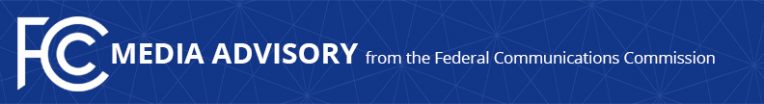

Media Contact:
MediaRelations@fcc.gov

For Immediate Release

FCC CHAIRWOMAN TO ADDRESS CONNECTICUT LIBRARY ASSOCIATION MONDAY TO DISCUSS ‘LEARN WITHOUT LIMITS’ INITIATIVE AND COMBATTING THE HOMEWORK GAP
Fireside Chat to Take Place at 1pm ET on Monday at the Mystic Marriot
--
WASHINGTON, April 26, 2024—On Monday, FCC Chairwoman Jessica Rosenworcel will address the Connecticut Library Association Conference in Groton, Conn. and participate in a fireside chat about the agency’s work to bridge the homework gap. The Chairwoman’s “Learn without Limits” initiative has worked on bringing Wi-Fi to school buses, connecting tribal libraries, modernizing the E-Rate program, and support the lending of mobile hot spots. The FCC also established and ran the successful $7.171 billion Emergency Connectivity Fund, a program that helped schools and libraries provide the tools and services their communities need for remote learning during the COVID-19 emergency period.

WHAT: Fireside Chat, Connecticut Library Association Conference

WHEN: Monday, April 29, 2024
1:00 p.m. to 1:20 p.m. ET
https://www.claconference.info/

WHERE: Mystic Marriott Hotel and Spa
625 N Road, Groton, CT 06340
Room: Mystic AD

###
Media Relations: (202) 418-0500 / ASL: (844) 432-2275 / Twitter: @FCC / www.fcc.gov

This is an unofficial announcement of Commission action. Release of the full text of a Commission order constitutes official action. See MCI v. FCC, 515 F.2d 385 (D.C. Cir. 1974).

