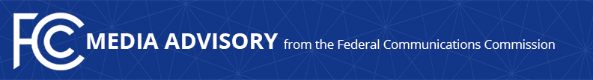

Media Contact:
MediaRelations@fcc.gov

For Immediate Release

FCC HOSTS SPACE BUREAU TRANSPARENCY EVENT ON INTERAGENCY REVIEW OF SATELLITES PRIOR TO LAUNCH
‘Don’t Get Grounded: Understanding the Interagency Review of Satellites Prior to Launch’
--
WASHINGTON, May 7, 2024—The FCC Space Bureau will convene a discussion of the roles different federal agencies play in the review of satellites before commercial launches take place. FCC officials will be joined by partners from the Federal Aviation Administration (FAA), State Department, and the National Oceanic and Atmospheric Administration (NOAA). Thursday’s Space Bureau event is the latest in its Transparency Initiative.

Prior to a launch, U.S. government agencies review information regarding satellites and other “payloads” onboard the launch vehicle, including assessing whether the satellites have all necessary licensing and approvals, such as an FCC license. The event will feature speakers from across the U.S. government to discuss the respective roles of agencies during this process, describe challenges for both government and industry, and identify ways to alleviate burdens throughout the process so satellite operators can prepare for successful and timely reviews.

This event is free and open to the public. Members of the media are welcome to attend.

WHO:
- Sabrina Jawed, Manager, Commercial Space Law Team, Federal Aviation Administration
- Stacey M. Zee, Manager, Operations Support Branch, Federal Aviation Administration
- Ryan Guglietta, Lead Foreign Affairs Officer, Office of Space Affairs, State Department
- Glenn Tallia, Chief, Weather, Satellites, & Research Section, Office of General Counsel, National Oceanic and Atmospheric Administration
- Karl Kensinger, Special Counsel, Space Bureau, Federal Communications Commission
- Merissa Velez, Chief, Satellite Programs and Policy Division, Space Bureau, Federal Communications Commission

WHAT: FCC Space Bureau Transparency Event:
‘Don’t Get Grounded: Understanding the Interagency Review of Satellites Prior to Launch’

WHEN: Thursday, May 9, 2024
10:30 a.m. to 12:00 p.m. ET

WHERE: Federal Communications Commission
45 L Street, NE
Washington, DC 20554

LIVESTREAM: www.fcc.gov/live

Register for the event here.

Note: Please leave time to go through FCC security.

###
Media Relations: (202) 418-0500 / ASL: (844) 432-2275 / Twitter: @FCC / www.fcc.gov

This is an unofficial announcement of Commission action. Release of the full text of a Commission order constitutes official action. See MCI v. FCC, 515 F.2d 385 (D.C. Cir. 1974).

